Efficient information flow as a key factor of success in logistics
Dębicki Tomasz
Institute of Logistics and Warehousing

The complexity of today transport and logistics chains needs a fast and reliable information exchange system to ensure an efficient and cost optimized logistics solutions. Article shows two specific business cases for intermodal transportation and benefits of using information sharing systems. In this short article I am not able to make a review of other ICT tools supporting electronic data interchange in transport and logistics. The objective of the article was to show the ideas and organization of information flow in real business cases and to show how with the help of ICT tools and existing standards of identification and information exchange logistics chains become more transparent, are more optimized. That is why customers, service providers and stakeholder are taking advantage of better and faster information flow.
The intermodal transport connections are very complex because involve many business actors in the process, because of often transnational character and because of it is inter-modality air, sea, rail, road, in-water transport and operations in nods between transport stages. With realization of such multi-modal transport a lots of information and fast exchange of this information is needed, different transport documents are required . This complex nature of intermodal transport can be supported by information sharing systems which helps involved players of intermodal transport on every stage of transport chain realization with documents exchange, services booking, status monitoring and financial settlements .
Business cases
Export from Poland to Russia through port of Elblag.
Most of the transport through port Elblag comes from polish small and medium size companies to Russia, to Kaliningrad. Polish companies exporting mostly building materials, wood and furniture, and also food like cereals, corn, soya and sugar this goes both ways. Other port are also on the map of port Elblag like Klaipeda, Scandinavian ports and other polish as well. In the usual process the following actors are participate: Shipper (company which sends goods through port), Receiver ( an Entity which ordered goods), Road Transport provider (transport provider who delivers goods to port) , Terminal Operator (company who owns or hires the terminal in port and does the goods handling in terminal) , Port authority (authority of the port who is interested of volume information) , Sea transport provider ( Sea transport provides a sea leg of intermodal transport).
Solution:
Within the ACL project an information sharing system has been produced and introduced in the port of Elblag for testing and further improvements. This system supports exchange of documents and information about orders between shippers, terminal operator, port authority and Sea agency. Besides documents the system helps to organize operational work better and make access to information from anywhere to all stakeholders. Main features of this system are :
- Documents exchange,
- Availability from anywhere by web-browser
- Availability on mobile equipments smartphones and tablets
- Import and export documents to excel and xml messages
- Reporting
Beneath figure shows the pilot system implementation in port of Elblag. Customers are providing handling orders to the t-scale platform, besides manual providing orders to web-forms it is possible import them from excel files or XML standardized file format. After customers sends their orders they are immediately available for terminal operator who can analyze them and accept them or reject. After acceptation customers will be informed about the status of his orders. Sea agency also have an access to orders so in this way they may use it for the payload for documents they produce like sea waybill. Port authority have an access to some of the reports and statistical data.

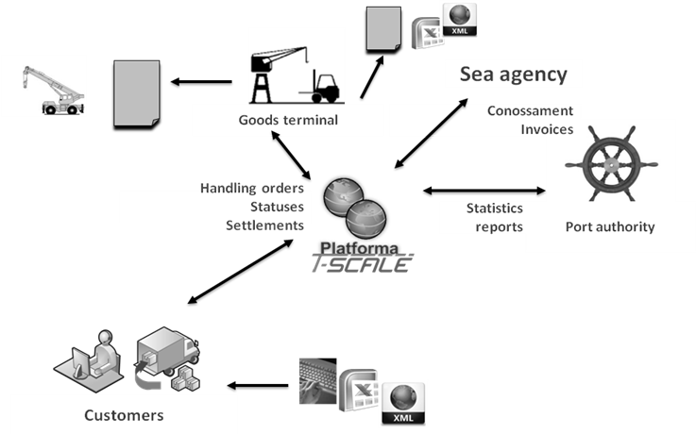
Figure 1 Pilot implementation of information sharing system in port.

Import goods from port of Gdansk.
In this business case several companies from East of Poland import containerized goods from Far East through the port of Gdansk. The volume of each of those companies are not enough to be able to use cheaper rail transport to Lublin and then last mile delivery on truck. However if several companies would have combined their cargo into one consolidated shipment to be delivered to terminal in Lublin and split again for individual shipments and deliver individually to the final destination then rail company would be able to transport bigger shipment and cost of transport would be less for the importers. Eventually there will be more benefits like greener transport and less trucks on roads.
Solution:
For this business case the same ICT Tool is used in different configuration with different business roles in this case we have customers, transport coordinator, logistics service providers (including intermodal transport and terminal operators in logistics nods), port. Customers prepare transport inquiries for their containers to be transported from port to their own facilities. Prepared inquiries are sent to transport coordinator who is planning them as one consolidated shipment negotiate conditions with logistics service providers then propose its offer to customers. If customers agree on this offer then consolidate transport is executed. Customers are able monitor their orders thanks to exchange statuses of the orders. If specific containers has a specific equipment which enable to locate it with GPS, then it also can be track on the map and more information are available like temperature and other conditions inside the container. After order is completed transport coordinator does financial settlements with transport and logistics service providers and customers.

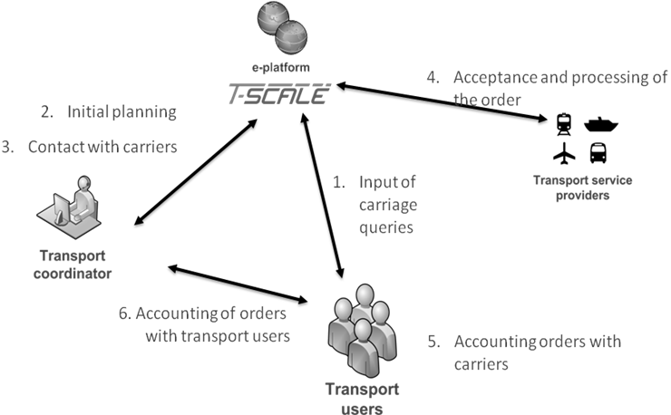
Figure 2 T-Scale platform as transport consolidation platform for intermodal transportation.
Port of Gdansk with its DCT terminal where the biggest container ships on the World arrives may also be interesting for countries on East border of Poland like Lithuania Belarus, Russia and Ukraine as their main logistics hub as there are also many rail transport providers from Poland which are cooperating with those countries.
Standardization as pillar of information exchange
In present information exchange in business, trade, logistics and transportation particularly is very important to use the same “language” of for information exchanged. For many years many different standards have been developed but also many solutions exposed by software solution providers . These many standards used by business players cause many serious problems in implementation of electronic data interchange between partners. Those two implementation of ICT tool for information exchange presented in article would not possible without using standards for identifiers of goods, logistics units and locations as well as for electronic messages exchanged between business partners.
In both business cases the implementation is based on GS1 standards for identification and electronic messages. SSCC for load units identification, GTIN for trade unit, GLN for locations, GSIN and GINC for shipment and consignment, GRAI for returnable packages, GIAI for tracing the equipments or parts used in transport. Using of global identifiers in whole transport chain makes possible to track and trace the logistics unit, shipments, means of transport on every stage of the chain which is very important for planning but also for traceability. With today technology and additional equipment available we can monitor not only where our goods are but also in what conditions they are being transported. System GS1 provides standards not only for identification but also electronic messages exchanged between business partners. There are dedicated messages for transport and logistics sectors and are available in both EANCOM standard and GS1/XML standard. Data exchanged with transport service provider are little bit different of those which are exchanged between buyer and seller. Transport service providers are more interested in identification of logistics units and shipments than identification of trade items. More important are physical features of goods than trade features. It is seen in electronic messages for transport and logistics. Transport Instruction most popular message used in transport business are nothing else like transport order containing all necessary information for transport providers to take in the order and executed. In this message we will find information about physical parameters of shipment, quantity and type of logistics units, transport conditions, loading and unloading places with its time frames, information about additional services related to this transport and many others important data. Transport Status message is used for monitoring the execution of transport orders on each stage of its route. Most often message is sent after finishing each leg of the transport chain. It may contain information about shortages, damages and discrepancies between delivery and expected goods at final delivery. Message may also contains the information from additional equipment on truck or container like GPS coordinates, alarms for example in case of unauthorized door opening, conditions of goods like temperature and humidity. Other important messages in transportation are booking request and booking confirmation which are used booking a transport service at transport service provider. There are many more which helps to organize transport chains the description of all them are available at website of GS1 organization.
Besides GS1 standards there also other which are also used by transport and logistics companies around the world like UN/CEFACT with its EDIFACT standard, Oasis with UBL or ANSI X.12 in North America. Today’s approach is changing in direct of use more sophisticated solutions of information exchange like semantic solutions for interoperability between companies and organizations. With help of semantic different companies or group of companies having their own standards for electronic messages can exchange the documents. Thanks to today’s level and accessibility of tools for semantic interoperability this idea becomes more and more popular it has its application not only in transport and logistics sector but everywhere where different standards and also different languages meet specially in transnational data exchange. This solutions is also promoted in European projects related with transport and logistics and e-administration. Figure below shows a layered approach for semantic interoperability in which the layers reflects the various company layers.

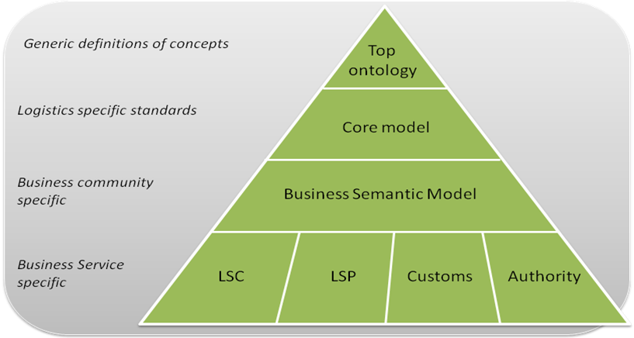
Figure 3 Layered approach for semantic interoperability based on i-Cargo project approach for logistics interoperability.
Different organisation requires different information in their business process. Some organisations can be interested in concerns related to the transport of dangerous cargo, while customs organisations may want to look into details of import/export declarations. Within the logistics domain, several global standardisation bodies for information exchange in logistics supply chains exist, including UN/Cefact, the World Customs Organisation (WCO) and GS1 [9]. Individual services of different business actors requires a specific information or delivers specific information which are described in business community specific layer where also are the rules for logistics messages standards. Ontology’s are also helpful with documents validation specially in customs or everywhere where legal rules are defining some formalities on documents ontology’s with automated reasoning may help to validate documents before further processing it.

List of the references
- The System for planning intermodal supply chains; Terms of References; WP3 of Interbaltic Project; Institute of Logistics and Warehousing, Poland, 2006.
- UN/CEFACT “Single Window” Project. http://www.unece.org/cefact/single_window/welcome.htm 2007-07-27
- Perishable goods logistics – feasibility analysis and ICT solutions; Global Integrated transport Logistics Data Network. Italy 2005.
- Logistics Interoperability Model Foundation Report Final. GS1 Global Office July 2011.
- OASIS ebXML registry 3.0. Oasis organisation 2013.
- DISCWISE “One Common Framework for Information and Communication Systems in Transport and Logistics – Facilitating Interoperability" 2011.
- GS1 – ecom Logistics Standards. GS1 XML v.3.0 Transport Management electronic messages.
- KOMODA “Definition of an integrated e-Logistics system Europe-wide”.
- iCargo “Intelligent Cargo in Efficient and Sustainable Global Logistics Operations”

GPS – Global Positioning System
DCT – Deepwater Container Terminal In Gdansk, DCT is the first terminal that attracted direct calls from Asia to the Baltic Sea and is today the destination for the largest vessels in the world departing from China, Korea and other Asian countries.
GS1 – Global System One – Global Standardization Organization
SSCC – Serial Shipping Container Code is used for identification of logistics units: pallets, packacges etc..
GTIN – Global Trade Item Number – Number for trade item identification mostly used in retail business.
GLN – Global Location Number is for identification of different location related with Transport and logistics like company department, ports, terminals, warehouses, delivery and pick-up places, etc.
GSIN – Global Shipment Identification Number used for identifying individual shipments
GINC – Global Indntification Number of Consignment – used for identifying consolidated shipments
GRAI – Global Returnable Assets Identifier
GIAI – Global Individual Asset Identifier used for recording life-cycle of parts, like history of plane parts.
UN/CEFACT - United Nations Centre for Trade Facilitation and Electronic Business
EDIFACT – Electronic Data Interchange For Administration, Commerce, and Transport standard issued by UN/CEFACT
Oasis - Organization for the Advancement of Structured Information Standards is a non-profit consortium
UBL - Universal Business Language standard issued by OASIS
ANSI X.12 - The Accredited Standards Committee X12 (also known as ASC X12), chartered by the American National Standards Institute in 1979, develops and maintains the X12 EDI and CICA standards along with XML schemas which drive business processes globally
i-Cargo – Intelligent Cargo in Efficient and Sustainable Global Logistics Operations European funded Project.
WCO – World Custom organisation

