SYNTHESIS OF A SILICON CARBIDE FROM NATURAL RAW MATERIAL IN A SOLAR FURNACE

M.S.Paizullakhanov¹, L.S.Suvonova², N.N.Cherenda^{3*}
¹Material sciences institute of the Academy of Sciences Republic of Uzbekistan, Tashkent, Republic of Uzbekistan
² “Tashkent Institute of Irrigation and Agricultural Mechanization Engineers” National Research University, Tashkent, Republic of Uzbekistan
³Belarusian State University, Minsk, Republic of Belarus

Abstract.
The processes of synthesis of silicon carbide from a natural mineral raw material - diatomite mixed with coke have been studied. The mixture of initial material was placed in a graphite crucible installed on the focal zone of the Large Solar Furnace. High-temperature heating was carried out using a stream of concentrated solar radiation of high density (200-300 W/cm²). The crucible with the sample of the material after irradiation with the concentrated solar radiation was cooled arbitrarily for 30 minutes. The synthesized material contain three phases - silicon carbide β-SiC with cubic crystalline lattice and lattice parameter of 0.436 nm; α-SiC with hexagonal crystalline lattice and lattice parameters of a=0.307 nm and c=1.511nm; and graphite with hexagonal crystalline lattice. The silicon carbide material obtained in a solar furnace in a freshly sintered state showed high refractoriness (up to 1650°C), while the material fired at 1550°C showed a refractoriness up to 1580°C.
Key words: solar furnace, concentrated solar radiation flux, silicon carbide, fireproof material.

* Corresponding author: Tel.: +375172095408; Fax: +3752095445, E-mail: cherenda@bsu.by
Introduction.

Silicon carbide is an oxygen-free ceramic and has exceptional properties such as high hardness and strength, oxidation resistance, high erosion resistance, etc. All of these properties make SiC an ideal candidate for high power, high temperature electronic devices as well as for application as abrasion and cutting. Silicon carbide (moissanite) is very rare in nature. That is why silicon carbide is produced by different techniques. For example SiC can be produced by sintering the highest purity silicon oxide with carbon in an Acheson graphite electric furnace at a temperatures of 1600–2500°C. In this case, a chemical reaction takes place:
SiO₂ + 3C = SiC + 2CO
Nitrogen and aluminum are the main impurities in silicon carbide obtained in this way. These impurities affect the electrical conductivity of the material obtained (Harris, 1995). Other methods for producing silicon carbide are also known. For example, high quality silicon carbide crystals can be obtained by the Lely process, in which powdered SiC is sublimated in an argon atmosphere at 2500°C and deposited on a colder substrate in the form of flake single crystals up to 2 × 2 cm in size (Lely, 1955). Also, cubic SiC can be obtained by chemical vapor deposition (Ohtani, 2001). Pure silicon carbide can be also synthesized by thermal decomposition of the polymer poly(methylsilane) (SiCH₃)_{n}, in an inert gas atmosphere at low temperatures (Byrappa and Ohachi, 2003). Finely dispersed silicon carbide powders were produced by processing rice husks in electric (Lee, 1975; Krishnarao, 1998) and solar heating (Adylov, 2003) furnaces. Silicon carbide was sintered from silica (Abdurakhmanov, 2021) and from quartzite melted in a solar furnace in a carbon medium (Gulamova, 2009). Silicon was received by arc methods (Parmentier, 2002; Morancais, 2003). The possibility of silicon carbide sintering in a flow of high-energy ion beams was studied by (Lee, 2004; Larciprete, 2003). The effect of the carbon raw materials morphology on the properties of the obtained silicon carbide was investigated by (Honda, 2003; Bayazitov, 2003).
At the same time, such techniques are power-consuming and cause high prices for silicon carbide. We find it interesting to use ditatomite containing silicon dioxide as a raw material for the production of silicon carbide using concentrated solar radiation. It is assumed that due to the fine dispersion of diatomite as a mineral of oceanic origin, the resulting product of carbothermal reduction will also have a fine dispersion. And fine dispersion determines the special properties of silicon carbide as a semiconductor and fireproof material, as well as an abrasive material (Rovin, 2014). Thus the possibility of silicon carbide sintering from diatomite mixed with coke by heating with a stream of concentrated high-density solar radiation was the aim of this work. The composition of mineral rocks of diatomite is presented in Table 1.

Table 1. Composition of diatomite.

Oxide | MgO | Al₂O₃ | SiO₂ | K₂O | CaO | TiO₂ | Fe₂O₃ | ZrO₂ | Other
Mass.% | 1.87 | 7,72 | 78.36 | 2.28 | 1.66 | 0.42 | 4,26 | 0.21 | 3.22

Silicon, aluminum, and iron oxides are the predominant components in diatomite rock as it follows from Table 1. Apparently, diatomite rocks mixed with clay and siliceous materials are either loose either cemented siliceous deposits of white, light gray or yellowish in color. This material has high porosity, low bulk density, good adsorption and thermal insulation properties. Diatomite has an increased sorption capacity for iron, manganese and heavy metals. It is a priori assumed that the presence of aluminum and iron oxides will play the role of a binding buffer layer at the grain boundaries and will favorably contribute to lowering the sintering temperature of the silicon carbide material.

Experimental

A mixture of diatomite with carbonaceous material (coke, coal, graphite) is used to obtain silicon carbide,. At the same time, it should be noted that carbonaceous materials for silicon carbide smelting must have high reactivity, sufficient mechanical strength, high electrical resistance, and contain a minimum amount of ash. These properties are possessed by charcoal, petroleum coke, some varieties of low-ash coal, etc. However, it should be noted that none of these materials fully satisfies all the requirements for a reducing agent.
In the experiments, coke was chosen as the carbonaceous material, as the most accessible and cheap. A mixture of diatomite with coke was used in the corresponding stoichiometry SiO₂:C=1:1.67 to obtain silicon carbide. The mixture was dry mixed in a ball mill for 10 hours. The mixture was placed in a cylindrical graphite crucible with a diameter of 250 mm and a height of 300 mm. The crucible was heated in the focal zone of the Large Solar Furnace (Paizullakhanov, 2021) in a stream of concentrated solar radiation of 200-300 W/cm². The process of the material heating in the crucible during irradiation was monitored using a FLIR thermal imager monitor installed in the pyrometric room, which is located at the opposite height of the focal zone of the solar furnace. After holding the crucible under the solar radiation for 20-40 minutes, the flow to the crucible was stopped by closing the shutters. The crucible cooled randomly on the surface of the water-cooled substrate. The powder material poured out of the cooled crucible was ground in a ball mill by the dry method.
X-ray phase analysis was carried out on a Panalytical Empyrean diffractometer in the Bragg-Brentano reflection geometry with CuK_{α} radiation (λ = 1.5418 Å). The mechanical properties of the obtained materials were studied by determining the hardness using TBM-1000 hardness meter, as well as the compressive strength on TP-1-1500 installation. The temperature coefficient of thermal expansion (TLCE) was measured on a dilatometer DKT-30 in the temperature range of 25 - 400ºC.
The synthesized material was ground in a ball mill just to test it possible application as an abrasive powder. Grinding was carried out in a wet way (material : water : grinding media = 1:1:1) for 10 hours. Produced powder was analyzed by the particle analyzer SALD 7500.

Results and Discussion

Figure 1 shows an X-ray diffraction pattern of a sample obtained on a solar furnace in a graphite crucible at 200 W/cm². The analysis showed presence of three main phases in the synthesized material: silicon carbide β-SiC with cubic crystalline lattice and lattice parameter of 0.436 nm; α-SiC with hexagonal crystalline lattice and lattice parameters of a=0.307 nm and c=1.511nm; and graphite with hexagonal crystalline lattice. According to (Stein, 1992; Stein, 1993), the main polymorphic modifications of silicon carbide belong to cubic, hexagonal and rhombohedral syngony. In the cubic structure of zinc blende, designated as 3C-SiC or β-SiC, Si and C atoms occupy ordered positions in the diamond framework. In hexagonal nH-SiC polytypes and rhombohedral nR-SiC polytypes, commonly referred as α-SiC, nSi-C bilayers consisting of C and Si layers fold into a primitive unit cell (Muranaka, 2008). Just the same diffraction pattern was received after processing the mixture in a solar furnace in corundum crucible.
The average value of microhardness of material synthesized at 200 W/cm² was 2900 kg/mm² and it compressive strength limit was 2200 MPa. These values are close to that of given in reference books.

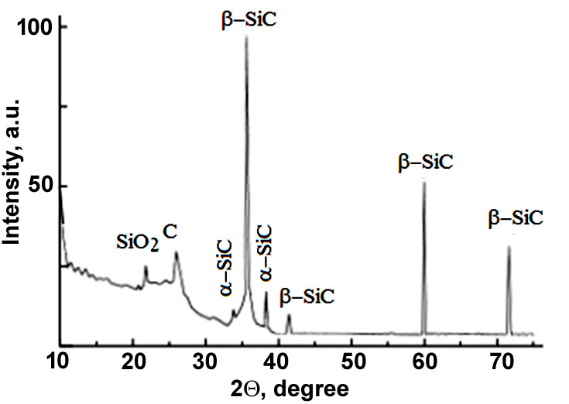
Fig.1. X-ray diffraction pattern of material synthesized after heat treatment in graphite crucible.

Figure 2 shows the particles size distribution in powder produced by ball mill. One can that the maximum number of particles have a size of 0.9 μm. Therefore, the synthesized material can be used for production of finely dispersed abrasive particles.
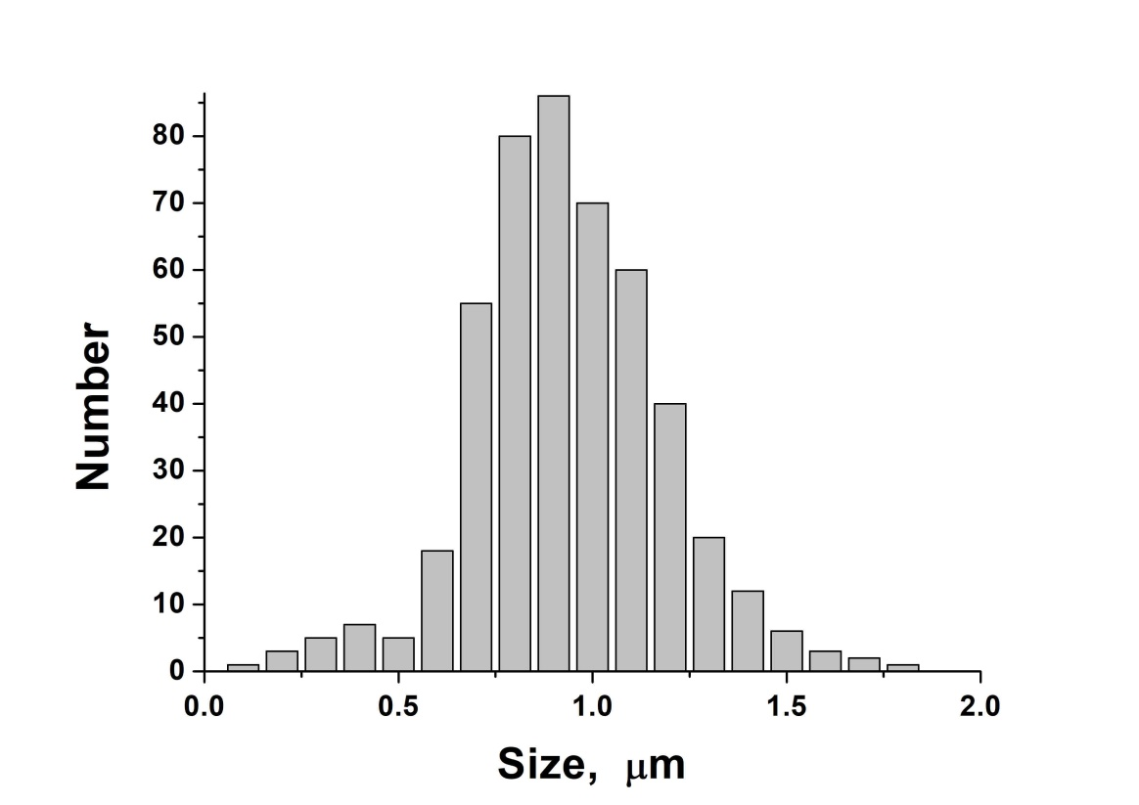
Fig.2. Particles size distribution.
In experiments conducted at flux densities of 300 W/cm², the predominant formation of hexagonal α-SiC was observed. Consequently, under certain heat treatment conditions, different polymorphic modifications of SiC can be synthesized from diatomite, a material necessary for the production of both refractory and abrasive products.
Figure 3 shows the temperature dependence of TCLE of material sintered at 200 W/cm². The material also showed a fairly high resistance to high temperatures. The value of TCLE in the temperature range of 300–400 ºC was changed insignificantly.
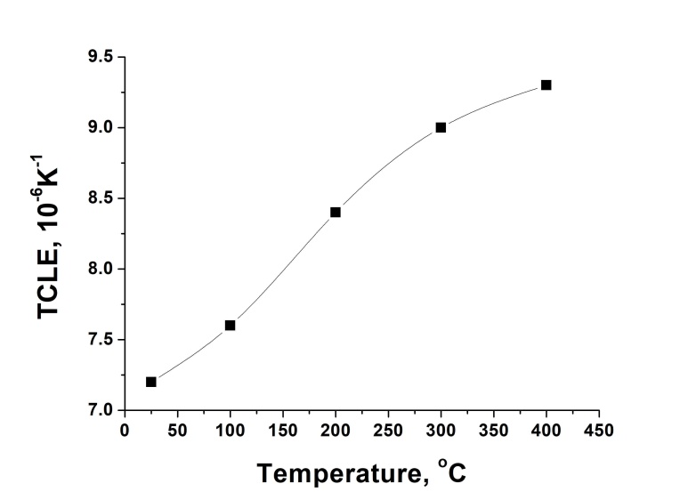
Fig. 3. Temperature dependence of the coefficient of linear thermal expansion

As it is known, refractoriness (or fire resistance) is the property of a material to withstand, without melting, exposure to high temperatures. To determine the fire resistance of a material, thermal deformation of a sample of a special shape (truncated pyramid) and size (30 mm high with base sides of 8 and 2 mm) - a pyroscope is investigated. When the sample is heated, the liquid phase accumulates in it and at a certain temperature the sample is deformed. The temperature at which the sample, leaning as a result of softening, touches with its upper part with the surface of the support is determined. This temperature determines the refractoriness of the material.
Thus at the second stage of experiments, pyroscopes were made from the synthesized material. Pyroscopes were used for testing the material for refractoriness up to 2000 ° C according to standard GOST 4069-69 (USSR) in a furnace with silicon carbide heaters. Table 2 shows the results of refractoriness testing for of samples of two types - freshly sintered in a solar furnace and fired at 1550 °C.

Table 2. Fire resistance of samples obtained using rice husks.

No | Sample type | Fire resistance, up to ◦C
1 | Freshly sintered | 1650
2 | Fired | 1580

As one can see from the Table 2, a freshly sintered sample reveals higher fire resistance. Analysis of the X-ray diffraction pattern of the sample after firing at 1550°C showed that this material contains silicon carbide SiC, silicon dioxide SiO₂ in the cristabolite form, and mullite (3Al₂O₃∙2SiO₂). The cristabolite phase can be formed due to the oxidation of some part of silicon carbide according to reaction: SiC+O₂ → SiO₂+CO₂.
Mullite phase was formed from the kaolinite that was added as a binder by reaction:
3(Al₂O₃∙2SiO₂∙2H₂O) → 3Al₂O₃∙2SiO₂+6H₂O.
The ratio of the intensities of diffraction lines belonging to different phases SiC : (3Al₂O₃∙2SiO₂) : SiO2 was 1 : 1 : 3.
The observed deterioration in the refractoriness of the samples after firing could be explained by the presence of cristabolite and mullite in it composition. As the temperature rises, the individual phases in the material gradually melt. The liquid states of these phases have different viscosities. As a result, the pyroscope sample begins to deform at lower temperatures thus reducing refractoriness. In this case, the interfacial boundary of a complex shape and character plays a peculiar role in the formation of the refractory and abrasive characteristics of the massive material - the product. Therefore, the choice of kaolin as a binder is not entirely justified.

Summary
Silicon carbide was obtained under heat treatment in a solar furnace from a mixture of diatomite with coke. Synthesized material contained β-SiC, α-SiC and graphite. At low flux density 200 W/cm² cubic β-SiC was the main phase of synthesized polycrystalline material while and at flux density of 300 W/cm² the hexagonal α-SiC phase was mainly formed. The average value of microhardness was 2900 kg/mm², with a compressive strength limit of 2200 MPa.
The silicon carbide material obtained in a solar furnace in a freshly sintered state showed high refractoriness (up to 1650°C), while the raw material fired at 1550°C showed a refractoriness up to 1580°C. The observed deterioration in the refractoriness of the material after firing can be explained by the usage of kaolinite as a binder.

References

Abdurakhmanov, B., Kurbanov, M., Nuraliev, U., Rothstein, V., Ruziev, U., Carbothermal synthesis of silicon carbide nanopowders using microsilica. Uzbek Physical Journal, Vol. 23(1), pp. 57–64, 2021. (in Russian)
Adylov, G.T., Faiziev, Sh. A., Paizullakhanov, M.S., Mukhsimov, S., Nodirmatov E., Silicon carbide materials obtained from rice husk, Technical Physics Letters, Vol. 29, pp.221-223, 2003.
Bayazitov, R.M., Khaybulin, I.B., Batalov, R.I. Structure and photoluminescent properties of SiC-layers on Si , synthesized by pulsed ion beam treatment, Nuclear Instruments and methods in Physics Research Section B, Vol. 206, pp. 984-988, 2003.
Byrappa, K. Ohachi, T., Crystal growth technology, Springer, pp. 180-200, 2003.
Lee, J.G., Cutler, I.B., Formation of silicon carbide from rice hulls. Am.Ceram.Soc.Bull, Vol. 54, pp. 195-198, 1975.
Gulamova, D.D., Uskenbaev, D.E., Turdiev, Zh.Sh., Toshmurodov, Y.K., Bobokulov, S.Kh., Synthesis of silicon carbide under the influence of solar radiation, Geliotekhnika, Vol. 2, pp.74-78, 2009. (in Russian).
Harris, G.L., Properties of silicon carbide, United Kingdom: IEE, pp. 19; 170–180, 1995.
Honda, S.I., Baek, Y. G., SiC nanofiber grown by high power microwave plasma chemical vapor deposition, Applied Surface Sciences, Vol. 212-213, pp. 378-382, 2003.
Krishnarao, R. V., Mahajan, Y. R., Kumar, T. J., Conversion of raw rice husks to SiC by pyrolysis in nitrogen atmosphere, Journal of the European Ceramic Society, Vol. 18, Issue 2, pp. 147-152, 1998.
Larciprete, R., Lizzit, S., Cepek, C., Goldoni, A., Thermal reaction at the interface between Si and C nanoparticles: nanotube self-assembling and transformation into SiC, Surface Sciences, Vol. 532-535, pp. 886-891, 2003.
Lee, Y. J., Formation of silicon carbide on carbon fibers by carbothermal reduction of silica, Diamond and Related materials, Vol. 13, Issue 3, pp. 383-388, 2004.
Lely, J.A., Darstellung von Einkristallen von Silicium Carbid und Beherrschung von Art und Menge der eingebauten Verunreinigungen, Berichte der Deutschen Keramischen Gesellschaft, H. 32, pp. 229—236, 1955.
Morancais, A., Louvet, F., Smith, D.S., Bonnet, J.P., High porosity SiC prepared via a process involving an SHS stage, Journal of the European Ceramic Society, Vol .23, Issue 11, pp. 1949-1956, 2003.
Muranaka, T., Kikuchi, Y., Yoshizawa, T., Akimitsu J., Superconductivity in carrier-doped silicon carbide, Science and Technolology of Advanced Materials, Vol. 9, p. 044204, 2008.
Ohtani, N., Fujimoto, T., Aigo, T., Katsuno, M., Tsuge, H., Yashiro, H. Large high-quality silicon carbide substrates, Nippon Steel Technical Report, No. 84, pp. 36-41, 2001.
Paizullakhanov, M.S., Shermatov, Zh.Z., Nodirmatov, E.Z., Rajamatov, O.T., Ernazarov, F.N., Sulaimanov, M.T., Nurmatov, Sh., Cherenda, N.N., Synthesis of Materials By Concentrated Solar Radiation, High Temperature Material Processes, Vol. 25(2), pp. 17–29, 2021.
Parmentier, J., Patarin, J., Dentzer, J., Vix-Guterl, C., Formation of SiC via carbothermal reduction of a carbon –containing MCM-48 silica phase: a new route to produce high surface area SiC, Ceramics International, Vol. 28, Issue 1, pp.1-7, 2002.
Rovin, S. L., Influence of dispersion of materials on the rate of solid-phase reduction processes, Casting and metallurgy, Vol.77, No. 4. pp. 7-9, 2014. (in Russian)
Stein, R.A., Lanig, P., Control of polytype formation by surface energy effects during the growth of SiC monocrystals by the sublimation method, Journal of Crystal Growth, Vol. 131, pp. 71-74, 1993.
Stein, R.A., Lanig, P., Leibenzeder, S., Influence of surface energy on the growth of 6H- and 4H-SiC polytypes by sublimation, Materials Science and Engeneering B, Vol. 11, pp. 69-71, 1992.

