УДК 520.874.7
Navitskaya Roza, Stashkevitch Ihar
POLARIZATION COUPLING ON DUAL-POLARIZATION GENERATION IN A PULSED ND:YAG LASER
Belarusian State University, Minsk, Belarus
This paper considers coupling between two orthogonal polarizations generated simultaneously in a Nd:YAG laser. It is experimentally shown that such generation is possible if the difference between the loss factors for two polarizations is rather considerable. A simple method is proposed to equalize the losses for both polarizations and achieve the same average intensity. It is shown that a theory based on a point laser model cannot adequately describe such a generation, as it does not take into account the incomplete overlapping of the cavity modes which correspond to different polarizations.
Dual-polarization laser generation has fairly interesting applications [1-2]. The intensities of the two polarizations are coupled as they have the same source of carriers - laser active medium. In continuous mode, dual-polarization generation is possible if absorption and emission cross-sections of an active medium, as well as the total loss factors are approximately equal for both polarizations. This paper describes the influence of the loss factors difference on polarization coupling in the free-running mode of a Nd:YAG laser.
The experimental setup used to obtain dual-polarization generation in the free-running mode of a Nd:YAG laser is described in Fig.1. The beams with two orthogonal polarizations were separated by a polarizer inclined at Brewster’s angle (about 57°). The mirror, common for the beams with different polarizations, was semitransparent with reflectivity of 53%, other mirrors were highly reflective and identical for both beams. Absorption and emission cross-sections for the Nd:YAG cubic crystal were equal for all polarizations.
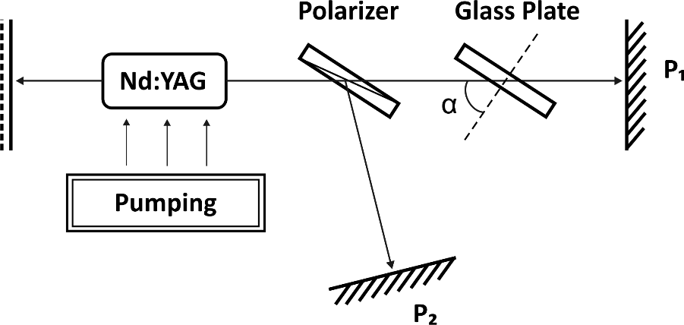
Fig. 1. Experimental setup scheme.
Additional losses for the light polarized in the plane of incidence were introduced by the glass plate tilted at a certain angle to the light propagation direction. The additional relative power loss per cavity trip γ₁ corresponds to Fresnel reflection from the air-glass plate interfaces. Its value depends on the angles of incidence and refraction α and α_{t} as described in (1-2). If the glass plate tilt α is equal to Brewster’s angle, the additional reflection loss γ₁ is zero.
(1)
. (2)
The measured average powers P₁ and P₂ correspond to those of the beams with orthogonal polarizations output from the highly reflective mirrors. Fig.2 shows the experimental dependence of the output power ratio P₁/P₂ on the glass plate tilt angle α, as well as the calculated dependence of the additional loss factor γ₁ on the corresponding angle (for n=1.45).
Fig. 2. The output power ratio P₁/P₂ (a) and additional power loss γ₁ (b) as a function of the glass plate tilt angle α.
The P₁/P₂ ratio equal to 1 corresponds to the equal total loss factors for both polarizations and is achieved for tilt angles 55.5° and 62.2°. The angle dα needed to change the power ratio by a factor of two is about 2.5-3.5°. This corresponds to the additional relative power loss per cavity trip γ₁ equal to 0.2-0.3%.
A simple model used to simulate the dual-polarization generation in a Nd:YAG laser is based on the approximation of the point model of laser [3]. The additional loss corresponding to P₁/P₂ = 2 obtained by theoretical modeling of the described laser is 3∙10⁻³% (measured for the intensity ratio of the first peaks I₁/I₂ = 2) that is lower than the experimentally obtained value by two orders of magnitude.
Thus, it was experimentally shown that the dual-polarization generation in a pulsed laser is possible when the loss factors for different polarizations differ rather markedly. To obtain the same intensity for both polarizations, it is required to equalize power losses per cavity trip with the accuracy of about 0.1-1%. This can be done, for example, by installing a rotating glass plate in one of the cavities. At the same time, theoretical modeling based on a point laser model gives a significantly narrower range of the loss coefficients, where dual-polarization lasing is possible. This may be explained by the fact that the point model does not account for the intensity and carrier spatial distribution in the cavity, and in a real laser the mode configurations for different polarizations overlap incompletely.
List of literature
1. Naceur-Eddine Khelifa, Philippe Averlant, Marc Himbert. Traceability of small forcemeasurements and the future international system of units (SI). // Int. J. Metrol. Qual. Eng. – 2016. – Vol.7. – P. 306 – 313.
2. M. Brunel, A. Amon, M Valet. Dual-polarization microchip laser at 1.53 μm. //Opt. Lett. – 2005. – Vol.30. – P. 2418-2420.
3. Navitskaya Roza, Stashkevich Ihar. Dual-polarization generation in the Nd:YAG laser. // Проблемы взаимодействия излучения с веществом. Материалы V Международной научной конференции (Гомель, 14–16 ноября 2018 года). – 2018. – Ч.1. – C.40 – 45.

