Dr. Siarhei Lukin,

Andrei Malikau

CORPORATE SOCIAL RESPONSIBILITY OF LARGEST GERMAN CORPORATIONS

12 CASES

Master’s Program “Industrial Management”

Belarus State University, Minsk, Belarus
Hochschule Mittweida, Germany

2017
About the Authors

Dr. Siarhei Lukin, Chair and Professor, Belarus State University, International Management Dept, lukin@bsu.by Belarus State University | bsu.by

Andrei Malikau, assistant-professor, Belarus State University, International Management Dept, andrey@vec-tech.by

Acknowledgments
We wish to acknowledge to Mittweida, Prof. Dr.-Ing. Habit Gerhard Thiem, Prof. Dr.rer.oec Volker Tolkmitt, Prof. Dr.oec Serge Velesco, Dr. Julia Kohler, Saskia Langhammer who provided immense support in our work.

A special acknowledgments must go to Sergey Pokotilov and Alex Ruban, post-graduate students, Hochschule Mittweida for assistance in collecting materials for these cases.

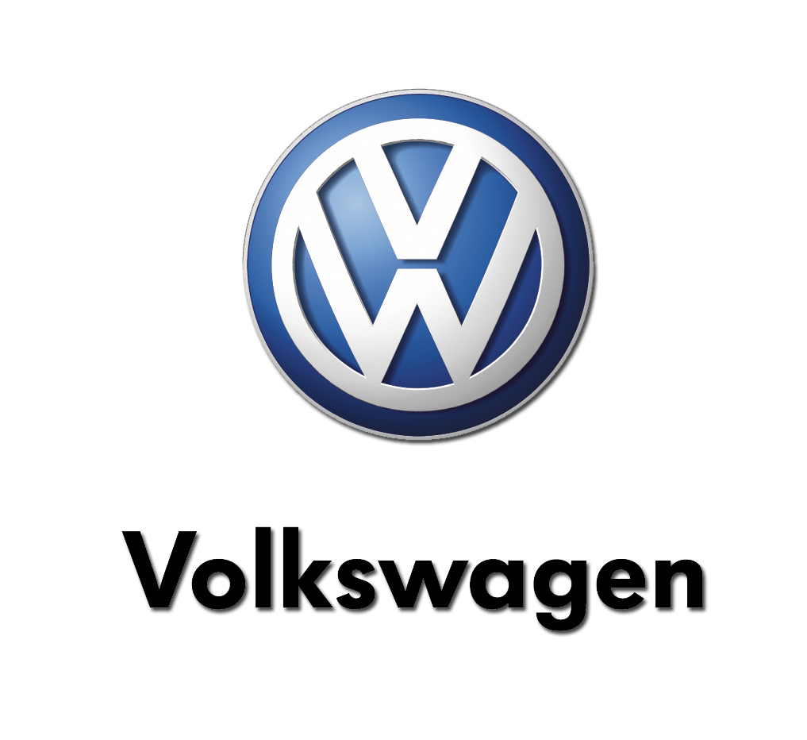

1.1 Employees
Our CSR priorities include support for future-oriented, education and social projects, primarily in the locations where the Group operates. But we also offer rapid support to the victims of natural disasters and promote volunteering by our employees. The following fundamental principles underpin our choice of CSR projects:

- The projects are in line with the Group’s Basic Principles and address a specific local or regional issue.
- They reflect diversity within the Group and in the social environment in which the projects are sited.
- They involve a close stakeholder dialogue with actors on the ground, who are involved in carrying out the projects.
- Project management is based locally and overseen by local units.

Senior Experts Benefit the Community

All employees looking for a new challenge once they have retired can volunteer with the “Volkswagen pro Ehrenamt” in-house “Senior Experts” scheme. This initiative offers them an opportunity to serve the community regionally or globally, for example, by passing on their know-how within the Company or as an adviser to external organizations. In 2014, 219 Senior Experts were able to choose whether, where and on which projects they wanted to put their specialist knowledge and skills to good use. Among other benefits, this valuable exchange of experience between older and younger people means that former employees maintain their links with the Volkswagen Group while both sides boost their knowledge and skills.

Сivic engagement week of action

Volkswagen supports the voluntary activities of its employees and aims to foster a wider awareness in society of the importance of voluntary commitments that advance social causes. As a cooperation partner to the German National Network for Civil Society (BBE), in 2014 Volkswagen pro Ehrenamt for the first time opened the 10th nationwide Civic Engagement Week of Action. During panel discussions on the topic of “Corporate Social Responsibility and Engagement” insight was provided into the voluntary activities of the Group and its employees.

The Volkswagen Employees’ Foundation

The Volkswagen Employees’ Foundation was set up in 2011 as a charitable foundation by Volkswagen AG with the aim of promoting initial, continuing and vocational training, education, and support for young people, with a particular focus on improving the living conditions of children and young people regardless of their origin, background or religion. To achieve this effectively, the Volkswagen Employees’ Foundation restricts its activities to areas surrounding the Group’s locations worldwide. Since 2011, the Volkswagen Employees’ Foundation has launched or supported ten projects in Germany and elsewhere. In Portugal, for example, it supports the “Tu import as” (“You count”) project, a three year training program for socially disadvantaged young people.

*Volkswagen sustainability report 2014: part „People“, p. 72-75
URL: http://www.volkswagenag.com/content/vwcorp/info_center/en/publications/2015/04/group-sustainability-report-2014.bin.html/binarystorageitem/file/Volkswagen_Sustainability_Report_2014.pdf
Date: 7th April, 2015

1.2 Supply/consume

Supplier management

Volkswagen Group procurement mainly purchases production materials, services and capex centrally. In the reporting period, the purchasing volume – including the Chinese joint venture companies – increased by 7.7% to €145.5 billion. Suppliers in Germany accounted for a share of 36.1%.

Concept and Organization

To ensure that flows of goods and services remain stable and efficient, in 2006 the Volkswagen Group formulated its Sustainability in Supplier Relations concept and has continued to refine it ever since. Together with traditional priorities such as quality, price and delivery times, the concept had been thoroughly integrated in our procurement process. To us, applying and monitoring sustainability standards in the supply chain is above all a matter of minimizing risk – preventing potential supply shortages and damage to our reputation and ensuring that the quality of the procured supplies and services remains consistent. Both the Group and its suppliers profit from the long-term supplier relationships which result. The concept, which is based on three main pillars, aims to minimize or prevent negative social, environmental and financial impacts along our supply chain:

- An early warning system that identifies and minimizes risks along the supply chain.
- Contractually mandated integration of the sustainability standards in the procurement process. These must be acknowledged by all suppliers before submitting a quotation on the Group Business Platform. Otherwise it is not possible to submit a quotation.
- Supplier monitoring and development.

We regularly benchmark the effectiveness of our concept against other companies and intensively analyze the results of sustainability ratings. This allows us to gain valuable insights for continuing optimization and development. In recent years we have systematically extended the Sustainability in Supplier Relations concept to all of the Group’s brands. In 2014 specific elements were still being rolled out at the Porsche, MAN and Scania brands. We continuously train employees and raise their awareness to ensure that the concept is further anchored within the Company. Consequently, the concept is an established part of the qualification program at the procurement academies run by the individual locations. In addition, cross-functional training courses were again held in 2014. In the reporting year, more than 900 purchasing staff received training in Sustainability in Supplier Relations. To reinforce the communication of our concept internally and externally, in 2014 we also published a brochure and made it available on the Group Business Platform.

Sustainability Requirements and Integration

Our supplier relations are based on the “Volkswagen Group requirements regarding sustainability in its relationships with business partners (Code of Conduct for Business Partners)”, which apply across the Group. They formulate our expectations for our business partners’ conduct with regard to central environmental and social standards. Among other things, they are based on the principles of the UN Global Compact, the International Chamber of Commerce’s Business Charter for Sustainable Development and the relevant conventions of the International Labour Organization. These principles are supplemented by Volkswagen’s Environmental Policy, the environment targets and regulations derived from it, the Group’s Quality Policy and the Volkswagen Declaration on Social Rights.
Before submitting a quotation, the supplier must acknowledge the sustainability requirements; this acknowledgement must be repeated every 12 months. The requirements have been contractually integrated since November 2013 for all suppliers to General Procurement, and since January 2014 for all suppliers of production materials as well. The requirements apply to all outsourced goods and services worldwide. We also expect our tier 1 suppliers to pass these requirements on to their own suppliers.
In addition, Volkswagen requires its main suppliers to put in place a certified environmental management system in accordance with ISO 14001 and/or EMAS. Such systems have been verified and documented at 87% of our main suppliers. As part of the EMAS and ISO 14001 environmental certification and auditing at the Volkswagen AG locations, the contractors and suppliers who work on the plant grounds and have an environmental impact are also subject to regular monitoring.
In the course of the business process, all suppliers are required to complete our sustainability questionnaire and to document their activities in the areas of environmental protection and social standards. By December 31, 2014, 15,405 Group suppliers had returned the questionnaire. In terms of procurement volume that equates to 87%.

Supplier Development and Qualification

In the interests of continuing supplier development, in the course of our business relations we make an electronic learning (E-Learning) module on sustainability available to all suppliers in all of the languages of the defined risk markets. After completing this task, the supplier has to perform a final test. By the end of 2014, 14,457 suppliers had completed the E-Learning module, which equates to 71% of procurement expenditures. The tool is made available to the supplier’s workforce as well as to employees of Volkswagen AG Procurement for qualification purposes.
In addition to this E-Learning format, we also conduct region- and topic-specific sustainability training courses and workshops with our suppliers. In the reporting period, courses were held in countries including Brazil, Argentina, Germany and Poland.
In addition, as part of the European Automotive Working Group on Supply Chain Sustainability, a supply chain forum took place in Istanbul in November 2014. In an intensive dialogue, suppliers and manufacturers discussed important challenges and solutions with the aim of improving sustainability along the supply chain. The event spotlighted social rights. Through these diverse measures, in 2014 we were able to qualify more than 900 suppliers.

*Volkswagen sustainability report 2014: part „Economy“, p. 42-44
URL: http://www.volkswagenag.com/content/vwcorp/info_center/en/publications/2015/04/group-sustainability-report-2014.bin.html/binarystorageitem/file/Volkswagen_Sustainability_Report_2014.pdf
Date: 7th April, 2015

1.3 Community

Company Donations

The Volkswagen Group’s commitment to donations and sponsorship is a key part of our corporate identity and reflects our desire to fulfill our corporate social responsibility. We support a wide range of organizations and events around the world. The principles underpinning donations and sponsorship are governed by our Group-wide Code of Conduct, which stipulates that we give donations in cash and in kind for activities and projects primarily devoted to research and education, culture and sport, and social causes. Donations are granted only to organizations recognized to be non-profit or that are authorized by special provisions to accept donations. Volkswagen does not donate to political parties, party- affiliated foundations or representatives of the political arena. Over the reporting year, Volkswagen AG donated a total of €14 million. Along with social organizations, in 2014 the main beneficiaries of donations were the victims of major natural disasters.

Employee Donations

In 2014, employees of Volkswagen AG alone donated more than €4 million to good causes. Employee donations represent a major contribution by Volkswagen AG companies and their employees to those in need in locations where the Company operates. Employee donations support specific projects, such as those that improve the lives of people whose quality of life is reduced by illness, disability or other circumstances. Our goal is to offer support to those who are disadvantaged and to boost social cohesion: for example, we support the “Starthilfe” (Getting Started) project, which helps socially disadvantaged children and young people and improves the lives and prospects of young people in the Wolfsburg region. In the “One Hour for the Future” campaign, Volkswagen and Audi employees donate an hour’s pay to help street children. Since the summer of 2003, this initiative has also included the collection of “spare cents”: employees donate the odd cents included in their monthly pay slip. To coincide with the 2014 World Cup in Brazil, Volkswagen donated over €2 million for a special project, “A chance to play – o direito de brincar”. The money helped children living in favelas in the vicinity of Volkswagen’s Brazilian locations.

Fairtrade

At the suggestion of the General Works Council, Volkswagen AG has been supporting the sale of TransFair-branded products in its catering facilities via its catering provider, Service Factory Gastronomie und Hotellerie, since 1999. This helps producers in developing countries to earn a decent living. In 2014, total consumption of fairly traded coffee rose 23.7%, to 60 t. And since 2012, Volkswagen has also been selling fairly traded craft items: producers in Madagascar use recycled cans to produce models based on iconic Volkswagen vehicles.

Corporate Social Investment. Activities by the VW Community Trust

Volkswagen of South Africa makes more than 3 million rand (273,000 euro) available to the Volkswagen Community Trust (VWCT) every year. The Trust uses these funds to initiate and manage schemes and projects, chiefly in the fields of healthcare, schools and education, employment, and youth and sports.

Our Global Engagement

The Volkswagen Group supports some 200 projects promoting social development, the arts and culture, education, regional structural development, health and sport, as well as nature conservation. When deciding which social projects to support and partnerships to enter into, we don’t take a scattershot approach but consider whether they make a good match for our corporate focus on mobility or are located in the vicinity of our production locations and benefit the people who work there or live locally. At all of our brands and in every region in the world of Volkswagen, living up to our social responsibilities is at the core of our corporate culture. On the Internet you will find a map of the world that you can click on for more details about all and any of our projects.
(This map is represented in part 1.7, to describe VWAG special projects)

*Volkswagen sustainability report 2014: part „People“, p. 75-77
URL: http://www.volkswagenag.com/content/vwcorp/info_center/en/publications/2015/04/group-sustainability-report-2014.bin.html/binarystorageitem/file/Volkswagen_Sustainability_Report_2014.pdf
Date: 7th April, 2015

Health, Community & Wellbeing

Empowering the community and their health and wellbeing is essentially all that Volkswagen Community Trust stands for. The projects we’re involved in and the organisations we donate to all enrich the lives of those who are in disadvantaged communities. Over the years, we have formed solid partnerships with various Non-profit Organisations that are focused on doing exactly what we wish to achieve.
Here are two of the many different ways in which we are helping to empower the health and wellbeing of communities:
- Missionvale Community HIV/AIDS Care Centre
Volkswagen South Africa has made annual donations to the Missionvale Care Centre since 2003. The Missionvale Care Centre operates in the extremely poor informal township of Missionvale in Port Elizabeth. It was founded by Sister Ethel Normoyle, from humble beginnings, under a tree donated by a resident of Missionvale. It has grown into a centre which provides love and care for the poor and destitute, with particular emphasis on those living with HIV/AIDS.The Missionvale Care Centre provides a meal a day to thousands of people living in the township and they provide the primary school next door with two meals a day.
- SOS Children's Village
The SOS Children’s Village consists of 12 homes, each with a “house mother”. Each home accommodates children who have been orphaned, abused or neglected. Volkswagen Community Trust has been giving donations on a regular basis for years and also sponsors one of the homes.
At the village, the children have the opportunity to be schooled and come home to a mother who cares for them and does homework with them, feeds them and tucks them in – something that these kids are definitely not used to getting at their real homes. The children at SOS are any age between 6 months and 18 years.

Below are more Health and Community Wellbeing projects and organisations that we support:
- SA Breastmilk Reserve
- Harvest Community Projects
- Oosterland
- Rape Crisis Centre
- We Care (Old Age)
- St Francis Hospice
- Ikhala Trust
- Nicky’s Drive
- Smile Madiba Bay (Northwood Palliative Care Clinic for Children)
- NMMU Community Development
- House of Resurrection (AIDS Haven)

*Health, Community & Wellbeing, Volkswagen community trust
URL: http://www.vwcommunitytrust.co.za/content/health-community-wellbeing
Date: ------

1.4 Environment

The Volkswagen Group has a long tradition of resolute commitment to environmental protection. The new Environmental Strategy adopted by the Group Board of Management in 2013 provides the framework for addressing these challenges with specific targets and measures, and improving environmental protection within the Group. Implementation of the Groupwide Environmental Strategy is binding and measurable across the brands and business units at every stage of the value chain, from product planning and development, to supplier management, logistics and production, through to sales, marketing and recycling.

By 2018, the Volkswagen Group is aiming to be the world’s most environmentally compatible automaker. In order to achieve this goal, we have set ourselves some ambitious targets, particularly with regard to environmental protection. In 2014 we continued our consistent pursuit of these goals. Our Environmental Strategy embraces all of our brands and regions, and extends throughout every stage of the value chain.

The Volkswagen Group has defined four overarching target areas:

- Leader in environmentally friendly products
We firmly believe that eco-friendly products should never compromise on world-class technology, comfort and safety. One of our key goals is to cut CO2 emissions from our European new car fleet to 95 g/km by 2020, to reduce fuel consumption by between 10 and 15% in each new model compared with its predecessor, to have the lowest fuel consumption levels in every vehicle class (for the Volkswagen brand), to expand our range of alternative powertrains, to achieve top rankings, ratings and awards for selected products, and to become the market leaders in electric mobility by 2018.

- No. 1 for lifecycle-wide resource conservation
We consider the environmental impacts of our products, particularly their CO2 emissions, at every stage of their life cycle. Along with climate protection, the main objective of this approach is to conserve finite resources. Our measures center on efficient product and process design, the use of innovative environmental technologies, and sustainable energy supplies. For this reason, we not only aim for every vehicle to better the environmental performance of its predecessor over its entire life cycle, but also target the significant reduction of our environmental footprint by 2018. Specifically, we are aiming for 25% reductions in energy and water consumption, CO2 and solvent emissions and waste for disposal per manufactured unit compared with 2010.

- No. 1 for intelligent mobility
Intelligent mobility brings together our pursuit of mobility and comfort, environmental protection and efficient transport. We aim for high levels of customer satisfaction and want to be perceived as the most eco-friendly automaker. Our principal strategies for achieving these aims include intelligent, networked vehicles, new, supplementary business models and services, accompanied by initiatives for transport, urban planning and social change.

- Anchored throughout the Company
We want every individual in our well-informed, qualified workforce to be actively involved. Our strength lies in combining the expertise and competence of our brands and regions. Environmental considerations are factored into every decision we make. We will motivate and qualify our employees even more intensively to meet our environmental targets.

Organization of Environmental Protection within the Group

The Group Board of Management is the highest decision-making authority on environmental matters. Since 2012, it has simultaneously acted as the Group’s Sustainability Board. The Group Chief Officer for the Environment, Energy and New Business Areas, a post established in 2011, heads up the Corporate Environmental and Energy Steering Group and reports to the Sustainability Board. The Steering Group is made up of representatives from all Group divisions as well as from the Group Works Council, brands and companies, and meets four times a year. Other Group-wide committees, such as the CO2 Steering Group, the Vehicle Recycling Steering Group and the Corporate Working Group “Life Cycle Engineering”, address a range of Specialist issues. The brands and companies are responsible for environmental organization at their headquarters and locations.
Building on the Group Environmental Policy and Environmental Principles, all brands organize their own environmental management systems autonomously in line with international standards, be it the European Union’s Eco-Management and Audit Scheme (EMAS) or the International Standards for Environmental Management (ISO 14001) and Energy Management (ISO 50001).
As per the end of 2014, out of a total of 106 Group production sites, 90 held a valid ISO 14001 certificate (see table). Alongside the Volkswagen brand’s production locations, Audi, Lamborghini and Porsche have also had their factories’ energy management systems certified to the relatively new standard ISO 50001, and others will be following suit in the near future. Volkswagen brand production locations in Germany (passenger cars and commercial vehicles) have participated in EMAS since as long ago as 1995, and publish annual environmental statements which are validated by an environmental auditor. In 1996, the Volkswagen brand became the first automaker in the world to introduce an environmental management system certified to ISO 14001, for the “development of motor vehicles with continuously improved environmental properties” in its Technical Development department. In 2009, the “integration of environmental aspects into product development for the Volkswagen brand” was likewise certified to ISO TR 14062 – another first for the industry. Both were recently recertified in 2013, and now have valid certificates until the end of 2016.

Environmental programs anchored within the Group brands

Since 2010, the international umbrella brand “Think Blue“ has encapsulated the sustainability philosophy of the Volkswagen and Volkswagen Commercial Vehicle brands, which aims to balance the need for personal mobility with environmental awareness. “Think Blue.” is much more than just products and technologies. It is designed to inspire and motivate employees, customers and the general public, and cooperates with environmental organizations around the world. Since 2010, “Think Blue.” has continuously evolved throughout every stage of the value chain in all Volkswagen brand-related business units, and in 2014 was extended to car dealerships in Germany. The central components of the “Think Blue.” philosophy are:

- Think Blue. Engineering. Since late 2012, this strategy has brought together all programs and measures aimed at continuously improving the environmental performance of new models, based on the Environmental Goals of the Technical Development department.

- Think Blue. Factory. is a program launched by the Volkswagen brand in 2011, which aims to reduce consumption of energy and water, the volume of waste for disposal, solvent emissions and CO2 emissions per unit produced by 25% at all our factories worldwide by 2018 compared with 2010 levels.

- Think Blue. Dealer. is an initiative to address energy efficiency in areas other than production. By 2018, the aim is to advise up to 60% of dealers worldwide on energy efficiency-related matters.

- Think Blue. Mobility. provides information on efficient powertrains and technologies, Volkswagen- brand electric vehicles,and our wide range of electric mobility services. With well thought-through service packages such as our green electricity product “BluePower” or wallbox installation the Volkswagen brand.

(More information about the “Think Blue” you can get on the pages 94-109 this report)

Climate Protection Strategy

Climate protection is at the heart of the Group’s environmental management philosophy, spanning every stage of the value creation process. We report regularly on our climate protection strategy to the CDP (formerly known as the Carbon Disclosure Project), a consortium of institutional investors. In 2014, the Volkswagen Group was again awarded 99 out of a possible 100 points for its transparency, and a top grade of A for its performance, as well as being listed in both Leadership Indices. Absolute CO2 emissions from our in-house energy generation at production locations and from purchased energy increased slightly in recent years, whilst specific emissions (in kg per vehicle) have fallen. This can be explained by the increase in production volume, coupled with an increase in the volume of purchased energy. One of the Group’s key environmental targets is to reduce specific energy consumption per vehicle during production by 25% by 2018 (compared with the base year 2010), and to cut specific CO2 emissions by the same amount.
For our German locations, which currently account for around 45% of our Group-wide CO2 emissions from production, the Volkswagen Group has set itself an even more ambitious target: CO2 emissions from energy supplies in Germany are to be reduced by 40% by 2020 compared with 2010. We aim to achieve this by improving energy efficiency, partially replacing coal with gas in our in-house energy production, and purchasing electricity from renewable sources. We are urgently awaiting a clear political framework for the energy industry in order to make further investments in power station conversion measures.

*Volkswagen sustainability report 2014: part „Environment“, p. 86-91
URL: http://www.volkswagenag.com/content/vwcorp/info_center/en/publications/2015/04/group-sustainability-report 2014.bin.html/binarystorageitem/file/Volkswagen_Sustainability_Report_2014.pdf
Date: 7th April, 2015

1.5 Education

Educational Initiatives

In addition to regional infrastructure projects, Volkswagen AG is also actively involved in education in the region. The “Neue Schule Wolfsburg” project, an initiative to set up a new school in Wolfsburg in partnership with the city and local businesses, opened its doors in August 2009. This primary and secondary school, which is open to all children from the City of Wolfsburg and the surrounding region, designs its curriculum around five key themes: a strong international focus, science and technology, business, the arts, and the promotion of talent. The school has a total of 688 students enrolled in the 2014/2015 academic year. In Ingolstadt, meanwhile, Germany’s first integrated school (Profilschule) opened its doors in September 2014 with support from Audi. Its motto is “Kein Talent verlieren” (“Fostering every talent”), and this unique beacon project offers children and young people with difficult backgrounds educational support at primary and secondary levels. The project resulted from collaboration between the Bavarian Ministry of Education, the City of Ingolstadt, the Roland-Berger Foundation and Audi. Education is also a key area of involvement in the regions in which Volkswagen operates around the world. Volkswagen South Africa, for example, supports the nationwide Nal’ibali reading campaign, which has so far set up 272 reading clubs. Volkswagen Group China, meanwhile, runs a bursary scheme that enables students at Xinjiang University to participate in academic exchanges in Germany.
We also use our expertise in mobility and road safety in school education projects. Just one of many examples from companies within the Group is the “Parque Polo”, an area providing road safety training through play for children and sited in the grounds of the Volkswagen Navarra plant (Pamplona, Spain) which was opened more than ten years ago. In 2014, 8,522 children aged between 5 and 15 visited the Parque, taking the total number of visitors to 114,268.

“PLANT- FOR-THE-PLANET”

The “Plant-for-the-Planet” initiative launched by school student Felix Finkbeiner aims to reduce levels of carbon dioxide in the atmosphere by planting trees. The aim is to plant some 1,000 billion trees by 2020. On the initiative of the Works Council, Volkswagen is supporting this project which has also been recognized by the German UNESCO Commission. The program includes academies for children and young people at which they learn key facts about climate change and global fairness and have the chance to take part in a tree-planting event. Almost all Volkswagen locations in Germany have already hosted such academies and plant-a-tree events and these activities will be continued over the long term.

*Volkswagen sustainability report 2014: part „People“, p. 73
URL: http://www.volkswagenag.com/content/vwcorp/info_center/en/publications/2015/04/group-sustainability-report 2014.bin.html/binarystorageitem/file/Volkswagen_Sustainability_Report_2014.pdf
Date: 7th April, 2015

Education

Education is important for the growth and development of children world-wide; so due to the number of disadvantaged children in South Africa, Volkswagen Community Trust has made Education a priority. We support a number of projects and initiatives throughout the country and strive to make the education centres, such as crèches and other schools, more efficient and accessible for children who are disadvantaged or in vulnerable positions.

Ikhwezi Lomso Early Childhood Education Centre

The name “Ikhwezi Lomso” derives from the Xhosa translation “morning star”. The Ikhwezi Lomso Early Childhood Centre educates 90 children in a safe environment so that they can be given the key to a brighter future.
VW Community Trust built and funded the centre and it is one of our flagship projects. Funds for the centre were raised as a result of Volkswagen SA’s “ONE HOUR for the Future” project; which encourages every VWSA staff member to contribute one hour of their salary per year.
This eventually accumulated to an amount that enabled us to contribute towards the building of this Early Childhood Development (ECD) Centre.
The centre is situated in Kabah, Uitenhage and it is fully-equipped to give the children the resources and education they need to have a better future. Our aim is to bring them hope and inspiration by showing them how much fun education is - irrespective of your circumstances.
Just as educating the young is vitally important for their development, so is educating the youth – and encouraging them to further their studies. In 2010, the Science and Technology Centre opened its doors. The centre equips young learners with the skills to become scientists, electricians and technicians to name a few. Volkswagen SA funded the exhibits in the centre to the value of R5 million.
Below is a list of the Education projects and initiatives that Volkswagen supports through the work of the VW Community Trust:
- PE Mental Health – Education Programme
- Ilitha Lemfundo Centre
- Masifunde Youth Development
- The Extended Hand
- Elukholweni Farm School
- Masimanyane Organisation
- Nal’iBali Reading Campaign
- Edupeg
- Supplementary Maths and Science
- Nelson Mandela Bay Science and Technology Centre
- Children of VW Bursaries

*Education, Volkswagen community trust
URL: http://www.vwcommunitytrust.co.za/content/education
Date: ------

1.6 Healthcare

HEALTH AND FITNESS

The Volkswagen Group’s integrated approach to health management goes well beyond traditional preventive health care and occupational safety and also includes aspects such as work organization, ergonomics, health promotion, integration and rehabilitation, leadership styles and prospects for each individual. To ensure a common standard of health provision across the Group, a multi-level audit system was introduced in 2010.

Free Health Checkups

The Checkup is a free, comprehensive preventive medical examination available at all locations in Germany and around the world. It helps maintain and improve the health, fitness and performance of the workforce. Employees value the high diagnostic quality of the checkups.

Prevention Measures

In 2014, we expanded the prevention and training provision linked with the Checkup, improved its quality and systematized it. In particular, we created and modernized medical training centers and fitness suites, introduced rehabilitation measures and health coaching, set up training on behavioral ergonomics, and launched new fitness and wellness programs. The “Fit im Büro” (“Fit in the Office”) program is a behavioral ergonomics program for employees working in an office environment, while its sister program, “Fit im Werk” (“Fit in the Factory”), aims to reduce physical stresses and strains on those working on the shop floor. Between May 2013 and June 2014, some 15,700 employees completed one of these programs at Volkswagen in Wolfsburg. Across the Group, a holistic approach to health management also includes healthcare schemes, a wide range of sport and leisure provision, and measures such as the weight-loss and healthy eating campaign run by Volkswagen South Africa or the company run organized by MAN Truck & Bus in Munich. As a matter of course, Volkswagen health services are available to the entire workforce, but for specific occupations, the current legislative framework makes such provision mandatory. In 2014, 20,924 Volkswagen AG employees were covered by such requirements.

Health programs around the group

- BeFit at Bentley
With the aim of encouraging employees to adopt a healthy lifestyle, Bentley launched its “BeFit” health campaign in 2014. The program focuses on four areas: Weight and Nutrition; Stress and Depression; the Corporate Step Challenge; and Exercise and Back Care.
- Combating HIV and AIDS in South Africa
Volkswagen continued its international commitment to combating infectious diseases in 2014, for example through continuing measures against HIV/AIDS at Volkswagen in South Africa. This program received a subsidy of ZAR 500,000, and by 2014, 93% of the workforce had taken the opportunity to be tested for HIV/AIDS.
- Home Care and Baby Care at Volkswagen do Brasil
The Home Care program is geared to those of all ages with chronic conditions and offers both medical care and supportive outpatient care. The Baby Care program focuses on the welfare of the next generation and provides expert support for parents and their newborn babies in the first few weeks and months.

Occupational Safety and Health Protection Policy

In 2004, the Volkswagen Group documented its underlying principles and obligations in relation to occupational health and safety in an agreement with the Group Global Works Council. In 2014, the Group issued the corporate policy entitled “Occupational Safety and Health Protection in the Volkswagen Group”. This applies to all brands and companies and sets out underlying goals, responsibilities and standards in relation to occupational safety and health protection. At the same time, another document, the “Guidelines on Health Protection and Health Promotion in the Volkswagen Group” – a supplement to the corporate policy including concrete examples – was brought up to date. Both of these documents, the corporate policy and the guidelines, are due to be signed off in 2015.
The Volkswagen Group sets the same standards for work organization, occupational safety and health care for its employees no matter where in the world it operates, taking account of the local medical infrastructure and the local legislative framework in each case. Compliance with these globally applicable standards is monitored through audits conducted across the Group.

Company Medical Services and Emergency Situation Management

Medical services and health care for Volkswagen Group employees are in line with national legislation and internal regulations as well as with Group guidelines on protecting and promoting health. All Group locations have at least emergency health provision, while most locations offer medical services under the oversight of a doctor.

Rehabilitation Measures

In many locations we offer a tailored rehabilitation program to reintegrate employees after serious and/or long-term illness, providing early intervention and job-related support. The aim is to stabilize or restore the employees’ capacity and performance ability within three to six months. Depending on the particular needs in each case, the program can also include preventive provision. Examples here could be “JobReha” (one to three weeks of outpatient, day-care or in-patient measures focused on the problem zones in the locomotor system), the RehaFit program (orthopedic, psychological rehabilitation) and physiotherapy provision, as well as individual or general rehabilitation training at in-house training centers. Support and mentoring opportunities for employees with mental health or psychosomatic problems are also being expanded on an ongoing basis.
Volkswagen AG’s Work2Work program has been creating new job opportunities for performance-impaired employees since 2001. It focuses on achieving an optimal fit between the requirements of the workplace and employees’ existing potential, enabling them to make a major contribution to creating value despite their performance impairment. Over recent years, some 1,850 employees have benefited from the program, and over 810 people are now employed in Work2Work jobs in Wolfsburg in some 95 different fields of activity.
Based on the three principles of responsibility, autonomy and solidarity, the success story of Work2Work is being continuously rolled out and taken forward. Here, though, the Company is not merely proving itself a socially responsible employer, because according to a remarkable study entitled “Social Return on Investment”, conducted in 2014 in collaboration with the Catholic University of Eichstatt-Ingolstadt, Volkswagen’s Work2Work program is also an economically viable concept for integrating employees with impaired capacity. It saves operational costs of around €29,000 per employee per year and savings on social and employment costs of up to €65,000 per employee per year once elements like potential disability pensions or transitional payments are also taken into account. Furthermore, the Work2Work program has been shown to bring qualitative benefits in terms of health and to have a positive impact on employees’ satisfaction with their work and lives.
The Automotive Learnware department at the Wolfsburg plant is a fine example of how performance-impaired employees can be integrated. Here, 39 employees develop and produce teaching and learning materials for the automotive sector for Chambers of Trade and vocational schools. No fewer than 25 performance-impaired employees under the Work2Work program form an integral part of the department, which generated sales revenue of €1.92 million in 2014. The product portfolio extends from fault simulators and test equipment to complete or cut-away training vehicles. Learnware is distributed in 57 countries across all five continents.

*Volkswagen sustainability report 2014: part „People“, p. 66-69
URL: http://www.volkswagenag.com/content/vwcorp/info_center/en/publications/2015/04/group-sustainability-report 2014.bin.html/binarystorageitem/file/Volkswagen_Sustainability_Report_2014.pdf
Date: 7th April, 2015

1.7 Specific Projects

Volkswagen AG has launched 192 different projects all around the world. All this projects with the description you can found here
URL: http://sustainabilityreport2014.volkswagenag.com/people/management-approach#/overview

All the points are clickable, so you can choose part of the world, country, and exactly the project you are interested in.

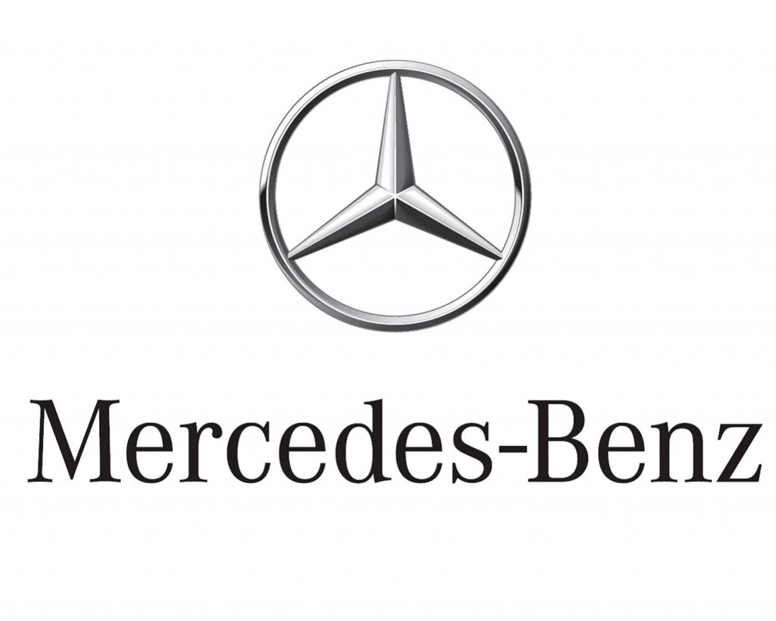

2.1 Employees
The human resces strategy of Daimler Group is based on the necessity to gain, develop, and retain highly qualified people. The main Principles of the can be found in the guidelines, such as “Principles of Social Responsibility, which can be found under: https://www.daimler.com/company/corporate-governance/compliance/principles.html
The key areas of action from these overarching objectives — ranging from generation management to topics such as diversity and equal opportunity, life balance, and the qualification training of specialists in the growth markets.
Human resces organization within the Daimler Group includes the company-wide “Safeguarding the Future of Daimler” agreement. It builds on the agreement reached in 2011 and essentially protects all of the employees of Daimler AG in Germany from being laid off until the end of 2020. In addition, it presupposed the flexible working-time models and collectively agreed framework conditions, which enable to make better use of market opportunities and absorb fluctuations in demand.
 |  | 2013 | 2014 | 2015
Workforce (general)
Total workforce (worldwide) |  | 274,616 | 279,972 | 284,015
- Trainees (worldwide) |  | 8,630 | 8,346 | 8,307
- Average age of the workforce (worldwide) | in years | 42.3 | 42.4 | 42.5
- Share of part-time employees (Daimler AG) | in percent | 7.4 | 7.6 | 7.7
- Personnel expenses (worldwide) | in € billions | 18.8 | 19.6 | 20.9
- Costs for training and advanced professional development | in € millions | 236 | 248 | 252
- Qualification hours per employee/year | in days | 4.1 | 4.1 | 3.5
- Share of women | in percent | 16.3 | 16.8 | 17.3
- Share of women in Level 4 management positions (Daimler AG) | in percent | 14.6 | 15.0 | 16.1
Fluctuation rate (worldwide) | in percent | 4.4 | 4.9 | 5.4
Sickness rate (Germany, manufacturing and administration) | in percent | 5.6 | 5.6 | 5.9
Incidence of accidents (worldwide)1, 2 | rate | 9.1 | 8.8 | 8.8
Contributions to company retirement and health benefits | in € billions | 9.9 | 12.8 | 8.7
The key HR figures for 2015

One of the key points within the Diversity management is creating the general conditions for a culture of diversity, which include the clear rejection of any form of discrimination, as well as the creation of a work environment that is free of prejudice.
All the members of the Board of Management support Diversity Statement and actively advocate the realization of its principles:
- Promoting diversity.
- Creating connections.
- Shaping the future
In order to implement all of this in the company, Diversity Management concentrates on f fields of action:
1. Gender Diversity
2. Generation Management
3. Internationalization
4. Working Culture

- Gender diversity.
Daimler has a self-designated target of increasing the share of women in management positions within the Group to 20 percent by the year 2020. In 2015 more than 15 percent of executives in middle and upper management were women. To achieve objective, has been installed a stringent internal reporting and forecasting system and are promoting women through special programs and seminars. This applies in particular to female professionals in the fields of engineering and technology. In 2015, over 35 percent of the trainees who entered the company through CAReer program were women.

- Generation management
In 2024, one in two employees of Daimler in Germany will be 50 years or older. The average age of the employees will then be about 47 years. With the increase in the retirement age, generation diversity will expand.
The demographic transformation considered as an opportunity and using generation management measures to help adapt to these challenges. A specifically focusing stetted on measures for maintaining the health and performance of younger and older employees and promoting cooperation between people of all ages.
In the fall of 2015, the General Works Council agreed on joint basic principles to which orient in generation management. The main topics are healthcare, work structuring, leadership, learning, and human resces development.

- Internationalization.
Daimler earns significantly more than 80 percent of its revenues abroad. Worldwide Daimler operate at over 180 locations on six continents. Most of the managers abroad come from the respective regions. The employees’ diverse cultural backgrounds helps to better understand the wishes of customers in the various regions and to tailor products accordingly.
Throughout the world, around 1,800 Daimler employees from 30 countries are taking part in international assignments. By far the most important country in which assignees from Germany work is China, with a share of almost 40 percent. It is followed by the United States at around 15 percent and Hungary at around 6 percent. Other important target countries include South Africa, India, and Japan. However, Daimler also promote the assignment of employees from global locations to Germany so that they can build up networks and deepen their know-how. Such expats from abroad also help to make Daimler in Germany more international.
- Working culture
The appropriate framework conditions to strengthen supportive working culture, which is based on appreciation and respect. These measures range from fair and flexible working time regulations to mobile working from home and on the road.
Flexible working arrangements. Many employees attach great value to the ability to structure their working hours individually. To make this possible, created appropriate framework conditions that enable to reconcile the needs of their work and their private lives as well as possible. To this end, the company agreed individual working (time) models with the respective employees. Of the 2,756 employees who took advantage of parental leave during 2015, 69 percent (2014: 73 percent) were male. More than 90 percent of the fathers took two “partner months” of leave. All employees who take parental leave to later return to their jobs at the company are encouraged. Furthermore, work agreements additionally enable employees to suspend their careers for several years for a sabbatical or training measures — with the promise that they can return to Daimler afterwards.
Reconciling work and family. The company helps employees find appropriate childcare solutions. In Germany, offered around 710 places in daycare centers in close proximity to company locations as well as 160 reserved places in other daycare centers. In addition, Daimler cooperates with a third party that assists employees in finding childcare providers. In September 2015, first “sternchen” daycare center outside Germany. Located in Hungary was set up , the facility can take care of over 60 employee children aged six or younger.
Expansion of job-sharing opportunities. Daimler also promotes job sharing, in which two employees share the same task/position and work up to 30 hours per week each. Helping in this way employees reconcile the needs of their work and their private lives. This is especially important for managers. However, reliable agreements are needed for this arrangement. In mid-2015, more than 100 employees worked in job-sharing positions at the team and department level.
Part-time community for managers. The Level 4 Part-time Community is an online platform where Level 4 managers can contact one another when they want to obtain a part-time position or would like to switch from a full-time job to a part-time one. On this platform, participants can find potential job-sharing partners as well as like-minded individuals with whom they can share ideas.
More mobile working. In 2015, Daimler teamed up with the General Works Council, the IG Metall trade union, and the Fraunhofer Institute to launch a joint “mobile working” initiative. Employees and managers also got involved in this broad-based process that aims to integrate the needs of the workforce and the requirements of business operations into an updated general works agreement.

2.2 Supply/consume
Success depends, not least, on good and trusting cooperation with suppliers all over the world. This cooperation is based on shared requirements and values, which include the companies’ compliance with Sustainability Standards along the supply chain.
Around 2,900 employees work in Daimler’s procurement units at more than 50 locations worldwide. Established procurement management committees ensure the cross-divisional management of sustainability issues as well as uniform communications within and outside the organization. Daimler regularly keeps employees up to date about new developments with regard to sustainability and compliance. In addition, training programs about these issues are mandatory for all new employees.
Increasing procurement responsibility at the local level. As part of its global growth strategy, Daimler is increasingly shifting its value added to the respective sales markets and production locations. As a result, Procurement will incorporate additional local suppliers in order to increase the local share of the value added. For example, while the value added from vehicle and engine production at the Beijing Benz Automotive Co., Ltd. (BBAC) car plant in Beijing currently has around 60 percent local content, this figure is scheduled to rise to about 80 percent in the future. To this end, the company already developed 250 local suppliers. This has clear benefits for sustainability, because locating procurement activities close to the production facilities in the growth markets supports the local areas, reduces logistics expenditures, and thus helps to cut CO2 emissions. Additional information under: URL: http://supplier-magazine.daimler.com/
Sustainability Standards
Supplier Sustainability Standards define requirements for working conditions, human rights, environmental protection and safety, and business ethics and compliance. They are a binding component of the contractual conditions and form the basis of all of business relations with manufacturing suppliers and service providers worldwide. By signing the contract, direct suppliers commit to observing sustainability standards, communicating them to employees, and spreading them to their upstream value chains. Daimler supports them in this through targeted information and training measures. The Daimler Supplier Portal serves as the central information platform. Additional information under:
URL: http://engp- download.daimler.com/docmaster/en/html/SUPPLIER_SUSTAINABILITY_STANDARDS.2013-06._multi.html
Certified environmental management in the supply chain. Suppliers are expected to take on responsibility for the environment, and could proof of their certified environmental management according to ISO 14001, EMAS or other comparable standards. The target for 2018 is for 70 percent of suppliers of production materials (based on revenue) to have such a certificate. This figure already amounted to 45 percent at the end of 2015. It’s expected, that selected suppliers of non-production materials have an environmental certificate. These suppliers are chosen on the basis of a risk filter.
Dialog and training. Cooperation along the global supply chains is essential so that sustainability can be permanently ensured. That is why Daimler continuously communicates with suppliers all over the world. The company also includes in this process the local supplier industry in countries with sustainability risks. In cooperation with other automobile manufacturers, Procurement has been organizing supplier training courses since 2010. In 2015, training programs were held in China, South Africa, and India. Such courses had previously already taken place in Argentina, Brazil, Mexico, Russia, and Turkey. A total of 19 local training sessions have been held worldwide since 2010. It is also planned to use an e-learning training module in the future to ensure that all of suppliers around the world can continuously progress. Additional information under:
URL: http://supplier-magazine.daimler.com/en/gemeinsame-lieferantentrainings-von-daimler-und-anderen-oems/
To implement sustainability standards in the supply chain, the company also held discussions at stakeholder dialog events. For example, Procurement initiated group talks with its key stakeholders in 2015 and in this way continuously improves measures and activities. Additional information under:
URL: https://www.daimler.com/sustainability/management/sustainability-dialogue.html
Social standards for contracts for work and services. The awarding and performance of contracts for work and services is subject to standards that extend beyond the existing legislation. standards define the requirements with regard to occupational health and safety, accommodation, remuneration, use of temporary employees, commissioning of subcontractors, and freelancing. These social principles are relevant for all orders that exceed a period of two months and are realized on the business premises of Daimler AG in Germany. The relevant suppliers are required to fill out and sign a declaration concerning their compliance with the standards. This is a prerequisite for receiving new orders. An auditing team from Procurement determines whether the standards are being observed.
Promotion of industry-wide initiatives
To make global supply chains more sustainable, the company is active in various national and international trade and industrial associations such as econsense, the Association Materials Management, Purchasing and Logistics, the German Association of the Automotive Industry (VDA), the American Automotive Industry Action Group (AIAG), and the European Automotive Working Group on Supply Chain Sustainability, which was founded as an industry initiative within the European corporate network CSR Europe. The goal of this collaboration is to develop a recognized company-wide and industry-wide frame of reference. One of the first results of this cooperation is the Automotive Industry Guiding Principles to Enhance Sustainability Performance in the Supply Chain. To date, Daimler and 13 other automobile companies from all over the world have committed themselves to comply with these minimum social and environmental standards. As part of CSR Europe Daimler cooperates with experts from the procurement units of other manufacturers, to develop tools for minimizing sustainability risks. For example, an industry-wide questionnaire with which suppliers can self-assess their sustainability performance has been developed. This questionnaire is recognized and used by all companies that take part in this initiative. In 2015, the company used these principles to assess more than 40 percent of suppliers of production materials (based on revenue). In addition, the questionnaire specifically used in high-risk, non-production-material product groups such as transport logistics. On the basis of the results, the company derive measures for improving sustainability performance and communicate these measures to suppliers.
In 2016, we aim to proceed with the questionnaire’s systematic rollout. Daimler continues to cooperate with other automobile manufacturers and associations in this area as well so that we can jointly promote sustainability in the supply chains, parallel enable direct suppliers to use the joint questionnaire for their own suppliers.
Responsible raw material procurement. Certain regions of the world are exposed to the risk that armed conflicts could be financed with the revenue from the sale of raw materials and minerals such as tin, tantalum, tungsten, and gold. To prevent this from happening, various voluntary initiatives or legislative guidelines have been introduced aiming at a declaration of the origin and the responsible procurement of such raw materials. In the United States, for example, the Dodd-Frank Act stipulates that companies listed on US stock exchanges must certify the source of these commodities along the entire supply chain. In Europe, the European Union also envisages legislation on this matter. Daimler supports an effective and practicable approach for the establishment of responsible procurement of raw materials. Even with great effort, companies cannot always precisely determine the source of a raw material, especially if they are at the end of long and complex supply chains. Daimler therefore cooperates with industry associations such as the German Association of the Automotive Industry in order to promote possible solutions that are feasible and that bring us closer to achieving this goal.
Prevention and risk management
Multi-stage concept for implementation uniform sustainability standards and monitoring of observance in global supply chain.
- Regular review of active suppliers. To identify sustainability risks with regard to issues such as child labor, environmental protection, corruption prevention, violations of freedom of association or violations of human rights at an early stage, Daimler conducts a risk analysis of suppliers by country and commodity at regular intervals. This analysis enables to identify suppliers that are subject to increased risk and to take preventive measures. The company uses media and database research to review cases of actual sustainability and compliance violations and systematically follows up all reports of violations.
- Assessments of new suppliers before contract awards. Particularly in the case of new suppliers from high-risk countries, auditors ask specific questions concerning their compliance with sustainability standards during on-site assessments.
- Escalation process. In the event of a suspected or actual violation of sustainability standards by a supplier, the company follows an established escalation process, which begins with a request for an explanation of the measures taken to remedy the irregularities. If any doubts remain, Daimler seeks direct contact with the supplier or demands a written statement from the supplier’s company management. All suspected violations are examined by the responsible management committees and with the involvement of the procurement heads. If required, trained experts and independent auditors conduct sustainability audits at suppliers. In justified cases the company refrains from placing further orders or terminates the cooperation until it is demonstrated that the irregularities have been remedied.

2.3 Community

Being a global company means a global responsibility. That is why Daimler supports the social environment at locations as well as a wide variety of aid projects around the world.
The company started longer-term projects aimed at helping people to help themselves.
Extensive support for refugees. Daimler has been helping refugees for a long time. For example, it has cooperated with “Wings of Help” since 2013 to send f convoys with relief supplies to Syrian refugee camps in Turkey and two flights with similar supplies to northern Iraq.
In addition, are providing the city of Stuttgart with 100,000 EUR annually for three years for a fund to welcome refugees. Providing an additional 100,000 EUR to fund refugee projects of the Bürgerstiftung Sindelfingen. Daimler also donated 1 million EUR to the child relief organization “Bild hilft e.V. – Ein Herz für Kinder.” Moreover, the company fund German language cses for refugees, donate food from the Daimler cafeterias, and offer a support fleet of Mercedes-Benz vehicles to relief organizations. The company is currently also determining whether company doctors from Daimler could provide medical care to people in refugee centers.
Furthermore, Daimler is assisting the social integration of the refugees and supporting the relief activities of its employees. For example, employees donated 300,666 EUR to help refugees. The company contributed the same amount. The total sum of 601,332 EUR was donated to the German Red Cross (DRK) in support of refugees. The fundraising campaign was jointly initiated by the company management and the General Works Council in Germany. Special “action days” were also held, during which employees helped refugees. Plans are also being drawn up to renovate refugee centers and build playgrounds for the children. Among other Community and charitable commitment things, Daimler pays for the required materials and ensures that craftspeople professionally supervise the activities.
In November 2015, Daimler launched a “bridge internship” for refugees. The first group of approximately 40 participants spent 14 weeks at the Mercedes-Benz plant in Stuttgart-Untertürkheim, where they learned the basics of industrial production work. The participating refugees were selected by the Federal Employment Agency, the Jobcenter Stuttgart, and the Jobcenter Esslingen. In the future, Daimler wants to offer such “bridge internships” at many other Mercedes-Benz plants in Germany. The aim is to equip several hundred refugees with qualifications that help integrate them into the German labor market and enable them to get jobs in German industry.
To help people living in great poverty, Daimler also funds the Ekukhanyeni project in Lawley near Johannesburg. Additional information under:
URL: https://www.daimler.com/sustainability/society/charity-involvement/

2.4 Environment

We pursue an integrated approach to corporate environmental protection that starts with the causes of potential negative environmental effects. We reduce the negative effects of our activities with the help of effective environmental management systems and state- of-the-art technologies. In this way, we promote climate protection, conserve valuable resources, and contribute to the preservation of a livable environment — at our locations and beyond.
We have formulated our requirements for a comprehensive system of environmental protection in the environmental and energy guidelines of the Daimler Group. Detailed specifications for the Group-wide environ-mental management system are defined in the Environmental Management Manual. In addition, we have internal standards for topics such as the handling of hazardous materials, waste management, and the prevention of soil and water contamination.
Effective organization. On behalf of the Daimler Board of Management, the Member of the Board of Management of Daimler AG who is responsible for Group Research & Mercedes-Benz Cars Development represents the environmental concerns of the Group. Different organizational units ensure the central management, networking, and communication of environmental issues:
- The Chief Environmental Officer is mandated by the Board of Management to coordinate the Group-wide environmental management activities and to advise the company’s management on environmental issues.
- The Corporate Environmental Protection unit coordinates the operational tasks of the Group-wide environmental management function, which include analyses of the legal requirements, the definition and advancement of environmental protection standards, environmental reporting, and production-related environmental protection risk management.
- Regional committees in Europe, Asia, and North and South America ensure that local and regional conditions are taken into account in production-related environmental protection measures and that the associated activities are managed in coordination with the Corporate Environmental Protection unit and the Group’s Chief Environmental Officer.
Comprehensive training. We regularly organize awareness and training programs for our employees and managers with a focus on the practical applications of operations-related environmental protection and questions concerning environmental responsibility. We also train our auditors, who review the environmental management systems of our plants. In addition, we conduct refresher courses on environmental management that enable participants to share ideas and experiences.

Targeted control. In order to eliminate or reduce environmental risks in advance, we regularly audit our locations in accordance with globally uniform standards. Suppliers must observe our sustainability requirements and are expected to operate with an environmental management system that is certified according to ISO 14001, EMAS or other comparable standards. In addition, Mercedes-Benz specifications define requirements for the environmental compatibility of our component deliveries. Further-more, the Mercedes-Benz contract terms contain requirements concerning materials selection, banned substances, and recycling, as well as compliance with environmental legislation.
Strict environmental risk analysis. Our environmental risk analysis system encompasses all processes of relevance to the environment: emissions into the atmosphere and wastewater, waste management, handling of hazardous materials, and damage to the soil and groundwater. A team of auditors visits all Daimler locations at fixed intervals - including the locations we operate as a majority shareholder with partners. The auditors conduct interviews and plant tours. The findings are documented in reports to the heads of the production locations and summarized in “Summary Reports” for top management. In addition, the analysis process facilitates the sharing of best practices that flow into the Daimler standards, which are valid worldwide.
- We address the challenges of the future related to environmental and energy aspects.
- We strive to develop products that are highly environmentally friendly and energy-efficient in their respective market segments.
- We plan all stages of manufacturing to provide optimal environmental protection and efficient energy utilization.
- We offer our customers comprehensive services and information regarding environmental protection and energy use.
- We endeavor to achieve an exemplary environmental and energy performance worldwide.
- We provide our employees and the public with comprehensive information on environmental protection and energy utilization.
The Daimler Group’s Environmental and Energy Guidelines
Global certification. Our production locations worldwide are certified in accordance with ISO 14001 and are regularly audited to determine whether they meet the requirements of this environmental management system. As a result, over 98 percent of all Daimler employees at production locations work within the framework of a certified environmental management system. In addition, almost all German locations are certified according to the EU Eco Management and Audit Scheme (EMAS). A total of 22 locations - including our major plants - already have energy management systems that are certified in accordance with ISO 50001. ass Environmental statements of the plants (only available in German)
Environmental protection costs. Our investments in environmental protection systems and facilities with integrated environmental protection features amounted to around €91 million in 2015 (previous year: €108 million), whereby the integrated environmental protection features are not always clearly separable. Current environmental protection expenditures for personnel, operations, and waste disposal were about €418 million (previous year: €432 million). Our Group-wide expenditures for development projects related to environmental protection, such as alternative drive systems, state-of-the-art emission control technologies, and efficiency increases in vehicles, amounted to around €2.4 billion (previous year: €2.4 billion).
sss Interactive data overview of environmental protection in production
Global certification. Our production locations worldwide are certified in accordance with ISO 14001 and are regularly audited to determine whether they meet the requirements of this environmental management system. As a result, over 98 percent of all Daimler employees at production locations work within the framework of a certified environmental management system. In addition, almost all German locations are certified according to the EU Eco Management and Audit Scheme (EMAS). A total of 22 locations - including our major plants - already have energy management systems that are certified in accordance with ISO 50001.
Environmental protection costs. Our investments in environmental protection systems and facilities with integrated environmental protection features amounted to around €91 million in 2015 (previous year: €108 million), whereby the integrated environmental protection features are not always clearly separable. Current environmental protection expenditures for personnel, operations, and waste disposal were about €418 million (previous year: €432 million). Our Group-wide expenditures for development projects related to environmental protection, such as alternative drive systems, state-of-the-art emission control technologies, and efficiency increases in vehicles, amounted to around €2.4 billion (previous year: €2.4 billion).
Principles of data collection. In our recording of environmental and energy data we take into account all the relevant locations that are majority-owned by Daimler AG.
Energy efficiency and low-carbon production
Targets achieved. In the sum of all divisions, we achieved our target of reducing production-related CO2 emissions per vehicle by 20 percent Group-wide by the year 2015 as compared to 2007. For the European plants we set an additional target of reducing absolute CO2 emissions by 20 percent relative to the 1992-1994 reference period. We have also made good overall progress toward achieving this target in recent years, but due to the production increase in 2015 we have slightly deviated from the set target.
Reduced CO2 emissions. We want to further reduce CO2 emissions in the years ahead with the help of new energy-saving production methods, even more efficient processes, and the use of renewable and low-carbon fuels. One of our targets is to reduce the specific energy consumption at Mercedes-Benz Cars by 25 percent between 2015 and 2022.
As a result of the above-mentioned measures, energy consumption in-creased by only 0.8 percent in 2015 and CO2 emissions even fell by 1.2 percent, despite markedly increased production volumes. The latter effect is also partly due to the sale of Atlantis Foundries. The total emissions depicted in Chart 28 and Chart 30 result from the combustion of fossil fuels and purchases of electricity and district heating from third-party energy producers.
Climate-friendly energy supply. For the heating of our plants we use low-carbon natural gas and, where available, district heating. Many locations make use of highly efficient cogeneration facilities, which are operated by Daimler or by a regional provider. The expansion of combined heat and power (CHP) units is an important pillar of our eco-friendly energy supply system. Since 2011 we have set up 35 CHP modules with a capacity of around 183 MW. With these modules alone, we can cover around 6 percent of our electricity and heating requirements under optimized CO₂ conditions.

 | 2011 | 2012 | 2013 | 2014 | 2015
GWh
Electricity | 4,685 | 4,870 | 4,545 | 4,586 | 4,452
District heat | 913 | 949 | 973 | 824 | 884
Natural gas | 4,161 | 4,305 | 4,971 | 4,922 | 5,075
Heating oil | 104 | 84 | 78 | 55 | 85
Liquid gas | 96 | 99 | 108 | 98 | 92
Coke | 181 | 139 | 69 | 61 | 55
Fuels | 325 | 322 | 315 | 305 | 296
Energy consumption of the Daimler Group

In several locations in Germany, Japan, the United States, and India, we operate photovoltaic installations on our roofs or provide roof space for the use of operating companies. More than 70,000 square meters of roof space are used for CO2-neutral electricity production in this manner.
Moreover, we also report the upstream and downstream CO2 emissions for the Mercedes-Benz Cars division (Scope 3). This amounts to 13.4 million tons of CO2 for the upstream production phase and 42 million tons for the service life phase (150,000 km) of the vehicles sold in 2015 (including fuel production).
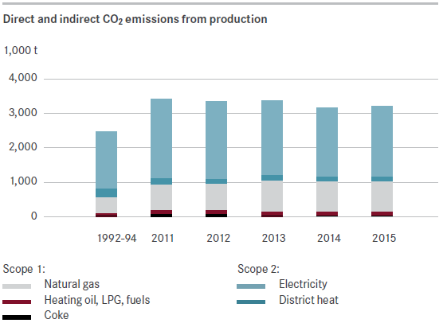

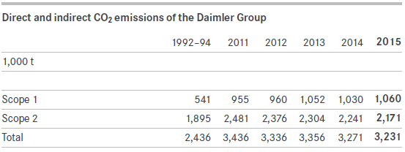

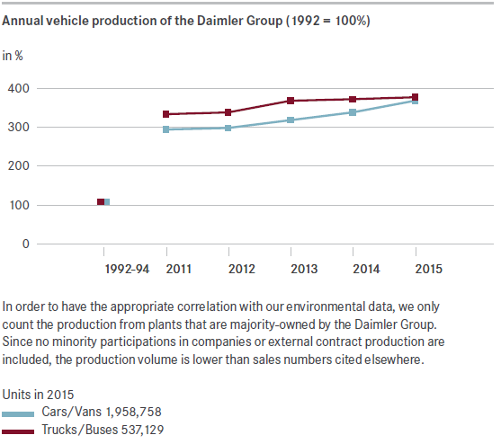

Approaches to saving energy. Our energy projects at all locations are operated on the basis of exact record-keeping through a dense network of automatic electricity meters. In line with this, we design our energy- saving measures in accordance with four points:
1. To avoid unnecessary use of energy during production breaks, we use intelligent switch-off and standby controls.
2. Furthermore, we are reducing the energy waste caused by compressed air leaks, heat losses, and excessive process requirements (e.g. temperature specifications). In these areas, we exploit the reduction potential of the production processes themselves and of the building infrastructure.
3. We achieve the most significant efficiency increases by replacing old production facilities with state-of-the-art plant technology and new building construction.
4. Moreover, we are raising our employees’ and managers’ awareness of energy conservation issues with the help of events and com-munication measures. In addition, energy-saving suggestions are rewarded within the scope of the company suggestions system.
Fuel cell with fourfold benefits. The AMG plant in Affalterbach is using an innovative fuel cell facility to supply its new logistics center with energy. Besides electricity, heat, and refrigeration, the facility supplies oxygen-reduced air for fire-fighting purposes.
Effective gas turbine. The multiple use of waste heat enables the new gas turbine of the CHP plant in Sindelfingen to have an efficiency of over 90 percent. As a result, the location’s CO2 emissions are reduced by 60,000 tons per year.
Energy-saving surface treatment. To enable the friction-reducing NANOSLIDE coating to be applied to crankcases, the interior of the cylinders has to be roughened. This process used to consume large amounts of energy, but engineers at Daimler have now developed a new mechanical roughing method that cuts energy use by 96 percent.
Certified energy management in Detroit. It took Detroit Diesel Cor-poration only ten months to establish an energy management system in accordance with ISO 5001 at its Detroit plant. Initial energy-efficiency programs achieved savings of up to 25 percent.
Air purification
Solvents (volatile organic compounds or VOCs) in particular are released during vehicle production. In addition, sulfur dioxide (SO2), carbon monox-ide (CO), nitrogen oxides (NOX), and particulates are also emitted into the atmosphere. Substances that damage the ozone layer are only emitted in tiny residual amounts. Through the introduction of largely solvent-free paint systems, we have already achieved a drastic reduction of solvent emissions; Mercedes-Benz Cars, in particular, is the benchmark here in comparison with its competitors. We are also unlocking further reduction potential through the use of new technologies, primarily in the painting of commercial vehicles and major components.
A new kind of air purification process. At the Gaggenau plant, a new process enables the dry deposition of fine paint droplets (overspray) to purify the air inside the paint booths. As a result, the plant emits around 160 tons less CO2 than was previously the case and has to dispose of nine tons less paint sludge as hazardous waste.
 | 2011 | 2012 | 2013 | 2014 | 2015
In t
Solvents (VOCs) | 6,355 | 6,618 | 6,907 | 6,547 | 7,321
Sulfur dioxide (SO2) | 55 | 55 | 72 | 76 | 39
Carbon monoxide (CO) | 2,636 | 2,766 | 2,336 | 2,813 | 2,898
Nitrogen oxides (NOX) | 869 | 958 | 1,012 | 1,005 | 1,071
Absolute VOC, CO, SO2, NOX emissions
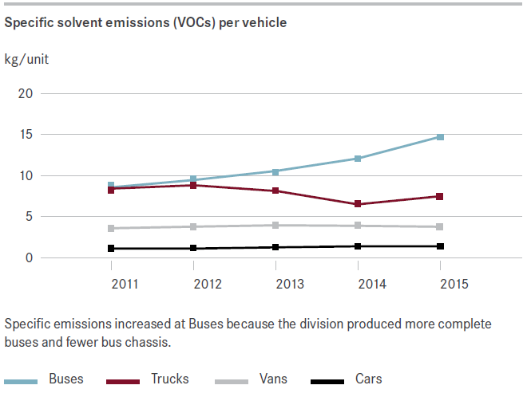

Waste and resource management
The recycling and reuse of raw materials, indirect materials, and supplies in our plants has been a self-evident activity for years now. We currently achieve a waste recovery rate of 91 percent. Our cutting-edge technical processes and environmentally sound production planning additionally enable us to avoid waste from the very start. With a view to meeting our special responsibility as a waste producer, we regularly audit the waste disposal operators of our production plants in accordance with an established process. None of our waste is exported to other countries.
 | 2011 | 2012 | 2013 | 2014 | 2015
1,000 t
Waste for disposal | 68 | 65 | 74 | 82 | 74
Waste for recycling (without scrap metal) | 214 | 254 | 222 | 232 | 269
Scrap metal for recycling | 790 | 778 | 821 | 863 | 866
Hazardous waste for disposal | 17 | 22 | 42 | 116 | 47
Hazardous waste for recycling | 63 | 66 | 68 | 70 | 71
Waste volumes
Effective resource management. As a company from an industry that consumes large amounts of materials, we strive to plan material use carefully and to employ finite resources as sparingly as possible. We purchase a large part of the materials used in our vehicles from suppliers in the form of components. Although the environmental effects of purchased components are not directly included in the assessment of our corporate environmental performance, we take them into account in our holistic assessment of product development and selection of materials. Under this assessment method, which we have used for our passenger cars thus far, we extrapolate the entire use of materials in the production chain and also consider the waste flows. Because of the size and complexity of the Daimler Group, the material flows cannot be analyzed in greater detail here. However, details of individual model series are provided in the respective life cycle reports.
Through the use of efficient technologies we have reduced the use of scarce resources to the absolute minimum. We already plan the recycling of materials at the end of the product life cycle as early as the development stage. In addition, we also remanufacture used parts to a great extent. This yields economic benefits for the customers and conserves resources.

Water pollution control
Our target is to prevent water pollution. We keep the use of the natural resource “water” as low as possible, especially in countries with dry climates.
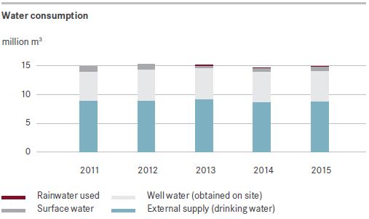
The great majority of our plants do not channel their wastewater directly into lakes and rivers, but only after pretreatment into local effluent treatment plants via the public sewage system. Detailed information on the various wastewater parameters is provided in the environmental declarations of our EMAS-certified plants.
At our car plants, we aim to reduce water consumption by 15 percent by 2022. The introduction of a new painting process is expected to make the biggest contribution to this reduction.
Innovative biofilter purifies surface water. Swamp plants are helping to purify surface water at the Bremen manufacturing facility. These plants grow in a 100-square-meter soil filter. While the filter purifies the water by mechanical and chemical-physical means, the plants help to biologically decompose pollutants.
Logistics and employee transport
The incoming and outgoing delivery traffic in our plants as well as the distances our employees travel for work and business also affect our environmental performance through emissions, noise, and resource use. We minimize the environmental effects of these transports through the use of an efficient logistics system and of rail transportation and inland shipping. We replace business travel with conference calls, video conferences or online conferences wherever possible and expedient. Employees at the Sindelfingen and Stuttgart locations receive discounted yearly passes for the public transit system.
 | 2013 | 2014 | 2015
1,000 t
Train | 0.8 | 0.8 | 0.8
Plane | 73.2 | 80.0 | 84.2
CO2 emissions from business travel (starting from Germany)
Truck deliveries to our German plants, the Hungarian plant in Kecskemet, and the plant in Vitoria, Spain, are monitored centrally. As of 2015, this evaluation now includes for example traffic between the plants, which largely accounts for the increase over the previous year. The CO2 emissions can be approximated on the basis of the tonnage and the truck-kilo- meters traveled.
 | 2013 | 2014 | 2015
Truck-kilometers (in millions) | 173 | 218 | 262
Cargo (in million t) | 4.3 | 4.9 | 6.9
CO2 emissions (in 1,000 t) | 139 | 171 | 206
Truck shipments to our plants in Germany, Vitoria, Spain, and Kecskemet, Hungary
Optimization of transport logistics. Our global transport logistics operations currently serve 75 manufacturing plants in around 30 countries and about 8,500 retailers in almost all areas of the world. We transported around 2.8 million vehicles worldwide in 2015. In the first half of 2015 alone, we also transported almost 3.8 million tons of production materials in Europe. The global transport volume amounted to around 330,000 standard containers of sea freight and about 66,000 tons of air freight.
In order to reduce the associated CO2 emissions, we are working hard to optimize the logistics network. Our main target here is to optimally connect the transportation hubs with one another so that the distances can be reduced and capacity can be better utilized. Innovative transportation concepts and new transport systems also play a major role here.
We select logistics concepts on the basis of not only their costs, duration, and transport quality, but also their CO2 emissions. When selecting providers of logistics services, we also take sustainability criteria into account, ranging from environmental certificates and the use of environmentally compatible equipment to the utilization of trucks that meet the latest Euro emissions standard.
Efficient return transport of shipping containers. One drawback of reusable shipping containers is that they have to be sent back to the supplier. In order to optimize this return transport, 17 Daimler plants in Europe have joined forces with five regional logistics centers to create a network and an IT-based container management system. As compared with the original situation, 2,200 tons of CO₂ emissions were thereby avoided and freight costs considerably reduced in 2015 alone.
Improved employee transportation system. In Indonesia, companies offer their employees transportation to work in the mornings and back home after the workday is over. In 2015 the Mercedes-Benz plant in Wanaherang optimized such employee transport by improving routes, using appropriately sized vehicles, and increasing capacity utilization. As a result, the transport system now emits 24 percent less CO₂ than before.
Nature conservation, land use, and biodiversity
Our production plants cover a total area of around 4,800 hectares, 61 percent of which are occupied by buildings and transport areas. Because land is a limited public resource, we use these areas as efficiently as possible through dense, multi-level building development. Whenever possible, we also design outdoor areas within our plants to serve as a habitat for indigenous plants and animals. In this way, we can facilitate biodiversity even amidst the industrial architecture. For example, peregrine falcons have found a new home on chimneys of our plants in Worth and Sindel- fingen. In the Tuscaloosa plant, natural vegetation and beavers with their dams ensure the retention and preliminary sedimentation of rainwater. Because of the way we use land and the location of our plants primarily in industrial zones, no significant negative effects on endangered species are to be expected.
Biodiversity index. To measure the effect of our activities, we have developed a biodiversity indicator whose practical viability is currently being tested in several plants. The indicator categorizes our horizontal and vertical areas in accordance with their environmental value. This indicator enables us to set targets for our plant-specific environmental protection programs and clearly evaluate the progress that has been made.
Environmental protection zone. In cooperation with biologists from Nuevo Leon University, our plant in Monterrey, Mexico, has created an approximately two-square-kilometer environmental protection zone that also serves as a habitat for endangered species.
Protecting trees in Brazil. Exotic trees, some of which belong to endangered species, grow on the premises of our plant in Sao Bernardo do Campo, Brazil. To draw attention to this biological treasure, we have created a tree database that contains around 5,000 entries.
Soil and groundwater. We eliminate any soil and groundwater contamination as far in advance as possible. An internal guideline provides minimum standards for the handling of soil and groundwater contamination at all locations. The requirements frequently extend beyond the local legal regulations. Compliance with these requirements is reviewed in the framework of our worldwide audits. In 2015 there were no significant accidents associated with soil or groundwater damage.

2.5 Education

Daimler supported by custom-tailored programs and promotional measures in all the important phases of employees’ individual training and career paths.
Industrial-technical and commercial vocational training, as well as studying programs at the Cooperative University, enable to attract most of the junior talents required by the company. In Germany, the Daimler Training System (DAS) ensures the high quality and efficiency of technical vocational education.
In 2015, around 70 trainees and 15 trainers had a chance to gather their first international experience. Moreover, ten trainees took part in an exchange project in Poland in cooperation with the Action Reconciliation Service for Peace. In addition, the training activities are continuously internationalized in order to achieve high training standards throughout the Group. For example, the Mercedes-Benz Qualification System (MBQS) for international passenger car locations.
In several countries, are also created own company training centers and qualification structures or the respective region’s offers are supported. Furthermore, also dual education elements outside Germany will be established.
Talented young people can development prospects by specifically addressing various target groups and providing them with a wide variety of training programs from career entry level to further qualification:
- The Cooperative University (DH) at Daimler combines a scientific study program with internships at 13 company locations in Germany. In 2015, Daimler had 650 DH students. Around 200 DH graduates hired each year.
- The FacTS program supports young skilled workers who have completed technical professional training cses with outstanding results, in the first years of their careers. The program currently has 41 participants, and 16 skilled workers have completed the program to date.
- The international trainee program CAReer enables outstanding university graduates to enter the company. Highly qualified participants who have an international profile receive support during and after the program phase, and are perfectly prepared for their prospective management tasks at the company. CAReer promotes the participants’ personal development and enables them to learn skills in a variety of divisions worldwide. The program’s participants are given a permanent job contract from the very start. In 2015 hired about 200 trainees, about 40 percent of whom were women and more than one-third were international participants.
The Daimler Academic Programs enable qualified managers and skilled employees to study with support of the company. Participation is determined by means of an internal selection process and the respective employees’ personal development plans. In the winter semester of 2015-2016, 173 employees studied as part of the program.
 | 2013 | 2014 | 2015
Costs for training and advanced professional development (in € millions) | 236 | 248 | 252
Investments in employee qualification (in € millions) | 107 | 121 | 126
Qualification days per employee/year | 4.1 | 4.1 | 3.6
Qualification days per woman employee/ year | 4.2 | 4.3 | 3.8
Qualification hours per employee/year | 28.7 | 28.7 | 24.5
Qualification of employees at Daimler AG
One of the main emphases of Daimler is promotion of science and education. In 2015, the company spent almost E60 million on donations to non-profit organizations and the sponsorship of socially beneficial projects in addition to foundation activities and corporate volunteering efforts, as well as projects initiated by Daimler.
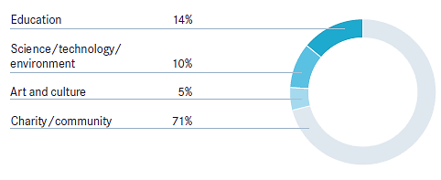
Donations and sponsorship in 2015

Education creates opportunities and opens up doors to a future full of possibilities. Improving access to education is one of the most long-lasting investments the companies can make for society and for company.
Daimler is involved in a variety of education projects around the world with a view to promoting people’s enthusiasm for science and technology and also their ability to look beyond working life and go through life with an open mind. The projects supported by Daimler also promote equal opportunity.
The STEM education initiative “Genius — Daimler’s young knowledge community” aims to get young people enthusiastic about science and technology. The initiative offers technology workshops that enable children and teenagers to learn in a playful and practical way, and supplies teachers with instructional materials and continuing education cses for the teaching of technology classes.
Opportunities for the inhabitants of South African townships. With Daimler’s help, the St. Anthony’s Education Centre trains men and women from Reiger Park, a township of Johannesburg.
Internships for talented young people from Arab countries. In cooperation with local universities, company promote talented young people from Arab countries.
Each Girl Is a Star. Together with the women’s organization CYDD Daimler paving the way to technical jobs for socially disadvantaged girls in Turkey.
Because people have to learn how to manage their money wisely, employees from Daimler in the United States take part in the Junior Achievement project, where they teach young people financial literacy and entrepreneurial thinking.
https://www.daimler.com/nachhaltigkeit/gesellschaft/bildung/junior-achievement.html

2.6 Healthcare

Demographic change and the transformations in the working world affect the performance of employees. This creates a requirement for forward- looking sustainable solutions aimed at maintaining the health and physical well-being of employees.
As part of health management measures, Daimler conducts a wide variety of projects to develop solutions that are implemented at the company. These solutions range from the workplace-related “Daimler HealthCheck” at three pilot locations so far to ergonomic workplace design and an IT system that makes it easier to permanently reintegrate employees whose health is impaired.
HR initiative “Life Balance” helps employees reconcile their professional responsibilities with their private lives, and thus also serves to keep them healthy.
https://blog.daimler.de/2016/02/08/wenn-life-balance-taeglich-auf-dem-programm-steht/
Determining the health risks of psychological stress. Using the system for determining the health risks of psychological stress (GPB) to find potential stress factors in relation to the employees’ daily work. Each Daimler AG location has GPB assessment teams composed of occupational safety experts, works council members, and company doctors.
First Global Health Conference. Held in 2015, first Global Health Conference in line with the slogan “Health@Daimler. One Vision. One Community.” The event took place in Stuttgart. Representatives from HR and health management units in Germany and abroad came together to discuss current and future challenges. The participants approved a health strategy that sets uniform health management standards.
Pandemic plan and pandemic management system. The pandemic and epidemic plan of Daimler AG addresses all medical occurrences that could potentially lead to a crisis. The associated Pandemic Management System (PMSys) was launched in 2015 with a pilot program in Rastatt. In the next step, the system will be introduced throughout Germany.
Component concept for risk assessment. Concept for assessing the risks of workplaces and work processes investigates individual processes (components). All of these individual assessments combined then generate the overall assessment.
Strengthening of psychosocial leadership skills. Social counseling unit increases managers’ awareness of behavioral problems and teaches them how to handle such situations. Moreover, the unit coaches managers who find themselves in difficult leadership situations. In addition, it helps employees deal with psychological problems, conflicts, and life crises.
IT process for assigning employees to tasks that are in line with their capabilities. Daimler developed a special IT system that enables employees suffering from health-related limitations to be permanently reintegrated into existing work processes. With the help of this system, can be determine which jobs correspond to an employee’s capabilities. As a result, utilize employees in line with their physical capabilities.
Ergonomics training. Employees continuously undergo ergonomics training. In addition to standardized ergonomics assessment methods, the employees are taught the basics of ergonomic workplace design. In 2015 this training program was expanded to several locations outside Germany for the first time.
IT project for ergonomics assessment. As part of the EAB 2.0 project, Daimler is currently working on an IT solution for standardized ergonomics assessment methods. The objective is to document the assessments in a database to ensure that uniform ergonomics processes and systematic ergonomics analyses can be established at all divisions.
Company health promotion is aimed at motivating employees to develop healthy lifestyles and to reinforce their sense of personal responsibility regarding health issues. This objective is promoted worldwide with the help of campaigns, counseling, and qualification offerings, as well as therapeutic and rehabilitation measures. All of the plants in Germany have health centers on their premises or cooperate with health centers located near the plants.
https://www.daimler.com/career/thats-us/daimler-as-an-employer/health-management/
Preventing accidents and making workplaces safe. Daimler’s occupational safety program includes all measures for the prevention of work accidents, work-related illnesses, and occupational diseases. Center of Competence for Safety creates the associated Group-wide guidelines. Key occupational and health protection processes are standardized in order to enable the creation and advancement of integrated processes and systems. Every organizational unit within the Daimler Group has to approve and implement occupational safety objectives on a regular basis in accordance with occupational health and safety guidelines and occupational safety strategy and the results of audits and reviews. Centers of Experts help the organizational units address overarching topics such as machine safety and the handling of hazardous materials. An effective reporting procedure helps the units achieve the previously set targets.
Occupational health and safety guidelines focus on prevention and continuous improvement. The guidelines emphasize the managers’ obligation to act responsibly but also underscore the fact that the employees have to actively participate in the associated measures.
The occupational safety and health management guideline of Daimler AG regulates the tasks, responsibilities, and communication activities for the implementation of the occupational health and safety measures from the headquarters functions all the way down to the individual company locations. Among other things, the guideline stipulates that each location must have an occupational safety committee. These committees are composed of the location managers, the responsible planning officers, occupational health and safety experts, and the employee representatives.
Accident documentation and accident statistics. Cross-site accident documentation system is supported by a standardized statistics system. It ensures the database is correct by enabling users to access the sce systems for the hs of attendance, lost days, and organizational structures.
Campaign for moving safely through the plants. The occupational safety campaign “sICHer,” which was launched in 2015, targets the employees’ behavior and makes staff at all units aware of safety risks. The campaign focuses on forklift trucks and the use of cell phones at the plants.
IT system for risk documentation. The newly developed risk documentation system (GDS) helps manage high-precaution hazardous materials, mandatory occupational health examinations, and other preventive and fitness examinations of the employees. The system ensures adhere to government regulations regarding substances classified as carcinogenic, mutagenic, and toxic for reproduction (CMR). The GDS is scheduled to be gradually introduced in all German locations in 2016.
Medical care for employees. At Daimler, occupational and emergency medicine includes all measures for the prevention of work-related illnesses or occupational diseases, health maintenance in the workplace, as well as for diagnostics and therapy of accidents and acute illnesses. It lies within the area of responsibility of plant and company physicians worldwide. Daimler AG provides all of its employees with comprehensive medical care. This care is supplemented by the measures and services of the company health program and the personal counseling organization. If an employee is suspected of suffering from an occupational illness, the company documents the occupational medical checkups and doctors’ diagnoses and reports the information to the responsible employers’ liability insurance association. The specialist departments and the occupational health and safety organization are responsible for implementing preventive health measures. After a risk assessment team has systematically recorded all of the risks, the employee in question is medically examined in accordance with Germany’s Regulation on Preventive Occupational Medicine.
Qualification | Consulting | Prevention | Therapy
▼ | ▼ | ▼ | ▼
- First-aid training  - Advanced emergency medical training | - General medical consultation  - Travel healthcare/care of expats  - Advice on workplace-related issues  - Medical reports following workplace inspections  - Advice regarding personal protective equipment  - Advice for the organization of first aid | - Preventive occupational medicine  - Fitness examinations/examination of newly hired employees and of people who have completed their training  - Medical service at events  - Diagnostics  - Vaccinations | - Emergency medical care following work accidents  - Rescue services  - Care of illnesses and mood disorders
Occupational healthcare portfolio⁷
2.7 Specific Projects

Daimler has launched different projects all around the world. Moreover about this projects with the description you can found here:
URL: https://www.daimler.com/sustainability/
All the points are clickable, so you can choose part of the world, country, and exactly the project you are interested in.



3.1 Employees

People are at the heart of everything we do. Like a coach ensures that all of the players on the pitch are in the right position for the best results, we empower people to exercise their rights and unlock their potential.
WHY IT MATTERS TO SOCIETY:
Education and personal development as well as health and the ability to exercise basic human rights are the founda- tion of a well-functioning society. WHY IT MATTERS TO THE ADIDAS GROUP:
Our employees’ performance, well-being and knowledge have a significant impact on our company’s success. At the same time, operating our business by complying with core labour standards is an imperative. Effective worker empowerment leads to a stable and conducive work environment. This stimulates workers’ productivity, thus increasing manufacturing performance, which ultimately leads to cost efficiency. Creating a collaborative working environment for our more than 55,000 employees as well as safe and fair working conditions for more than one mil- lion workers employed in our supply chain allows us to be the employer of choice and our suppliers to achieve sustainable leadership.
WHAT WE HAVE ACHIEVED SO FAR:
26% of our direct suppliers are in self-governance model in 2015. On top of our existing grievance mechanisms, accessible to all employees and factory workers, more than a quarter of a million workers in our supplier factories already have additional access to our anonymous SMS worker hotline to raise concerns.
OUR WAY FORWARD:
By 2020, we will
- — Empower10 our supply chain workers by expand- ing and refining grievance systems and skill training programmes. - This includes the expansion of the Workers’ Hotline to the countries where our strategic suppliers are located.
- — Achieve sustainable leadership at our suppliers and licensees. - By 2020, all strategic suppliers and licensees will achieve self-governance11. - By 2020, at least 20% of our strategic suppliers and licensees will achieve Leadership level

In 2015, the global employee base of the adidas Group increased further. On December 31, 2015, the Group had 55,555 employees, which represents an increase of 3% versus 53,731 in the previous year.
New hirings related to the Group’s global marketing and sales orgnisation aimed at further strengthening key growth areas and categories were the main drivers of this development. On a full-time equivalent basis, our Group had 47,435 employees on December 31, 2015 (2014: 45,917).
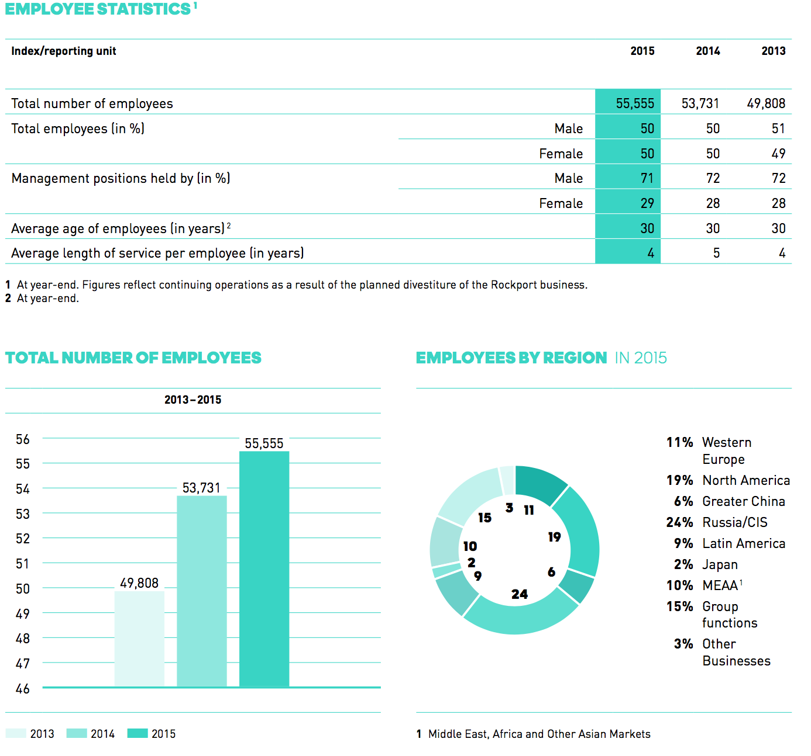
Our overall objective to empower people also includes the employees of the adidas Group around the world. We believe that only when our employees have the best training, bene- ts and environment can they work at their best. For this reason, we strive to create a culture that cherishes and celebrates collaboration, creativity and confidence – three behaviours we deem crucial to the successful
delivery of our ‘Creating the New’ business strategy and the well-being of our employees.
As one element of the strategy, we strive to provide meaningful reasons to join the adidas Group. At the same time, we want to create an environment that enables employees to develop their individual path towards their career goals and makes them want to stay with us. There are already several programmes in place all across the Group that aim to deliver a unique working environment and work towards our aim to be the ‘employer of choice’.
functional skills and behaviours, learn about a new culture, broaden their experience and develop new networks. In addition, they will receive coaching and mentoring opportunities that will not only give them a detailed plan on how to realise their career and life aspirtions, but also prepare them to take on a senior leadership role in the future and serve as a role model for the next generation of talent. While the Talent Carousel allows employees to take owner- ship of their careers and play an integral active part in creating the new, it also provides an invaluable platform for HR to test innovative programmes before they are introduced on a larger scale.
The Talent Carousel, like all other programmes as part of the People Strategy, was developed based on extensive research, which included the exploration of the personal meaning of work, global megatrends and their impact on people, organisations, and innovation as well as the digital and physical workplace of the future. It also played an essential part in creating the new business environment at the adidas Group to empower our people and help them to achieve their personal best.

One of the most recent additions is the Talent Carousel. While complementary to other formal learning programms, the programms sets itself apart by providing a new career boost to internal talent: First, it was open to all employees across the Group, regardless of their location and function, and second, all elements were tailored to create an extremely personalised candidate experience. As a result, 20 participants from across the company were placed in a new role in a different location. The goal was to enable them to gain new.

  - Supply/consume
When it comes to partnerships, we rely on open and trans- parent communication between all parties to create positive change along our supply chain. A challenge that is harder when certain products are made under license, which means that a licensee has the direct relationship with a supplier and not us. While we regularly audit our licensee factories to ensure compliance with our Work- place Standards, we went one step further in 2015 and started evaluating the responsible sourcing practices of our licensees as their own practices can also contribute to persistent code violations influencing workplace conditions and workers’ wellbeing in the factories. This has made us one of the first companies to implement the responsible sourcing concept.
Our key priority to ensure that even those suppliers we do not have a direct relationship with comply with our Workplace Standards is an ongoing effort. In 2009, we already used our engagement with the licensees to develop a Strategic Compliance Plan (SCP) and Report Card Process, which help the licensees to integrate compliance into their daily performance and us to evaluate it accordingly. To measure our progress we have set a clear target for 2015. It states that report cards for all eligible business entities (BE) managing our indirect suppliers have to achieve an average performance rating of 70% or higher. Our efforts were rewarded as this target was exceeded with an average performance rating of 72% as of the end of 2015. This showed that BEs managed to embed compliance into their daily practice more effectively. At the same time, three of our BEs achieved an overall score of more than 80%, demonstrating that they made strong progress in managing their supply chain responsibly.
Based on our belief that a licensee’s sound internal sourcing policy and procedures are essential for a suppliers’ workplace conditions and workers’ well- being, the process saw further improvement in 2015 when we integrated a concept called ‘Responsible Sourcing’ into our lice sees’ SCP. Inaccurate planning and forecasting, inadequate costing approaches or orders above the factories’ capacity are just some

examples of licensees’ sourcing practices that can force suppliers to unintentionally follow practices that do not comply with our Workplace Standards. The new approach asks licensees to acknowledge and mitigate the negative impacts of their sourcing practices on supplier’s and their workers, to review their practices and develop their own policy.
In more detail, the ‘Responsible Sourcing’ concept out- lines that licensees seek long-term and mutually beneficial relationships with their suppliers that are based on a constructive and two-way dialogue, train their staff efficiently on their policy, make sure that departments and individuals are held accountable, engage in an effective internal and external dialogue and recognise those suppliers with high performance. Overall, licensees and sup- pliers have to work together to ensure that a licensee’s sourcing decision and actions do not harm the workers making our products or impact the supplier’s ability to ad- here to our Workplace Standards.
In order to familiarise our licensees with the new approach, we provided special training to some of them in 2015. We supported them in developing and improving their internal responsible sourcing policy and related procedures, training their relevant staff and providing effective communication channels between their sourcing and planning departments and their compliance team. We will expand these training sessions to the majority of our licensees in 2016.
We believe that with this integrated approach on Responsible Sourcing, licensees will start evaluating their internal policy and practices to avoid causing any negative impacts with their own practices and improve the working conditions and workers’ wellbeing together with their suppliers.

  - Community
In 2015, we saw an increase in donation requests compared to the previous two years. Donation or funding requests significantly varied in nature and purpose. Incoming requests were carefully reviewed against the adidas Group Corporate Giving Guidelines to ensure alignment with corporate policies, guidelines and budget framework.
Compared to 2014, the number of supported projects decreased, which re ects our more stringent approach in conducting needs assessments. This helped us to focus on supporting fewer but more impactful organisations.
The amount of product donations decreased, which arises from fewer product placements in North America due to strategic changes in this market. In the EMEA region, we targeted major volumes of product donations to support people in severe need such as refugees at the Turkish-Syrian border as well as in Germany in 2015. To effectively respond to the refugee crisis in Europe, the adidas Group expanded its nancial support in order to ensure an even more purposeful support. Compared to previous years, we saw an increase of volunteer hours of our global workforce, which is the result of rising employee involvement, in particular in the context of refugee support.
With our data tracking system we aim to fully cover activities from all subsidiaries worldwide. We are constantly reviewing our approach and the system to improve data quality.
Community engagement and support for those in need (relief efforts) are key components of our corporate culture. For many years now, the adidas Group has been working closely with a number of different organisations on both local and global level and has been actively supporting communities for many years now. All programmes are built on three complementary pillars – community involvement, employee engagement and corporate giving – determined by local cultural, economic and social factors.
Programmes on Group level are supplementary programmes led by our Social and Environment Affairs team. They include activities at Group headquarters, relief operations and projects in suppliers’ countries. At brand level, our programmes are aligned to the brands’ missions.
Our community engagement is embedded within the adidas Group sustainability strategy ”Sport needs a space" in which we have set ourselves three strategic People priorities: We empower people, we improve health and we inspire action. These strategic priorities are supported by our corporate giving guideline and various programmes for community and employee involvement, such as our adidas Fund volunteering programmes.
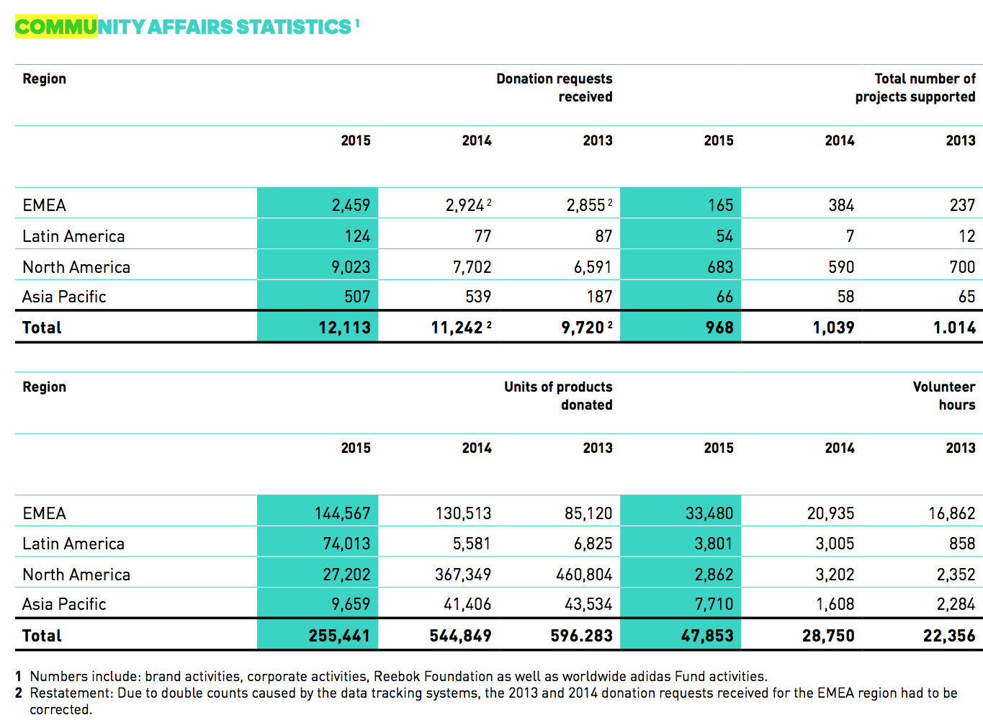
  - Environment
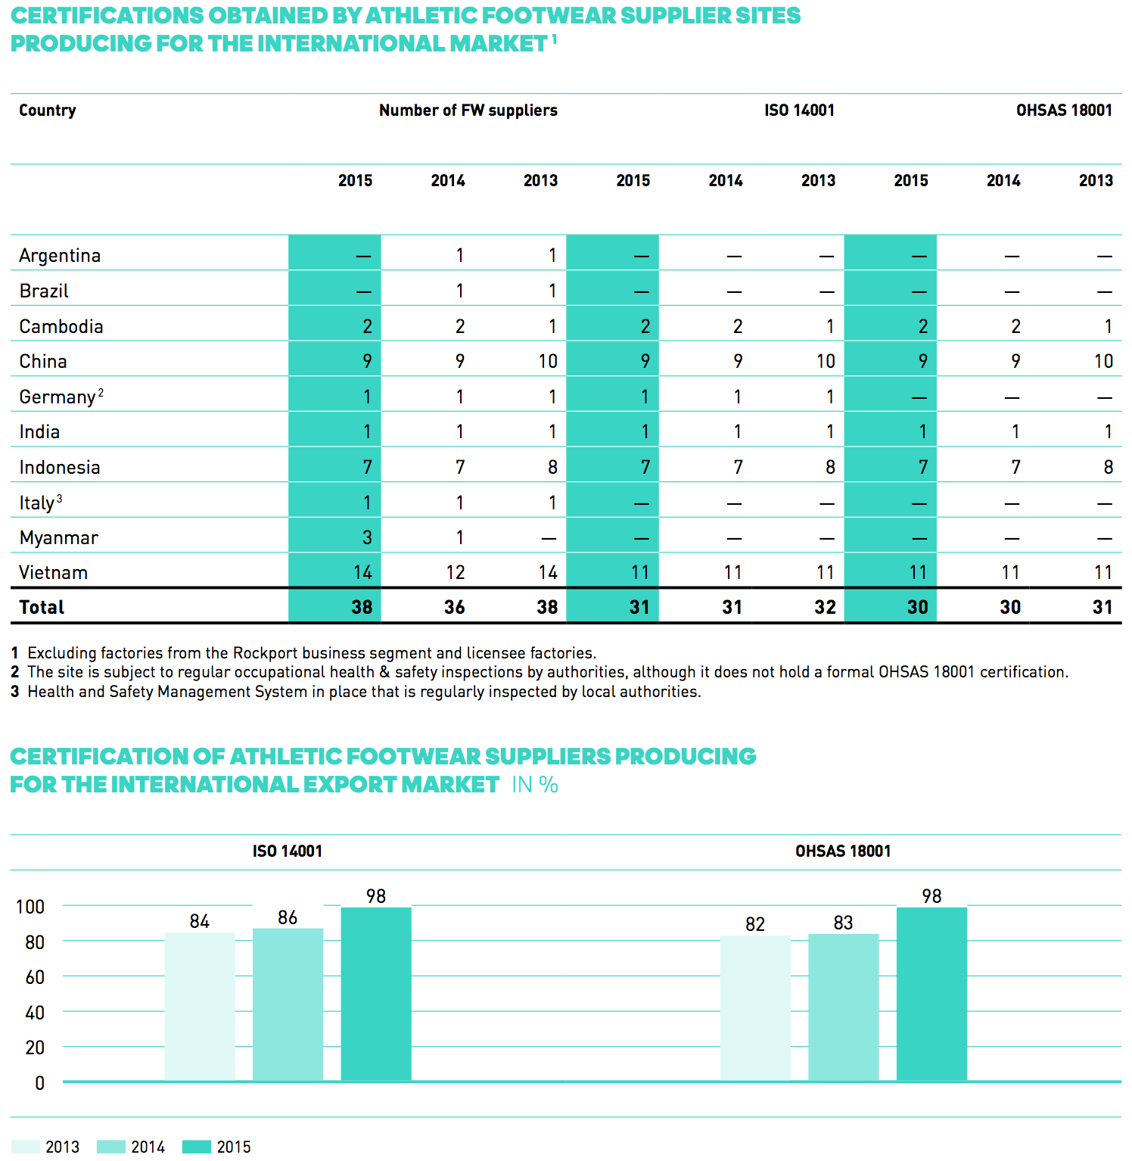

Since its launch in 2008, the Green Company programme and its ambitious 2015 targets have driven continuous improvement in the environmental impacts of our own site operations. As of the end of 2015, we have well achieved our targets for water savings per employee, household waste reduction and reducing carbon emissions, but had challenges to meet the targets for paper reduction and energy consumption per square metre. The data reported covers 48 of our corporate sites, including administration offices, own production sites and distribution centres.
With water savings of 28% per employee we have well exceeded our targeted savings of 20%. Our overall household waste volume per employee was reduced by 27%, exceeding the 2015 target of a 25% reduction. Furthermore, we achieved our 2015 target of reducing carbon emissions by 30% per square metre. These savings have been mainly achieved through energy efficiency projects and several carbon offsetting programmes. Some of our sites are still facing common challenges in accessing greener energy and scaling up their use of renewable energy. However, reducing carbon emissions will remain a focus of the Green Company initiative.
Our investment in more than 40 energy efficiency projects over the last years, supported through our greenENERGY Fund, has strongly contributed to energy savings at our corporate sites leading to a reduction of our energy consumption of 15% per square metre. But we have faced challenges to meet our ambitious target of 20% savings in 2015. Especially the increased eCommerce business and growing number of employees have in uenced energy savings per square metre at our distribution centres and administration offices. The same is true for paper reduction. Whereas our administration offices exceeded the 2015 target to cut our paper consumption by 50% per employee, the increased amount of products handled at our distribution centres continues to be a challenge to reducing our overall paper consumption. In total, a reduction of 38% of paper per employee was achieved by the group of reporting sites including administration offices, own production sites and distribution centres.
During 2015, we developed and launched the second phase of our Green Company strategy, including targets to be achieved by 2020. Read more about the results in our 2015 Green Company Performance Analysis on our website.
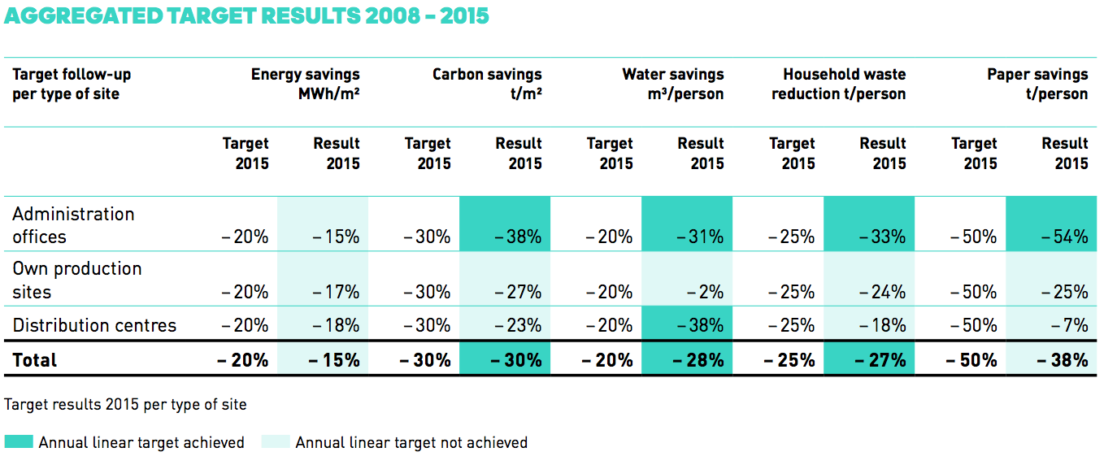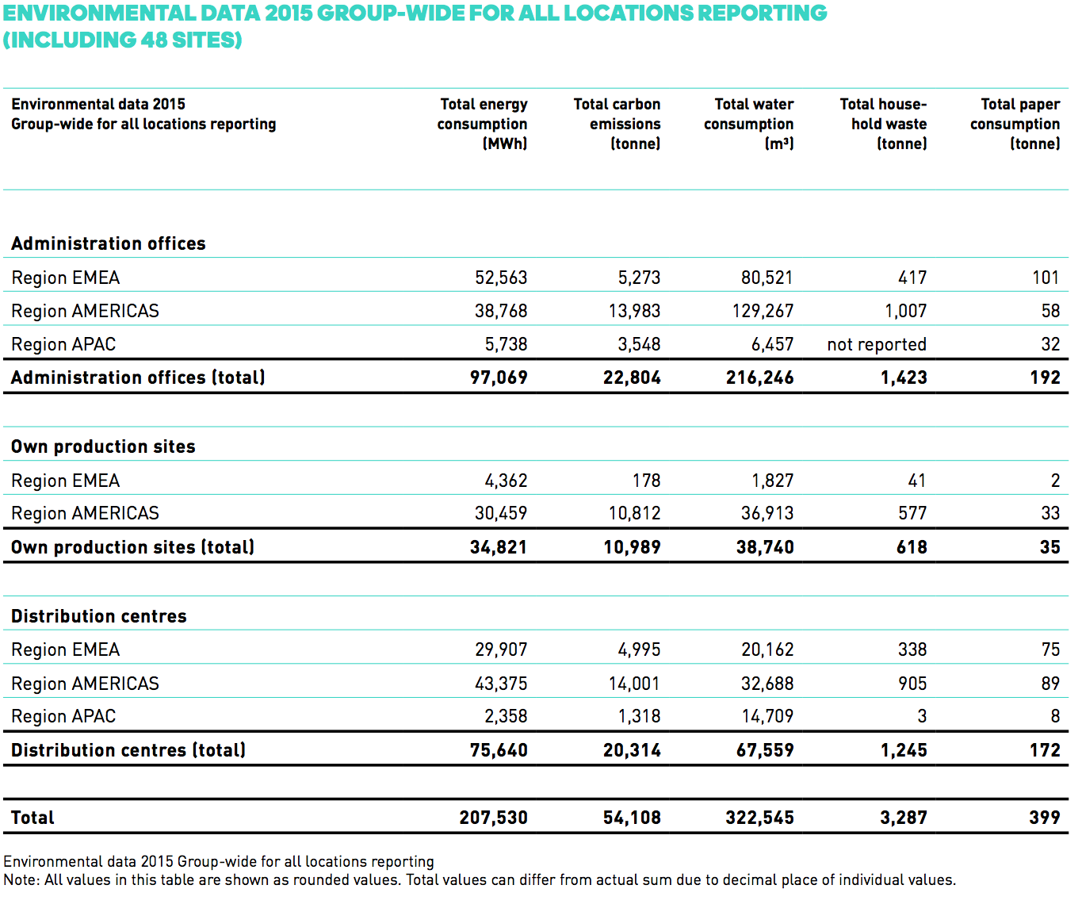

  - Education
Overall, the number of training sessions conducted in 2015 declined slightly compared to the previous year, although almost 2,000 people still attended training sessions. The training offered in each region covered basic, as well as long-term, strategic topics.
There were two reasons for the drop in the total number of training sessions: firstly, group training sessions especially related to sustainability training topics partly replaced individual ones (i.e. for more than one supplier). This offered both higher efficiencies and opportunities for cross-learning and best practice sharing among suppliers. Secondly, fewer fundamental training sessions were held since there were fewer factories to onboard.

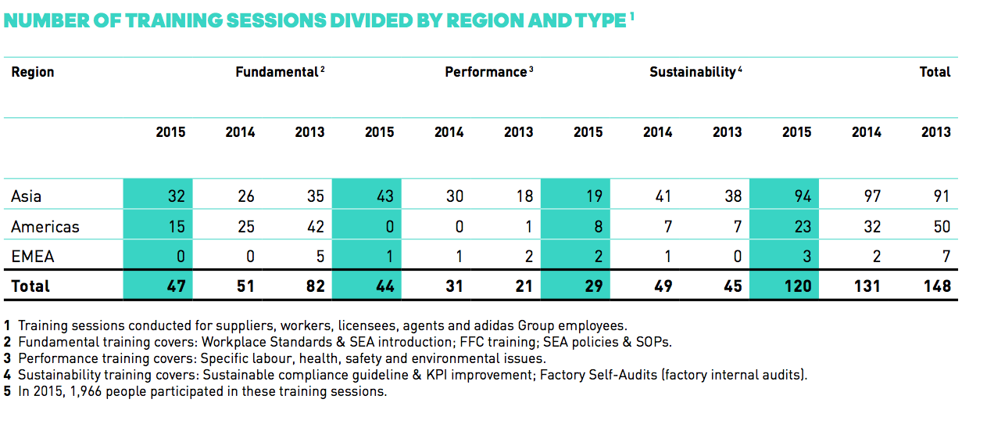

  - Healthcare
Sport is the key to an individual’s health and happi- ness. Our aim is to enable people around the world to participate in sports, while educating them on physical and mental health, fitness and nutrition. This will ulti- mately allow them to lead a healthier and more fulfilled lifestyle.
Sport is beneficial to individual development, health pro- motion and disease prevention. WHY IT MATTERS TO THE ADIDAS GROUP: Sport is our foundation, our heart, our DNA. By enabling our employees to live an active and healthy lifestyle, we have a positive impact on their lives and our business success. We inspire people to be active by supporting grass- roots programmes directed by the adidas Fund or BOKS that highlight the positive impacts on health as well as physical and mental fitness sport can have. This association with a healthy lifestyle will ultimately support our good reputation among our consumers and create demand for our products.
We have created a Health Management Team, organise Health Weeks globally, and offer a wide range of company sport programmes at major sites.
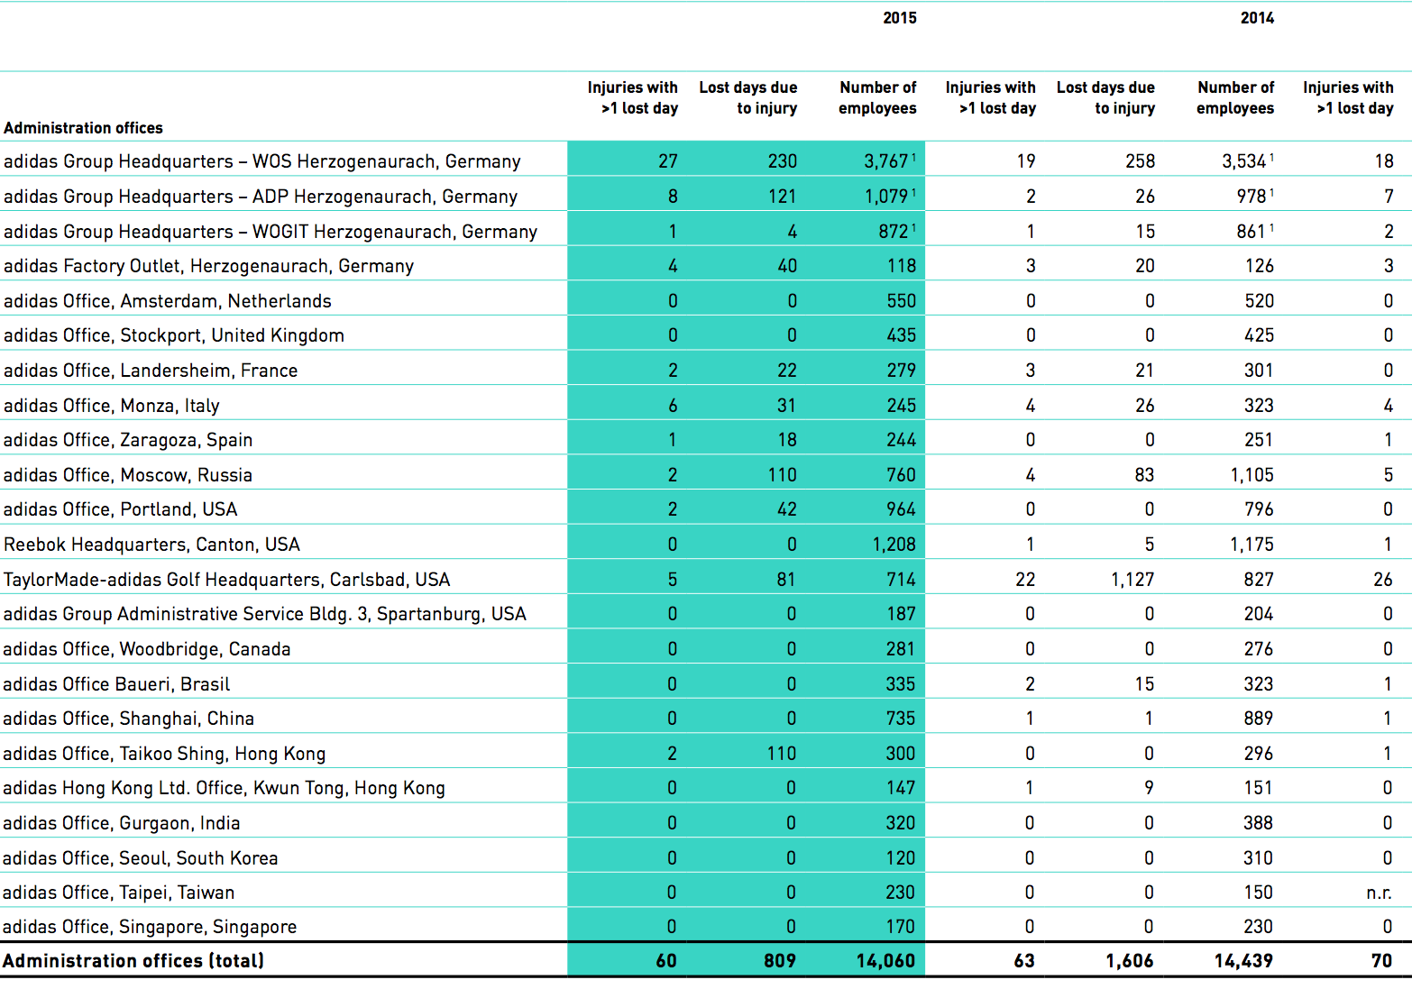

  - Special projects

With water savings of 28% per employee we have well exceeded our targeted savings of 20%. Our overall household waste volume per employee was reduced by 27%, exceeding the 2015 target of a 25% reduction. Furthermore, we achieved our 2015 target of reducing carbon emissions by 30% per square metre. These savings have been mainly achieved through energy efficiency projects and several carbon offsetting programmes. Some of our sites are still facing common challenges in accessing greener energy and scaling up their use of renewable energy. However, reducing carbon emissions will remain a focus of the Green Company initiative.
Our investment in more than 40 energy efficiency projects over the last years, supported through our greenENERGY Fund, has strongly contributed to energy savings at our corporate sites leading to a reduction of our energy consumption of 15% per square metre. But we have faced challenges to meet our ambitious target of 20% savings in 2015. Especially the increased eCommerce business and growing number of employees have influenced energy savings per square metre at our distribution centres and administration offices. The same is true for paper reduction. Whereas our administration of ces exceeded the 2015 target to cut our paper consumption by 50% per employee, the increased amount of products handled at our distribution centres continues to be a challenge to reducing our overall paper consumption. In total, a reduction of 38% of paper per employee was achieved by the group of reporting sites including administration offices, own production sites and distribution centres.

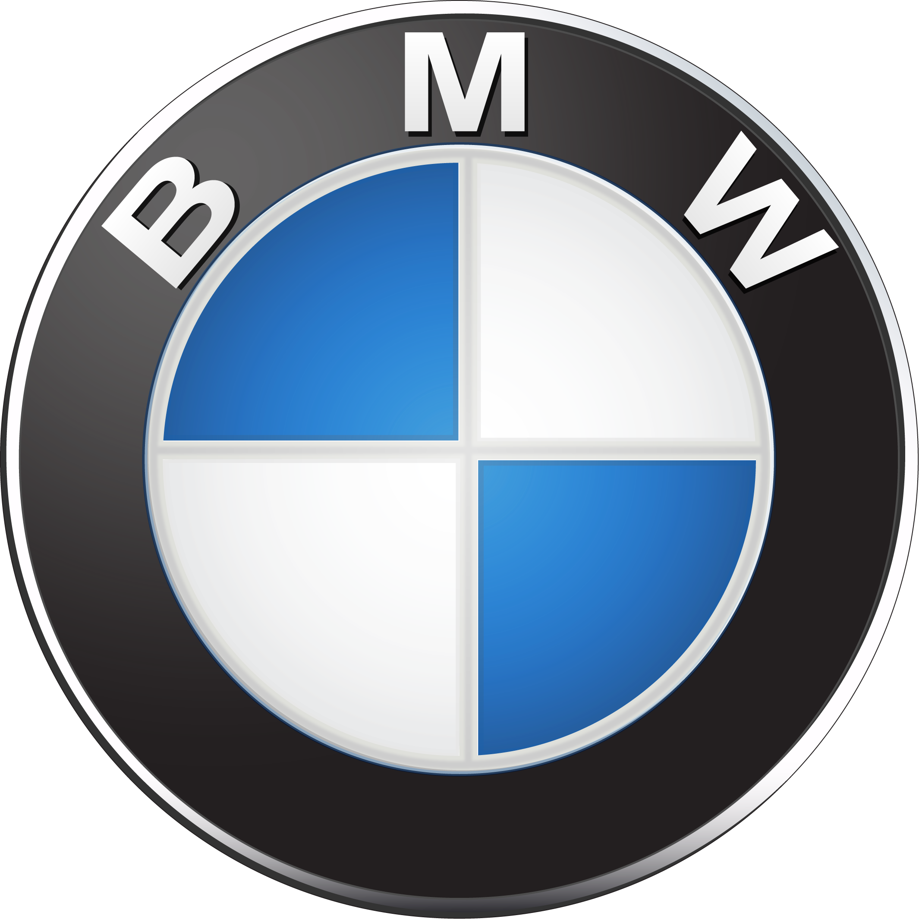

4.1 Employees

The success of the BMW Group is based on the performance of its employees. Their dedication makes the crucial difference in remaining competitive. The increasing average age of the world population as well as the diversity of lifestyles and cultures call for foresight and flexibility. As a company that is currently active in over 150 countries, these developments affect us worldwide. With secure and attractive jobs and our commitment to promoting intercultural communication, we make a contribution to safeguarding our future viability.

Key facts
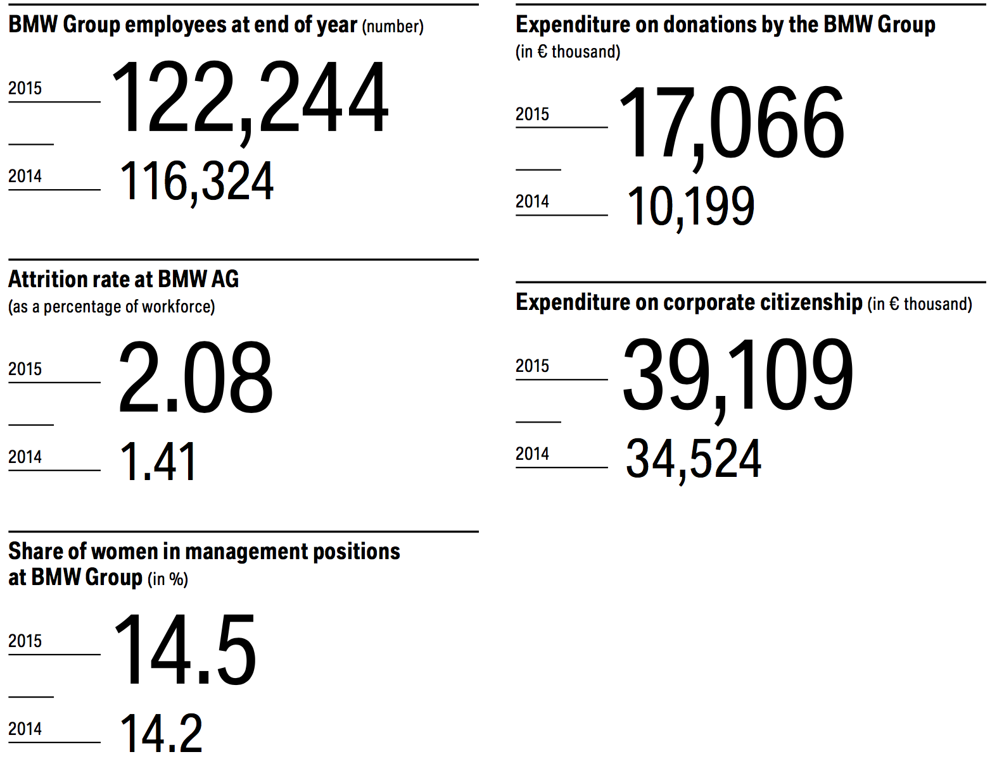

The BMW Group attaches great importance to the training and further education of our employees. This is essential for keeping pace with the technological advances in the automotive industry. We therefore continuously invest in the qualification of our employees as a way of promoting the long­term innovative strength of the BMW Group. The BMW Group consistently pursues the concept of life­long learning. We also pay above­average compensation and give our employees a range of options to help them end the right worklife balance.
As one of the world’s most attractive employers, the
BMW Group has a decisive advantage in the competition for skilled workers. This is demonstrated, for example, by studies on the attractiveness of employers conducted by Trendence and Universum, in which we were once again given top ratings in 2015.
Thanks to the high demand for our products and services, the number of employees working for the BMW Group increased worldwide by 5.1 % to a total of 122,244 by the end of 2015 > Table 4.03. Job security is our highest priority here.

OFFERING FAIR PAY AND ATTRACTIVE SOCIAL BENEFITS
The BMW Group policies for remuneration and additional bene fits apply for all of our companies, and we follow the guiding principle that the total remuneration package must be above the average for the respective labour market. Our remuneration policy is furthermore based on the principle of quid pro quo: we see pay as a reward for good performance and not simply as an incentive. The total remuneration package, made up of the monthly fixed salary, a variable share in the company’s profits and a wide range of social benefits, enables us to reward personal performance in a fair manner while continuously promoting employee motivation. Our remuneration policy is thus an integral part of a consistent and trans­ parent process of employee development.
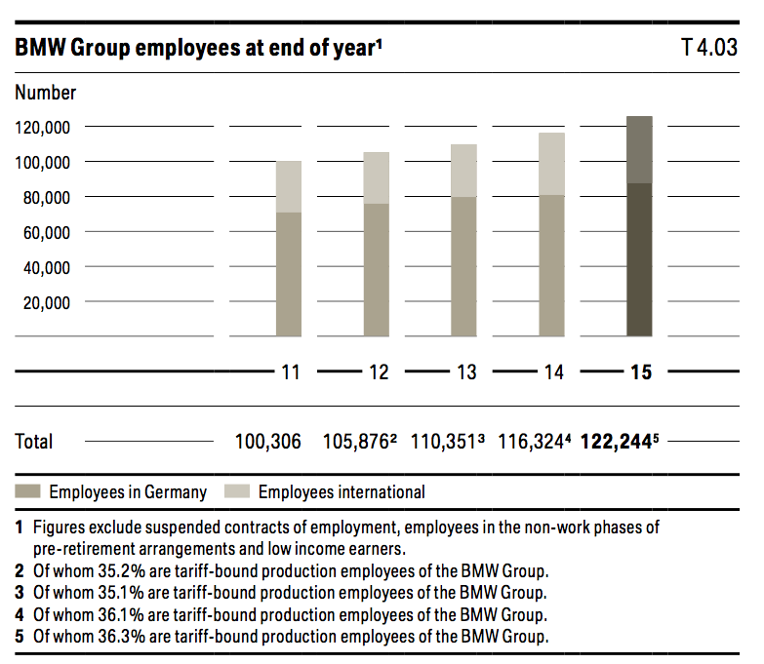
Guaranteeing a gender-neutral remuneration system
The BMW Group policies for remuneration and additional bene ts apply regardless of gender, religion, origin, age, disability, sexual orientation or country specific characteristics. Our commitment to equal pay is pursued worldwide and monitored regularly.
In 2014, the BMW Group established a multidimensional monitoring process to annually verify that remuneration is gender­neutral. Men’s and women’s monthly salaries are compared based on the dimensions of full­ or part­time, pay grade and age. There were no significant differences between the base salaries of women and men for either non­tari employees or for tarif employees paid based on working time (administration, IT and development) or performance (production).
ENCOURAGING WORK-LIFE BALANCE
To enable the best possible work­life balance, the BMW Group offers its employees a wide range of flexible modules so they can tailor their working hours and locations to their personal needs. More and more private services (for example, laundry services) are also being o ered close to the workplace to free up more time for people to spend either on work or private pastimes.
Offering exible working hours
In addition to statutory working time arrangements such as part­time work or parental or caregiver leave, the BMW Group also offers employees options such as sabbaticals (worldwide) or the “Vollzeit Select” (Fulltime Select) scheme to provide further attractive ways to individually plan working hours. Our “Vollzeit Select” working time tool allows employees in Germany and Austria to take 20 additional days of leave each year with corresponding adjustments to their salaries, without any complicated red tape. Demand for these options continued to grow in 2015, conforming that the offer of flexible working time arrangements meets a real need.
Enabling mobile working
In 2014, the rst year after the introduction of mobile working, the number of tari employees working all day on a mobile basis already more than quadrupled, with some 25,072 users > Table 4.04. Mobile working does not change the volume of work but allows for a more flexible organisation of existing working hours to gain more personal freedom and flexibility. Childcare and caring for dependents, for example, can then be better integrated into the everyday work routine. Outside of agreed working hours, employees also have the right to switch o and be unavailable.
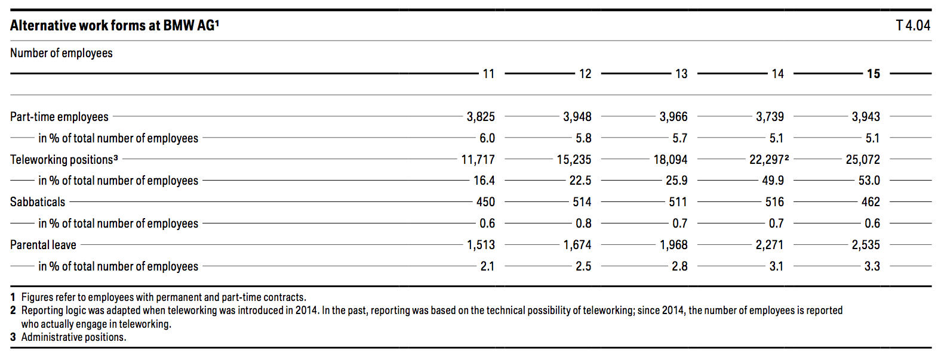

Supporting parents through childcare
We have established childcare services at many of our German and international locations. With the support of parents’ initiatives, we were able to accommodate over 300 children aged zero to six years at our German sites as of the end of 2015.

4.2 Supply/Consume

As part of the global growth of the BMW Group, we are shifting our value creation more strongly towards the respective sales markets. Increasing internationalisation of procurement leads to great opportunities but also to new sustainability risks. In view of our large number of suppliers and sub­suppliers, maintaining sustainability standards is a huge challenge. Only if we work closely with our business partners can we increase transparency and resource efficiency in the supply chain and ensure that sustainability standards are complied with.
Because much of the value­added is created by our suppliers, it is not enough for us to comply with sustainability standards only for our own production. This is why we insist that our suppliers also implement social, environmental and governance standards. In addition, we train our own employees
as well as those of our business partners to implement sustainability criteria along the value chain.
We have set ourselves the goal of significantly increasing transparency and resource efficiency in the supply chain by 2020. To do this, we have a comprehensive risk management system in place to ensure that our sustainability standards are complied with, in particular at the production facilities of our direct suppliers. We work with our suppliers to develop increasingly efficient ways of using resources, provide direct support for innovations in the area of sustainable technologies and processes, increase transparency and improve the working conditions at our suppliers’ companies. For selected raw materials we also analyse what action needs to be taken to implement sustainability criteria along the supply chain and carry out the required measures in collaboration with our suppliers. This helps us to reduce risk, raise awareness for sustainability and protect resources.
We were able to make significant progress in 2015:
– Around 1,900 supplier locations were assessed for the rst time based on an industry­specific sustainability questionnaire. Assessments are carried out at all nominated supplier locations as well as at potential and already active facilities.
– Supplier locations that do not comply with the
BMW Group’s minimum requirements (e.g. in accordance with > UN Global Compact criteria) must agree to install a corrective action plan. In 2015, our system logged corrective action plans with target deadlines for around 400 supplier locations.
– Suppliers who took part in the Supply Chain Programme of the CDP in 2015 reported an overall reduction of 35 million tonnes in CO2 emissions (2014: 21 million t).
Principles and standards for suppliers
For the BMW Group, it is essential that our business partners meet the same environmental and social standards we have set ourselves. The BMW Group Supplier Sustainability Standards are the foundation on which this process is based. The standards establish basic principles that are to be adhered to by all BMW Group suppliers. This includes compliance with all internationally recognised human rights as well as environmental, labour and social standards. The BMW Group Sustainability Standard is an integral part of the request for proposal documentation for new suppliers and is thus a key tool in the integration of sustainability aspects into the procurement process.
Each potential new supplier must take into consideration the BMW Group sustainability requirements when submitting a proposal. All agreements concluded by BMW AG with
its suppliers contain clauses based on the principles of the
commitment must be made to comply with human rights, labour and social standards as well as to implement environ­ mental management systems > BMW Group website on supplier network. When they sign the contract, our suppliers also commit to ensuring that their suppliers in turn comply with these agreements.
Adapting purchasing to local value creation
Increasing globalisation, networking of supplier markets and expansion of the BMW Group’s sales and production activities overseas leads to constant change in the distribution of purchasing volumes. The focus of growth in the coming years in this area will be in the NAFTA region (USA, Canada and Mexico). In 2015 the share of local value creation was 15.9 % (2014: around 14.5 %). This is due to the increase in production volume at the Spartanburg plant in the USA. It is also the result of the construction of the BMW Group plant in San Luis Potosí in Mexico, which is scheduled to open in 2019. This is in line with the company’s strategy of balanced global growth in sales, production and purchasing volumes.
> Table 3.10 gives an overview of the origin of our production material.
Training employees and suppliers
Our sustainability training programmes are designed both for our purchasers and our suppliers. We raise their aware­ ness of the topic and they learn about cause and effect. We also clearly communicate our expectations to them. In this way, we enable participants to make decisions that contribute towards greater sustainability in the supply chain.
We aim to train as many of our purchasers as possible. In 2015, around 247 new purchasers (2014: 581) took part in this training. We also provided training for 20 of our suppliers (2014: 38) and carried out crossindustry training courses
for BMW suppliers with identifiable sustainability deficits in India (15 suppliers) and South Africa (46 suppliers).
Regional mix of BMW Group purchase volumes in 2015
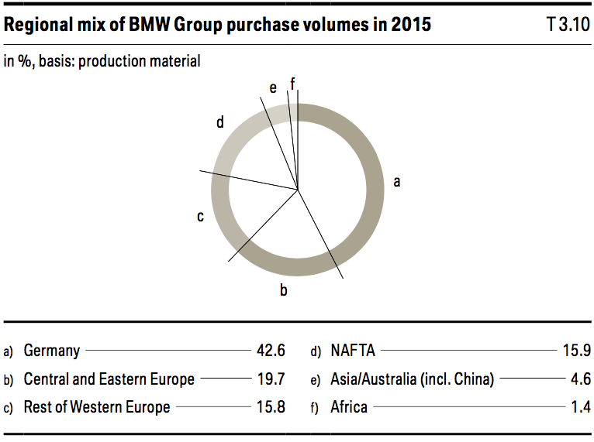
Another important enabling measure in 2015 was our sustain­ ability day for suppliers and all employees of the BMW Group at the Munich/DE location, where 19 of our most innovative suppliers presented their sustainability strategies and measures.
1. Identify risks
In order to identify risks, we use a BMW Group speciffic sustainability risk filter. This filter takes account of both regional and product specific risks. This includes, for instance, an assessment of social risks in certain countries, such as child labour or forced labour. However, we also consider environ­ mental risks such as damage to nature, emissions and process materials containing substances that can be hazardous to health.
2. Retrieve self-assessment questionnaire
In many areas, it is more efficient to take a cross­industry approach. In autumn 2014, we replaced the BMW Group self­ assessment questionnaire with a sustainability questionnaire for the automotive industry. Each nominated supplier must provide information about their implementation of environ­ mental, social and governance standards, for example with regard to compliance with human rights and bans on forced labour at their production locations. Sustainable use of materials such as secondary aluminium is also verified at the request for proposal stage. The existence of an environmental
management system in accordance with ISO 14001 is also logged by the new questionnaire and is the basic prerequisite for our suppliers of production material and capital equipment. After the proposal has been submitted, these details are included as key decision­making indicators in the procurement process. In 2015, a total of around 1,900 nominated, active and potential suppliers were assessed via this questionnaire. By establishing sustainability requirements in the tendering process, we not only increase transparency along the supply chain but also raise the awareness of this topic on the part of our suppliers’ top managers. As a result, a number of our suppliers have taken decisive measures to better establish sustainability within their companies.
from the perspective of the > UN Global Compact were related to implementation of the following aspects: Sustainability policy for suppliers and their sub­suppliers, Human Rights policy, social and compliance management systems, as well as instructions on how to work with chemicals.
For suppliers with sustainability de cits, we supplement the supply contracts with corrective action plans and binding rules. We can thus ensure that all sustainability requirements will be met by start of production or provision of services.
In the case of sub­suppliers, we only have indirect in fliuence on the implementation of sustainability standards. However, we oblige our direct suppliers to ensure that our sustain­ ability requirements are also met by their sub­suppliers. In addition, we develop specific measures for individual supply chains such as participation in the > Aluminium Stewardship Initiative (ASI) , a cross­industry initiative for sustainable manufacture of aluminium. The ASI aims to establish a standard for responsibly produced aluminium along the entire value chain. The initiative was able to make significant progress
in recent years. This includes the formulation of principles, criteria and indicators in a multi­stakeholder process. In addition, a traceability model for the value chain was developed. The next step is to establish the ASI as an independent organisation and carry out a pilot application of the standard.
3. Carry out assessments and audits
If the sustainability risklter identffes supplier locations that demonstrate an increased risk of non­compliance with sustainability standards, they are checked, trained and, if applicable, certified by independent sustainability audits or BMW Group sustainability assessments. The sustainability audits are carried out by external auditors, while the sustainability assessments are implemented by employees of the BMW Group.
If the results of an audit show non­compliance or potential for improvement, we work with the supplier to develop a speci c plan of action and provide as much assistance as possible with implementation, which generally must take place before start of production. If the supplier is uncooperative or in breach of
a fundamental BMW Group sustainability clause, the contract may not be granted or termination of business relations may follow. Our goal, however, is to determine the majority of risks during the first two steps, to manage these risks and to help suppliers raise their sustainability standards.
Our Supply Chain Response Team responds to individual non­compliance with our sustainability principles. The team is made up of one representative each from Operational and Strategic Purchasing, Corporate Strategy (a sustainability expert), Corporate Communications and the Works Council. In 2015, the Supply Chain Response Team had no cases to address as there were no reports of potential non­compliance with our sustainability principles.
Our sustainability risk management system increases transparency with regard to social and environmental risks in the supply chain, raises awareness among our suppliers’ top management and helps us to introduce and track the corresponding corrective measures. A further measure to increase transparency in the supply chain and to improve resource effisciency is the Supply Chain Programme of the > CDP .
Since 2014, we have been participating in the Supply Chain Programme of the CDP and have set ourselves the ambitious goal of having a large part of our direct purchasing volume covered by the CDP reporting of our suppliers by 2016. In 2015, we were already able to cover around half of our purchase volume. Within the CDP, participating suppliers report on their CO2 status and, if applicable, the water consumption status of the previous year. A large number of qualitative and
quantitative questions are answered, ranging from integration into corporate strategy, to risk management, targets and initiatives, right up to CO2 emissions and volumes of renew­ able energy used. An overall evaluation veries the complete­ ness and content of the answers. The results are fed into the purchasing strategies of the relevant departments and a competitive comparison is played back to the key suppliers during their annual supplier development interviews. Based on this, we make agreements with our suppliers on development paths for improvement.
Of the 99 BMW suppliers participating in the CDP in 2015, 84 % integrated measures to combat climate change into their corporate strategy and 64 % also set themselves corresponding targets. 80 % of participating suppliers already reported reduced emissions for individual projects and 35 % were even able to keep their overall CO2 emissions constant or reduce them. Savings of 35 million tonnes of CO2 equivalent were reported to us from our supplier network for the year 2015 (2014: 21 million t). These savings mainly resulted from an increase in energy efficiency in production processes and from optimisation of transport processes.
The rising number of suppliers in the CDP as well as the increase in average disclosure within the CDP would seem to indicate that our e orts to increase transparency in the supply chain are effective. In addition, the rise in CO2 savings communicated to us indicates that resource effciency in the supply chain is increasing.

With today’s multilayered and dynamic global supply chains, tracing the route of a raw material from the mine to the end product is an extremely complex undertaking. This is mainly due to the intermediate trade and processing stages and commodities trading on the stock exchange. It is therefore quite a challenge to implement sustainability standards as early as the raw materials extraction stage.
In view of this, the BMW Group focuses on selected relevant or critical raw materials and supply chains. We analyse and evaluate both the supply chains as well as the action required and then derive measures that we implement in conjunction with our suppliers. We also participate in cross­industry initiatives for sustainable use of raw materials.

4.3 Community

Corporate citizenship should have a measurable effect. For this reason measurability is high on our list of priorities. Since 2010, we have been measuring the effects of our corporate citizenship activities using the iooi (Input Output Outcome Impact) method. This approach provides us with important feedback on whether projects are continuing to develop and whether they are having a long-term impact.
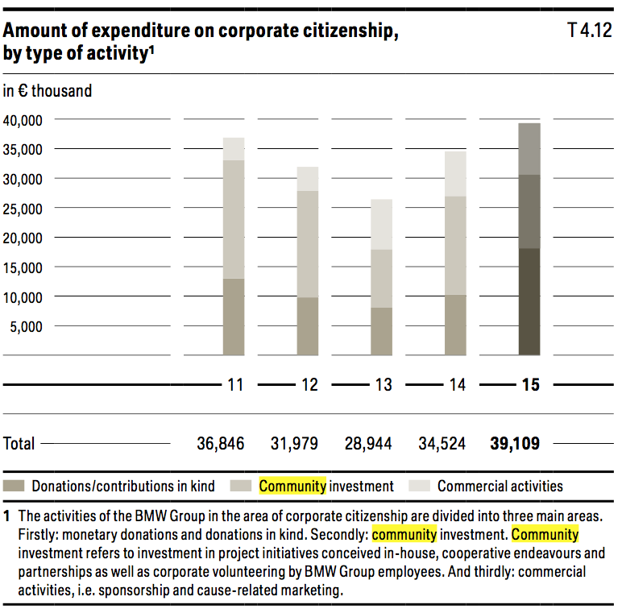
Modern society is characterised by a variety of different life­ styles. The diversity of the population as a whole has increased as a result of demographic change, changing values in society and increasing global mobility. As an international company, the BMW Group regards an intercultural workforce, an appropriate gender balance and a good age mix as beneficial to our business. We are convinced that a diverse workforce enhances our innovative strength and further increases our competitiveness, for example by helping us to better understand customers’ needs. The right mix lets us see the bigger picture so we can make smarter decisions.
Each and every one of our employees, in all their diversity, is accorded equal levels of appreciation, respect and opportunity. To further promote diversity among our workforce, the Board of Management passed a Diversity Concept in 2010, defining three dimensions where diversity is to be strengthened throughout the BMW Group, taking due consideration of local conditions: gender, cultural background, age and experience.
Ensuring equal opportunities
The BMW Group’s declared goal is to promote human diversity in the company worldwide, because employees’ unique and di erent talents and personalities are a valuable resource. At all of our locations, we seek to prevent discrimination on the grounds of gender, age, sexual orientation, religion, disability or origin. The BMW Group Legal Compliance Code prohibits discrimination of any sort. Employees can address any queries in this connection to their own managers, the relevant o ces of the BMW Group, the HR department or the works council. The BMW Group SpeakUP Line furthermore gives all em­ ployees worldwide a way to anonymously and con dentially report possible breaches of this principle.

4-4 Environment
We apply an environmental management system in order to continuously reduce the energy required to produce our vehicles, CO2 emissions and raw materials. As a result we reduce our environmental impact, make a contribution towards climate protection and save on scarce resources. At the same time we reduce our production costs.
Since 2006, we have reduced our use of energy and water, waste and waste water as well as solvents and CO2 emissions from vehicle production per vehicle produced by an average of 48.1 %
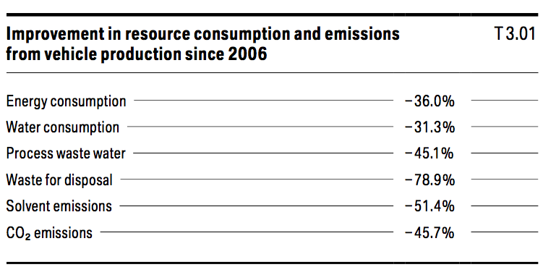

In 2015, utilisation of resources and emissions per vehicle produced were reduced by an average of 7.0 % compared with the previous year, yielding savings of € 8.2 million.
Environmental protection is part of our sustainability management system. When we signed the > International Declaration on Cleaner Production of the United Nations Environment Programme in 2001, we expressly committed to keeping the environmental impact and resource consumption of our production activities as low as possible.
The BMW Group has thus established environmental manage­ ment systems at all of its existing production plants and plans to install them at all future facilities. With the exception of the motorcycle production in Manaus/BR, which is certified
in accordance with a national standard, all of our production locations, German dealerships, as well as six others in Europe (Vienna/AT, Zurich/CH, Rome/IT, Milan/IT, Madrid/ES and Barcelona/ES) are now certified in accordance with ISO 14001 > Further key indicators.
Environmental improvements that have been effective at one location are implemented at other locations wherever possible. Our six competence centres (for water, waste, energy, emissions, training and the environmental management system) are stayed by environmental experts from the different plants and by specialists from Corporate Environmental Protection. They discuss legal requirements and best­practice solutions with technology experts from the production plants and develop reference systems on which to base future planning and process improvements.
INTELLIGENT APPLICATION OF RAW MATERIALS THROUGHOUT THE LIFE CYCLE OF OUR VEHICLES
In the early stages of vehicle development, the decisions our designers and engineers make, including the materials and components they select, will determine the resource efficiency of our vehicles. We use Life Cycle Engineering to increasingly integrate environmental aspects into the design and development of our products
Using secondary and renewable raw materials
Secondary raw materials are finding more and more applications in our vehicles. Up to 20 % of the thermoplastic materials in our automobiles are already made from recyclates (2012: up to 15 %, 2013 and 2014: up to 20 %). These materials account for an average of 12 % of vehicle weight > Tabelle 3.14. The increasing proportion of recyclates used shows how successful our e orts to complete material cycles in our vehicles have been. Wherever it makes technical, business and environmental sense and is socially acceptable, we replace technical primary materials with natural, renewable materials. This enables us to make an important contribution towards resource efficiency.
Reducing use of rare earths
Rare earths are key raw materials of a number of components in modern vehicles. How we use rare earths can contribute towards reducing fuel consumption, for example by increasing the efficiency of electrical systems. They are among the critical raw materials when it comes to availability risks. When using them, we carefully balance weight, function and costs.
For example, we are working to further develop magnetic materials in order to reduce the use of rare earths without any negative functional impact. For other components, too, it has been possible to nd alternatives to rare earth elements which may become scarce.
End-of-life vehicle recovery and recycling
Established recovery systems for end­of­life vehicles, components and materials ensure that they are reintegrated into the raw materials cycle. So we do not consider end­of­life vehicles as waste to be disposed of, but rather as a secondary source of raw materials.
Together with its sales organisations in each country, the BMW Group has installed recovery systems for end­of­life vehicles in 30 countries and offers vehicle owners environ­ mentally friendly vehicle recycling at dedicated recovery centres.
In 2015, the legally required recycling rate for end­of­life vehicles, components and materials in the EU and South Korea was raised to 95 % overall recovery (85 % reuse and recycling of materials). We laid the groundwork for this early on:
all BMW Group vehicles brought to market since 2008 already meet the requirements set for 2015.
At our recycling and disassembly centre, we continuously test new recycling concepts for new vehicle components, for example for the innovative lightweight material carbon­brereinforced plastic (CFRP).

4.5 Education
We invest in training our employees and fostering their talents on an ongoing basis. This enables us to ill our long­term sta ng requirements in a dynamic, fast­changing environ­ ment. The BMW Group’s global package of measures ranges from vocational training to young talent programmes for student target groups to high­potential programmes for future managers. BMW Group expenditure on training and further education increased in 2015 to € 352 million. On average, our employees participated in 4.1 days of further training in 2015 Furthermore, every BMW Group employee receives a consistent and comprehensive individual performance and career development review at least once a year. GRI G4-LA11
In 2015, we had over 1,500 apprentices worldwide. There are currently over 4,700 young people taking part in vocational and young talent programmes in the BMW Group, over 3,800 of them in Germany
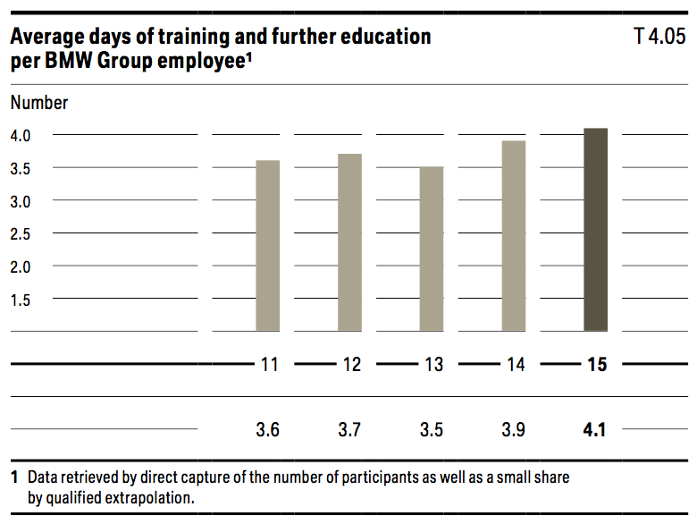
Establishing dual vocational training worldwide
We believe in the dual vocational training system because it optimally combines theoretical content with the acquisition of practical skills. For this reason, we are extending the dual concept, which has proven so successful in Germany and at our production sites in China, the USA, South Africa and the UK, to our other international locations. In 2015, we launched dual training programmes in Brazil, Thailand and Mexico. In Germany, we introduced a new recruiting process for trainees that is tailor­made for the BMW Group. In addition to the applicant’s academic credentials and technical skills,
it also takes into account interdisciplinary abilities and per­ sonality traits. This enables us to select those best suited for vocational training.
Training managers and employees
Our Group­wide “Corporate Leadership Programme” offers our managers a wide range of advanced training opportuni­ ties. The programme promotes the further development of strengths­based leadership skills at all hierarchy levels.
To foster international young talent, the BMW Group developed the “Global Leader Development Programme”. Integral components of the programme are various practical phases in Germany and abroad, targeted training measures, and diverse networking and exchange opportunities. Special emphasis is placed on developing intercultural competence

4.6 Helthcare
In an ageing society, we can only be successful in the long term if we contribute towards ensuring that our employees remain healthy. The merging of our Health Management, Occupational Safety and Ergonomics and Corporate Catering departments to form the “Working Environment and Health” unit led to more e cient collaboration between areas related to preventive occupational health and safety. The measures we take are geared towards avoiding accidents, maintaining the health and performance capacity of our employees, and reducing absenteeism as well as health-related costs. Our health promotion activities also pay o in other ways as they lead to more creativity, productivity and innovation.
The health and performance of our employees is a top priority at BMW. As the workforce ages, absenteeism tends to increase. We carry out prevention campaigns in specific areas, e.g. high blood pressure prevention and resilience measures. We implement the campaigns internationally, according to common goals and standards. Our prevention measures contributed, for example, towards keeping absenteeism low in 2015 in spite of the in uenza epidemic. Absenteeism due to illness was below average in Germany.
Some of our main activities in the areas of occupational health and safety include integrated health management, ageing­ appropriate work systems, a high level of work safety and a focus on offering healthy canteen meals. At the same time, we are raising employees’ awareness of healthy eating habits by labelling meals and carrying out campaigns – and we have achieved measurable success in this area. Compared to 2013, the number of employees choosing healthier meals has increased by 5,000. We also offer an extensive prevention and rehabilitation programme, which includes fitness courses and other sports activities as well as nutrition seminars, occupational health and safety and ergonomics courses as well as stress management. We hold special events that draw attention to important topics such as resilience, cancer prevention and addiction hazards. They are designed to motivate
employees and executives to become active in these areas. The measures and programmes listed form part of the BMW Group’s Health Initiative, which was launched in 2011 to serve as an umbrella entity for the company’s commitment to the health and performance of its employees. These measures contribute to the BMW Group keeping its HR costs competitive.
FOSTERING HEALTH AND PERFORMANCE IN A HOLISTIC MANNER
The “Health Management 2020” programme is a holistic, internationally focused approach to fostering the long­term health and performance of our employees throughout their working life. The programme includes building knowledge about health (information, talks, seminars, training courses), identifying health issues (questionnaires, medical check­ups), as well as deriving and developing needs­based measures (e.g. prevention).
Around 10,100 employees have participated and received personal health reports since the programs was launched in 2014. At departmental level, 170 reports were compiled in 2015, identifying a range of potential improvements and strengths in the area of health promotion within the departments. From this we derive specific measures for the working environment. The programme contributes to reinforcing individuals’ personal responsibility and designing a healthy working environment. The aim is to integrate 10 % of the BMW Group’s workforce annually into the “Health Management 2020” programme from 2016 onwards. The percentage of participants was 7.5 % in 2015.
INTEGRATED HEALTH AND SAFETY MANAGEMENT
Occupational health and safety committees are in place at almost all BMW Group locations, with representation from both the employer and employee sides.
At the BMW Group, occupational health and safety issues are dealt with in collaboration with the works councils. GRI G4-LA8 Well over 90 % of employees are represented on the health and safety committees. This gure also includes temporary workers, interns, thesis students working at the company as well as doctoral candidates.
At present, 25 of our 30 production locations have occupational health and safety management systems certified according to the OHRIS (Occupational Health and Risk Management System) or OHSAS (Occupational Health and Safety Assessment Series). The other facilities work with systems that meet national standards. The new production plant in Brazil as well as the UK location Hams Hall will be certified in 2016 according to OHSAS 18001.
Continuous improvement of occupational health and safety systems, workplace safety conditions and dedicated safety training courses contributed to a decrease in the accident frequency rate at the BMW Group in 2015 to 4.4 accidents per one million working hours > Table 4.01. At our German dealerships, the accident frequency rate decreased by over 20 % compared to the previous year, i.e. less than half the industry average (BGHM).
There have been no fatal accidents at the BMW Group for the last ten years. GRI G4-LA7 In 2011, we set ourselves the target of reducing the long­term accident frequency rate worldwide to below 4.5 accidents per one million hours worked by 2020. This is a decrease of around 50 % compared to the accident frequency rate in 2010. We were already able to beat this target for the first time in the current reporting period.
SUPPORTING AGEING-APPROPRIATE WORKING CONDITIONS AND PEOPLE WITH PERFORMANCE LIMITATIONS
The BMW Group sees demographic change as a challenge that we are actively addressing. We have been developing constructive responses to this trend for many years in our “Today for Tomorrow” programme. We aim to create working conditions worldwide in which young employees can remain healthy as they grow older and older, employees can contribute their particular strengths. The BMW Group therefore speaks not of age­appropriate but of ageing­appropriate working conditions that preserve employee health and performance.
At our plants, we make every e ort to secure the workplaces of employees with debilitating health issues in the long term. One preventive measure from the “Today for Tomorrow” programme in 2015 is the “Chairless Chair” pilot project, which helps keep assembly employees healthy. This stand­up/ sitdown device helps employees with debilitating health issues by reducing physical stress and improving workspace ergonomics.
The share of BMW AG employees with severe disabilities continued to increase in 2015, reaching 6.4 % of the workforce.

4.7 Special projects
We believe it is possible to successfully shape a society that is based on social cohesion and innovation if the competencies and skills of each individual are harnessed for the general good and used to implement social change. Our foundations contribute towards making this happen. The BMW Foundation Herbert Quandt and the Eberhard von Kuenheim Foundation have been working in these fields for decades, receiving financial support from the BMW Group. Both foundations are independent, both legally and with respect to their content, and they plan and manage their programmes themselves.
BMW Foundation Herbert Quandt The > BMW Foundation Herbert Quandt brings people from different cultures, nations and sectors together to drive social innovations, promote global dialogue and encourage decision­ makers to act responsibly. We take this approach in order to break down barriers between policymakers, industry and civil society, so that the community can bene t from the cre­ative diversity that results from cross­border collaboration.
About
The BMW Foundation aims to facilitate global dialogue and to drive social innovation. To this end, we bring together people from across cultures, countries and communities around selected key areas.
Who We Work With – International Leaders
Our work targets one group in particular: international leaders. As influential opinion makers with a wealth of experience, they can make an important contribution to a society based on solidarity. On one hand, this allows them to consider the social impact of their professional activities, while on the other, also allows them to step out of their comfort zone and embrace a more civic-minded approach. We help leaders to utilize their skills and networks in the form of pro-bono or philanthropic engagement, or to cooperate with civil-society organizations.
How We Work – Cooperatively, Internationally, Willing to Take Risks
We believe that interdisciplinary thinking and cross-sector cooperation is indispensable to understanding and solving the problems of our times. We therefore seek cooperations with a wide variety of institutions – government departments, foundations, think tanks, and social actors – in all areas of our work. These collaborations help us to recognize trends and innovative ideas more quickly and to further develop our activities thematically and methodologically. Through a growing number of new partnerships, we have been able to systematically expand our programs and more effectively advance our objectives, including at the political level. A special focus is on strong partner organizations abroad, who help our work take on an increasingly global reach.
BMW AG, BMW Foundation Herbert Quandt, and Eberhard von Kuenheim Foundation
In 1959, Herbert Quandt secured the independence of BMW and thus laid the foundation for the successful development of the automobile company. In recognition of his entrepreneurial achievement, BMW AG in 1970 established the BMW Foundation Herbert Quandt.
Thirty years later, BMW AG launched another corporate foundation, the Eberhard von Kuenheim Foundation, in honor of Eberhard von Kuenheim, long-time chairman of its management and supervisory boards.
On the occasion of its centenary in March 2016, BMW AG further expanded its commitment to its foundations and consolidated the two corporate foundations in order to pool their strengths and resources. Since then, the foundation’s activities are carried out primarily by the BMW Foundation Herbert Quandt, whose capital has been significantly increased.
The Eberhard von Kuenheim Foundation continues to support its own projects such as JOBLINGE and tat:funk. Projects such as Lehr:werkstatt, Sinnvestition, Junge Vor!Denker and the initiative Verantwortung unternehmen will be continued by the “new” BMW Foundation. A detailed overview of all these projects can be found on www.kuenheim-stiftung.de.
In its relation with the corporate founder, the BMW Foundation is guided by the Ten Recommendations for Nonprofit Corporate Foundations, published by the Association of German Foundations.
Eberhard von Kuenheim Foundation BMW AG’s The Eberhard von Kuenheim Foundation was established in 2000 in honour of Eberhard v. Kuenheim. In his almost 30 years at BMW AG, Eberhard v. Kuenheim left his mark on the development of the company, first as Chairman of the Board of Management and later as Chairman of the Supervisory Board. Under his direction, BMW AG developed from a traditional automobile and motorcycle manufacturer to a prestige global brand.

The mission of the foundation is to foster entrepreneurial thought and behaviour – beyond the context of business.

With the motto "freude am neu:wagen", the Eberhard von Kuenheim Foundation is developing and testing new model solutions to contemporary social issues – currently in the areas of education, work and sustainability. To do this, it is joining hands with partners from business, academia, politics and the third sector. With such cooperation across system boundaries in concrete projects, it is creating the conditions for social innovation. After completing the pilot phase, the model projects will be on their own to make an impact on a day-to-day basis.

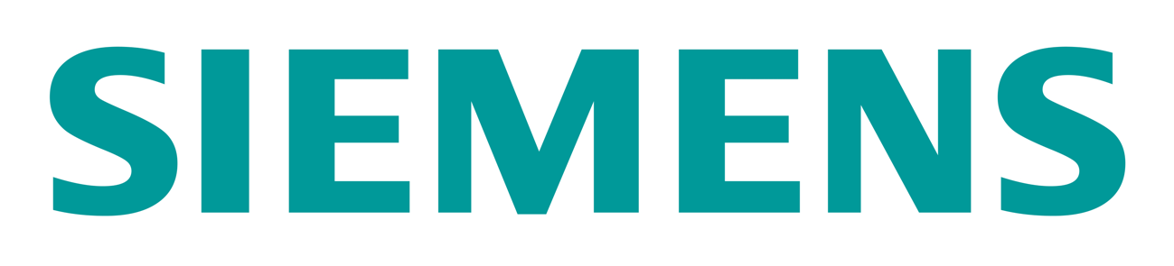
5.1 Employees
People are one of Siemens’ vital strengths. Employees have made Siemens what it is today, and their expertise, capabilities and high level of engagement are laying the foundation for our future success. To stay competitive, we need to continuously win and retain the best and brightest talent worldwide. As an employer of choice, we empower our diverse and engaged people worldwide with a high­performance culture, encourage life­long learning and development, offer an attractive working environment and ensure occupational health and safety. We also believe that employee engagement is a key driver for sustainable company performance. Since 2010, the Siemens Global Engagement Survey has been regarded as an import­ ant management tool for measuring employee satisfaction. In our “Vision 2020,” we set the target to achieve an approval rating of over 75% on a sustainable basis in the key categories of Leadership and Diversity. In fiscal 2015, more than 260,000 Siemens employees (77% response rate) took part in our world­ wide survey, demonstrating once again their strong commitment to shape Siemens, its values and its strategy. Based on the constantly high employee engagement and our results in both key categories in fiscal 2015, we are con dent of achieving our target by fiscal 2020.
Demographic change, lifelong employability and the impact of digitalization are Siemens’ key employee­related topics. As an employer of choice, we train and develop our people to master the challenges of the tough projects we are taking on for our customers. Each project and each task is an opportunity for personal and professional growth. We are respectful, inclusive and diverse. At Siemens, everyone has a variety of opportunities and everyone is treated in a fair way, even when times are tough. We fatten hierarchies and welcome individual contributions and different ways of thinking.
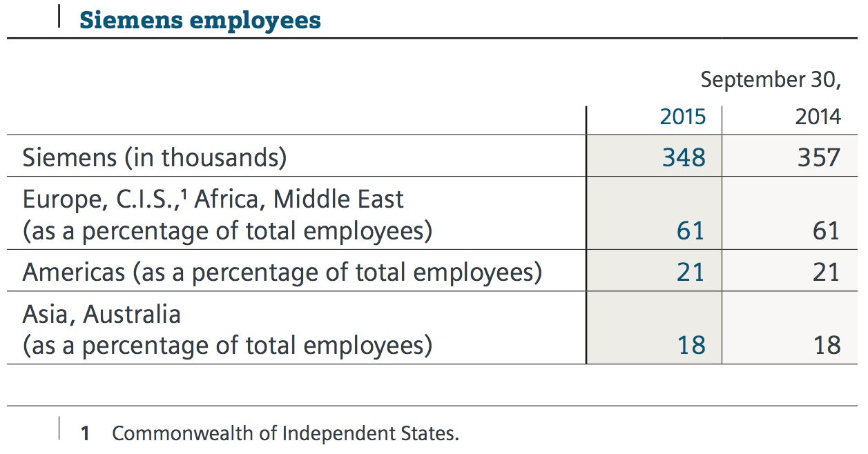
New hires were down by 3% in the year under review. In the same period, exits were down by 11%. The percentage of all Company dismissals – as share of employee exits – was 18.3% for the year, compared with 19.1% the previous year. All other variations result from changes in the basis for consolidation and other changes.

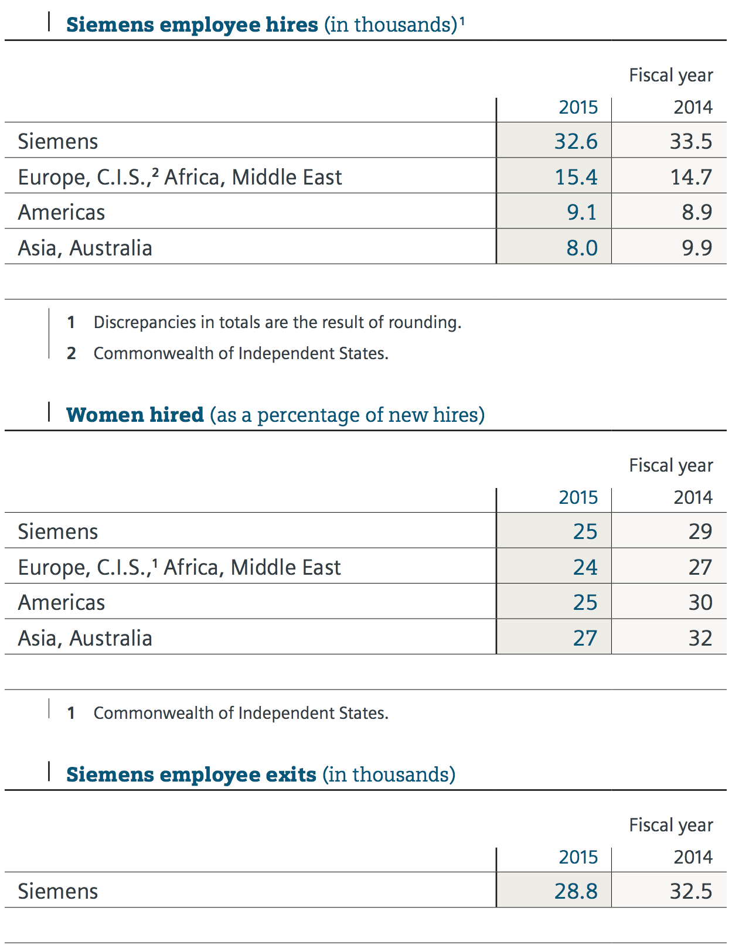
Diversity strengthens our innovative capacity and unleashes the potential of Siemens’ employees, thereby directly contributing to our business success. All our activities, measures and programs aim at leveraging the diversity in the workforce and enhancing Siemens as an employer of choice. We strive for an inclusive working environment that taps the maximum potential of all employees. We want to create a working environment that is open to all people, independent of their cultural back­ ground, heritage, ethnicity, sexual orientation, gender identity and individual gender expressions.
As an example, we have adapted our recruitment processes to ensure that the preliminary selection of candidates better refects the diversity of our customers and employees at all levels and in all regions. For instance, the percentage of women in management positions at Siemens globally has nearly doubled since scal 2002, rising to 15.4%.

5.2 Supply/Consume
SUPPLY CHAIN MANAGEMENT PRINCIPLES
The principal goal of supply chain management (SCM) at Siemens is to provide a substantial and sustainable value contribution for the success of our businesses. The four elements of this value contribution include:
As such, the objectives clearly go beyond cost savings alone. In fiscal 2015, Siemens’ purchasing volume amounted to approximately €38 billion, which equaled roughly half of our total revenue. Based on the priorities of the Siemens divisions, the Siemens Procurement Council defined several key levers to achieve the SCM value contribution in alignment with Vision 2020. With the reorganization of the SCM function concluded in 2015, a strong focus will be on the ratio output to input – i.e., the financial contribution of the SCM functions versus its cost of organization.
All purchasing activities are being executed within the limitations of our sustainability requirements. They are the guiding principles for our supply chain management and an integral part of all relevant supplier management processes – such as supplier selection, supplier qualification and evaluation, and supplier development.
REQUIREMENTS FOR SUPPLIERS
We require all our suppliers to comply with the principles of our “Code of Conduct for Siemens Suppliers and Third­Party Intermediaries”, among which include, besides others, “respect for the basic rights of employees,” strong “health and safety” and “environmental protection” standards, and as well as zero­ tolerance on “corruption and bribery”. The Code of Conduct is based on the 10 principles of the UN Global Compact and reffects the content of our Siemens Business Conduct Guidelines.
In fiscal 2015, we updated our Code of Conduct and included additional requirements on “fair competition, antitrust laws and intellectual property rights,” a chapter on “conflicts of interest” and the avoidance of “conflict minerals.” By doing so, we managed to harmonize our requirements for our Suppliers and our Third­Party Intermediaries with in one Code of Conduct
IDENTIFYING RISKS AND IMPLEMENTING MEASURES FOR IMPROVEMENT Due to our very large and widely spread supplier network – we procure from some 90,000 suppliers in over 160 countries – it is not possible for us to inspect all suppliers to the same ex­ tent by auditing them on site. We have therefore established a risk­based system to systematically identify potential risks in our supply chain. This system consists of sustainability self­assessments by suppliers, risk evaluations conducted by our purchasing departments, sustainability questions within supplier quality audits and sustainability audits by external auditors.
Due to our very large and widely spread supplier network – we procure from some 90,000 suppliers in over 160 countries – it is not possible for us to inspect all suppliers to the same ex­ tent by auditing them on site. We have therefore established a risk­based system to systematically identify potential risks in our supply chain. This system consists of sustainability self­assessments by suppliers, risk evaluations conducted by our purchasing departments, sustainability questions within supplier quality audits and sustainability audits by external auditors.

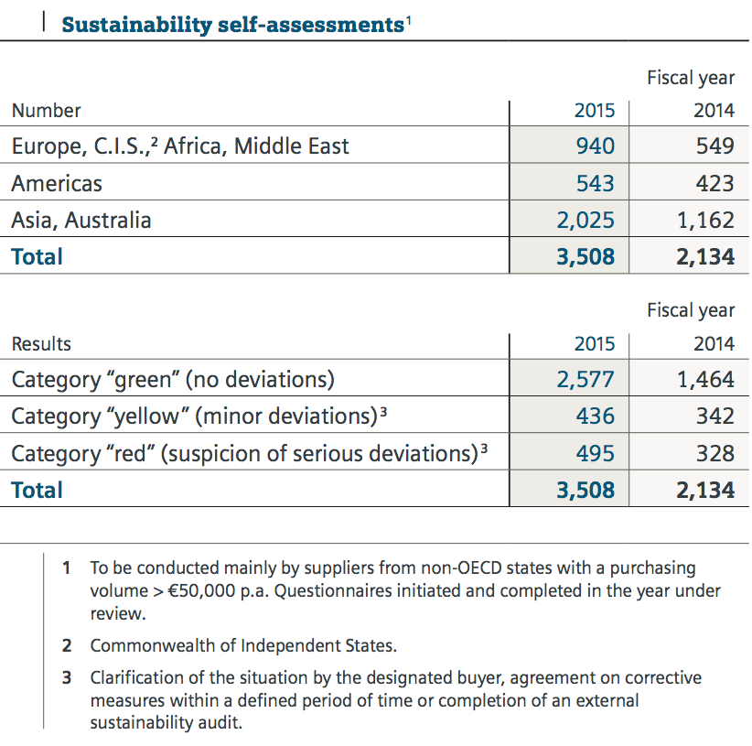
The sustainability self­assessments are, as part of the Siemens supplier qualification process, under continuous review in order to meet the latest requirements. Besides the qualification of new suppliers, our existing suppliers are periodically requallified in accordance with our supplier qualification process. This three­year­modus leads to a substantial increase in sustainability self­assessments compared with fiscal 2014.
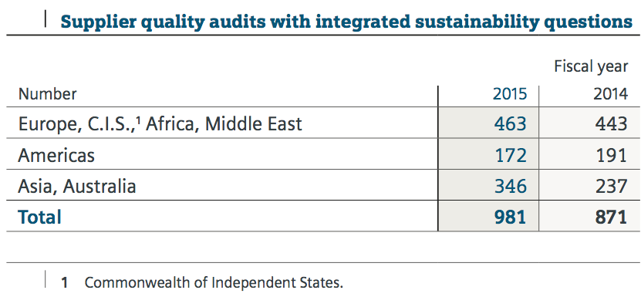
Since late fiscal 2013, we increased the number of supplier quality audits with integrated sustainability questions due to a modification of the audit procedure. We now assess sustainability in all supplier quality audits as part of the modified procedure. The strongest detection tool to review our suppliers’ sustainability performance is an external sustainability audit. It is conducted by one of our audit partners. As a quintessential element of our risk­based approach, we use this tool as a control mechanism for higher risk suppliers. In fiscal 2015, the number of external sustainability audits remained stable.
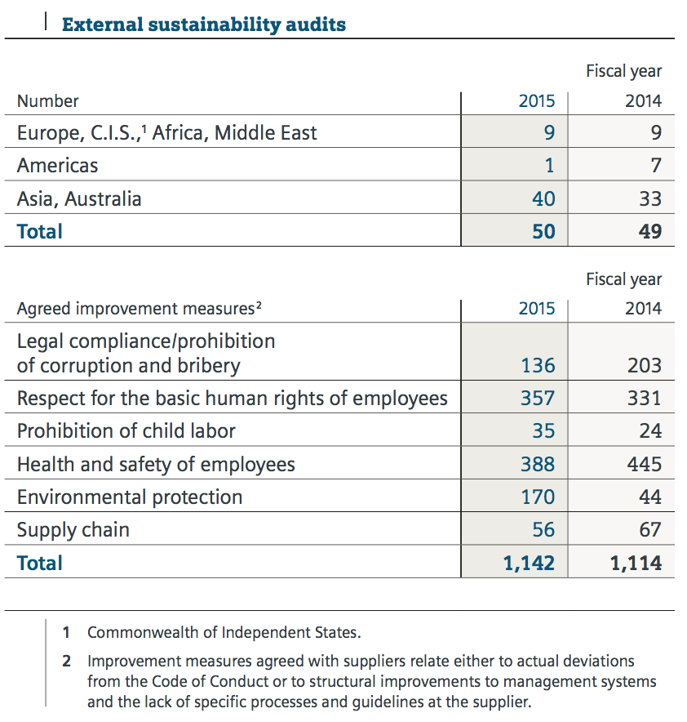
If deviations from our requirements are identified in our sustainability self­assessments or different audits, they must be remedied by the suppliers in question within a reasonable period of time. Besides follow­up audits handled by our external audit partners, the responsible procurement units also discuss the corrective actions defined during our audits directly with the respective suppliers.
In all we do, we are guided by the principles of developing our suppliers in close partnership and building up their competencies for the long term. Deviations identified in the audits mainly relate to structural deficiencies in management systems and the lack of specific processes and guidelines at the supplier. This includes, for instance, measures to effectively ensure occupational health and safety and prevent corruption and bribery. Serious deviations, such as in the areas of “health and safety for employees,” were identified at five suppliers but were corrected by the set deadline.
In the event of substantial deviations or an unwillingness to implement measures for improvement, we exclude the suppliers from any business with Siemens. To be faster and more effective in reacting to major breaches of the Code of Conduct requirements – e.g., proven child labor issues – we have implemented the process of a “Central Warning Message,” which again was tightened in fiscal 2015: All local instances of blocked suppliers now have to be reported to Corporate SCM, where the necessity of a worldwide blocking is discussed and decided centrally. It allows us to block suppliers for all Siemens organizations worldwide in the short term.
Since fiscal 2012, we have been continuously working on the requirements for occupational health and safety standards for suppliers at our project construction sites. Specifically for the health and safety management systems, we require a detailed risk assessment for every site, an appraisal of the risks identi ed and measures to minimize them. In fiscal 2015, we promoted specially designed health and safety audits in our procurement organizations worldwide: The 12 largest countries identified their contractor business and their need to audit contractors to minimize health and safety risks. For fiscal 2016, Corporate SCM, together with the Siemens divisions and their local organizations, agreed on specific audit targets that include occupational health and safety audits at our project construction sites.
KNOW-HOW TRANSFER AND CAPACITY BUILDING
We continue to promote our strategy and belief that our suppliers’ commitment to complying with our sustainability principles is most effective when it is based on their own convictions. The underlying key is to build up our suppliers’ competency levels, while intensifying their knowledge of sustainability. In support of this, we updated our “Code of Conduct brochure” in 2015, which is available in both an electronic and print version. In addition to in­person meetings, we support our suppliers with an Internet­based information and training platform available free of charge to all suppliers. Currently, we are updating our respective “Web­Based Training,” which will be published in fiscal 2016.
On top of that, sustainability is an integral part of the compa­ ny­wide training programs for buyers. Moreover, all employees with purchasing responsibility are obligated to take part in intranet­based training on the subject of “Sustainability in the Supply Chain”.
RESOURCE EFFICIENCY, CLIMATE PROTECTION AND REGULATORY REQUIREMENTS IN THE SUPPLY CHAIN As part of CDP reporting, we collect and publish data on our greenhouse gas emissions (Scope 3) caused by purchased products and services.
We work to minimize the environmental impact within our logistics and transport network. To this end, a corporate tutorial provides our logistics employees with all the necessary information and tools to not only create and optimize sustainable logistics networks, but also design transport solutions within projects. The measures we have initiated include using carriers with modern fleets, optimizing our logistics networks, ensuring the contractual commitment of service providers to improve efficiency and bringing about modal shifts, for example, from air freight to sea or road freight to rail.
We continuously adapt our internal supply chain processes to meet new regulatory requirements such as the European Union Timber Regulation and the “con ict minerals rule,” which is mandatory for many of our customers in the United States. Both regulations require an indepth transparency of the several tiers of our supply chain.
Siemens is aware of the challenging situation whereby products and components purchased from suppliers may contain minerals originating from conflict­affected countries. We there­ fore continue to pursue our Con ict Minerals policy, rolling out a uniform process to determine the use, source and origin of conflict minerals in our supply chain. We cooperate closely with our direct suppliers to support the process of carrying out these steps. Where necessary, we work with suppliers in order to mitigate risks and perform additional due diligence so that we can continue to source responsibly, building on established management processes.
Siemens has actively supported the “OECD Due Diligence Guidance for Responsible Supply Chains of Minerals from Conflict­ Affected and High­Risk Areas” and will continue to do so as a pilot member in the initiative to develop the respective due diligence processes, expressly recognizing a risk­based due diligence in the mineral supply chain. We also support industry­ wide initiatives such as the “Conflict­Free Sourcing Initiative.”

5.3 Community
Our lasting contribution to society has not only been a moraland legal obligation for us for almost 170 years, but lies at th ecenter of our business activities with societies being our ultimate customers. For us, being a business to society means bringing our mission “We make real what matters” to life in the societies we are operating in and in demonstrating how Siemens’ portfolio, own operations, thought leadership activities and voluntary contributions translate into sustainable societal value. Via the electrification, automation and digitalization value chain, all our businesses contribute significantly and measurably to the sustainable development of societies around the globe. With more than 348,000 employees in nearly all countries, our own operations and supplier network provide a valuable contribution to employment, the local economy and skills development, while ensuring stringent standards with regard to health, safety, compliance and the environment. We are committed to consulting with societies and applying our thought leadership and domain expertise in our business activities and beyond. We drive voluntary external activities in projects on education, environmental protection, compliance and social inclusion. In fiscal 2015, we developed methodologies on how to assess and measure our impact on the societies we are operating in as the outcome of two pilot projects in the Great Britain and South Africa. In fiscal 2016, we will roll out these methodologies to several of our key countries. In this way, we are equipping our local teams with the necessary expertise for making strategic choices on the four elements of the Business to Society framework: portfolio, own operations, thought leadership and voluntary activities.

5.4 Environment
To respond to today’s global ecological challenges responsibly, Siemens has installed a comprehensive EHS (Environmental protection, Health management and Safety) management sys­ tem. The process requirements of this management system help our operating units to comply with the applicable laws, regulations and customer requirements; fully satisfy our corporate requirements; and achieve our Siemens­wide environmental targets. The environmental protection management system requires our relevant production and office sites to implement an environmental management system that full ills the requirements of the internationally recognized ISO 14001 standard as well as our own internal standard, known as “Specifications on environmentally compatible product and system design.” This internal standard defines requirements to reduce the environ­ mental impact of our products and systems during the production, use and disposal phase and forms an integral part of our business processes. We conduct regular internal reviews of our environmental performance and progress in order to create a cycle of continuous improvement. Siemens aims to improve energy and resource efficiency, full ill growing international requirements with regard to environ- mental protection, increase customer bene fits and proactively strengthen our position as a sustainable company. To continuously support this approach, the programs “Serve the Environment” (StE) for industrial environmental protection and “Product Eco Excellence” (PrEE) for product-related environmental protection were reconfirmed in 2014 and extended to 2020. As of fiscal 2016, we also intend to start the process of cutting our own CO2 emissions by 50% as early as fiscal 2020, with the ultimate aim of being carbon neutral by 2030. As Siemens plans to invest €100 million globally in energy-efficiency measures for its major plants within the next three years, this will also considerably support the StE energy-efficiency target and enhance carbon efficiency. We monitor the success of our programs using corporate-wide indicators:
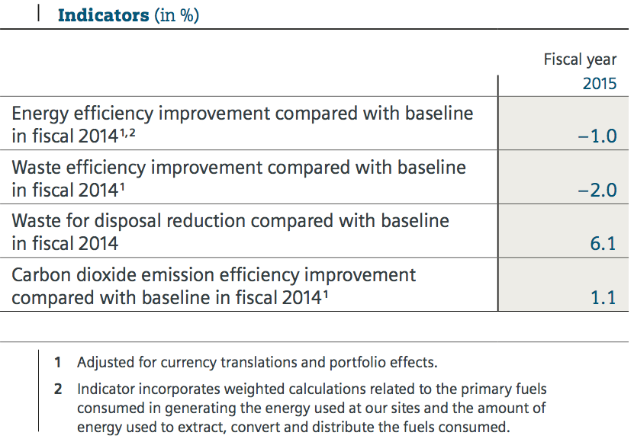
We calculate environmental performance in industrial environmental protection on a portfolio-adjusted basis equivalent to the adjustment used to calculate the comparable revenue change as stated in the annual report. Revenue change in this context means the change of revenue from fiscal 2014 to fiscal 2015 excluding currency translations and portfolio effects. This portfolio adjustment procedure for revenue was accordingly used for the environmental parameters of waste, energy and CO2 from energy use. The approach therefore enables us to monitor and compare our environmental performance over time, regardless of acquisitions and disposals from year to year, and closely relates environmental performance to business performance. In the first year of continuing StE applying the new metric and compared with the baseline of fiscal 2014, the decrease in revenue adjusted for currency translations and portfolio effects of 1.3% had a negative impact on our efficiency KPIs, although we were able to reduce total energy use and CO2 emissions from energy use on a portfolio-adjusted basis. Waste production in fiscal 2015, on the other hand, also increased due to improved awareness and waste reporting as a result of our worldwide waste training campaign during fiscal 2015.
With regard to efficiency improvements from the last StE program period from 2010 to 2014 (energy efficiency: +11%, CO2 efficiency: +20%, waste efficiency: +12%, and reduction of waste for disposal: +8%), we can see that overall efficiency improvements since the start of the StE program are still at a overall high level and, as far as CO2 efficiency is concerned, even increasing. In view of these efficiency improvements to date, our objectives for 2020 are certainly achievable, and the new €100 million energy-efficiency budget, combined with other initiatives to reach our new carbon targets, will contribute to this.
NDUSTRIAL ENVIRONMENTAL PROTECTION
Our industrial environmental protection efforts focus on optimizing energy and resource efficiency at our sites. With the reconfirmed program “Serve the Environment,” we are committed to the following Siemens-wide main targets in the period from fiscal 2014 to 2020:
> Continue our systematic effort to improve energy efficiency and carbon dioxide efficiency
> Improve waste efficiency > Reduce waste for disposal
To continue the StE program, energy and waste efficiency aspects will be integrated into our supply chain. Air pollution control will be considered holistically, taking into account the local air emission situation at our production plants and offices. Climate-change-inducing impacts of water use in our businesses will also be integrated.
Reporting on environmental factors and collecting environmental data In fiscal 2015, we used our environmental information system to analyze 307 reports from sites in all relevant countries where defined threshold values were exceeded for parameters such as energy use, resource consumption and emissions within environmental management. To measure and monitor our environmental impact, we use absolute values such as energy consumption in gigajoules. We report environmental data for continuing operations. Extrapolation to 100% was applied to refflect complete consumption in our figures. Overall, the extrapolation was significant only for primary energy, with 14%, and water and wastewater, with 10%, in the figures reported. We monitor our environmental impact for all office and production sites of environmental relevance using environ­ mental data gathered quarterly.
Environmental management system
All our locations have an environmental management system in place; 268 of them are also certified in accordance with ISO14001. The majority of these, 264 sites, are externally certified, while four have been audited and certified by Siemens internal auditors. The decision as to whether a unit has its environmental management system certified in accordance with ISO14001 is made by the environmental protection executives of the businesses and countries in close consultation with the environmental protection officers. The requirements of the new ISO 14001:2015 standard were introduced into our management processes. A total of 28 Siemens locations have implemented an energy management system in accordance with ISO50001, and further locations are in the process of implementation. To implement the EU Energy Efficiency Directive EED (2012/27/EU), a European­wide approach has been developed taking full ad­ vantage of our own energy services.
PRODUCT-RELATED ENVIRONMENTAL PROTECTION
With respect to product­related environmental protection, Siemens strives to continuously and comprehensively improve the overall environmental performance of its products and systems. The confirmed “Product Eco Excellence” program therefore aims to generate transparency, responds to market developments and delivers added value for the customer. To this end, our program is focused on materials and components, product environmental assessments and increased material­ related resource efficiency. Our program supports operational units in taking future market and customer requirements into consideration as well as regulatory developments. At the same time, communication about the program increases employee and stakeholder environmental awareness. y 2020, the Product Eco Excellence Program will:
> Implement automated data collection and processing for declarable substances to increase transparency on substances in our products. This is the prerequisite for further proactive substitution activities to address future statutory requirements and customer demands.
> Improve the coverage of LCAs (Life­Cycle Assessments) and EPDs (Environmental Product Declarations), as we consider the availability of product-related environmental information an important basis for future legal and customer requirements such as Product Environmental Footprinting.
> Reduce critical materials being used in Siemens products through the support of a material assessment methodology. The overall target of the program module is the reduction of critical material purchasing volumes.
To achieve these objectives, several tools will be developed by Siemens in the framework of the continued environmental pro­ gram, e.g., a map of evaluated substance risks and evaluated substitutes, quality check for substance declarations, enhanced EPD guidance (including service and supplier aspects), tools and training for critical material assessment to support the process of reducing or substituting substances, enhanced communication to increase awareness of critical materials and environ­ mental impact assessments.

5.5 Education
We believe that people are the key to the success of Siemens and that attracting, developing and retaining them are the most important activities we can engage in. We are continually striving to hire the best people in the most effective way possible, which means we are revolutionizing the way in which we search, engage and onboard our future workforce. We have de ned global principles, which all of our countries are applying to their recruiting activities to ensure that all candidates globally have a quality hiring experience.
At Siemens, we consider every employee a talent. Dedicated processes and practices are in place to ensure that our people develop across the board.
The Performance Management Process (PMP) is a one core element of talent development at Siemens. PMP essentially involves maintaining a continuous dialogue about expectations regarding individual contributions and behavior as well as feedback on actual impact and a demonstrated ownership mindset. At the same time, we aim to foster meritocracy. To reffect the focus on recognizing and rewarding high performance within Siemens, our compensation system for our top executives and senior management worldwide includes a variable component.
Furthermore, we promote concepts such as selfreection on aspirations and abilities to grow into different roles and taking ownership for career development. To continuously develop our talents, we offer a varied portfolio of balanced people­ development measures (on the job, people experiences and formal learning) as well as dedicated potential development programs.
LEARNING, LEADERSHIP DEVELOPMENT AND VOCATIONAL EDUCATION
We encourage our employees at all locations to develop their competencies and qualifications. In scal 2015, we invested around €265 million in continuing education (without travel expenses), which equals about €758 per employee.
Siemens Global Learning Campus is responsible for managing and offering the global learning portfolio to employees in all countries. It ranges from courses for employees and managers, through tailored training programs and services for groups, to solutions for entire organizations.
In fiscal 2015, the Global Learning Campus was reaccredited by the renowned European Foundation for Management Development (EFMD). The Corporate Learning Improvement Process (CLIP) accreditation emphasized, as a point of excellence, the creation of a globally integrated learning organization that reaches out to all Siemens employees worldwide and makes a signi cant strategic contribution to the company.
Siemens Leadership Excellence (SLE) is aimed at our current and future senior and top leaders. Targeted programs and offerings are provided to help them end long­term competitive and sustainable solutions to lead their businesses and employees.
Siemens continues to be one of Germany’s largest providers of professional education for secondary school graduates (7,000 places for Siemens trainees and 2,700 places for trainees from other companies). As in previous years, we again made 10% of our trainee positions available to young people from disadvantaged backgrounds.
Each year since 2012, young Europeans (approximately 30 persons a year from about 20 countries) have been completing their apprenticeships in mechatronics and electrical/electronic engineering in Berlin. After the apprenticeships, they return to their home countries and work in one of our local operating companies. There is continuous growth in this field and we are in the process of establishing similar programs in other European and non­European countries.
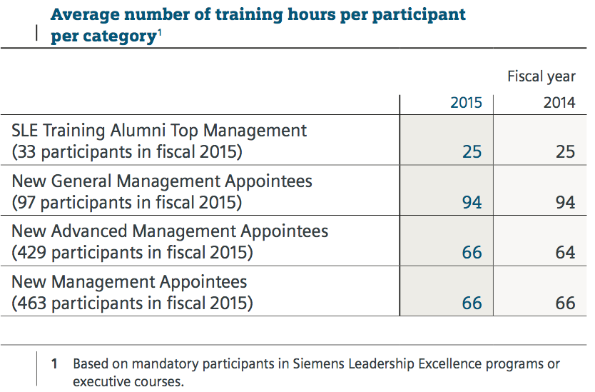
Compared with the previous fiscal year, the average number of hours spent on training by participants in Siemens Leadership Excellence (SLE) programs remained unchanged in fiscal 2015. Training measures at the corporate management level are decided on and implemented as needed in close cooperation with the CEO and the Company’s Managing Board.
SIEMENS EQUITY CULTURE
Siemens established its first employee share program in Germany back in 1969. Building on this successful program in Germany, Siemens decided in 2008 to extend employee and management participation. Today, Siemens offers approximately 97% of its employees in 67 countries the opportunity to become a Siemens shareholder, thus rewarding the commitment and loyalty of employees with a participating interest in the company.
The Share Matching Plan is based on a simple principle: Employees participating in the plan will receive one Siemens share without payment of consideration (matching share) for every three Siemens shares bought and continuously held for the applicable vesting period of two or three years – provided the employee is still employed by Siemens and has not transferred or sold the shares. The main idea of the plan has always been to make stock ownership available to employees at all income levels.
Siemens’ Vision 2020 sets a clear goal to increase the number of employee shareholders from the current level of approximately 144,000 by at least 50%. With the aim of strengthening the participation of Siemens employees worldwide in the company’s success, the Managing Board of Siemens AG is launching a new concept in fiscal 2015 called Siemens Pro t Sharing. The Siemens Pro t Sharing aims to allow employees below senior management level worldwide to bene t from free Siemens shares in the case of extraordinarily successful business years.
We are convinced that empowering employees with shares motivates them to assume greater responsibility and helps them identify more closely with the company they work for – a fundamental prerequisite for the sustainable development of Siemens.
5.6 Healthcare
Occupational health and safety management are key elements of our Company’s sustainable strategy and an integral part of our business processes. We therefore develop central programs and processes that are applied locally and adapted to the respective business needs. Occupational health and safety management are an integral part of our Business Con­ duct Guidelines, our internal monitoring systems, and our risk management and internal controls. In addition, occupational safety is part of an international framework agreement be­ tween Siemens AG, the Central Works Council of Siemens AG, IG Metall and the global union IndustriAll.
Promoting a culture of safety – In the past, occupational safety was often characterized by focusing on technical protective measures, an approach that achieved considerable success. We are convinced, however, that further improvement can be achieved only through an actively practiced occupational safety culture and optimal working conditions – in every country and for all Siemens employees as well as those of our contractors. Both as a company and as individuals, we are responsible for ensuring that the working environment at Siemens is safe at all times and for every employee. At present, local management systems and best practices exist that we can build on. We will achieve sustainability, however, only through a global and consistent approach.
Our customers, suppliers and regulatory authorities expect high safety standards from us. Safe behavior is governed not only by complying with laws, regulations and procedures, but also by the personal values of managers and employees. Our “Zero Harm Culture @ Siemens” program, which was launched in scal 2012, has been further developed and rolled out to drive the targeted cultural change on occupational health and safety. It contains three principles:
To align the different businesses and countries, we have developed a Zero Harm Culture @ Siemens Country Concept. In addition, our businesses and countries further improve safety at the local level through various activities according to local needs and requirements. One example of a local activity is the safety park in India, where Siemens and third­party project site managers and personnel are trained with a focus on high­risk
activities. The training is conducted together with TÜV Rhein-land and ends with an exam and certificate. Management attention is of utmost importance in fostering and improving safety. The responsible CEO of the business concerned there­ fore demonstrates commitment by personally reporting any work­related fatality or serious incident, its cause and the measures taken to the Siemens Managing Board.
To achieve sustainable improvement and share lessons learned we have further strengthened our incident investigation capabilities by providing professional training and support. Several courses have already been completed.
In fiscal 2015, the overall number of fatalities was higher than in fiscal 2014. Regrettably, we reported 12 fatalities. Of these, four fatalities (all work related) involved contractors and eight involved Siemens employees. The eight Siemens cases included four commuting accidents on the way to or from work. In the previous year, there were three fatalities involving contractors and four involving Siemens employees.
Promoting health – We are convinced that sustainable health promotion among our employees will only succeed if all health­ related measures and initiatives are consistently aligned with the permanently changing requirements of today’s working environment and complement each other in a sensiblener. Simply increasing the number of individual measures in itself is not enough. A systematic approach is called for, within which health is actively managed as a resource. Our company wide program Healthy @ Siemens supports a continuous improvement process within health management. To encourage implementation, we introduced the Health @ Siemens label as a quality characteristic for sustainable health management.
Our innovative approaches in health management are already recognized externally. Siemens Belgium received the “Healthy Workspaces Good Practice Award” in managing stress and psychosocial risk at work from the European Union.

5.7 Specific projects
OneDollarGlasses
The vision of the OneDollarGlasses Association is a world where every person is able to afford eyeglasses. Since 2012, the association has been creating structures in developing countries to provide a sustainable supply of affordable, locally-produced glasses for visually-impaired people. Siemens Stiftung supports the association as it implements its concept in Burkina Faso.
Help for 150 million people: The idea behind the OneDollarGlasses Association
$800 per year – that’s the WHO’s estimated economic benefit of a single pair of glasses. Glasses provide relief for everyday tasks, create chances for education, and increase professional opportunities. Around the world, approximately 150 million people suffer from a form of vision impairment and do not have access to glasses. That's a figure Martin Aufmuth from Erlangen, Germany, didn’t want to accept. He came up with a simple design for glasses that even people living on less than one US dollar per day could afford. He and his association are implementing this concept around the world.
Creating a local social enterprise plays a decisive role in this effort. OneDollarGlasses can be handmade by people in a given location using a specially-designed bending machine. The glasses can then be sold to other members of the community. The cost of the materials for one pair of these glasses is around one US dollar. The retail price is between two and three days’ pay. So far, the association is active in eight countries and has used this method to help over 50,000 people gain access to glasses. More than 100 people have been trained in production and sales of the glasses. Donations are funding expansion into further countries. The retail price of the glasses covers wages, infrastructure costs, transport and marketing in each country, and the materials for new glasses. The association is therefore able to provide continual and financially-independent optical care for people in developing countries.
We got to know the OneDollarGlasses Association as part of our empowering people. Award, which recognizes simple technical innovations that sustainably contribute to improving basic services in developing regions. Martin Aufmuth won first prize in 2013 for his idea. In addition to 50,000 euros in prize money, his organization has received consulting as part of our empowering people. Network. To make the custom-made and affordably-priced glasses available to even more people, Siemens Stiftung has supported the association's efforts to expand to Burkina Faso since 2015.
OneDollarGlasses became active in Burkina Faso in 2013, and the local organizational structure has been constantly expanded ever since. With the exception of the cost of support from Germany, the project is already financially self-sustaining for the most part: wages for the manufacturing and operational staff, travel costs, rent, and other expenses are covered by the sale of the glasses. So far, more than 16,000 glasses have been sold.
Our collaboration focuses particularly on developing a sales strategy as part of a three-year pilot project that would allow rural regions to be reached. This is especially important in Burkina Faso, where large portions of the population continue to live in rural areas where access to basic medical services is limited. Based on a social enterprise business model, the goal is to establish coverage that is as comprehensive as possible using a combination of fixed shops selling glasses and a mobile sales team.
Safe Water Enterprises
With Safe Water Enterprises, Siemens Stiftung is committed to a sustainable supply of safe drinking water in rural regions in Kenya. Small kiosks are equipped with mobile SkyHydrant water filters, which remove suspended solids, bacteria, and viruses from water with hair-thin membrane fibers. The filtration process operates without electricity, requiring no grid connectivity.
The purified water is sold at an affordable price; the earnings cover operational costs. In addition to expanding the supply of drinking water, Safe Water Enterprises create income opportunities for members and local communities. Community members receive technical and business training to become kiosk operators.



6.1 Employees
The financial strength, performance and ultimate success of Deutsche Post DHL Group is founded on the commitment, creativity and know-how of its people. e Group employs some 500,000 people around the world, and it is their ability to deliver peak performance on behalf of our customers – and their commitment to continuous improvement – that will allow us to remain the world’s postal and logistics leader into the future. It’s no accident that one of the Group’s three corporate strategy objectives is to become and remain Employer of Choice in the industry. e job of Human Resources at Deutsche Post DHL Group is to make a tangible contribution to the company’s business success; it does this by recruiting the right people to ill open positions, and by continuously motivating and developing our existing workforce worldwide. We treat our people with respect and honor their contribution with competitive remuneration. is the foundation for productive working relationships over the long term.
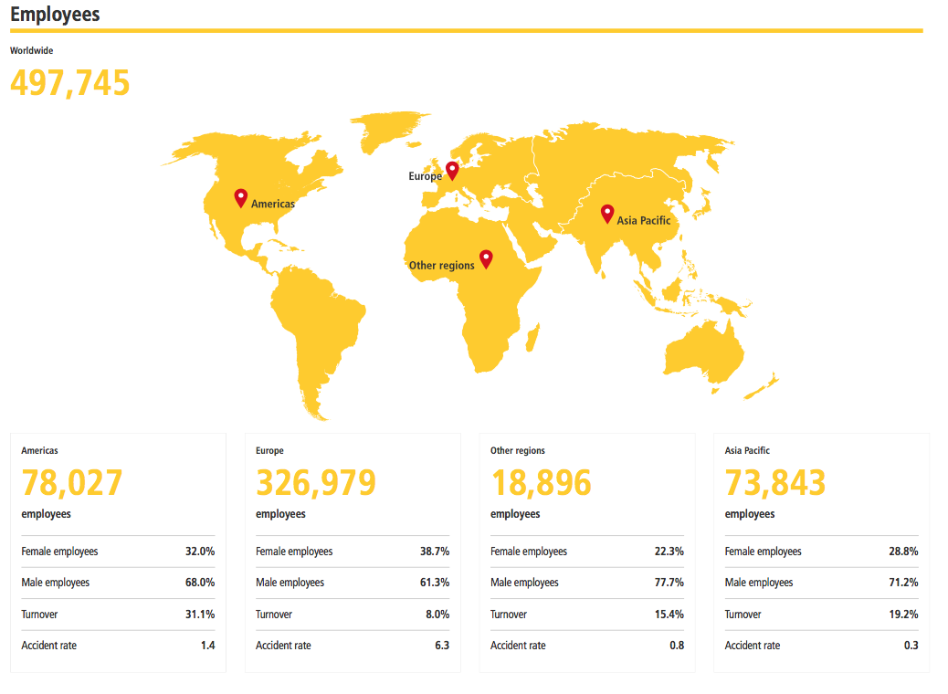
Our Code of Conduct guides us in our actions as individuals and as a company; it is the foundation for a corporate culture characterized by openness, trust and mutual respect. We see great strength in the diversity of our workforce and the potential in each and every one of our employees. Ours is a working environment that opposes any form of discrimination. e objective of our diversity management is to increase diversity awareness at all levels of the company and to reinforce employee commitment to conduct based on respect and a sense of personal responsibility.
The safety and health of our employees is our highest priority. Workstations are designed and equipped according to the latest workplace standards, and we offer a broad range of trainings on topics from accident prevention to healthy lifestyle choices. is not only meets our obligations as a responsible employer, but also helps boost employee motivation and performance.
e high-level quality of our products and services results from the dedication, know-how and innovative strength of our employees. Our Group-wide initiative Certified is designed to promote the growth and development of our employees, making them the best in the business. e modules convey knowledge specific to an employee’s respective division and function, as well as more general content relevant to all Group employees.
We use our annual Employee Opinion Survey to assess employee engagement and motivation. e survey is a central element in the open and constructive dialogue we maintain with our employees. Survey results are used, among other things, to derive our “Active Leadership” indicator, which helps determine bonus payments for all company executives.
We measure the success of our HR measures with the help of various KPIs, which we track and evaluate with the help of the HR Scorecard; results are then reported to management on a regular basis. For the core HR themes, which were reaffirmed by the 2015 materiality analysis, we have defined the following management parameters and targets:
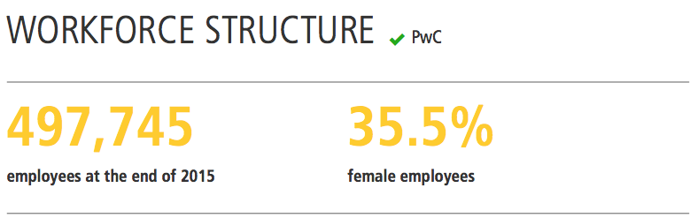
At the end of 2015, our global workforce numbered 497,745 employees. is makes us one of the biggest employers in the world. Given our position as the leading postal and logistics services provider, we are constantly creating new and secure jobs. We have some 327,000 employees in Europe. Of these, around 209,000 are based in Germany, where our headquarters are located. At the end of the reporting year, we had 8,900 more employees as compared to the previous year.
Our global workforce comprises 64% men and 36% women. One of our objectives is to make career opportunity within our company equally attractive to women and men. However, for jobs involving strenuous physical activity, we do receive more applications from men than from women.
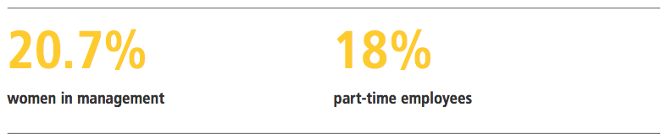

In upper and middle management, the share of women in executive positions is 21%. rough the use of targeted measures, we aim to better prepare our women employees to take on leadership positions and thus further increase the share of women in middle and upper management.
While some 18% of employees worldwide work part-time, as many as 34% do so in Germany.
Compensation
Monetary compensation includes a base salary plus variable remuneration components like bonus payments that are subject to national and position-specific requirements and regulations. Across the Group more than 70% of our workforce is employed under contracts where monetary compensation is impacted by regulatory frameworks like legally binding statutory increases, collective labor agreements or works agreements.
Positions are evaluated and graded based on job classification and responsibilities. In accordance with our Code of Conduct and Corporate Diversity & Inclusion Statement, this occurs independently of personal factors, such as age, gender, religious affiliation, skin color, sexual orientation and ethnic background which could incite discrimination. We apply a systematic job evaluation approach to ensure fair and equitable compensation within the company.
Aware of our responsibilities as an employer, our pay structures take into account not only national minimum wage requirements and the needs of our divisions, but local market demands as well. We strive to o er fair and competitive compensation packages in all of the markets we serve.
In addition to direct cash compensation, we provide employees in many countries with access to defined bene t and defined contribution retirement plans. In some countries, Deutsche Post DHL Group assumes the costs of health insurance and treatment. In countries with primarily privately financed health systems, we provide employees with access to health insurance by way of health insurance allowances.
Remuneration for employees in Germany
In contrast to many other countries, the majority of our employees in Germany receive wages or salaries covered by collective wage agreements. In many of our companies throughout Germany, our wage-scale employees also receive a performance-based bonus in addition to their wage or salary. At our principle company Deutsche Post AG in Germany, wage-scale employees generally receive a bonus of between 5% and 17.5% of their annual base salary. Non-managerial, non-pay-scale employees are entitled to a bonus of between 17.5% and 40% of their annual base salary.

6.2 Supply/Consume
We want to be the quality leader in contract logistics – the company that best understands customers’ needs and leads the way in customer satisfaction. To this end, we implement practices and methodologies that provide our customers with the highest level of service quality and the most added-value. We use globally tested processes to offer our customers comparable solutions and uniformly high service standards. In order to measure and monitor the quality of our service, we have defined a number of key performance indicators (KPIs) for the division, which include safety and operational performance. We consistently deliver products and services that meet the highest service standards worldwide, achieving ratings of over 95% in all relevant categories.
Innovations
Deutsche Post DHL Group is developing business models that bene t both our company and society. Technical innovations are key factors in this process. e task of researching and developing those new technologies is assigned to Customer Solutions & Innovation (CSI) in the CEO board department, which works in close collaboration with divisional experts.
We intend to use our innovations in multifaceted ways to create added value for our customers. It’s more than just a matter of simplifying and automating logistics processes. With our innovations, we seek to make logistics chains more secure and more stable. Many of these new technologies are also designed to reduce the carbon footprint of logistics services.
Strategic innovation management
We drive innovation strategically in two ways. First, we use technology that is available today to develop new, more energy efficient and more robust solutions. Second, we strive to develop alternative technologies. In this process we seek to collaborate with customers, suppliers, financial institutes, the scientific community, logistics initiatives and many other reference groups. is cooperative approach gives our innovation projects better chances to succeed, accelerates their development, and expands their impact. Our innovation projects are multi-faceted and adapted to specific situations. In the reporting year, we launched a number of new e orts and reached important milestones in current projects. Moreover, our company has received external recognition for our innovation management.
Project examples
A pilot project at a distribution center in the Netherlands focused on testing for the use of "smart glasses" and "Augmented Reality (AR)". Developers working together with customers used the technologies to explore the effectiveness of an AR concept called "Vision Picking"
in warehouse operations. Employees were given smart glasses that display order information step-by-step, the goal being to expedite the picking process and reduce errors.
Economic performance
Deutsche Post DHL Group provides services that are indispensable to a modern society. With our world-spanning logistics networks we not only ensure that information and goods are conveyed securely but also create the conditions necessary for companies and people to participate in world trade. It’s how we can contribute to the welfare of companies and individuals around the globe.
A detailed look at our Group’s significance for global trade and our economic performance is provided in our Annual Report. e Group’s solid results in 2015 are once again a reflection of the trust our customers place in us as a company that acts responsibly. At the same time, this income gives us the opportunity to expand our commitment to corporate responsibility.
Taxes
The Group pursues a conservative tax strategy. As a company that does business around the world, we have a presence via different enterprises in a number of nations, including some that are considered “low-tax countries”. ese companies are not tools for optimizing our tax payments, but instead are used to support our operating activities.
With the help of our global team of tax experts, we ensure that taxation risks can be recognized and counteracted, that national and international tax-related compliance requirements are met and as a result that the commercial activities of the Group are properly taxed in the respective countries.
rough the payment of taxes and other duties to federal, state and local authorities in many countries, the Group helps finance infrastructure maintenance and expansion world-wide. Please refer to our Annual Report for details on our tax expenses.
Dividend
Our shareholders also bene t from our economic success. In 2015, we paid out €1,030 million in dividends for fiscal year 2014. Information on dividends for fiscal year 2015 will also be available in our Annual Report.
Wages and salaries
With around 500,000 staff members, we are one of the world’s largest employers. Staff costs in the reporting year amounted to some €19.6 billion. ey include wages, salaries and compensation as well as all other bene fits paid to employees of the Group for their work
during the fiscal year, including social contributions. ese are primarily statutory contributions, in particular the social security contributions. In numerous countries we offer defined bene t and/or defined contribution-based pension plans, and which accounted for approximately €1 billion of total staff costs in 2015. More detailed information regarding the defined bene the pension plans is available in our 2015 Annual Report.
Remuneration of Board of Management and Supervisory Board Members
In the reporting year, the total remuneration paid to active Board of Management members amounted to €17.4 million; for the Supervisory Board, that total was €2.7 million. These figures include share-based remuneration. Overall the remuneration paid to the Board of Management and the Supervisory Board represents a 0.1% share of total staff costs. Please refer to the Remuneration Report in the 2015 Annual Report for further details related to the Board of Management and Supervisory Board remuneration.
Investments
We continue to optimize the networks and to refurbish our vehicle and aircraft feet as well as our buildings, machines and facilities. e Group’s investment expenditures amounted to some €2 billion in the reporting year. Detailed information about these investments is available in this year’s Annual Report.
Environmental aspects enjoy great significance in our capital expenditure policies. Our Corporate Investment Policy, for example, specifies that the company may not make a replacement purchase if the replacement is not more energy efficient than its predecessor model or does not at least offer other environmental advantages. Our policy applies to all decisions related to building and renovation projects as well as for example to measures related to renewing our road vehicle and aircraft feets. For examples of these investments, please see the Shared Value chapter.

6.3 Community
We expressly encourage employees to volunteer in their local communities, because we feel that volunteering on behalf of society and the environment benefits not only our partner organizations, but also the individual employees who donate their time and energy. Volunteer work opens our employees to new and different perspectives; this strengthens the bonds between them and makes a significant contribution to a more engaged and motivated workforce. Moreover, employee community involvement supports the company’s strategic goal to act responsibly with regard to the environment and society in all areas of our business.
Global Volunteer Day
Since its inception in 2011, Global Volunteer Day (GVD) has become a major component and driver of employee volunteer work across the Group. GVD provides a platform for employees to realize community projects in close collaboration with independent local organizations and charities. Volunteer work in the context of GVD is not limited to a single day or single project, but is designed to promote lasting ties between our employees and the many local non-profits and charities in which they are involved.
In the reporting year over 110,000 employees provided support to non-pro t projects in their communities as part of the GVD program; 78,000 (2014: 77,000) of these employees in 114 different countries worldwide took active part in local projects, contributing more than 260,000 volunteer hours in more than 2,000 individual projects. Employee participation in GVD – and the diversity of GVD projects – continues to grow year to year.
2015 marked the first time GVD participation levels were measured using the LBG model. Reconciliation between the previous and the new method is presented in the Annex to this report.
Living Responsibility Fund
We also provide nancial support to local community projects in which our employees are involved as volunteers. e Living Responsibility Fund (LR Fund), which is fed by Group funds, provides nancial support to local partner organizations to help them expand their scope of activity together with our employee volunteers. In order to qualify for nancial support, at least two Group employees must devote 50 hours of their time to the project over the course of one year. Our goal is to support employees who demonstrate lasting commitment to social or environmental causes and serve as models for their fellow colleagues. Each year a jury consisting of representatives from all board departments across the Group selects projects for funding. Projects in which employees invest more than 400 hours are eligible to receive a maximum of €4,000. e exact gure depends on the number of hours volunteered by employees over the course of the application year. In 2015, 79 employee projects in 31 countries received financial support through the LR Fund. A total of 4,600 employees volunteered approx. 39,000 hours of their time to these projects, or the
Employees supporting employees
Our internal relief fund “We Help Each Other” (WHEO) is testament to the team spirit and solidarity among Deutsche Post DHL Group employees. WHEO is funded by individual employee donations or larger employee donation drives organized at the local level. WHEO’s goal is to provide financial support to Deutsche Post DHL Group employees who are victims of a natural disaster. In the reporting year 52 employees in six countries received financial support from the fund. Among the beneficiaries are 38 DHL employees in Nepal who were a
Effected by the devastating earthquake that shook the country in the spring of 2015.
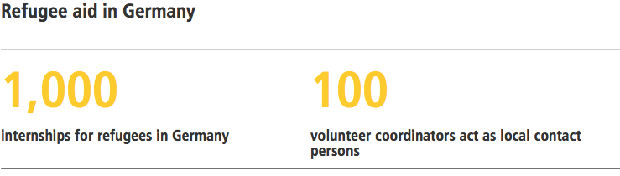
Since September 2015, Deutsche Post DHL Group has been actively involved in refugee aid in Germany. e Group works closely with highly experienced aid organizations such as the “Aktion Deutschland Hil ” alliance, SOS Children’s Villages, Stifung Lesen and Teach First Deutschland. We see our involvement in refugee aid as a longer-term commitment. For the first year the Group has earmarked a total of €1 million for refugee aid. Our focus is on cultural integration, with an emphasis on language acquisition and vocational preparation and training.
As one of the largest employers in Germany we will also offer up to 1,000 internships to give refugees exposure to the German working world and provide them with opportunities for integrating into the German labor market. In addition, we want to encourage up to 10,000 employees to get involved in their local communities. We have deployed 100 volunteer coordinators across Germany to act as local contact persons for employees and relief organizations. In addition, we met with federal and state-level representatives in 2015 to discuss the utilization of Group property for refugee housing, as well as the deployment of employees to support with administrative tasks.
6.4 Enviroinment
Improving carbon efficiency and reducing air and noise pollution are the focus areas of our Group-wide environmental protection program GoGreen. is includes not only the direct emissions generated by our own feet, but also the indirect emissions from our transportation subcontractors, which account for the largest share of the Group’s overall emissions.
The focus areas of our GoGreen program are defined in our Group-wide Environmental and Energy Policy; our environmental management system, in turn, ensures implementation of this policy. Other Group policies designed to help achieve our environmental protection goals include our
Investment Policy: Requires that new acquisitions offer greater carbon efficiency or eco- friendliness than existing assets.
Biofuel Policy: Prohibits the use of biofuels that negatively impact local food production in the countries where they are produced.
Paper Policy: Requires us to purchase recycled paper whenever certified recycled paper is available on the local market. e policy is available for download.
e Group’s Environmental Policy was revised in the reporting year and reissued as the Deutsche Post DHL Group Environmental and Energy Policy. The policy was modified to respect the introduction of an energy management system based on the ISO 50001 standard as well as our increased focus on local air and noise pollution as material issues for our operations.
In 2015 our stakeholder survey also addressed other environmental issues, such as water consumption, waste production, recycling and biodiversity. As a logistics service provider, Deutsche Post DHL Group uses only a limited amount of natural resources such as water and wood, and does not generate significant amounts of waste. Nor do our facilities and operations have a significantly negative effect on biodiversity. Independent of our environmental protection priorities and main action areas, we of course always act in accordance with existing environmental laws and regulations.
We regard environmental protection as a continuous and dynamic process. As part of our materiality analysis, we regularly review the relevance of identified focus areas and the implemented action measures. e materiality analysis conducted in the reporting year largely affirmed the focus of our environmental protection e orts – energy efficiency and climate change. At the same time, other environmental factors such as local air pollutants and noise pollution have gained considerably in significance.
Fuel and energy efficiency
Our goal is to increase fuel and energy efficiency to the point where higher transport volumes do not necessarily translate into increased emissions. A comparative analysis of the various modes of transport we use – including air, road, rail and ocean – reveals that air transport produces the greatest share of both greenhouse gas emissions and the local air pollutant sulfur dioxide (SO2). In the case of ground transport, greenhouse gas emissions and ne particulate air pollution (PM10) emerge as the most relevant factors. For our operations, this means constant attention to route optimization, as well as modernizing our aircraft and renewing our road vehicle fleets.
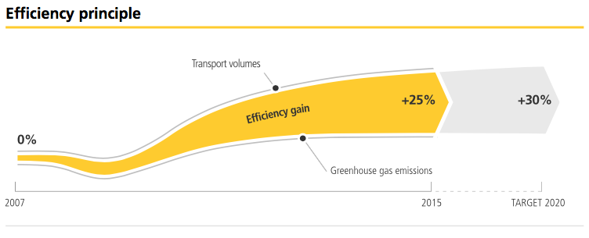
Thanks to these measures we were still able to decrease our greenhouse gas emissions in the reporting year despite transport volumes remaining nearly as high as in 2014. is reflected in our main performance indicator, the Carbon Efficiency Index (CEX). In the reporting year we were able to improve our carbon efficiency by one percentage point over the previous year, meeting our 2015 target.
Green products
Our customers also bene t from our expertise in environmental protection. Our DHL GoGreen Solutions help customers optimize the environmental efficiency of their own business processes. More and more customers today expect eco-friendly transportation services and will award their business to providers who have environmental management systems and measures in place. In this way we make a positive contribution not only to society and the environment, but – in the spirit of Shared Value – also to the success of our company and that of our customers.
We have made environmental awareness an integral part of our day-to-day business. Using our 6-Step Approach, an internal process based on the ISO 14001 standard, we are engaged in a continuous improvement process – constantly developing and implementing improvement measures to help us achieve our environmental targets. We also apply the 6-Step Approach to sites that are not (yet) ISO-relevant.

6.5 Education
In 2015, our employees each spent an average 1.4 days in various further education and training measures. ese measures are naturally available to employees who work part-time. The only requirement is that they must have an indefinite employment contract. Other than in previous reports, because this indicator is not used to measure the effectiveness of our training measures, we will no longer provide data on the costs involved in conducting apprenticeship programs and providing further education and training measures.
Because demand for online training continues to grow due to the flexible and targeted way it can be used, the broad range of training offerings covering specialist subjects and language lessons will be expanded on an ongoing basis and made available in many different language versions. In addition, all employees in Germany will have the opportunity to take part in an open seminar program which covers the categories of management skills and knowledge, and so skills.

6.6 Healthcare
Having truly motivated and empowered employees is the prerequisite to being able to deliver top-quality service and performance to our customers. Because of this, we make it a top-priority to provide our employees with a working environment that ensures their safety and, at the same time, helps maintain and improve their health and well-being. Both aspects – safety and health – are equally important if we want to become and remain Employer of Choice.
Our goals and action measures in the area of occupational safety and health management are clearly defined in our Corporate Health Policy. In addition to this, our Occupational Health & Safety Policy Statement makes clear both our understanding of occupational safety, and standards we have established to achieve safety goals. Road safety is also important for a transport and logistics company like ourselves. at is why we have laid out seven safety rules in our Road Safety Code.
Occupational health and safety at Deutsche Post DHL Group is integrated into the Group's quality management system and, in Germany, complies with the ISO 9001 standard. Group-wide, we apply OHSAS 18001, the internationally recognized standard for occupational health and safety.
Managing occupational safety & health
Each Group division has its own organizational and management structure dedicated to occupational safety and health. Cross-functional topics are discussed by the Operations Board, a committee made up of division executives under the leadership of the CEO, which among other things is also responsible for managing and developing occupational safety KPIs. In the reporting year the Operations Board met five times to discuss and approve the following measures in the area of occupational safety:
Development and implementation of the OHS Policy Statement within the Group
Alignment of methodology for accident rate calculation to international standards Implementation of OHSAS 18001
Improvement of coverage rates for recording key performance data Formulation of effective targets for reducing the work-related accident rate
These measures will now be implemented by the responsible parties in each division, with support from our occupational safety experts.
e Group-wide Occupational Health & Safety Committee facilitates dialogue and collaboration between occupational safety experts in the different divisions. It defines cross-divisional regulations and standards, identifies accident black spots, develops appropriate prevention measures, and lays the groundwork for decisions made by the Operations Board.
Health Management is led by the Chief Medical Officer (CMO). e CMO maintains direct contact to important external institutions and organizations, analyzes where action measures are required and provides consulting and/or decision-making support as needed to help the Group prepare for possible health threats and the associated economic challenges. In addition, the CMO advises executives on the implementation of health measures, and heads Corporate Health Services in Germany. As part of the Central Health Working Group – an internal committee which plays a key role in our system for promoting employee health – the CMO also presents an annual health report and regularly reports to the HR Board.
Outside of Germany, the CMO supports in the development and implementation of targeted local health promotion activities. To help in both design and execution, we use data made available through the local insurance providers that already work with us as part of our global insurance program. We also make use of the country pro les published by the World Health Organization (WHO). is allows us to develop and offer health measures tailored to regional needs.

6.7 Specific Projects
Disaster preparedness program: "Get Airports Ready for Disaster" (GARD)
Man is no match for the power of earthquakes, tsunamis, volcanic eruptions or floods. But there is one thing people can do: they can prepare themselves, so that natural disasters do not automatically become humanitarian disasters.
When natural disasters strike, the airports in and around the disaster zone very often become bottlenecks in the flow of relief supplies, as the existing infrastructure often cannot handle the tremendous volume of incoming goods. As a result, the onward transport of life-saving relief supplies is delayed or rendered impossible. The goal of our "Get Airports Ready for Disaster" (GARD) training program, launched in 2009 together with the United Nations Development Programme (UNDP), is to prevent such bottlenecks.
GARD
- Conducted by DHL air freight experts
- Aimed at airport managers and disaster management organization employees
- Brings together the key players in a possible disaster relief effort
- Conveys a practical approach to disaster relief in 3-5 day training courses
- Includes workshops as well as a formal risk analysis of the airport infrastructure
- Results in an action plan to increase the airport's maximum capacity (Airport Assessment Report)

Partnership with the United Nations Development Programme
Our GARD program involves a long-term strategic partnership with the United Nations Development Programme (UNDP). Through this partnership we are able to cooperate closely with local authorities and government ministries in each of the GARD workshop countries. This facilitates both planning and execution of the workshops, as well as subsequent implementation of the action measures identified during the workshops. Through the partnership with UNDP, GARD also becomes a platform for dialogue and exchange between experts in humanitarian logistics and disaster management. The UNDP receives financial support from Germany’s Federal Ministry for Economic Cooperation and Development (BMZ) for the GARD program.
Workshop and methodology
During the three-to-five day GARD workshops, the Deutsche Post DHL Group air freight experts act mainly as consultants. The participants themselves, including airport staff and representatives of disaster management agencies, are responsible for developing and finalizing the concrete action measures designed to prepare the airport. To be successful, it is critical that the emergency plans take into account the conditions specific to the individual airport, including architecture, geography, etc. For this reason, the workshops always take place directly at the airport. The workshop also includes a detailed inspection of the airport in question.

Contents of the GARD workshop cover both theory and practice, including an analysis of the airport's maximum processing capacity (goods and passengers) and identification of action measures to quickly increase airport capacity in the event of a natural disaster. Workshop participants also work with the trainers to identify possible bottlenecks at their airport, and to develop concrete measures for avoiding such logjams. The results are documented as part of an action plan for increasing the airport's maximum capacity (Airport Assessment Report).

Improving educational opportunity and employability (GoTeach)
The Goal of our Group-wide GoTeach program is to improve educational opportunity and employability of young people, especially those from disadvantaged socio-economic backgrounds. As one of the world’s largest employers, we rely on access to highly qualified employees around the world. Furthermore in today’s rapidly changing world, education promotes greater stability and prosperity – both for individuals and for the societies and markets.



7.1 Employees
As at 31 December 2015, E-ON Group employs 56,490 employees worldwide in fully consolidated companies. The number of employees has thus decreased by 3.9 percent compared to late 2014. It includes 1,254 trainees and 173 Board members and executives.
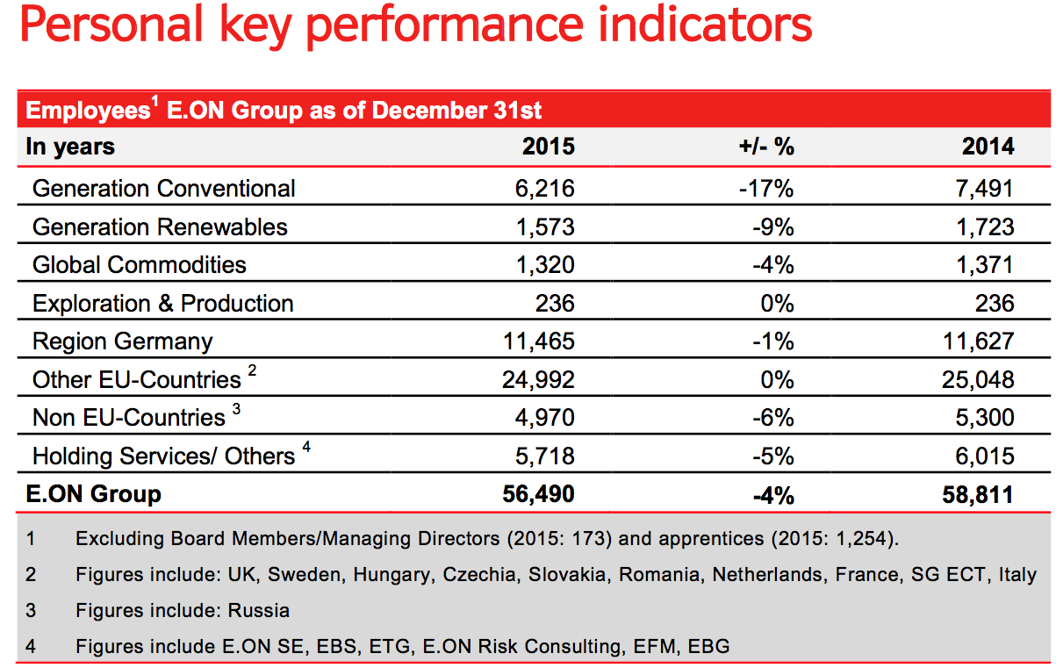
35,009 employees, or 62 percent of all staff, were working outside Germany, unchanged compared to late 2013.
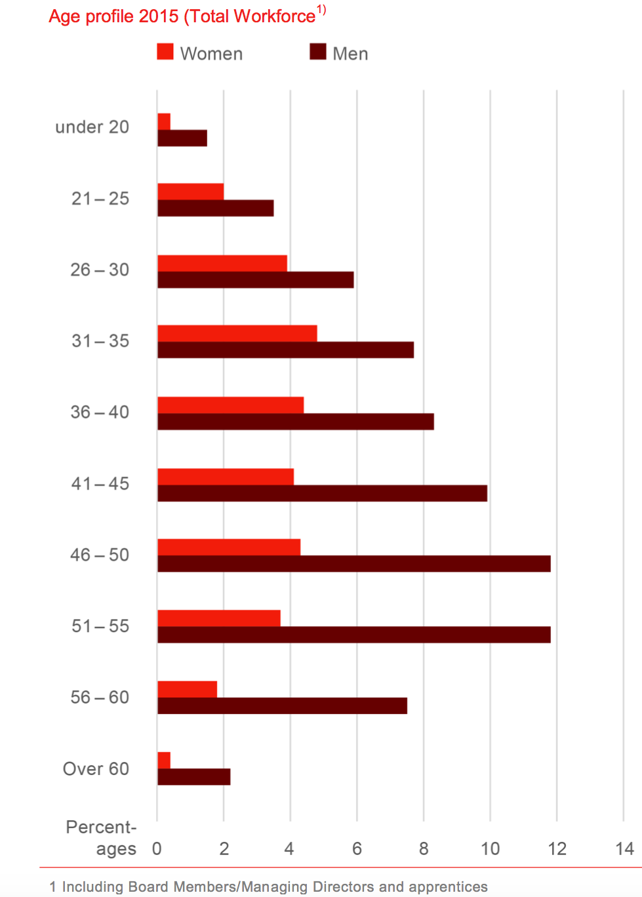
The average age across the E.ON Group was at year’s end 42 years and is comparable to that in other DAX 30 companies. The age structure of E.ON employees reflects the demographic development of the labour force potential: In year 2015, approximately 17 percent were less than 30 years old, 55 percent were between 31 and 50 years old and some 28 percent were older than 50.
E.ON is well prepared for the demographic change and has already taken steps to address the demographic changes such as in the area of health care, recruitment, promotion and training.
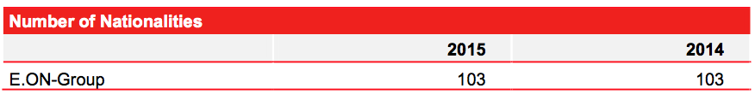
The proportion of women in our personnel has increased from last-year’s 29% to 30%.
The absolute number of trainees and training quota has been reduced as opposed to the previous year. Declining recruitment figures resulting from production and the transfer of training from fully consolidated into non-consolidated companies are responsible for this. With a very high acceptance rate (385 of 441 = 87%) of skilled trainees, E.ON counteracts the shortage.
In 2015, German E.ON companies employed 1,269 severely disabled persons or persons with a similar disability. The absolute and relative number of severely disabled persons have been reduced as opposed to the previous year 2014. However, due to the fact that the average number of employees has also been reduced, the number of severely disabled employees decreased only slightly, from 6.2 to 5.8 percent.
In total, 4,904 people at the year’s end were employed on a part-time basis in the E.ON Group, thereof 3,252 women (66 percent). The number of employees on a part-time basis has increased as opposed to the previous year (2014: part-time employees 4,413, thereof women 3,202), as well as the percentage (from 7% to 8%). The reason for the heavy increase of the number of part-time employees in the segment of production is a collective agreement on working hour reduction to 97% as opposed to full-time employees, for prevention of personnel reduction in the Power Plant Group West.

7.2 Supply/Consume

Observance of human rights, quality and environmental standards are extremely important for us at all E.ON sites. We also set this demand for our business partners in the supply chain. We want to exclude human rights violations, ensure proper working conditions and implement ethical business practices. To this end, we have introduced various policies and management processes. In dialogue with our stakeholders, we are continuing to develop our own environmental and social standards and are committed to establishing sector standards. In this way, we are gradually extending control over supply routes – because in the procurement process, the main challenges arise in relation to protecting the environment and human rights.
We reviewed and revised our Principles for Responsible Procurement in 2015. This also entailed the revision and updating of general purchasing conditions: we inserted new paragraphs in which we deal particularly with compliance failings of suppliers.
Development of our supplier relations management
In 2014, the central purchasing division, supported by the Health, Safety & Environment (HSE) and Corporate Responsibility (CR) areas, developed an optimised and unified process for qualification of new suppliers. The implementation of this synchronised process was included in the Group procurement directive and has been mandatory for all Group entities since April 2015. The new process helps us to evaluate our new suppliers in terms of sustainability. We want to ensure that only suppliers that are classified as uncritical in environmental, social and governance (ESG) areas are admitted. We are currently engaged in a project to evaluate the supplier qualification already carried out to check if the new process is successfully implemented.
New compliance check to prevent corruption
In addition, we developed and tested a Compliance Check that enables us to verify compliance by new suppliers with antitrust and criminal law and their anticorruption measures. The check, which takes place during pre-qualification, was made mandatory in the Group in 2015 to mitigate reputation and liability risks.
Occupational safety and environmental standards in the supply chain in view
Occupational safety and environmental protection are fundamental to E.ON’s core business: the production and distribution of energy. We require these of our partner companies as well. We have integrated even stricter environmental and safety standards in the non-fuel procurement process in our 2015 revision of our Group procurement directive. It was important for us to identify potential risks in our suppliers as early as possible so as to be able to take appropriate countermeasures. For this reason, we developed a unified process for risk assessment in 2015 and documented it in the Group directive. A Group-wide training programme and the Group-wide unified documentation of the results of the risk assessment are further important milestones for 2015.
Expansion of inspections in the coal supply chain
As part of our collaboration in the Bettercoal Initiative, we seek to improve the working and environmental conditions in the coal supply chain. As a member, we have set specific environmental conditions and self-evaluations for our coal suppliers. These were updated in 2015. Accordingly, four coal mines are to be audited by 2017, as well as 12 self-assessments under the Bettercoal Code. The results are evaluated by the Bettercoal initiative’s Secretariat, which afterwards works out specific improvement options together with suppliers, and reviews their implementation. Mines which do not yet meet the Bettercoal Code standards receive targets for improvement of their processes and structures. Each member has access to all auditing and self-evaluation results in the Bettercoal Initiative data bank. E.ON draws on the audit and self-reporting results in their evaluation of their own suppliers.
Main source countries for fuel
Together, Russia and Columbia provide more than 58 percent of our hard coal, making them by far our largest suppliers. Neither country is a member of the OECD; both are therefore potential sources of the risks described above.
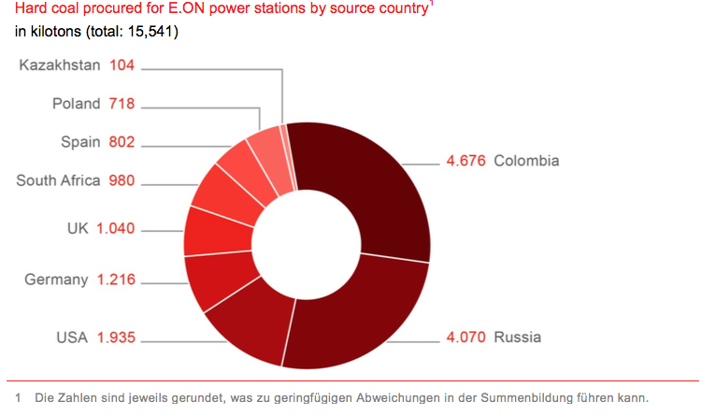The most important countries for gas supply in 2015 were Russia, Germany and the Netherlands. We ensured access to about 400 billion kWh of natural gas using long-term supply contracts in 2015. Our total trading volume of natural gas was 2,565 billion kWh (2014: 1,794 billion kWh).
The largest uranium reserves are in politically stable countries like Canada and Australia. E.ON covered its demand for natural uranium through suppliers from Kazakhstan, Canada and Uzbekistan
(47 percent, 27 percent and 13 percent respectively). Smaller amounts come from Australia, Russia, Namibia, South Africa and the USA. The uranium was enriched in Europe and Russia. We also have our own stock of natural uranium, two thirds of which come from Australia, Kazakhstan and Canada. In 2015 we sourced a total of roughly 890 metric tons of natural uranium for our nuclear power stations in Germany and Sweden (2014: 1,000 t).
Development of purchasing volume in non-fuels
We obtain the majority of our goods and services (non-fuels) from the countries in which we are active. This is borne out by figures from 2014 and 2015; during the period from January 2014 to December 2015, approximately 89 percent of our non-fuel purchasing volume was commissioned from suppliers in the countries of our regional units, as well as from suppliers in Norway and the United States; global units are engaged in these countries to an extensive degree. For example, in the following diagram, the share of total purchasing volume in Germany, the UK, Sweden and Romania are shown:
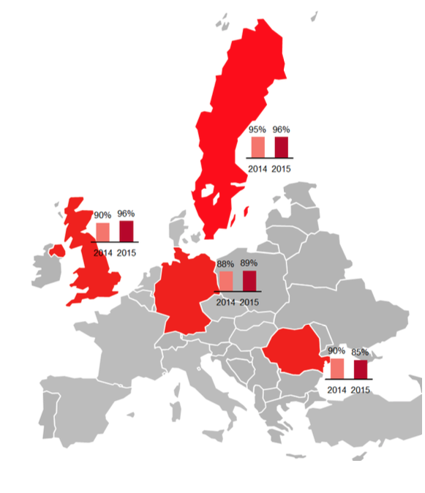
7.3 Community
What activities does E.ON engage in as part of "Community Involvement"?
Our regional units are involved in what are in some cases long-standing partnerships to support local projects (Community Involvement). We focus here primarily on energy and environmental education, climate protection and energy access. In the countries in which we are active we have thus implemented many educational projects (some of which are ground-breaking) for children aged between 3 and 18 or their teachers and educators. Group management provides advice in the design and implementation of these projects.
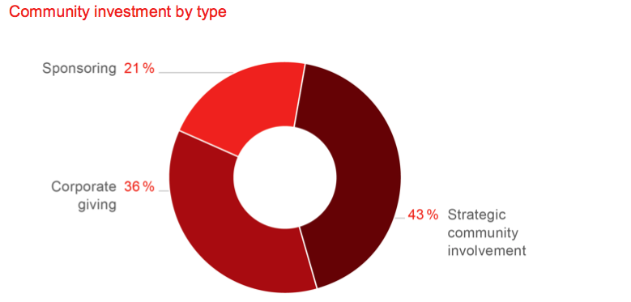

In 2015, the volume of social investments decreased further, falling from EUR 23 million in 2014 to EUR 14 million last year. There are two reasons for this: cost discipline in the company and the decision not to continue with certain programs in Britain. Each year we publish details on the extent of our social investment in individual thematic areas for seven categories: 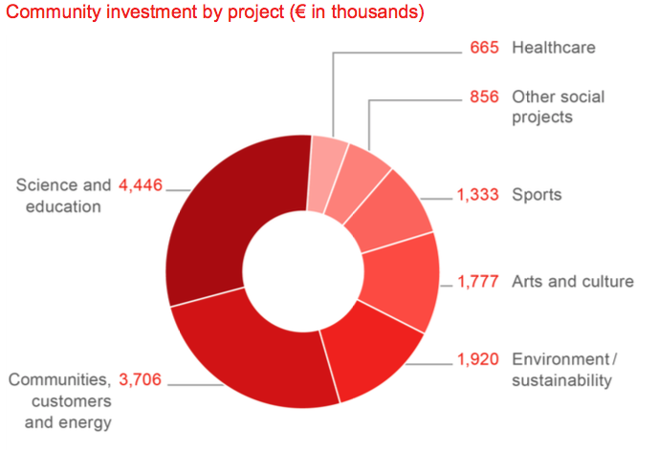
How does E.ON encourage its employees to be involved in volunteering?
Since 2009, there have been corresponding activities in all countries in which we are active. The scope of these, however, varies depending on the particular country. Last year, over 2,167 E.ON employees throughout the Group worked around 12,747 working hours doing volunteering (figure adjusted for the commitment by the regional units in Spain and Italy). The Group consequently provided the equivalent of around EUR 318,675 of work in all.
In what international industry forums, initiatives and conferences is E.ON active?
World Energy Council:
We are involved in the World Energy Council (WEC), which campaigns globally for an affordable, reliable, and eco-friendly energy supply. Leonhard Birnbaum, a member of the Board of Management, currently heads the European arm of the WEC. In this capacity, he was involved in 2015 in numerous discussions at a national, European, and global level. The WEC includes all energy sources in its work and has a broad membership base. This includes governments and authorities as well as companies, the scientific community, and NGOs.
econsense – Forum for Sustainable Development of German Business
Leading German companies and organisations with global operations have joined forces in econsense – Forum for Sustainable Development of German Business. Since its foundation in 2000, E.ON has participated in a variety of econsense working groups focusing on issues such as sustainability in the supply chain, climate and environmental protection, and sustainability performance metrics. We share experiences, develop joint positions, and contribute to social discourses together with other companies. econsense also moderates the preparation of the "National Action Plan (NAP) for Business and Human Rights", which is to be adopted by the Federal Cabinet in 2016. E.ON was involved in the hearing on "Reporting and Transparency" with the members of the NAP steering group. E.ON is also involved, as part of the Supply Chain Management working group, in the design and development launch of a Human Rights training module.
CDP Worldwide
E.ON participates in the Climate Change Programme and the Water Programme of the independent information service provider CDP (formerly Carbon Disclosure Project). We also participate in CDP forums: Our aim in doing so is to communicate our strategy to a broad range of professionals and learn from other organisations.
World Business Council for Sustainable Development
The World Business Council for Sustainable Development (WBCSD), a coalition of leading sustainability-oriented companies, serves as an important interface between international policymaking and the corporate world. The initiative focuses on energy and climate protection, ecosystem protection, and sustainable development. We participate in a number of WBCSD working groups, such as the Greenhouse Gas Emissions Working Group. We are also involved in collaborative projects, for instance in developing standards for sustainable water management in the energy industry. Apart from that, we were once again involved in the
"Reporting matters" initiative and are sharing information and ideas with the WBCSD "Low- Carbon Micro Grids" working group.
Global Compact
Within the United Nations Global Compact, E.ON participated in 2015 as a member in the work of the Business and Human Rights peer learning group. The group, attended by around ten DAX companies from different sectors, provided a special type of forum for discussion with its personal meetings in 2015. One of these meetings, which was attended also by a representative of the UN High Commission for Refugees (UNHCR) and corporate representatives from the Southern Europe Global Compact Group, was devoted to the experiences companies had had relating to the issue of aid for refugees.

7.4 Invironment
Our business as an energy company poses considerable environmental risks, primarily through our operation of conventional power plants. With the combustion of coal and gas, harmful pollutants and significant quantities of CO2 are released into the air. Waste products from conventional production can also affect the environment if we do not dispose of them properly. Especially radioactive waste resulting from the use of nuclear energy and the dismantling of facilities particularly provides us with challenges.
Raw materials that we use in production processes are not available in unlimited quantities. We can only operate our power plants in the future if we handle these resources carefully and efficiently. We must also keep the potential effect on the environment in mind with the expansion of renewable energy and rule out placing bird and fish species at risk.
Material aspects
In our materiality analysis we have analysed the expectations of our key stakeholders. In this regard, we lay out the following significant topics in the field of ‘environmental protection’:
Avoiding impact of conventional power plants on the environment and biodiversity
Our conventional power plants contribute to security of supply by switching to low CO2 energy generation. Hence, reducing the impact that emerges from the use of coal, oil and natural gas towards the environment and biodiversity remains a central concern for us. Government and society set high demands. Naturally, we must satisfy these to secure our business activity as well. If we are successful in reducing emissions from our power plants to the required level, we can meet stiffer environmental regulations in advance and proactively counteract stricter requirements. A positive effect on the length and cost of approval procedures is not a negligible concern either. If we do not observe environmental regulations, it may result in fines and withdrawal of our approval.
Environmentally replacing nuclear power plants and safely storing radioactive waste
The disposal of radioactive waste is the most important environmental issue in the coming year for 28 percent of all Germans. In accordance with the amendment to the German Atomic Energy Act that entered in force in August 2011, all remaining nuclear power plants in Germany must be removed from the grid by the end of 2022 at the latest. E.ON operates nuclear power plants in Germany and Sweden. Environmentally-friendly decommissioning of these facilities and the safe handling of radioactive waste is coming more and more into focus for us. We have already gained extensive experience in decommissioning nuclear facilities from our first decommissioning projects. And as we expand our competence in this area, the opportunity to move into new areas of activity opens up to us, for example in offering consulting services in decommissioning.
Responsible use of water (Water management)
Water is an indispensible resource in our work. As the world population grows, and wealth and energy consumption increases, the International Energy Agency (IEA) expects that water demand in the energy sector will increase by 85 percent by 2035.In addition, climate change will affect the availability of water, according to findings by the Intergovernmental Panel on Climate Change (IPCC). Therefore, we must establish a responsible approach of handling water. Only this can ensure that this valuable resource will also be available for our business and our stakeholders in the future. By implementing new, innovative and environmentally friendly technologies for our facilities, we will require not only less resources, but our operating costs will drop as well.
Considering environmental impact in the development of renewable energy and the grid
E.ON will also be developing renewable energy further in the coming years. This requires further expansion of the grid, because locally generated power must be transported from the place of production to the consumer. As we operate distribution networks in seven countries1, this challenge also affects E.ON. We must develop both of these – the development of renewable energy and the expansion of the grid – as ecologically compatibly as possible. This is the only way that we can ensure public acceptance of these projects. Development of the most environmentally friendly technologies for the construction and operation of renewable generation facilities can also afford us a competitive advantage in an internationally growing field of business and help us deal with increasing regulatory requirements.
Management and measures Our actions are guided by the precautionary principle endorsed by the United Nations. Hence, we consistently support the concept that environmental damage will not even occur. For E.ON, integrity of people is bound together with protection of the environment. A dedicated department at Group Management is responsible for the foresightful management of our health, safety, and environmental (HSE) performance. The management chapter of this report contains a detailed description of our HSE organization.
Uniform standards for environmental and climate protection
HSE Management, our business governance group directive that was released in September 2013, requires all E.ON units, both global and regional, to introduce an externally certified environmental management system. In this way, we want to combine group processes and ensure integrated and effective health, safety and environmental (HSE) management within the group.
Part of the “HSE Management” group directive is our “Declaration of Principles for Health, Safety and the Environment”. In this declaration of principles, we commit ourselves to reducing our ecological footprint in all our areas of activity. We also commit our suppliers to fulfilling our HSE requirements. For example, HSE Management and Performance include criteria that we apply testing under queries for procurement from non-fuel suppliers. Depending on the size of the supplier, we require, among other things, OHSAS 18001, ISO 14001 or EMAS III certificates or we conduct an HSE audit.
Identifying and avoiding environmental incidents
We monitor, inspect and maintain our facilities in accordance with our environmental management, so as to prevent environmentally relevant incidents as much as possible. However, if such incidents should occur, such as pollution by spillage, our environmental and crisis management will ensure that the impact will be reduced as much as possible. With “Prevent!”, our online-based event management system, we have documented such incidents centrally since 2012 and develop risk minimisation measures on this basis.
Systematically identifying and allowing for environmental risks
Aspects of environmental protection such as biodiversity and water scarcity play an important role in the development, planning and implementation of our generation projects. As required by environmental management standards, we continually collect and evaluate all relevant environmental factors. These vary by type of facility: with biogas facilities, we must primarily deal with air and noise emissions, and with renewable energy such as wind turbines and power lines, with surface use and biodiversity aspects.
In the planning of facilities, all project managers are responsible for taking into consideration the results of environmental impact assessments (EIAs). They are supported at every phase of the project – from construction and commissioning to operation – by our HSE experts. Regular meetings of the HSE managers facilitate the exchange of experiences and best practices.
Decommissioning of nuclear power plants and storage of radioactive waste
The goal of E.ON Nuclear Power is to make a significant contribution to climate-friendly, reliable and affordable electricity generation in Germany and to ensure safe and reliable decommissioning of existing facilities. We have extensive experience in the dismantling of nuclear facilities under related projects at the Würgassen and Stade sites. We will bring this expertise to future decommissioning of other facilities.
Secure provisional storage of all radioactive waste from operations and decommissioning must be ensured until the provision of necessary final storage facilities by the federal government. We fulfil this requirement under the strict requirements of existing regulations. We are monitored by the appropriate regulatory agencies in this regard.
Provisions for environmental protection measures
Before all else, our provisions for environmental protection measures ensure that we have enough funds for possible sanitation and water protection measures and remediation of contaminated sites. In 2015 our short-term provisions for environmental-protection measures and similar commitments amounted to EUR 76 million (2014: 75 Mio Euro); long-term provisions amounted to EUR 775 million (2014: EUR 796 million).
Extensive water management
E.ON has been a member of the “UN CEO Water Mandate” (UN WM) since December 2015. We belong to an easily manageable number of companies whose water management complies with the requirements of the mandate. The UN WM is an internationally recognised voluntary association and a network that seeks to improve water usage worldwide. With E.ON’s Water Management Corporate Policy, which was approved at the end of 2014, we established an important requirement for membership. The policy complements our HSE basic requirements for fundamental principles of responsible water management.
Targets & Performance Review
For E.ON, environmental and climate protection go hand in hand. Our goals for reducing CO2 emissions that we have set in our climate protection field of implementation also play into environmental protection. Furthermore, we have set the following goal for our 2012-2015 operational programme: we want to establish comprehensive water management along our value chain to meet requirements for membership in the ‘UN CEO Water Mandate” by 2015. We were able to reach this goal on schedule.
Environmental incidents in the E.ON Group
The effectiveness of our externally certified environmental management system can be recognised in, among other things, the extent that we have been successful in avoiding environmentally-related incidents in the E.ON Group. We divide environmentally relevant incidents into four categories: “severe”, “moderate”, “minor” and “inconsequential”, based on certain features. Severe and moderate environmentally related incidents are subject to reporting within 24 hours. They must meet at least one of the established criteria. Examples of serious incidents include irreparable damage to protected habitats or clean-up costs exceeding EUR 1.5 million.
In 2015 there were zero serious incidents and twenty-nine moderately serious incidents at E.ON. The number of moderate incidents increased in comparison with the previous year, in which there were only 16 incidents in this category. In addition, there were 120 minor incidents and 375 inconsequential incidents. The number of inconsequential accidents decreased slightly; 391 incidents were recorded in this category in 2014.
The steep decline in incidents with inconsequential impact – in 2014 there were still about 21,191 incidents in this category – can be attributed to the fact that gas leaks in the distribution network in Romania in 2015 were not included in the calculation. Such incidents often occur due to the steel piping still being used. This was not included in the calculation so that better comparability with other incidents in this category could be established
Just as in 2014, there were no category one to seven incidents at our nuclear power plants in 2015, based on the seven-level International Nuclear Event Scale (INES).
Detailed information on the management of radioactive waste, our decommissioning activities and security measures related to nuclear power plants can be found at the Nuclear Energy website, and starting in May 2016 on the PreussenElektra site.

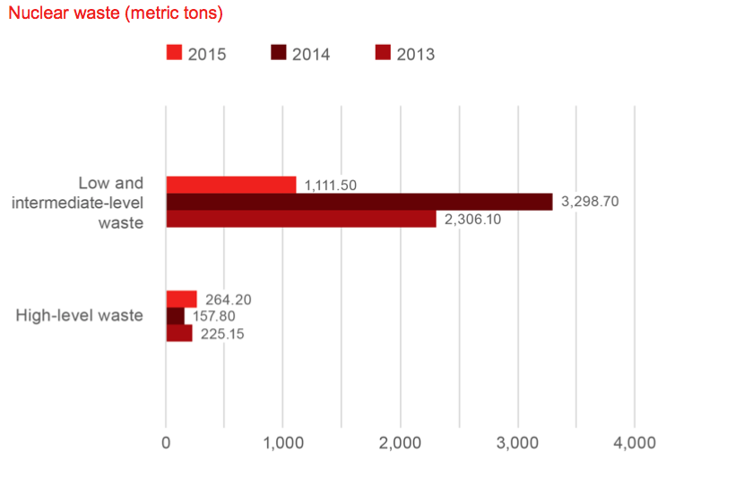
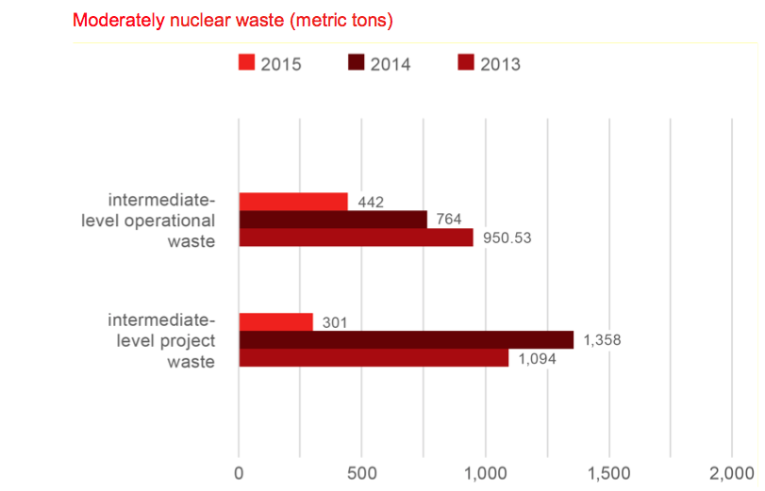

There was a sharp decrease in the quantity of low and moderately radioactive waste in 2015: in comparison with the previous year, 2,187 less metric tons of low and moderately radioactive waste accumulated; this corresponds to a drop of 66.3 percent. 301 metric tons of moderately radioactive waste – some 40.5 percent – occurred during the decommissioning of our facilities (project-based business) and not in the operation of the nuclear power plants. The sharp decrease noted in comparison with the previous year is primarily due to the complete decommissioning of the Würgassen nuclear power plant, which was already completed in 2014. So no further waste accumulated in 2015. Presumably, this value will increase again in the coming years due to the upcoming decommissioning projects.
The increase of highly radioactive waste by 106 metric tons to 264.2 metric tons is primarily due to the decision made in 2015 to take the Swedish Oskarshamn 2 reactor permanently out of operation and not restart it. Consequently, all fuel elements of the reactor have been designated as highly radioactive waste.

7.5 Education

Vocational training of young people is of great importance for us. In 2015, 331 young people began their apprenticeships at German E.ON locations (previous year: 342), and 385 of a total of 441 graduates were taken on in subsequent employment. A German vocational training model is not offered in this form in other countries. However, we also offer similar career-building programmes in other European countries as well, such as, for instance, Great Britain.
The changes in the energy sector should in future be reflected already in training. Therefore, the content of the training, for instance, is increasingly focused on industrial and technical professions and more than ever, on renewable energies and thus on our new strategies. In 2016, we will offer for the first time a commercial training station abroad as well, with the aid of our “E.ON abroad” programme. In addition, as part of tariff negotiations with the unions we agreed that all graduates completing training in 2015 would be taken on for at least 12 months fixed-term, and at least 120 graduates in permanent jobs. With a total of 179 permanent acquisitions, we could even exceed this figure in the reporting year. A large number of permanent acquisitions should be pronounced in the year 2016.
Furthermore, we have been contributing to a German-wide training agreement with the aid of the E.ON Education Initiative ever since 2003. In 2015, we supported some 550 young people during the process of transition from school into their professional life. This has been carried out e.g. in the form of school projects, education preparatory courses and internships with partners. Our programme for refugees is also included therein.
E.ON Graduate Program for college graduates
E.ON Graduate Program (EGP) plays an important role for us during training and development of high-qualified college graduates. The trainees work in different business areas and functions for several months each, from engineering to IT, finance, distribution and corporate development and HR, and attend various seminaries. In this way they can familiarise with various business units in Germany and abroad.
In 2015, 80 promising talents started the graduate programme-coming, among others, from Great Britain, Germany, India, Turkey, Indonesia and Czech Republic. Although the portion of female students amounts to only 10 to 20 percent in many technical studies, we were able to realise a women’s share of 41 percent in year 2015.
Identify talent and develop it systematically
Support and further development of our employees is a central task of executive officers at E.ON. An important basis for this is E.ON’s new advanced training course which integrates formal learning processes more thoroughly in the work routine. Furthermore, we support the executive staff when performing this task with the aid of a systematic talent management.
New competence model “grow@E.ON”
The changes on the energy market represent new challenges for our personnel management as well. In order to reach our goals and be successful in the future as well, we define inter-divisional and transnational competences for executives and employees and comprise them into a global competence model. The new model that carries the working title “grow@E.ON” should ensure transparency of expectations we define for our employees and executives, and provide help to their personal development. Topics such as customer orientation and responsibility are still the main focus thereof.
“grow@E.ON” also represents a basis for selection and development processes of our employees and for our programme for talent promotion. We want to provide experiential value for our managers and employees and ensure the highest quality standards. That is why we adapt appropriate instruments, such as the competency-based development talks or the follow-up formats for internal and external assessment centres. The first pilot projects for staffing and staff development with the new title “grow@E.ON” are currently launched in various units and countries such as Germany, UK and Sweden. The findings from the pilot projects will then be integrated in the final model, which will be rolled out during the year 2016.
New training approach integrates learning processes into everyday work
The integration of learning processes into the daily work routine is still a fundamental principle of our activities in the training. The increasing digitalisation of the learning has a major influence on this development.
The so-called 70/20/10 model was the focus thereof in year 2015. According thereto, only about 10 percent of the knowledge about formal learning processes - such as for instance, during structured training - are learnt. The remaining 90 percent, the so-called “informal learning”, accounts for interaction with others (20 percent) and collection of experiences (70 percent). Through a wide range of part-time programs, courses, workshops and self-study materials and with the aid of raising awareness of opportunities for informal learning, we promote a self-reliant learning culture. Executives and employees should be able to organise their training themselves in terms of content, duration, location, pace and method.
Supporting processes of change through CoC Global Learning
In 2015, we, among other things, placed a particular focus on supporting our employees and executives in better identification, understanding and management of human aspects of processes of change. Various offers were developed for this purpose, which facilitate an independent learning process. Intranet-based Change Cube, which best summarises the self-help tools already available in the E.ON Group for the change management is a part thereof. The tools are tested, up-to-date, easy to use and placed at the disposal of all executives, superiors and employees. The introduction of the Change Cube was accompanied by the so-called “Change Unplugged” short-term events. In the form of a marketplace, the participants were informed about methods, tools and offers about how one can master change processes himself while assisting employees and their team. In addition, the format
offered the opportunity to get together with other executives and HR colleagues and exchange experiences.
New system for the talent management
In order to optimise our personnel processes and our talent management, we implement new systems and programmes on a regular basis. The most recent example hereof is the talent management suite (TMS) introduced in 2015. This integrated software solution facilitates various HR processes which relate to attracting and professional development of talents. They are: employee recruitment, talent nomination, annual assessment of our managers, including variable compensation, succession planning and staffing management positions. This new solution improves the data quality and provides an overview for the employees of the data which have been stored at our company.
Executive and talent portal provides a transparent overview
The executive and talent portal supports our executive officers and talents during their professional development. The portal represents an information platform for E.ON executive officers and talents, but also for all our HR colleagues who are responsible for these target groups. It offers a transparent overview of all relevant HR services: For example, a learning curriculum with special seminars and trainings, information about the new global staffing process and a calculation tool for the compensation. In close cooperation with the product and process experts from the education and further training departments, the Business Services Centre (BSC) works in Berlin continually to update and improve the content. The portal has been online since November 2014 and recorded steadily increasing numbers of users.
New process for global staffing of executive positions
In 2015, we successfully filled top management positions over 29 percent across business units and over 9 percent across countries. In 2015, we introduced a revised, Group-wide process of staffing executive positions in order to optimise the allocation of executive positions even further. The key element of the process is a placement conference, where representatives of different areas of the company at least every other week discuss the free leadership and possible candidates. The transparency of the decision-making process is increased thereby. Furthermore, the equal opportunity is promoted in the list. The final decision as which applicant will be appointed at the selected position is a task of the respective executive officer.
7.6 Healthcare
We believe that it is of great importance that our employees do not jeopardize their health in any way when performing their work. In addition, they are to have the opportunity at any time to discuss physical or mental problems openly and confidentially. In 2015, corporate management and the Group works council in Germany signed the “Health" Group Works Agreement. In signing it, E.ON commits to ensuring that it provides a healthy work environment and to promoting the health of every single employee in an optimised manner. As part of the Works Agreement, four equally ranked areas of activity were defined: Corporate Health Management, Addiction Prevention and Intervention, Corporate Integration Management, and Employee Counselling.
Focus on mental health
As in years past, our employees’ mental health was again the focus of our corporate health management program. Disability days due to mental stress are occurring with greater frequency in countries like Germany. Among other things, these may be caused by the workplace and the work environment. In addition to awareness campaigns and training for employees and managers, we conducted a risk assessment for mental stress in 2015. To this end, we used a survey that was distributed in various companies and locations in Germany, to analyse whether our employees’ work conditions are mentally stressful. Based on the findings, we developed various measures of which many have already been implemented. Plans call for conducting the risk assessment in 2016 in other areas using this systematic analysis.
Health rate at a glance
The health rate provides information about the percentage of days worked in relation to the agreed upon work time. At 96.7 percent, the figure remained at a high level again in 2015.
In 2015, many employees and managers Group-wide participated in programmes to promote awareness for physical health and psychological issues. The respective activities and campaigns in the various regions were selected based on need. For example, new challenges are emerging due to demographic changes. Employees must work longer and more flexibly, and must still be efficient. This is only possible in a work environment that promotes health.
In 2015, many employees and managers Group-wide participated in programmes to promote awareness for physical health and psychological issues. The respective activities and campaigns in the various regions were selected based on need. For example, new challenges are emerging due to demographic changes. Employees must work longer and more flexibly, and must still be efficient. This is only possible in a work environment that promotes health.
In 2015, following health-promoting measures were conducted, among other things, in the individual regions:
Introduction of “E.ON Life” – an interactive online platform that provides information and advice on health-related topics, such as mental health, nutrition, and sleep (Great Britain)
Pilot project in regard to dealing proactively with alcohol and drug addiction (Sweden)
Development and implementation of new tools to assist managers in dealing with stress (Hungary)
In 2015 as in years past, all units Group-wide were encouraged to participate in an HSE Day that focused on the topic of “Health.” In addition, our HSE experts held an international knowledge-sharing workshop that was based on a health-related survey among all management units in the Group. Attendees presented best-practice measures and agreed on developing Group-wide indicators pertaining to health.
External counselling via the Employee Assistance Program
By signing the “Health” Group Works Agreement in 2015, we also committed all E.ON companies in Germany to offer their employees counselling services. Since 2013, employees of administrative units and most of the associated regional supply companies of the regional unit Germany have already had access to the Employee Assistance Programme (EAP), which is an independent external counselling service. It operates on a strictly confidential basis and may be used by managers and employees. They receive counselling in personal meetings with qualified experts in regard to personal, work-, or health-related issues and problems. If therapy is needed, the experts promptly refer the respective employees to the appropriate specialists, therapists, or treatment centres.
In the meantime, the EAP is also available in Great Britain, Sweden, the Czech Republic, and Hungary. Other global and regional units offer their employees comparable assistance programs.
Risk-identification training for employees
Generally, E.ON’s objective is to generate awareness among its managers so that they can correctly identify absentee patterns and address discrepancies directly. Since 2013, the Centre of Competence for Global Learning (CoC for Global Learning) has offered managers an e-learning tool, among other things, on the topic of “Mental health in the work environment” to assist them. In 2015, a total of 1,400 training sessions were conducted for managers on this topic. In addition, the Group offers online courses and training on other topics, such as “stress management,” “health management,” and “drugs and alcohol.
Protection for travel and overseas assignments
Due to the globalisation of the workplace, many E.ON employees nowadays are required to travel for work-related reasons or to take on longer assignments or projects abroad. Our responsibility is to prepare them systematically and to protect them against health- and safety-related risks. For that reason, we introduced a structured management process and established binding regulations in the “International protection for employees” business directive. The COC for Global Learning also conducted various courses and training on the topic of “Safe travelling” in 2015. A total of 40 employees have participated in online training.
Epidemics represent a special challenge to the health of our employees. For that reason, travel medicine is becoming more significant in occupational health-related counselling Group-wide. The “fitness examination for activities in the tropics, subtropics, and other work locations with particular climatic conditions and infection hazards” is an integral part of our occupational health office’s care services. In addition, when sent overseas, our employees can turn to an international service provider, including its global assistance centre and teams of international, multilingual experts, for assistance.

7.7 Specific projects
Solar power from a container
It began in 2014 with a single 20-foot shipping container in Komolo, a small village in northwest Tanzania. The photovoltaic-and-battery hybrid system in the container provides 46 households in Komolo – E.ON’s first-ever retail customers in Africa -- with clean power around the clock. The system was designed and installed by E.ON Off Grid Solutions (EOGS). The power is sold under a new E.ON brand: Rafiki Power, which is Swahili for “friendly power.”
Seven additional container systems had been added through the end of April 2016, raising Rafiki Power’s customer base to about 420 households. EOGS headquarters now has seven employees (four Tanzanians and three Europeans). The company´s objective is to become self-funding and make its business model sustainable.
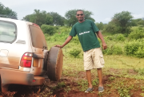
Roving customer service
Mohamed Roshi has been working as an EOGS customer service representative since mid-2014. The former safari driver now travels from village to village resolving issues and answering the questions of new and existing customers. We talked to him about his job, his customers, and EOGS.
Mohamed, what are some of your customers’ typical questions?
One common question is about the cost of electricity and how to pay for it. Many customers also want to learn more about electricity, such as how it’s metered and billed. We spend a lot of time explaining to them what a kilowatt-hour is and how much electricity is consumed by different household appliances and devices.
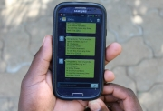
How do Rafiki Power customers pay for their electricity?
With their cell phone. Almost everyone in sub-Saharan Africa has one. Unlike the power network, cell phone coverage is quite extensive. Customers make an electronic prepayment by sending an SMS on their cell phone. This gives them a credit for a certain amount of electricity. They can also monitor their consumption and remaining balance at any time and contact customer service.
What do you think the project means for customers? Have you seen positive changes?
It makes them happy because it has improved their contact with the outside world. They can now charge their cell phones, listen to the radio, or watch TV whenever they want to. Newspapers take a week to get here. But continuous power enables our customers to stay up to date about what’s happing in their region, their country, Africa, and the entire world.
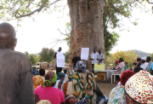
What do you see as EOGS’s biggest challenges?
Our customers need to take what they’ve learned about electricity and apply it in their daily lives. For example, an old tube TV uses four times as much electricity as a flat-screen, which makes it that much more expensive to run. To help keep electricity affordable, we’ve started selling energy-saving refrigerators, TVs, and other household devices. These would otherwise be hard for our customers to come by, since the nearest city is simply too far away.

Reliable technology in a small package
The 20-foot shipping container has two sections. The back houses the batteries and other electrical equipment, the front a small retail store. The electricity is generated by a photovoltaic-and-battery hybrid system. The system’s output is adjusted to meet the consumption of each village, which currently varies between 6 and 12 kilowatts of peak power. If cloudy weather interrupts the production of solar power, the battery has enough useable storage capacity to meet the village’s needs for at least one day.
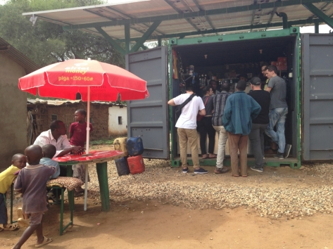
Households in the village are connected to the system via a mini-grid, providing them with uninterrupted service of 230-volt alternating current. It not only powers lights and televisions but also machines like water pumps and milling equipment. In short, the system provides people who live beyond the reach of conventional power grids with a reliable and affordable source of electricity.



8.1 Employees
More than 45,400 men and women work for Heidelberg Cement worldwide. Their achievements make us one of the leading companies in our sector. That’s why it is very important for us to provide them with good and attractive working conditions. As a manufacturing company, we put a high priority on occupational safety and the protection of our employees’ health. To ensure our company’s sustained success, we must have highly qualified and motivated employees. That’s why our human resources policy focuses especially on identifying talented individuals in the market, developing them within the company, and binding them permanently to our enterprise. Our Leadership Principles specify binding personnel management regulations. They deal with issues such as respectful treatment, employee development and our company’s pronounced feedback culture. The main leadership principles are embedded in standard human resources processes and described in detail in Heidelberg Cement’s Human Resources Guidelines.
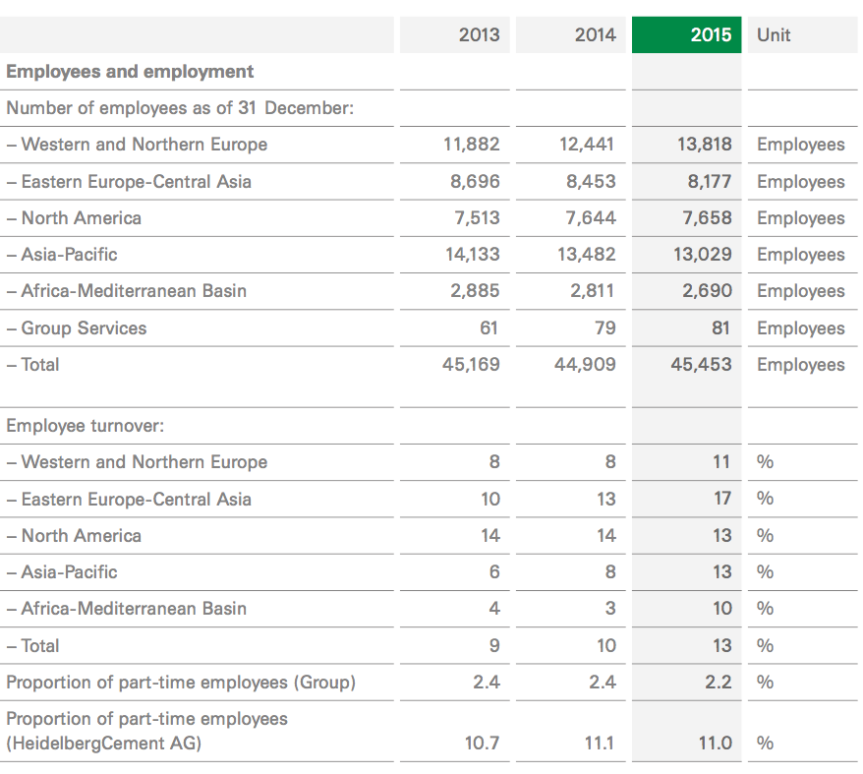
Because outstanding business performance is also a result of legally and ethically compliant behaviour, the Managing Board has approved a Code of Conduct that is binding throughout the Group. This code specifies our values and our ethical and legal standards. This particularly includes non-discriminatory employment conditions and an open and fair dialogue with employee representatives.
Heidelberg Cement is also committed to upholding the ILO’s core labour standards, the OECD guidelines for multinational enterprises and the UN’s Universal Declaration of Human Rights. We have also enshrined this commitment in our Leadership Principles. We expect our employees and business partners worldwide to act in conformity with these essential guidelines and recommendations
. 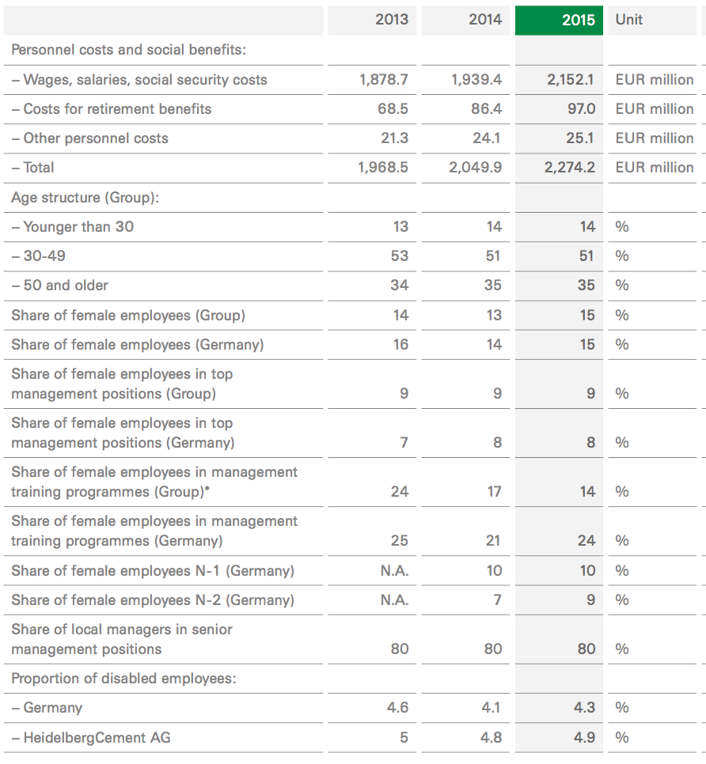
Development of workforce numbers worldwide
At the end of 2015, HeidelbergCement employed 45,453 (2014: 44,909) men and women. The increase of 544 employees was primarily the result of two opposing developments. On the one hand, we eliminated more than 1,000 jobs, most of them in the Group areas of Eastern Europe-Central Asia as well as in India and Indonesia. These job cuts resulted from facility optimisation and increased efficiency at sales and administrative units. On the other hand, the merger of our Swedish subsidiary Abetong AB with Contiga AB to create Nordic Precast Group AB caused our workforce to increase by almost 1,400 employees in Northern Europe. Moreover, around 200 employees were added in Australia, mainly due to the insourcing of truck drivers.
Dialogue with employee committees
HeidelbergCement has a long tradition of employee co-determination, which has proven its worth at our business locations in Germany. The employee committees at the individual locations constitute the Central Works Council and its associated committees for the company and the Group Works Council. Moreover, employees are equally represented on the Supervisory Board.
Employee representation committees also exist in most of the European countries. Managers and employee representatives engage in a continuous, constructive dialogue on the European Works Council. The council supplements the local information and consultation processes in the various European countries.
In addition, there are labour unions and similar organizations in nearly all countries in which Heidelberg Cement operates. As required by our Code of Conduct, we also engage in a fair and open dialogue with their representatives.
Remuneration policy and work time regulation
Our remuneration systems are based on performance and results, in accordance with the market standards for internationally operating companies in our sector. In addition to fiixed salaries, which are specified by collective bargaining agreements or individual employment contracts, our employees also receive variable remuneration elements that depend on individual job performance and the success of the company.
We want the variable component to make up a large share of our managers’ total remuneration so that their individual and joint performance and the company’s success are clearly and directly taken into account. For the period from 2015 to 2017/18, we have created a Group-wide long-term bonus plan for the 150 executives from our top
management level. This bonus plan pursues the same objective as the long-term bonus plan of the Managing Board.
The employees of our foreign subsidiaries pro t from attractive remuneration systems that correspond to the conditions of the respective local labour markets. Collective regulations apply to more than half of the Group’s employees.
Personnel costs and insurance contributions
In 2015 expenditures for wages, salaries, social security, pension contributions and social assistance increased by 10.9% to EUR 2,274 million (2014: EUR 2,050 million). That corresponds to 16.9% of turn- over (2014: 16.3%). After adjusting for currency effects, the increase amounted to 5.3%. Higher provisions for the ongoing long-term bonus plans accounted for 2.3% of this increase.
The amount of the contribution to the pension scheme at Heidelberg- Cement corresponds to the accepted market level. In Germany, we have created a matching model for the pension scheme, with contributions from the employer and the employees. In countries without any statutory retirement or health insurance, we support our employees in a manner that is at least commensurate with local practices.
Work time regulation
In our work time regulation practices, we conform to the legal requirements in effect at our locations. We promote adherence to these regulations by means of our compliance system, which enables employees to individually report possible violations (passive monitoring). To promote flexible work time options, we offer models such as flextime, work time accounts, part-time positions and leaves of absence to our employees in Germany. Older employees have the option of switching to pre-retirement part-time work. Part-time work currently accounts for 11% of all positions at Heidelberg Cement AG and for 2.2% of the positions at the Group as a whole.
Heidelberg Cement is also faced with the consequences of demo- graphic change. Only about 14% of our employees are under 30. Most of our employees are aged 30 to 49; they constitute about 51% of the Group’s total workforce. A total of 35% of our employees are over 50. This age group’s share of the workforce will rise in many countries in future.
We are responding to this development with numerous regionally adapted measures that are intended to maintain the employees’ ability to work and promote cooperation between people of different generations. In Germany, for example, we have further expanded our range of health management services and consolidated them in our FIT for LIFE initiative. Besides encompassing a preventative programme for the early detection of illnesses and risk factors, the initiative primarily helps employees take a proactive approach to leading a healthy life. The services include check-ups to prevent intestinal vaccinations, special “Health Days” and presentations on health-related issues. In future, our health management activities will continue to focus on preventing typical age-related health risks and increasing employees’ awareness of this issue. As a result, we particularly pro- mote company sports activities for people of all ages.
According to the law for the promotion of women in leadership positions, companies in Germany have to specify concrete targets for the two management levels below that of the Managing Board. The first of these two levels consists of the Heidelberg Cement executives who, in their main position, report directly to the Managing Board, while the second level encompasses their employees with leadership responsibilities.
In 2015 women held 10% of the positions on the first level and 9% on the second level. Heidelberg Cement has decided to retain its tar- get for the two levels from its self-commitment, but to pull the tar- get-achievement date forward to mid-2017. This means that by 30th June 2017, we want women to hold 14% of the positions on the first management level below that of the Managing Board and 15% of the positions on the second level. As a result, the percentage of women in leadership positions would then correspond to their share of our entire German workforce. Our decision to pull the target-achievement date forward to mid-2017 demonstrates that we have forged ahead with the promotion of women in recent years and achieved successes in this regard. For example, the share of women in programmes for the advancement of future executives is already at 24% across Germany as a whole, and thus much higher than the percentage of women in the total workforce.
The global NOW – Network of Women also aims to promote women at Heidelberg Cement and assist them in their individual career development. This initiative connects women with one another worldwide — virtually as well as face to face. Among other things, it offers specific development training and provides an informal setting where women can regularly share their ideas and experiences.
Reconciling work and family
In competing for the best employees, we are making adjustments worldwide in line with changing lifestyles. In support of our employees who must reconcile their family and professional responsibilities, we rely on models such as flextime, part-time and leave of absence. Part-time work currently accounts for 11% of all positions at Heidelberg Cement AG. Given the small size of our facilities, cooperation with external networks has provided good solutions for support services such as daycare centres, summer camps for children and the care of family members who require assistance. This enables our employees to bene t from easy access to a professional and flexible network at affordable costs. As part of our FIT for FAMILY initiative, we have formed partnerships with daycare centres for our location in Heidelberg. In this way, we can offer a number of daycare slots specifically for our employees.

8.2 Supply/Consume
Management of supplier relations
In 2015 Heidelberg Cement procured goods and services with a total value of EUR 9,045 million (2014: EUR 8,678 million), which corresponds to 67.2% of total turnover.
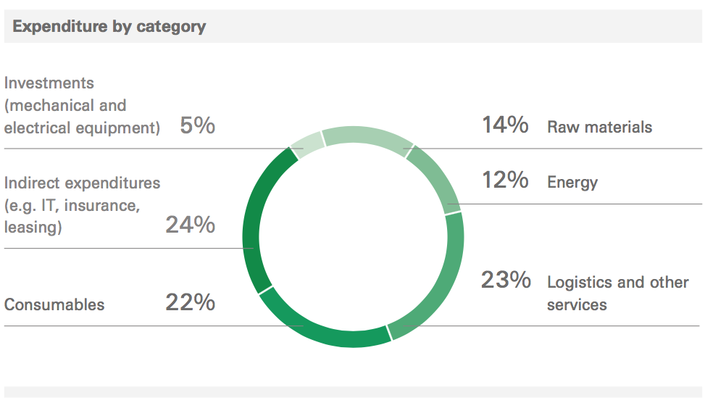
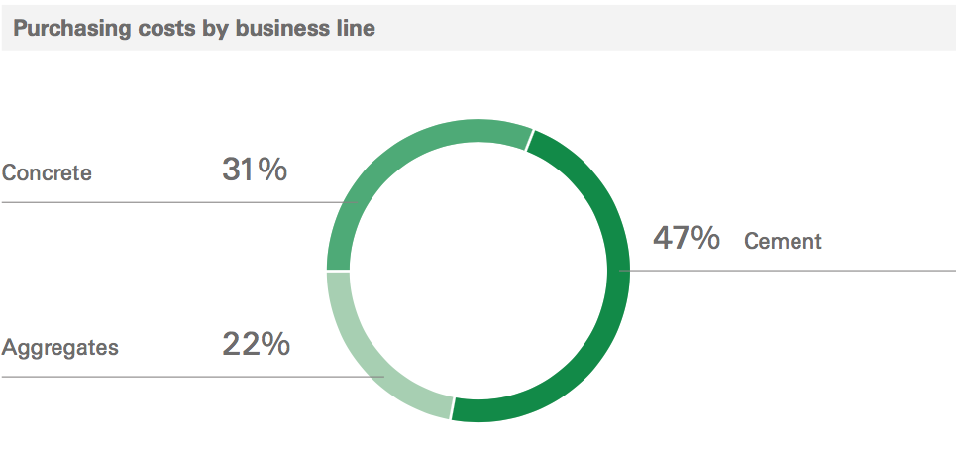
Heidelberg Cement strives to ensure compliance with sustainability standards throughout the supply chain. Group-wide procurement guidelines therefore provide clear instructions regarding supplier relationships and procurement activities.
Here too, we adhere to ethical principles such as respect, fairness and credibility, as laid out in our Supplier Code of Conduct. We systematically and transparently communicate this code to our global and local suppliers, who are obligated to act in line with the principles defined in the code. The code incorporates the key elements of the SA 8000 International Social Accountability Standard, the ISO 14001 international environmental standard and the principles of the International Labour Organisation (ILO). The code is meant to motivate our suppliers to make continual improvements to their operations. The failure of a supplier to correct a weakness or deficiency that has been identified can result in the termination of the contractual relationship.
Within the framework of a working group in the international Cement Sustainability Initiative (CSI), Heidelberg Cement is also helping to establish a standardised approach to sustainable supply chain management in the cement industry. The working group has developed a joint catalogue of principles that are based on the UN Global Compact and ILO standards, and which cover the following areas:
– Occupational health and safety
– Working conditions
– Freedom of association and protection against retaliation
– Forced labour
– Child labour
– Anti-discrimination
– Observance of environmental regulations
– Environmental impact management
– Bribery and corruption
– Transparency and integrity.
In 2015 Heidelberg Cement also launched a project for the systematic management and assessment of suppliers. A main component here will be the establishment of a platform for evaluating the sustainability aspects addressed in our Supplier Code of Conduct. This online platform will simplify the systematic collection and consolidation of data and serve as an important tool for identifying areas where the implementation of additional measures, including physical audits and onsite visits, might be necessary. The platform will thus serve as the basis for a continual improvement of sustainability performance in the Heidelberg Cement supply chain.

8.3 Community
Relations with local stakeholders
As most of our plants and quarries are situated near local communities, it is essential for us to continually maintain contact with local communities and government agencies and local organisations. Plant or facility management teams are generally responsible for such stake- holder relationships. Wherever necessary, they are supported by the national subsidiary’s communication department. We take criticism expressed by our stakeholder groups seriously and we discuss with them the points they bring up. We have adopted new approaches in many places in order to reconcile the interests of the company with those of the local community. Along with personal discussions, we also make use of the entire range of modern information and dialogue media (e.g. in the form of newsletters or guidelines) as well as differ- ent concepts of civic participation.
A CSR expert group at Group level regularly brings together man- agers from all levels for discussing local activities and the various experiences the managers have had in their communities. This helps us continually improve the stakeholder dialogue and the associated internal guidelines.
The stakeholder dialogue at the international level
Heidelberg Cement is a member of both general and industry-specific associations that represent their members’ interests vis-à-vis governments, businesses and the public. These memberships also promote an exchange with other companies and organisations and a common determination to achieve greater sustainability. The topics addressed focus on challenges specific to individual countries and industrial policy, particularly as regards the secure supply of raw materials, environmental protection, energy conservation, health and occupational safety and social and labour issues.
As a Group headquartered in Germany, we are a member of “econ- sense – Forum for Sustainable Development of German Business”. This network of global German companies views itself as a partner and an expert forum for dialogue with governments, the scientific community, media and society.
On the international level, we are a member of the Cement Sustain- ability Initiative (CSI) that seeks to create a more sustainable cement industry. The CSI always incorporates affected third parties into the process for developing standardised guidelines and protocols for the cement industry. Interested partners such as industry associations or non-governmental organisations are therefore brought into many pro- jects.
Heidelberg Cement and its subsidiaries also work with Green Building Councils in 12 countries. The goal here is to jointly develop certification systems for sustainable construction and to make the design, construction and operation of buildings more sustainable.
Dialogue with political decision makers
Legislation in the European Union is increasingly impacting our business operations by addressing all aspects of sustainability. For this reason, Heidelberg Cement has established a separate corporate function for political dialogue at the EU level. The manager responsible for this dialogue chiefly represents our interests in CEMBUREAU, the European Cement Association, which speaks for European cement manufacturers in discussions and negotiations with the EU and its various institutions. The key issues addressed by CEMBUREAU include the use of alternative raw materials and fuels, climate protection, emissions, biodiversity and occupational health and safety. As a member of the European Aggregates Association (UEPG), we also present our positions on aggregates through an effective lobbying organisation. Our interests concerning concrete are represented by the European Ready-Mixed Concrete Organisation (ERMCO) and the European Concrete Platform (ECP).
Dialogue with analysts and investors who focus on sustainability issues
Dialogue with the capital markets is also becoming more and more important, as our shareholders and an ever greater number of financial analysts and rating agencies are now interested in how Heidelberg- Cement integrates the issue of sustainability into its corporate strategy. They also want to know how successful the company has been in this regard. Dialogue with capital-market stakeholder groups generally has a bilateral format.

8.4 Environment
Our environmental policies focuses on protecting the earth’s climate. In December 2015, we reconfirmed our commitment by joining the LCTPi during the COP 21 in Paris. As an energy-intensive company, we have for many years been diligently striving to reduce our CO2 emissions. Between 1990 and 2015, we reduced specific net CO2 emissions by 22% to 606 kg CO2/t cement. By 2030, we plan to lower CO2 emissions by around 20 million tonnes of CO2 per year as compared to 1990 levels. This is an ambitious goal, but also one that can be achieved.
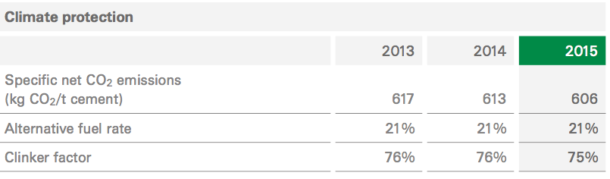

In recognition of our transparent and comprehensive CO2 reporting system, the CDP named us Sector Leader Energy & Materials in the DACH region (Germany, Austria, Switzerland) in 2015. Heidelberg- Cement’s rating of 99 A- makes the company one of the five best in the industry in these countries and one of the ten best companies listed in the DAX stock index.
Participation in the EU’s emissions trading system
Heidelberg Cement operates 35 facilities in 11 countries that participate in the EU Emissions Trading Scheme (ETS). Our Group is also actively involved in the market for emissions certificates. A Group- level position for dealing with emissions trading issues was therefore established in 2004. The associated corporate department not only manages our trading activities within the European Union (EU), but also monitors developments in countries outside of Europe that might impact the operations of our plants.
The EU now has to make critical decisions regarding the future of the European emissions trading system. Moreover, uncertainty will increase due to the discussions regarding a fundamental reform of the EU emissions trading system. We are trying to minimise the effect that these uncertainties in the European emissions trading market can have on our company by making more extensive use of alternative, CO2-neutral fuels and replacing some of our CO2-intensive clinker.
Emissions trading systems outside of Europe
Emissions trading systems are also being set up in regions outside of Europe. China, for example, is testing a variety of concepts in six of its provinces. One of these provinces is Guangdong. We operate a joint venture there, so we closely monitor how the local emissions trading system is developing. A national emissions trading system will be introduced in China in 2017. In 2013 California (USA) launched its long-awaited emissions trading system, which we helped to develop. However, the system has minimal impact on our business operations.
In 2015 we completed our tests of four different technologies for separating CO2 from combustion exhaust gases at our plant in Brevik, Norway. We presented the test results at the Carbon Capture and Storage (CCS) conference that we held in May 2015 with the support of Norway’s Ministry of Petroleum and Energy. We are now using the knowledge gained from the tests to put together a comprehensive feasibility study for the construction of a major CO2 capture facility in Brevik. We are receiving financial support for the study from Norway’s state-owned Gassnova carbon capture and storage company. This facility would be the first major CCS plant in the cement industry.
As part of our efforts to further develop oxy-fuel technology, Heidelberg- Cement is participating in the CEMCAP project for promoting the use of CO2 separation technology in the cement industry. The project is being financed through the EU’s Horizon 2020 programme. In the oxy-fuel process, pure oxygen rather than ambient air is fed into a rotary furnace, which makes it easier to capture CO2. We are currently working on the development of this technology on a pilot-plant scale at our facility in Hanover, Germany.
Habitat protection
Heidelberg Cement has been able to restore many habitats by recultivating and renaturating former quarries. In order to effectively promote biological diversity, we became the first company in the construction materials sector to define uniform standards for recultivation, renaturation and habitat management. These standards are combined in a guideline that is binding throughout Europe. In comparable form, the standards are also used as a handbook in Asia and Australia.
Heidelberg Cement continued to focus on the development of more sustainable construction materials in 2015 as well. Experts at our central research laboratory have discovered a new reactive clinker phase and we are now working on the development of a manufacturing technology for this clinker, which has already been registered under the brand name TernoCem®. To this end, and within the framework of the TernoCem® product development programme launched in 2015, we now want to obtain scientific-technical knowledge about raw materials suitability, clinker production and hydration mechanisms for cement. We are also establishing the expertise needed to ensure important product attributes such as workability and durability.
As a leading member of the European Construction Technology Platform, we also promote the development and utilisation of product solutions for energy efficient buildings and cities. In 2015, for example, we continued to move ahead with the distribution of our Cemflow technology for a self-levelling floor finish that perfectly embeds in-floor heating pipes. We also continue to develop Heatcrete, a new concrete-based solution for thermal energy storage.
As a founding member of the Concrete Sustainability Council, we actively participated in 2015 in the development of a new certification system for sustainably manufactured concrete. This system takes into account social, ecological and economic aspects along the value chain. The widespread use of this transparent certification system will make it possible for the concrete industry to obtain greater recognition from Green Building Councils and in tendering processes for public construction projects. HeidelbergCement is also a member of 12 national Green Building Councils.
As early as 2013, we launched Ecocrete® in the Netherlands. This concrete, which contains recycled aggregates, makes an important contribution to closing the loop in the material cycle. In 2015 our organisation in Germany took over the management of a research project on the futilisation of recycled construction materials. The project, which supports the goals of the European Commission regarding the transition to a more circular economy, was launched with several co- operation partners and receives funding from the German government.
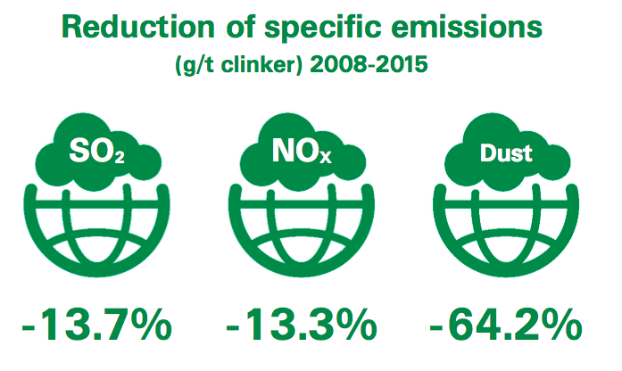
Local environmental impact
During the reporting year, we made technical improvements at many of our plants in Europe and Indonesia in order to reduce emissions of dust, nitrogen oxides and sulphur oxides. In the Czech Republic, we continued our long-term project for reducing noise and dust at our cement plants in Mokra and Radotin. We also installed sound dampers at TulaCement in Russia in order to reduce noise levels at that facility. Our new plants in Togo and Burkina Faso comply with inter- national standards for reducing emissions. Facilities for the continual monitoring of dust, nitrogen oxide and sulphur oxide emissions in line with CSI guidelines were installed at our new clinker plant in Tabligbo, Togo. In 2015 activities at our aggregates business line also focused on reducing noise and dust emissions.
Our primary focus in terms of waste management concerns the kiln dust that is a by-product of clinker production. This dust has to be removed from the kiln systems at several facilities in order to prevent disruptions to proper kiln operation. We generally use the kiln dust as an alternative raw material in cement production, thereby improving our ecological efficiency. In some exceptional cases, the composition of the dust prevents us from being able to recycle it 100%. A second option for us is to use the kiln dust as a raw material for the production of special concrete. If no other option is available, it can be deposited in landfills in a controlled process. The local operating permit at each plant specifies the allowable amount of process-related waste products and how it is to be used.

8.5 Education
Human resources development
Talent management
Qualified, motivated employees are a key prerequisite for the long-term success of our company. That’s why our Group-wide human resources policy focuses on identifying and further developing highly talented individuals and competing with other companies to retain them. We use the Heidelberg Cement competence model to do so. This model defines the professional and personal talents and skills that are crucial for our business success. It thus allows the respective supervisors to carry out systematic Group-wide evaluations of performance and potential on the basis of standardised criteria. It also serves as a basis for strategic executive development and effective succession planning. Supervisors and employees hold structured human resources talks in which they discuss development opportunities and prospects. The dialogue is primarily geared toward senior and middle management, experts and future executives. It helps us to attain three goals:
– To fill key positions worldwide with top-quality candidates from within the company;
– To develop highly talented individuals in a targeted way;
– To bind talented employees to the Group over the long term byoffering individual development planning programmes.
IT-supported human resources processes
In recent years, one of the focal points of the Human Resources unit was the global introduction of key IT-supported processes for the top, senior and middle management levels. Since the beginning of 2013, the unit has been conducting the performance management, target agreement, remuneration, employee dialogue and individual development plan processes for senior executives on the new IT-supported platform HR GLOBE. At the end of 2015, we completed the platform’s expansion to the middle management and the future executives as scheduled.
Training and career development
Sustainable human resources work means investing in the systematic training of our staff and thus in recruiting and training highly qualified young employees. In Germany as a whole, 5% of our employees are involved in training programmes (2014: 5%). Around 80% of the people who complete their traineeships are retained as permanent employees (2014: 84%).
Technical and mechanical skills are indispensable for ensuring that process engineering and maintenance activities are properly carried out at our plants. Besides professional training, we therefore offer master craftsman courses every year at the Verein Deutscher Zement werke (VDZ).
As was the case in the previous year, occupational safety was a key focus of our Group-wide training and career development programmes in 2015. Around 50% of all the training measures were devoted to this topic. Other focal points included specialist career development (30%) and advanced management training (6%). Each of the Group’s full-time employees spent 31 hours on training measures on average.
Our extensive training programmes cover nearly all areas of work and are characterised by a practical and business-oriented curriculum that enables our employees to increase their skills in a targeted way.
Management training
The motivation and skills of our managers are key reasons why HeidelbergCement occupies such a strong position in the global competitive field. In order to prepare managers for their future assignments and challenges, we offer training courses that are specially tailored to the needs of our company. Training is provided in classic disciplines such as strategy, leadership and management, and special training options are offered in the area of engineering, for example. The standardised course content ensures that everyone at the company develops a shared understanding of strategy, leadership and integrated management.
One of the Group’s strategic initiatives focuses on further increasing the skills of our top managers. In the Summit programme that was developed in close cooperation with Duke Corporate Education, all of the Group’s top managers from 41 countries participate in a three- stage curriculum. The programme focuses on general management and leadership, and takes global, regional and local issues into account.
Securing and promoting future executives
The promotion of future executives continued to be a very important objective during the reporting year. We always offer highly motivated and qualified college graduates international training programmes that focus on engineering, sales, finance, human resources, purchasing and IT.
We continued to expand our programmes for the advancement of future executives and further intensified our global activities for the recruitment of college graduates with or without initial job experience. In 2015 we hired a total of 296 college graduates. Around 830 employees are currently participating in programmes that prepare them for higher-level tasks.
In 2011 we launched a pilot project in Europe and Central Asia that prepares high-quality engineers from the cement business line for higher-level engineering positions. After completing the introductory Engineer in Training programme, the participants attend specific engineering courses for several years, during which they work at various plants in Germany and abroad. This training is supplemented by additional courses in management and leadership. Since 2013 we have been expanding this programme to other Group areas, such as Africa and Asia.
Aggregates Academy
At the aggregates business line, the company’s Aggregates Academy offers a comprehensive range of training and career development opportunities. Over 1,800 managers from 18 countries were trained in 2015. The courses offered by the Aggregates Academy are geared towards almost all of the levels of our company’s hierarchy — from the Managing Board as well as the top and senior managers to the plant directors and the specialists from quality assurance and sales.
During the reporting year, we introduced additional practice-related CREW training modules at our plants. With the help of these modules, we want the participants to achieve key learning objectives and our plant workers to receive further qualification in order to forge ahead with the continuous improvement process. The Aggregates Academy has also developed several e-learning modules and video clips as well as printed and electronic handbooks. They enable employees to learn at their workplaces at their own pace. The training materials and courses are generally offered in the employees’ languages. The career development activities are supported by local managers who have been trained in adult education techniques.
Knowledge management
Because knowledge is needed in order to gain a competitive edge, we promote the sharing of knowledge, experiences and expertise — not only in our business operations, but also during in-house projects and in our cooperation with external partners. Our Knowledge Management Board, which consists of representatives from our Group areas and functions, controls internal knowledge management and supports our external activities in national and international bodies. Key components of our Group-wide system involve the systematic networking of our experts — for example, through the utilisation of an integrated online knowledge platform and a Technical Discussion Forum on our company’s intranet. Both platforms enable access to knowledge and promote the sharing of experiences throughout the entire Group.

8.6 Healthcare
Occupational health and safety
Occupational health and safety have top priority at Heidelberg- Cement. Health and safety are, in fact, two of our main corporate values. Our stated objective is to minimize the risk of accidents and injuries, and the risk of occupational illness, by means of effective preventative measures. In our corporate guideline on occupational health and safety we have specified our principles for promoting the health of the workforce.
Group standards
In the reporting year, we further improved the Group’s technical and organisational safety standards in order to strengthen the company’s safety culture. Occupational safety management systems that correspond to the internationally widespread OHSAS 18001 standard, for example, have already been introduced at most of our plants. These systems require the site managers to employ a structured approach involving plans, clear work regulations, responsibilities and controls in order to ensure a continuous improvement process and prevent accidents even more effectively than in the past. In 2015 several plants in Sweden and Malaysia introduced new management systems in accordance with OHSAS 18001, while other plants were able to renew their certifications. As a result, 77% of our operational locations worldwide have externally certified occupational safety management systems. Additional locations will introduce management systems in 2016.
To enable us to identify and exploit additional improvement potential, we have supplemented the required management audits with Health & Safety Improvement Reviews.
Occupational safety as a management task
Even though we have been continuously improving the technical and organizational aspects of occupational health and safety for many years now and further reduced accident frequency, serious accidents, and even deaths, continue to occur at our facilities and the cause is often human error.
To make it unmistakably clear that all of the management levels at Heidelberg Cement are responsible for occupational health and safety, we once again highlighted this management responsibility in our corporate guideline on health management and occupational safety, which was revised in 2015. At the same time, we emphasize that every employee, contractor and visitor is responsible for complying with the occupational safety regulations.
Together with the Group guideline, we have also introduced a series of basic rules that are binding for all employees and contractors. These basic rules relate to actual accident black spots. Although they are already covered by our Group standards, we still have to pay attention to them at all times. In 2016 we will intensify our communication activities regarding these basic rules.
Our Group-wide Safety Week, which was first held in 2011, has now become an integral part of our company training activities. As part of these activities, both our employees and our customers receive occupational safety training and are made more aware of dangerous situations. The line managers have also launched and supported many local events that demonstrate that everyone has to work together so that occupational health and safety measures can be effective. In addition to various occupational safety topics, the local units primarily focus on emergency and health issues. Family members, customers and neighbours also get involved in the activities during the Safety Week.
Accident management software
In 2015 we introduced a new software for the Group-wide registration of accidents. The software eliminates the need for manual entries, as was previously the case, and combines the qualitative recording of accident details with the statistical evaluation of accidents. The soft- ware will replace a series of local programs and standardise accident investigations Group-wide. The uniform processes will make accident analyses and the implementation of corrective and preventative measures more transparent for the responsible supervisors. We will further enhance the software so that it can be used for other applications as well.
Development of accident figures
For the first time in several years, we were unable to significantly re- duce accident frequency in 2015. This is very unfortunate, especially since many locations have now experienced no accidents for years while others drastically reduced their accident rates. As encouraging as the latter development is, we will have to continue to implement the current measures and further intensify them in order to prevent accidents everywhere and on a lasting basis. This applies especially to locations where accident frequency rose substantially in 2015 com- pared to the prior year.
During the reporting year, we mourned the death of six Group employees who lost their lives as a result of work accidents. We also regret that eight employees from external companies died, with two of them being traffic fatalities. Although these results constitute a slight improvement on the prior year, they also clearly show that we will have to further intensify our efforts and continue to improve our occupational health and safety. We analyse every fatality in depth and the Managing Board discusses all such cases. Appropriate measures are then drawn up and shared throughout the Group in order to prevent similar accidents from happening at other locations.
Occupational illnesses
The general sick rate has been low at Heidelberg Cement for many years, amounting to around 1.8% of all hours worked.
Most of the cases of occupational illness acknowledged in recent years have involved noise-induced hearing impairment. In addition, some employees suffered from respiratory diseases and back problems.
To prevent job-related illnesses, we check the levels of noise and dust at the work sites and regularly conduct medical examinations of the employees. In countries with less-developed statutory healthcare systems, our subsidiaries offer comprehensive health check-ups for all employees and in some instances for their families. In regions where HIV/Aids, Ebola or malaria can frequently occur, the local units have set up programmes to advise the employees and inform them of the risks. These services are mostly offered through our own medical stations or the medical staff of in-house hospitals.

8.7 Specific projects
KIS – Cooperation Industry-School education initiative
In 2000 Heidelberg Cement launched its nationwide “KIS – Cooperation Industry-School” education initiative in Germany. We are now working with ten schools just in Heidelberg, where our Group headquarters is located, and we have 25 school cooperation partners throughout Germany. The goal of KIS is to teach students principles of economics and economic relationships and enable education with high practical relevance at schools. The initiative offers every- thing from practice-oriented instruction modules to presentations by Heidelberg Cement employees, job-application training, continuing education for teachers and tours of company plants and quarries.

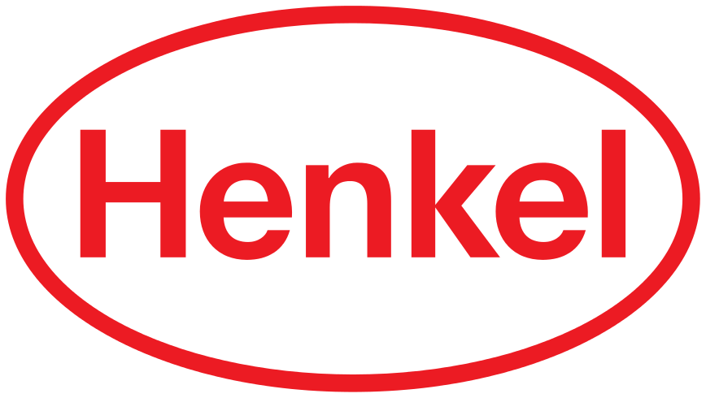

9.1 Employees
The commitment, abilities and experience of our employees build the basis for our international business success. Essential prerequisites for this are appreciation and further development of our employees. As a globally operating company, Henkel employs people from 125 nations in more than 75 countries.
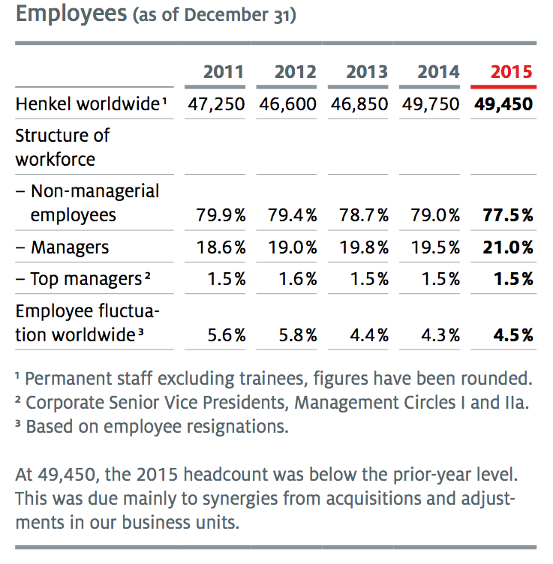
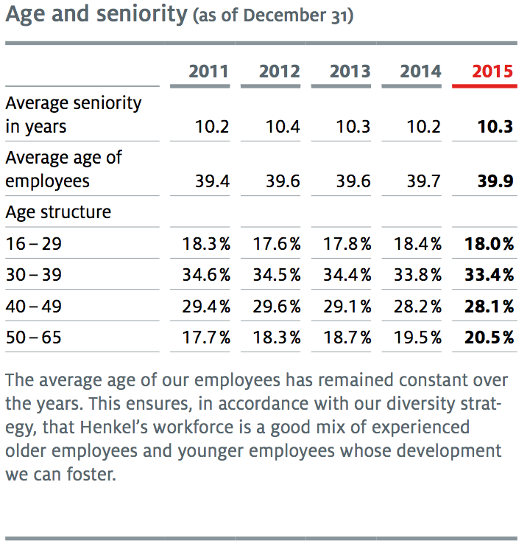
More than 80 percent of them work outside of Germany. Our goal is to create an inspiring, challenging and attractive workplace, where a shared vision and actively lived corporate values serve as a unifying element and a foundation for orientation worldwide.
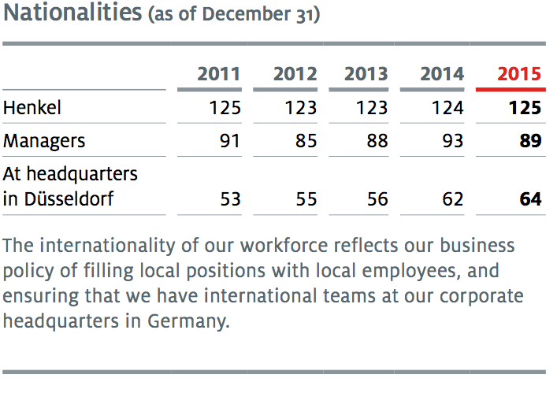
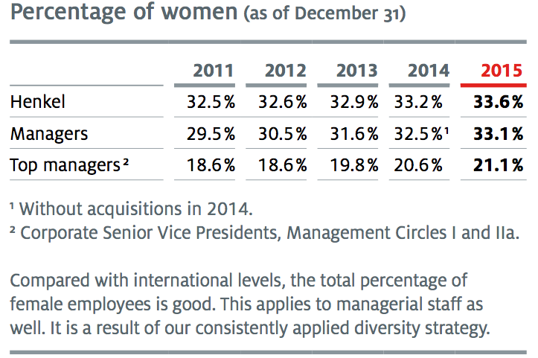
The diversity of our employees and their individual differences, whether regarding their cultural origins, gender, generation, religious orientation or differing values, abilities and experiences, is essential to our strength and innovative capabilities.
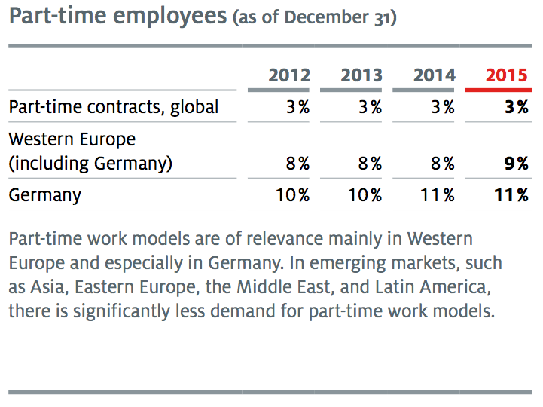
We promote individual development worldwide through numerous measures, such as training courses, workshops, and a new, comprehensive eLearning platform.

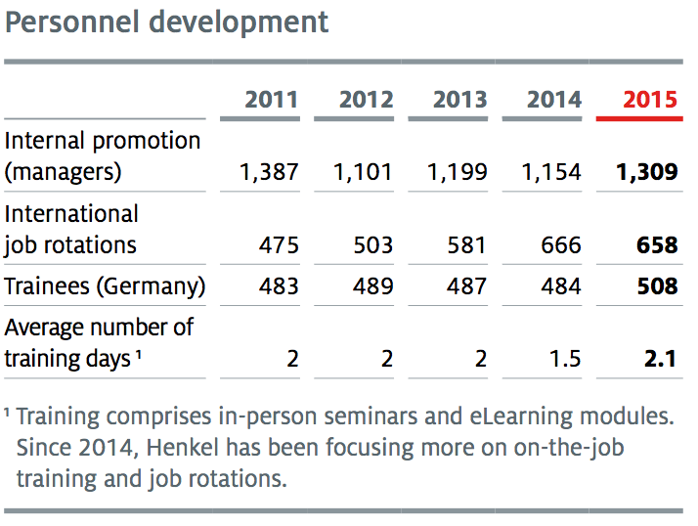
Our 2015 Diversity & Inclusion campaign was designed to further strengthen the understanding of diversity and respectful behavior at Henkel. Selected employees from all regions demonstrated how they initiate change processes and interact respectfully with one another.
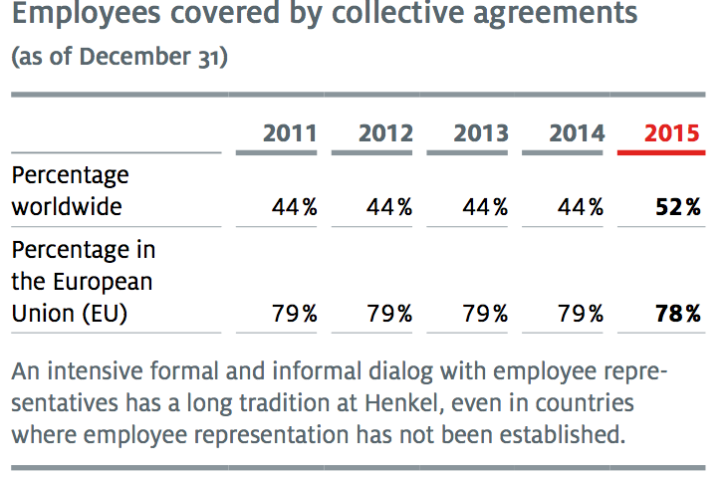
In 2015, our Diversity Weeks took place for the third time in a row, with numerous activities and events all over the world, making it possible to personally experience the company’s diversity and to emotionally involve employees through their engagement.
9.2 Supply/ Consume
We have merged the production, logistics and pur- chasing activities for all of our business units into a single global supply chain organization. We are working to continuously improve efficiency in all areas while maintaining the high quality of our products.
The production site in Wassertrüdingen, Germany, produces around one-fifth of the products in the Beauty Care portfolio and serves the entire European market – up to 3.3 million units are filled here every day. Since cleaning of the filling lines is a main generator of wastewater, we use steam instead of hot water to clean and disinfect the equipment. This has enabled us to reduce the wastewater volume per cleaning cycle by more than 90 percent, thus avoiding around 850 cubic meters of waste- water per line every year. Another sustainability example is the bundling of single product bottles with film wrapping. This is normally done by shrink wrapping under the application of heat. A new machine now achieves the same effect by mechanically stretching the film, which saves up to 70,000 kilowatt hours of electric power per year.
By implementing many such measures, this site has been able to reduce its wastewater footprint by more than 65 percent and its electricity consumption by more than 50 percent per production unit from 2005 to 2015. All of this contributes to achieving our “Factor 3” goal.
In 2011, Henkel and five other companies in the chemical industry established the initiative “Together for Sustainability – The Chemical Initiative for Sustainable Supply Chains” (TfS). It is based on the principles of the United Nations Global Compact and the Responsible Care Initiative of the International Council of Chemical Associations (ICCA). The TfS initiative aims to harmonize the increasingly complex supply chain management processes with regard to sustainability and to optimize the dialog among worldwide business partners. Above all, synergies are to be created
so that resources can be used more efficiently and with a minimum of administrative effort, not only among the member companies but also with all of our shared suppliers.
At the heart of the initiative is the idea: “An audit for one is an audit for all.” Suppliers only have to undergo one assessment or one audit. These are conducted by independent experts. An internet platform is then used to make the results available to all members of the initiative for information and approval. Since 2014, TfS has a new legal identity:
Through partnering with the Brussels-based European Chemical Industry Council (CEFIC), the initiative now has the status of an independent, non-profit organization. This collaboration will generate even more synergies across the chemical industry.
The TfS grew once again in 2015 and the number of members has tripled from the original six to 18. Last year, the first companies from the USA joined the initiative. Global expansion of the assessment and audit program, driven in part by supplier conferences in Shanghai and São Paulo, was again a main focus of activities in 2015. In addition, the initiative was singled out for mention by the Ethical Corporation: TfS was “highly commended” in the category “Best Supplier Engagement.”
Henkel is also a member of AIM-PROGRESS, a forum of companies in the consumer goods industry. Like the TfS initiative, AIM-PROGRESS encourages member companies to share experiences and utilize synergies. A common CSR platform is to be set up for this purpose.
Responsible Supply Chain Process
The results of our assessments and audits from the TfS initiative are a core element of our five-step Responsible Supply Chain Process. This focuses on two main challenges. First, ensuring that all of our suppliers comply with our defined sustainability standards. Second, we aim to purposefully work with our strategic suppliers to continuously improve sustainability standards in our value chain – for example, through knowledge transfer and continued education about process optimization, resource efficiency, and environmental and social standards. This process is performed both at the beginning of our relationship with
a supplier and as a regular check of our existing suppliers.
Step 1: Risk assessment
Henkel uses an early warning system for sustain- ability risks in global purchasing markets. We begin by estimating the potential risks in a market or a region. In doing so, we concentrate on countries identified by international institutions as being associated with heightened levels of risk. The assessment includes the criteria of human rights, corruption, and the legal environment. We also appraise a second dimension, that of risk value chains. These are industries and sectors that we consider to potentially represent a risk for our company. This helps us to identify countries and purchasing markets that may require special precautions.
Step 2: Assessment
We use supplier self-assessments based on questionnaires and have them examined as TfS assessments by the independent experts EcoVadis. These cover our expectations in the areas of safety, health, environment, quality, human rights, employee standards, and anticorruption.
Step 3: Analysis
Based on the risk assessments and the suppliers’ self-assessments, we classify suppliers according to a “traffic light” system. A “red” score always leads to an audit. In the case of a “yellow” score, the areas where improvement is needed are identified and the supplier is audited if necessary.
Step 4: Audit
Henkel works with independent audit companies to audit compliance with the defined standards in TfS audits. Our audits include on-site inspections, e.g., at production sites, and discussions with local employees. Follow-up measures after an audit ensure that suppliers implement the corrective actions that have been specified. Repeated serious non-compliance leads to prompt termination
of the supplier relationship. In this area, we also actively participate in cross-sectoral initiatives with the aim of improving the transparency and efficiency of supplier audits and helping to establish cross-company standards.
In 2015, we conducted a total of 687 assessments and audits. In the case of repeat audits, 78 percent of the suppliers audited had improved their sustainability performance. Overall, we did not receive any notification throughout 2015 of an infringement by any of our strategic suppliers which would have given cause for terminating our relationship with that supplier.
Step 5: Further development
As part of our supplier management activities, we work intensively with our suppliers to improve sustainability standards. We strive to initiate positive changes throughout the value chain, through training programs and joint projects. Our target for 2020 is to work with our partners to improve the working conditions for one million people employed in our supply chains.
As part of our supplier management activities, we collaborate intensively with our strategic suppliers. We aim to initiate positive changes throughout the value chain, through joint projects on process optimization, resource efficiency, and environmental and social standards. Furthermore, Henkel has been honoring sustainable innovations by its suppliers for four years.
The Laundry & Home Care business unit awarded the biotechnology company Novozymes in 2015 for the development of new, powerful enzymes as the basis for a new generation of innovative formulations. They are used, for example, in thelaundry detergents of our Persil ProClean brand in the USA and have been designed specifically to meet the needs of the local market.
The Beauty Care business unit recognized Ball Aerocan in 2015 for the joint development of the ReAl can. The technology makes it possible to use recycled aluminum and has been applied to make cans for the deodorant sprays of our Fa, Souplesse and Neutromed brands.
The Adhesive Technologies business unit pre- sented its 2015 sustainability award to Covestro Deutschland AG (formerly Bayer MaterialScience), a supplier of polyurethane technologies. Covestro was recognized for its development of raw materials for our wood adhesives that will allow us to further expand our business in sustainable wood engineering.

9.3 Community
Understanding the social demands that stake- holders of all kinds place on the company is a key component of our sustainability management. That is why we are open to dialog with all stake- holders, including our customers, consumers, suppliers, employees, shareholders, local communities, government authorities, associations and non-governmental organizations, as well as politicians and academia. We discuss concrete questions in a direct dialog with relevant stakeholders, in many multi-stakeholder initiatives, and on dialog platforms on sustainability topics. Numerous internal platforms provide feedback on the insights gained and on opinion formation.
In a comprehensive survey in 2014, we asked our stakeholders what topics have priority for them. Through this we learned how important the integration of sustainability in all of our activities and product life cycles is to our target groups. A second topic our stakeholder groups identified as vital is the targeted influence on consumers to lead more sustainable lifestyles and to use our products responsibly. The results of the survey were taken into account in 2015 in the further development of our strategy and our targets.
This regular dialog helps us not only to understand what our stakeholders think of our actions and expect of us in the future. It also enables us to recognize decisive trends and challenges in good time and to responsibly shape and implement future-oriented sustainability concepts. This is why we participate regularly in scientific and political discussions on future frameworks.
Open dialog helps us to understand which aspects of sustainable development are of interest to individual stakeholder groups. Timely consideration of the views of our stakeholders regarding future
environmental and social challenges helps us to set priorities and to adapt our plans and actions in a responsive manner. For instance, we recognized stakeholder concerns regarding the slow progress toward sustainable palm oil early on and considered these while revising our strategy.
Stakeholder dialog thus makes an important contribution to our innovation and risk management and helps us to continuously develop our sustainability strategy and reporting. At the same time, this exchange provides a basis for mutual understanding and an opportunity to achieve social acceptance of our entrepreneurial decisions.
Integrated dialog
All of our around 50,000 Henkel employees worldwide are called upon to assume responsibility in their working environment and to base their decisions on the principles of sustainable development. For many of our employees, this includes regular dialog with stakeholders. Experts at our various company sites and in our different business areas engage in discussion with the relevant stakeholder groups on specific local and regional challenges. This enables us to develop strategies and solutions where they are assessed and put into practice.
In 2015, as in each year, Henkel employees met with politicians, scientists and scholars, business- people and members of the public.
At the fourth Global Footwear Sustainability Summit 2015 held in August in Shanghai, Robert Field-Marsham, Asia Marketing Director Industrial Adhesives, explained the sustainability challenges in the shoe industry and presented Henkel’s sustain- able adhesive solutions for shoe manufacturing.

9.4 Environment
If we are to live in harmony with our limited resources in 2050, we must become five times more efficient. By 2030, therefore, we want to triple the value we create through our business operations in relation to the environmental footprint of our products and services by comparison with the base year 2010. We can achieve this goal, our “Factor 3,” in different ways: We can triple the value we create while leaving the footprint at the same level. Or we can reduce the environmental foot- print to one third of today’s level while delivering the same value.
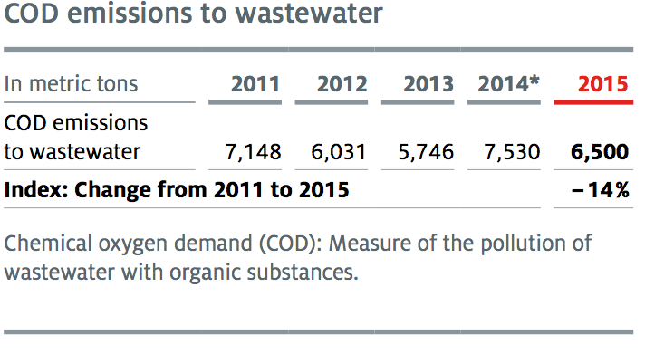
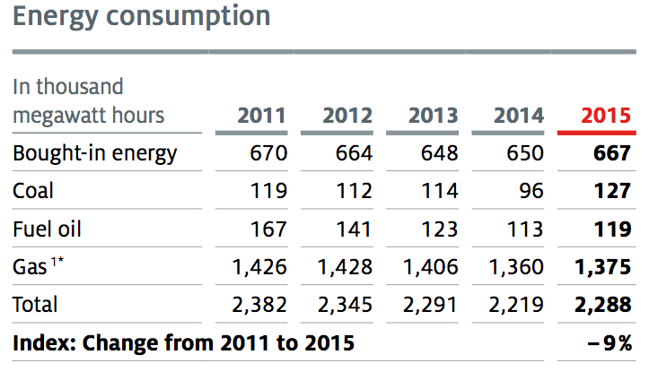
To reach our goal by 2030, we will have to improve our efficiency by an average of 5 to 6 percent each year. We had therefore set interim targets for our focal areas for the five years from 2011 to 2015. With improvements of 18 percent in energy efficiency, 23 percent in water use, 17 percent in waste volume, 33 percent in occupational safety, and 11 percent in sales, we reached these targets. By the end of 2015, we had thus improved the relationship between the value we create and our environmental footprint by 38 percent overall.
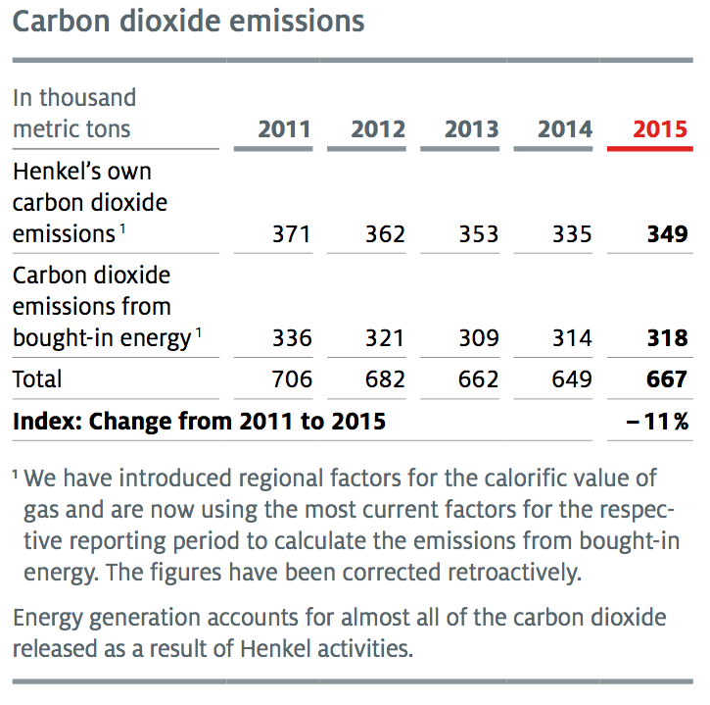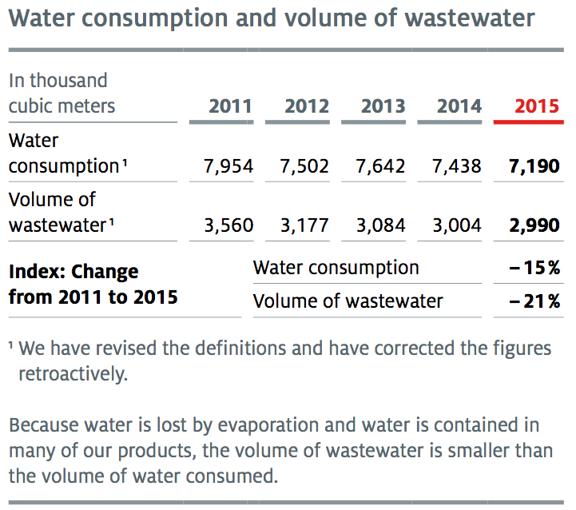
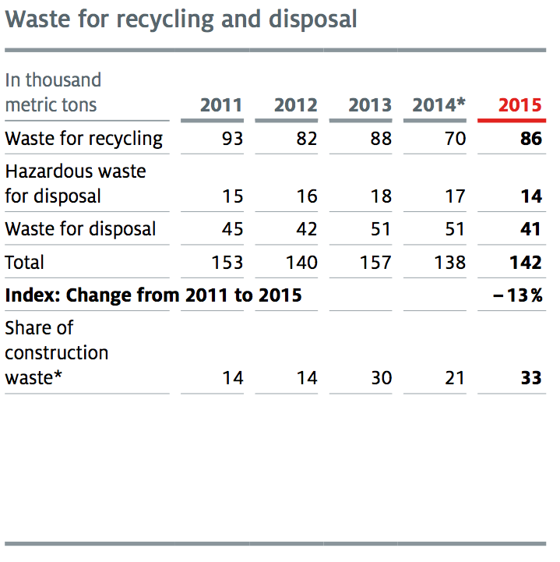
On the road to our long-term goal of “Factor 3,” we intend to improve our performance in these areas still further over the coming years. To do this, we have defined new interim targets: By 2020, we want to further reduce the direct and indirect carbon dioxide emissions from our production sites, our water use and our waste volume, in each case by 30 percent per ton of product relative to the base year 2010. We want to improve our occupational safety performance by 40 percent and our sales by 22 percent per ton of product.
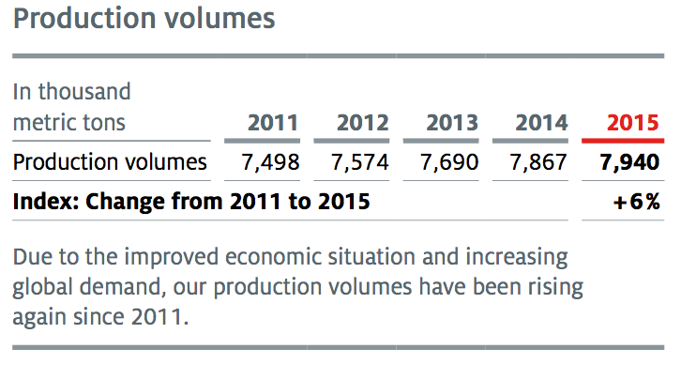
9.5 Education
Digital learning
Learning during day-to-day work and through job rotations plays a central role at Henkel. To implement these measures even more successfully, we have integrated formal learning to a greater extent in day-to-day work and made it available in digital form as needed. For this purpose, the contents of the Henkel Global Academy were combined in a central learning platform in 2015. The system now bundles all available training programs in a uniform format. General in-person training is complemented by more than 500 eLearning modules and around 500 videos and webinars. Business unit- specific seminars are also available there. The greater transparency and better presentation of these options facilitate individual selection and flexible use. The system also enables users to repeat partial sequences. The link with the Talent Management System reinforces our understanding of learning as an integral part of the job. The digital learning opportunities also reduce the need for travel and make printed materials unnecessary.
Educating for greater sustainability
One of our most important educational initiatives is the Henkel program for Sustainability Ambassadors, which was initiated in 2012 to inspire employees to engage even more intensively with the topic of sustainability. Since then, Henkel has trained around 6,200 ambassadors in 74 countries. As part of their activities, the ambassadors work with elementary school children, to teach them about the responsible use of resources. We have now reached around 63,000 schoolchildren in 43 countries.
Added to the program in 2014 was the initiative “(Y)our move toward sustainability,” which encourages employees to put sustainability into practice in their day-to-day work, such as in regard to saving energy and eating healthily.
In 2015, another initiative was added to the program: In “Say yes! to the future,” Henkel sales representatives all over the world are being trained on all sustainability topics that apply to sales, going beyond the contents of the Sustainability Ambassador program. They then apply this know- ledge in joint projects with our retail customers – in logistics, for example, or in promoting sustain- able purchasing decisions. In addition to sales-relevant sustainability matters, the exchange
of international best practice examples for retail collaborations is an important component of the training courses, in order to initiate new forms of cooperation.

9.6 Healthcare
We care about the health and performance capability of our employees. We offer targeted health and preventive programs to guard against workplace- related risks that might lead to illnesses. The recently introduced Health Procedure describes the minimum global standards for health protection and health promotion. With our standardized programs for promoting a healthy lifestyle, we want to reach more than 90 percent of our employees worldwide in the future. In designing these programs, our sites determine different priorities based on local requirements. All Henkel sites worldwide report on four key figures each quarter: availability of first aiders and emergency medical care, the conducting of occupational health exams, and the occurrence of occupational illness.
Occupational safety is one of our highest priorities. We remain focused on our long-term objective of “zero accidents.” Our new interim target is to reduce our worldwide occupational accident rate by 40 percent by the end of 2020 (base year 2010). With this objective in mind, we are working continuously to improve our occupational safety levels through awareness-raising training events; investments to enhance technical safety; and by monitoring the strict compliance with our Safety, Health and Environment (SHE) Standards.
Regular training sessions are held at all sites to raise employees’ awareness and enable them to develop safety-conscious behavior. We also con- duct training sessions for the staff of contractors working at our sites.
The Laundry & Home Care business unit trained its employees using various methods, including seminars by external experts, and by defining global focal topics every two months, on which the sites then conducted a series of events.
In addition to the regular safety training sessions, the Beauty Care business unit introduced a newprogram in Tunisia that is based on recognizing and honoring employees who exhibit outstanding safety-consciousness.
The Adhesive Technologies business unit is focusing more strongly on positive dialog on safety in day-to-day work situations. The focus here is on mutual encouragement to develop safety culture and constructive feedback on unsafe behaviors.
2015 status
In 2015, we recorded 0.8 occupational accidents per million hours worked. That is an improvement of 33 percent relative to the base year 2010 and means that we exceeded our 2015 target of 20 percent.
Despite our continuous focus on health and safety, an employee in Lianyungang, China, suffered a fatal accident in a warehouse. An employee of an external contractor was fatally injured during construction work in our factory in Perm, Russia. These accidents show that we must intensify our global safety training efforts still further.
In addition, we also mourn the passing of an employee who died in the Germanwings plane crash in France during a business trip.

9.7 Specific projects
Supporting equal opportunity in education is a top priority. In 2015, we continued our partnership with the educational initiative Teach First Deutsch- land. In this program, university graduates in all fields work as fellows in schools with socially disadvantaged students. With the Light Up project in China, we are promoting the reading skills of Chinese children by donating books and writing materials.
Brand engagement
Henkel also provides support for many social projects through its brands. In the fasting month Ramadan in 2015, Henkel initiated the New Beginnings campaign in Saudi Arabia. For every bottle of Persil Abaya, a special laundry detergent for the traditional Muslim outer garment that is usually black, that was sold, a donation was made to the Saudi Arabian organization Al Bir. The campaign supports the Productive Families program, which helps women from low-income families to establish their own microenterprises.
In its fifth year, Schwarzkopf Professional brought the Shaping Futures initiative to Germany. In collaboration with vocational schools in Hamburg and Nuremberg, young refugees are given an opportunity to find out whether hairdressing could be a career for them. The goal is to establish a long-term and permanent educational program. The initiative began in 2010, in collaboration with
the charitable organization SOS Children’s Villages. Up to now, 1,200 young people in 25 countries have been trained thanks to the volunteer work of almost 250 hairdressers and employees.
Together with Plan International, Henkel and the Pritt brand began a construction and educational project in 2015 in two schools in Brazil. The goal of the two-year project is to break through the cycle of poverty through improvements in the educational situation at two schools in the northeastern part of Brazil. In addition to renovation work and school equipment, the program includes additional measures to improve the quality of schooling – such as workshops for students and their parents.
Emergency aid
When emergency aid is needed after a natural disaster, Henkel provides quick and pragmatic assistance through the “Fritz Henkel Stiftung” foundation. In 2015, Henkel supported the reconstruction work following the humanitarian disaster caused by the earthquakes in Nepal. As a first step, the foundation provided the urgently needed emergency financial aid. Now it continues to support volunteer projects of Henkel employees who are assisting with the reconstruction work in the country.
Henkel’s Forscherwelt
Henkel’s Forscherwelt (Researcher’s World) project, in which elementary school children learn in age-appropriate lessons how a scientist answers research questions with the help of experiments, was also further broadened internationally in 2015. At the beginning of the year, the project in Russia was expanded to include three new schools, in which more than 100 children took part in the lessons. In April, the first Forscherwelt outside of Moscow took place at the Henkel site in Engels. In Turkey, too, through the collaboration of Henkel colleagues with the local Society for Creative Children and the Turkish Chemical Society, we made it possible for children to participate in Forscherwelt programs.



10.1 Employees
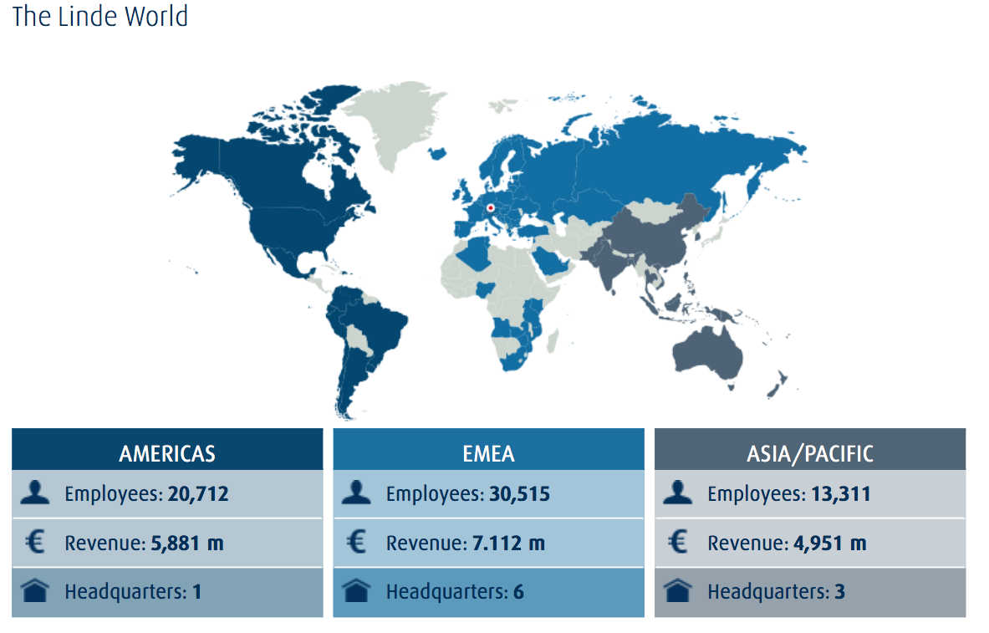
As a group with global operations, we rely on employees who understand local markets and customers and use their different experiences and perspectives to enrich the work of their team. At 31 December 2015, employees from 134 different countries worked in our Group, while 64 nations were represented in the German companies alone. The proportion of senior managers from countries other than Germany in The Linde Group was 70 percent in the reporting year, with 49 nations represented at this level. In 2015, around 200 of our employees were sent on secondment to subsidiaries abroad.
Linde’s executives play an important role in promoting diversity. On the Executive Board, Thomas Blades is responsible for Diversity & Inclusion. For a number of years, diversity has been an integral part of our executive development programmes. It is also considered when employee evaluations take place. In the Asia/Paci c segment, which comprises 15 countries, we launched an initiative in 2015 on diversity in the workplace which involved talks, mentoring schemes and workshops and the setting up of women’s networking groups. In the United States, we promoted inter-generational exchange programmes and exchanges between African American and Latin American colleagues. 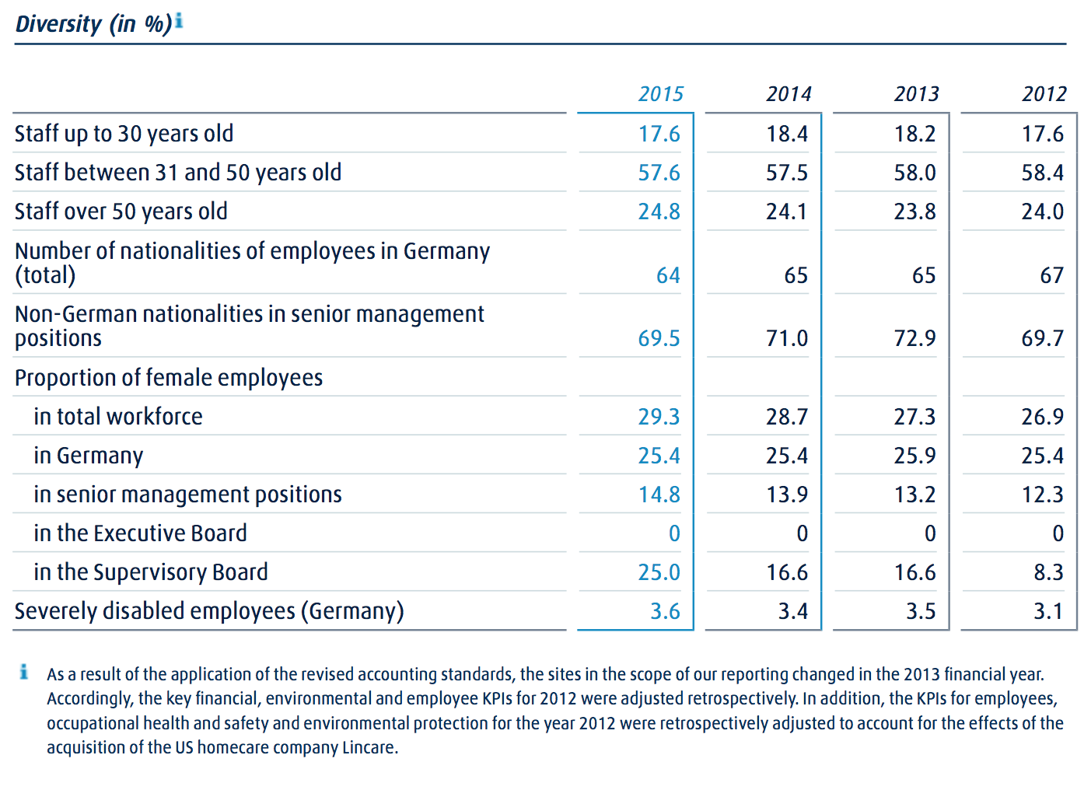
An important priority for Linde in the area of diversity is to increase the number of women in management positions. As part of a joint initiative set up by all 30 DAX companies in Germany, Linde set itself the target in 2011 of increasing the proportion of women in senior management positions to between 13 and 15 percent by 2018. In 2015, this proportion was 14.8 percent. During the reporting year, we replaced this target with more detailed targets for the two upper tiers of management. The proportion of women in the first management tier below the Executive Board should rise to 14 percent by 2017 and 18 percent by 2022. In 2015, the proportion of female senior managers in this tier was around 11 percent. In the second management tier below the Executive Board, we want the proportion of women to be 17 percent by 2017 and 22 percent by 2022. This gure was 16 percent in 2015. In order to meet these targets, the Linde Executive Board is supporting various employee initiatives promoting women. These include cross-departmental networking events and training programmes for women with management responsibility or leadership potential. An internal mentoring programme was launched in 2015 in Germany. Experienced managers provide support particularly to women to enable them to continue to develop their personal and professional skills. The programme should be expanded in 2016. The proportion of women taking part in the Global Leadership Development Circle, our development programme for senior managers, was 23 percent in 2015 (2014: 27 percent).
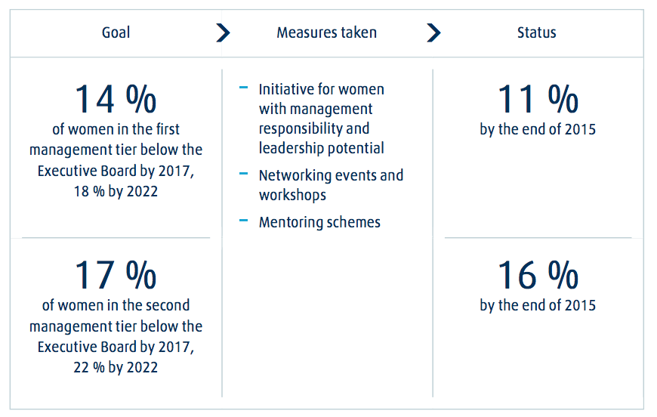

10.2 Supply/Consume
We have business relationships with suppliers in more than 100 countries. When selecting suppliers, we consider not only commercial criteria such as quality, price and availability, but also aspects such as safety and the environment. The most important items we purchase include energy, gas cylinders and valves, tanks and tank equipment, vehicles, IT products, services and components for production plants, as well as equipment and consumables for our Healthcare business. In 2015, we spent around EUR 10.5 billion (2014: EUR 11.6 billion) on purchasing goods and services worldwide. Of this amount, approximately EUR 9.0 billion related to the Gases Division and approximately EUR 1.5 billion to the Engineering Division. Around 78 percent of the total was spent in OECD countries. We purchase about 80 percent of the products and services locally in the countries where they are needed. This cuts down the distances travelled and reduces costs and emissions. Working with local companies also enables us to support the local economy.
Global standards
In 2013, we introduced a global Code of Conduct for Suppliers. This sets out minimum requirements for safety, environmental protection, labour rights and human rights, and corporate integrity. Our new suppliers automatically sign up to the Code of Conduct and there has been a continual process of ensuring that those suppliers with whom contracts were signed prior to 2013 also agree to be bound by the Code. By the end of 2015, more than three quarters of our strategic suppliers had signed up to the Code. During the reporting year, we provided training on the implementation of the Code of Conduct for Suppliers to around 20 percent of employees working in procurement across the Group. More training is planned for 2016.
Evaluating our suppliers
We conduct random checks to ensure that our suppliers comply with the guidelines set out in our Code of Conduct. We focus in particular on suppliers in higher-risk areas, such as environmental protection, safety and social responsibility.
In 2015, we reviewed just under 1,000 suppliers to ensure that they complied with our guidance on environmental and safety issues and other issues relating to sustainability. We investigate any breaches of our requirements by our suppliers. When conducting audits of construction sites during the reporting year, we identified around 200 deviations from the Code, some of which related for example to work permit procedures and construction traffic. We then worked together with the contractors affected to devise measures to improve the situation and to monitor their implementation. Six cases were reported in 2015 via our Integrity Line relating solely to supplier relationships. In one case, the supplier relationship was terminated.
We also involve selected suppliers in the training we deliver on safety and environmental management. More than 1,000 employees of contractors, for example, took part in our global initiative, which aims to strengthen awareness of safety risks on construction sites in our Engineering Division. Drivers who are contractors as well as our own Linde drivers regularly participate in driver education programmes and training. Measures such as these are designed to ensure that suppliers comply with our requirements and that we help our suppliers to improve their performance.
In 2015, we worked together with 25 selected suppliers to develop business continuity plans. These should ensure that the best possible way is found to resume business operations following unexpected events such as natural disasters. The aim was to identify any potential risks and to remedy any weaknesses in procurement processes. This led to some suppliers introducing back-up systems for critical processes and increasing inventory levels of finished products and critical equipment parts.
In addition, we invited selected Chinese suppliers once again in 2015 to a workshop focusing on the importance of sustainability for successful business relationships.
10.3 Community
We consult our major stakeholders on a regular basis about key topics. Our most important stakeholders are our employees, customers and suppliers, and shareholders, as well as politicians, economists and scientists, non-governmental organisations, neighbours in the vicinity of our sites and the general public. We conduct regular analyses of the expectations of major shareholders in our Group, in order to identify at an early stage relevant topics, opportunities and risks.
In 2015, we once again conducted a survey within the Group about sustainability topics across all regions. The survey covered local activities and focus areas, collaborations with stakeholders and corporate citizenship within communities. We incorporate the results of the survey into our report.
We engage in debates with experts on specialist topics. The invitation to our Linde Technology Days 2015 on the subject of digitalisation was accepted not only by specialists within our Group but also by experts from other companies. The participants discussed how digitalisation is changing the business world and examined the opportunities and competitive advantages arising as a result.
We cooperate with scientific institutions and other companies to develop sustainable solutions; for example, in the fields of energy supply and mobility. Linde is one of the founding members of the Clean Energy Partnership (CEP), the largest demonstration project for hydrogen-based mobility in Europe. With the support of the German government, the CEP is testing fuel-cell vehicles and their refuelling systems. H2 Mobility is the name of a joint venture between Linde and vet leading industrial companies devoted to setting up a nationwide network of hydrogen lling stations in Germany. The network of public hydrogen lling stations in Germany is planned to be expanded to around 400 by 2023.
Linde is an active member of a number of German, European and international industry associations and trade associations. These include the German Chemical Industry Association (VCI), the German Engineering Association (VDMA), the European Industrial Gases Association (EIGA), the European Chemical Industry Council (CEFIC) and the Asian Industrial Gases Association (AIGA). From October 2014 to December 2015, our Chief Executive Officer, Dr Wolfgang Büchele, was Chairman of the North Africa Middle East Initiative of German Business (NMI). In November 2015, he was elected Chairman of the Committee on Eastern European Economic Relations. He assumed office on 1 January 2016. Linde is also a member of selected corporate responsibility networks. These include the UN Global Compact and econsense (the Forum for Sustainable Development of German Business).
Politics
In 2015, our dialogue with politicians and society focused among other things on securing a competitive framework for the purchase of energy for our production plants and on the reform of the European Emissions Trading Scheme. Increasing use of renewable energy as a source of energy and ambitious climate protection targets in Germany and in Europe are creating significant opportunities for innovative and efficient technologies. On the other hand, the transformation of the energy system and ambitious climate targets result in rising costs for the industry. Against this backdrop, Linde has highlighted the importance of industrial gases for a variety of industrial value chains. In addition, we have provided information about the contribution made by our technologies to climate protection and efficiency. One particular example of this is our commitment to the expansion of emission-free electromobility through hydrogen-powered and fuel cell vehicles.
As a group, Linde does not make donations to political parties or to individuals. In the United States, employees of Linde North America have formed a political action committee. Under the umbrella of this independent registered committee, employees collect donations to politicians, political parties and associations and make decisions as to how the funds will be used.
With its gases and services, Linde is a partner to companies in virtually all industry sectors. We supply our products and services to more than two million customers worldwide. A third of the revenue of our Gases Division is derived from around 500 major customers. These customers are the focus of our key customer management. We work constantly to ensure that we deliver customer satisfaction and continue to increase customer loyalty. Experts in our key customer management teams in all three operating segments exchange views about customer satisfaction initiatives within the Group, identify success factors and communicate them to other business units. In 2015, we expanded and extended two key initiatives to optimise our customer focus, with a particular emphasis on optimising order processing in all customer segments. We conducted for the second time a detailed survey of our customers in the 12 countries in which our Gases Division generates the most revenue. In the future this survey should take place every 18 months. Based on the findings from the 2015 survey, we launched more than 120 additional projects across all our business units during the year. These projects focused on areas such as customer enquiries, invoices and delivery information. We were able to complete over half these projects successfully during the reporting year.
In the second major initiative we enable customers to rate Linde immediately after the completion of a transaction: for example, following a delivery or once the customer has received the invoice. The aim is to ensure that every customer complaint receives a prompt and appropriate response and that we provide systematic solutions to any potential problems. Customers will also receive information from us about the steps we are taking to avoid any recurrence of the event which provoked the
complaint. We are already actively using customer feedback to improve our products and processes in all regions. By the end of 2016, we are planning to include the 29 countries which generate the most revenue in the programme. We also organise events for our customers, so that we can gain a better understanding of their needs. In the UK and Ireland, for example, four events during the reporting year were attended by more than 70 customers. In 2015, our Group again received recognition from a number of different business partners. In the United States, we were given a Preferred Quality Supplier award by a major customer in the electronics industry. In China, we were awarded the status of Excellent Supplier by a customer in the telecommunications industry in recognition of our delivery reliability, quality and customer focus. For the sixth time in succession, Linde Gas Deutschland received an award from TÜV Saarland for service and customer satisfaction. More than 85 percent of TÜV customers questioned declared that they were satisfied or very satisfied with the service provided by Linde.
10.4 Environment
Linde understands and knows about the environmental impact of its processes and works constantly to develop solutions which will limit and control such effects. We focus not only on reducing emissions, but also on making continual improvements in our operations to ensure the efficient use of resources, materials and energy. We provide our customers with gases and technologies which decrease the consumption of natural resources and encourage the use of renewable energy.
We control our energy consumption and greenhouse gas emissions worldwide and report thereon based on the standards set out in the internationally recognised Greenhouse Gas Protocol. To make the CO2 balance sheet of the main air gases transparent for our customers, we use a standard formula which has been externally certified. In 2015, Linde was included in CDP’s regional Carbon Disclosure Leadership DACH index for the fourth time in a row. Through this index, the independent organisation recognises the quality of companies’ reporting on climate protection.
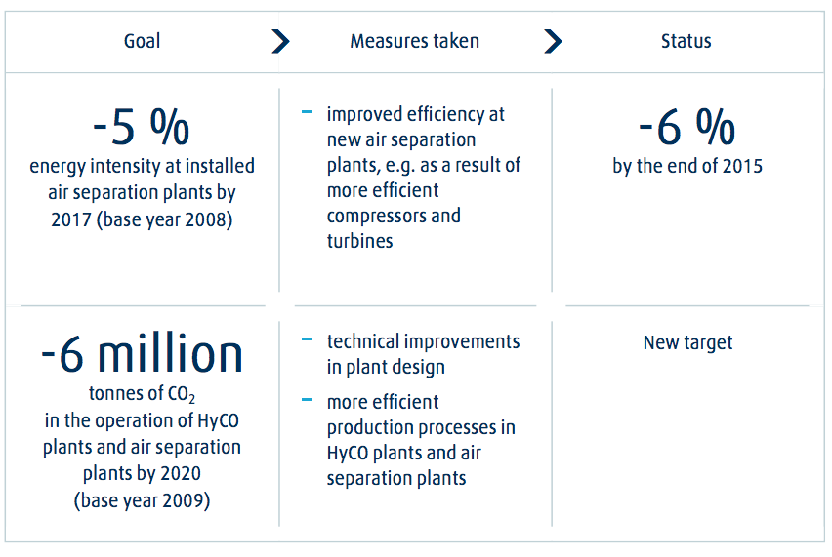
Around 60 percent of the Group’s total CO2 emissions are by-products of electricity generation by energy providers and are reported by us as indirect emissions. Most of this electricity is required for the operation of more than 400 air separation plants. We have already exceeded the global target we had set ourselves of improving the average energy intensity of our air separation plants by 5 percent by 2017. By the end of 2015, we had achieved efficiency improvements of more than 6 percent compared with the reference year 2008. The benchmark is the global average efficiency of the air separation plants operating at the design plant load. This was possible mainly as a result of continuous improvements in efficiency in the air separation plants newly brought on stream: for example, by using more efficient compressors and turbines.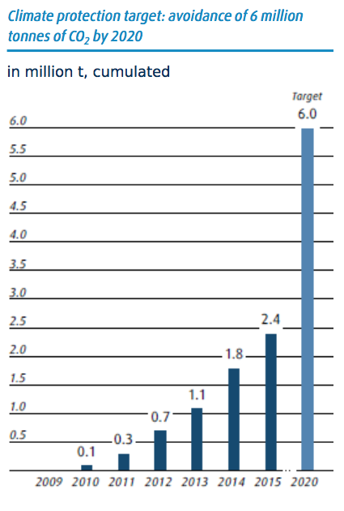
Direct emissions at Linde stem mainly from the operation of hydrogen and synthesis gas plants (HyCO plants). By 2015, we achieved the target we had set ourselves of increasing the energy efficiency of our HyCO plants installed around the world by 2 percent. We had increased the energy efficiency of the plants concerned by 2.7 percent by the end of the reporting year compared with the reference year 2009.
We have therefore set ourselves a new climate protection target. By 2020, we are seeking to avoid a total of 6 million tonnes of CO2 emissions compared with the year 2009. To meet this target, we are focusing on technical improvements in plant design and more efficient production processes in our HyCO plants and air separation plants.
Another key focus of our climate protection measures is the transportation of products. Our own transport feet and transport service providers carrying Linde goods covered more than 1 billion kilometres in 2015. Optimised routes, better use of transport capacity and defensive driving training helped us reduce the number of kilometres travelled, cut the amount of fuel consumed and bring down the level of transport emissions.
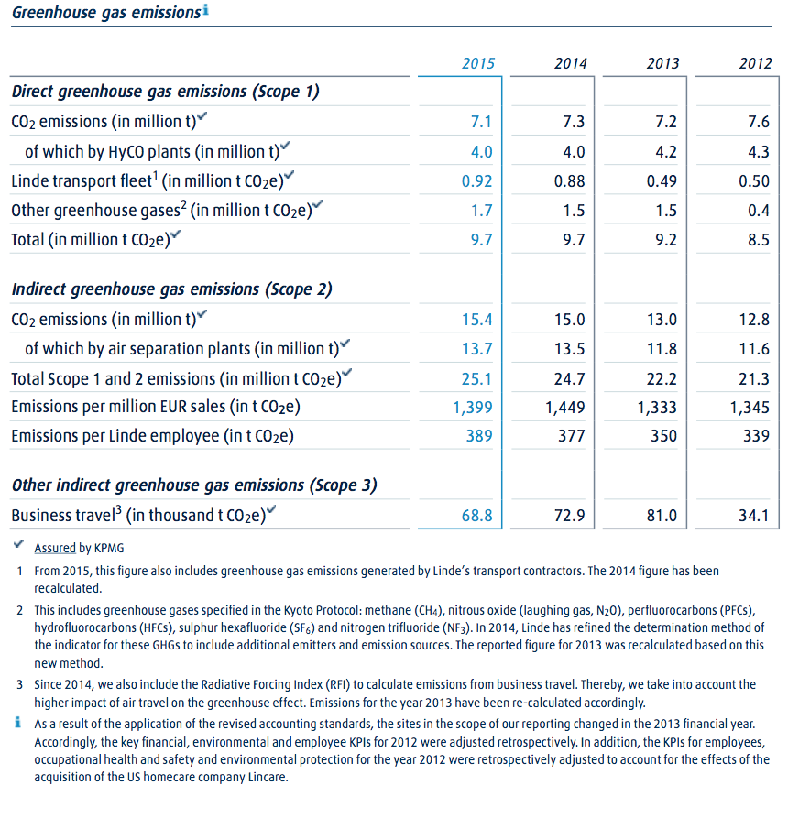
As an energy-intensive company, we require a reliable and competitively priced energy supply and are constantly reviewing the energy efficiency of our production processes. In 2015, our energy consumption was around 1 percent higher than in 2014. In the reporting year, we took part in the European Union’s Emissions Trading System at seven of our production sites. There were around 1.1 million tonnes of CO2 emissions at these plants during the year. Linde was allocated emissions allowances for around 0.9 million tonnes of CO2 in 2015. Further certificates were purchased.
In the reporting year, we identified some 200 projects around the world that helped reduce our energy consumption and CO2 emissions. Implementing these projects generated cost savings of over EUR 23 m in 2015 and avoided around 160,000 tonnes of CO2 emissions. For example, we increased the energy efficiency of compressors at 14 production sites by replacing old installations with new and more energy-efficient models. As a result of these projects alone, we achieved cost savings in the reporting year of over EUR 1.6 m.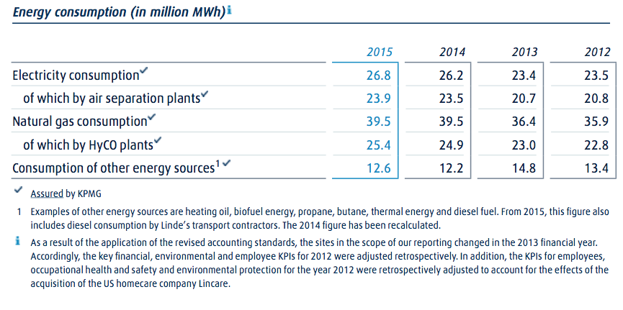
In Europe, we worked on the implementation of the provisions of the European Union’s Energy Efficiency Directive (EED). These include regular energy audits for companies at production sites, distribution sites and offices, or alternatively certification in accordance with ISO 50001. The global standard testifies to systematic energy management, which allows efficiency potential to be recognised. Since 2012, around 85 percent of Linde Gas production plants in Germany have been certified according to ISO 50001. We are also exploring the use of renewable energy, the current level of which largely reflects the energy mix applicable in the various regions.
In the US State of California, we won the 2015 COOL Planet Award presented by Southern California Edison and non-profit organisation The Climate Registry in recognition of our energy management and commitment to reducing greenhouse gases.
Products for energy efficiency and climate protection
We offer our customers various solutions to make production and energy generation processes more environmentally friendly. Our gases and technologies help our customers to reduce emissions to a large extent. In oxyfuel plants, which are used for example by the glass and steel industries, the combustion air is enriched with oxygen, resulting in much more efficient combustion than if normal ambient air was used. Hydrogen produced by Linde is utilised by the oil industry in desulphurisation. Desulphurised fuel combined with a lter significantly reduces emissions of soot particles, which like CO2 contribute to the greenhouse effect. In 2015, the use of these two technologies alone by our customers avoided around 30 million tonnes of CO2.
Our products are also deployed in the mobility sector to reduce environmental pollution. The use of liquefied natural gas (LNG) or hydrogen reduces or eliminates emissions from cars, buses, trucks and ships. We are investing in the development of forward-looking, efficient refuelling technology as well as cooperating with partners to set up a supply infrastructure. In the UK, we introduced cryogenic refrigeration trucks in 2015 which use liquid nitrogen as the refrigerant. Not only do these trucks emit 64 percent less CO2 than conventional trucks with diesel-powered refrigeration units, they are also significantly quieter. This means that they can be used around the clock even in urban areas with noise restrictions.

10.5 Education
Linde is competing globally for skilled employees. We want to win the best talent for our Group and to build long-term loyalty amongst our employees. We therefore cooperate with universities and research institutions around the world in order to attract the interest of newly qualified graduates. We also provide training opportunities in various technical and commercial areas. In Germany alone, we offer training in 21 different professions. In 2015, half of one year’s cohort of apprentices and trainees in Germany were taken on as permanent employees at the end of their vocational training and a further 47 percent were offered a xed-term contract. The number of apprentices and trainees as a proportion of the total number of employees in the Group was 0.9 percent in 2015, of which
53 percent were in non-German companies. From 2016, we are planning to increase the total number of places for new apprentices and trainees in Germany to 100. In 2015, 82 people began apprenticeships and traineeships at Linde in Germany. For autumn 2016, we have scheduled to start the new cohort of our European Graduate Programme. This programme offers talented young people practical insights into various areas of our Group within Germany and outside Germany and prepares them for future management roles.
Professional development
We promote the individual development of our employees. In 2015, we invested around EUR 14 m in the professional development of our staff. Linde University provides professional development programmes covering such subject areas as personnel management, intercultural communications and diversity. During the year, for example, around 500 managers in the Regional Business Unit (RBU) South Asia & ASEAN took part in training on handling change processes within the Group. Besides, more than 80 employees and managers in North America completed training on intercultural communication.
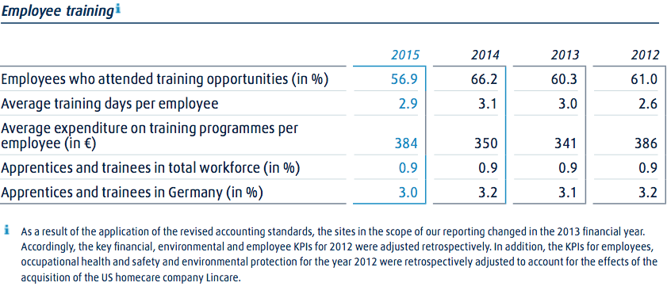
As part of the Group-wide Six Sigma programme, we provide employees with training on successfully identifying opportunities for improvement in all areas of the Group, from production to administration. Projects during the year focused on more efficient processes and the quality of products and services. In 2015, Lean Six Sigma training was provided to more than 1,100 employees. Over 800 optimisation projects were completed, leading to total cost savings of more than EUR 40 m.

10.6 Healthcare
The key aim of our global safety management is to protect our employees. We have set out global guidelines governing occupational safety and health protection. We carry out risk assessments and audits to ascertain whether the right conditions are in place to ensure safety at work. In 2015, we conducted audits at 52.6 percent of our operating sites (2014: 57.4 percent).
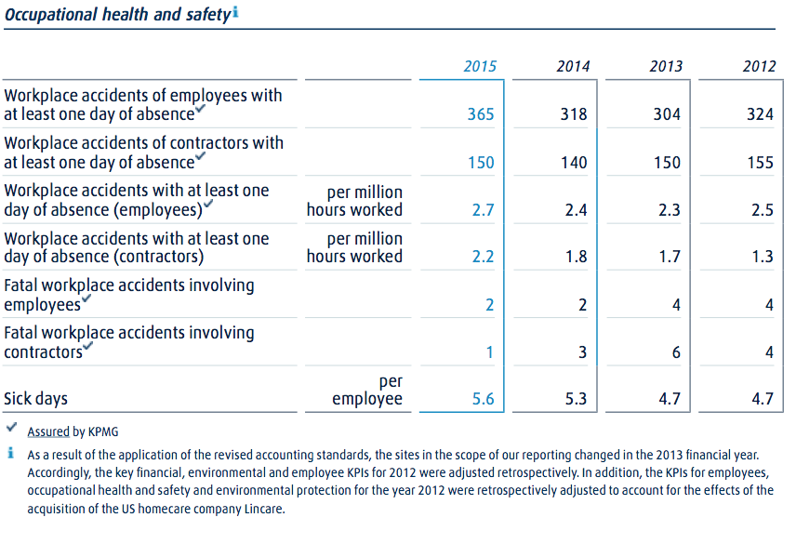
We have set ourselves the target of continuously reducing the number of workplace accidents resulting in lost working days per million hours worked by our employees by 2020. The reference year is 2012. In 2015, the rate of workplace accidents at Linde sites around the world per million hours worked was 2.7 (2014: 2.4). The equivalent figure for contractors during 2015 was 2.2 (2014: 1.8). It is with the deepest regret that we must report that two Linde employees lost their lives while working for us in 2015 in road accidents in Brazil and Tunisia.
As part of our global safety initiative, we have launched numerous measures designed to continue to reduce safety risks and to reinforce the importance of personal responsibility and safety-conscious behaviour. Around 30 to 50 percent of workplace accidents and chronic illnesses at Linde can be attributed to manual or repetitive activities. Many of our health protection initiatives therefore focus in particular on the risks associated with such activities. One such initiative in 2015 was our introduction of powered movers at 25 sites in North America for lifting and transporting cylinders containing liquefied oxygen weighing up to 360 kilograms. These powered machines allow our employees to avoid heavy physical exertion. In the Gist Division, 99 percent of personnel handling heavy loads received training on how to do so safely during the reporting year.
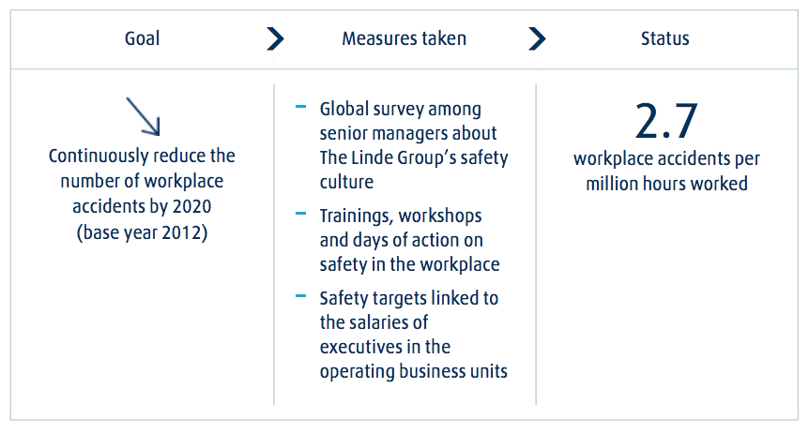
In 2015, we devised a new healthcare management programme. The initiative focuses on areas such as work-life balance and preventive measures to enhance health protection. Starting in Germany in 2016, our employees should be offered a broad range of options as a result of this initiative.

10.7 Specific projects
We are involved in a variety of projects around the world near our business locations. Our main focus is on education. We also support selected initiatives in areas such as safety, environmental protection, health and social affairs as well as some cultural projects. Cross-regional involvement in such projects is managed by our Corporate Centre, while local initiatives are coordinated by employees in the region concerned. In 2015, we provided funding of several million euro for projects and initiatives worldwide, around EUR 2.4 m have been donated by the Group. This allowed us to support more than 200 projects. As a result of our social commitment, we were able to reach, amongst others, more than 125,000 children, school pupils and students during the year under review.
We support science education projects in several countries, for example, exhibitions, scientific or technical experiments and competitions. We provided foundation capital of over EUR 8 m to set up the Carl von Linde Academy at the Technical University of Munich. By the end of the summer semester of 2015, around 18,000 students had attended courses offered by the Academy. The institution provides engineering, IT and natural science students with key skills that extend beyond the limits of their theoretical subjects, covering such areas as innovation and business ethics. In Munich, home to our Corporate Centre, we are also a founding member of the Deutsches Museum Future Initiative, the aim of which is to modernise the largest technology museum in the world. By 2018, we will have provided financial backing of EUR 5 m. We have also formed a public-private partnership with the Schloss Hansenberg boarding school in Hesse, Germany. The school fosters the talents of pupils with particularly strong academic and social skills. Since the beginning of our involvement in 2004, more than 600 pupils have completed their education at the school. Linde has been the Season Partner of the Bavarian State Opera since 2007. We have also sponsored the live streaming of selected performances since 2012. This allows people who are unable to attend a performance at the opera house to enjoy a world-class cultural event for free.

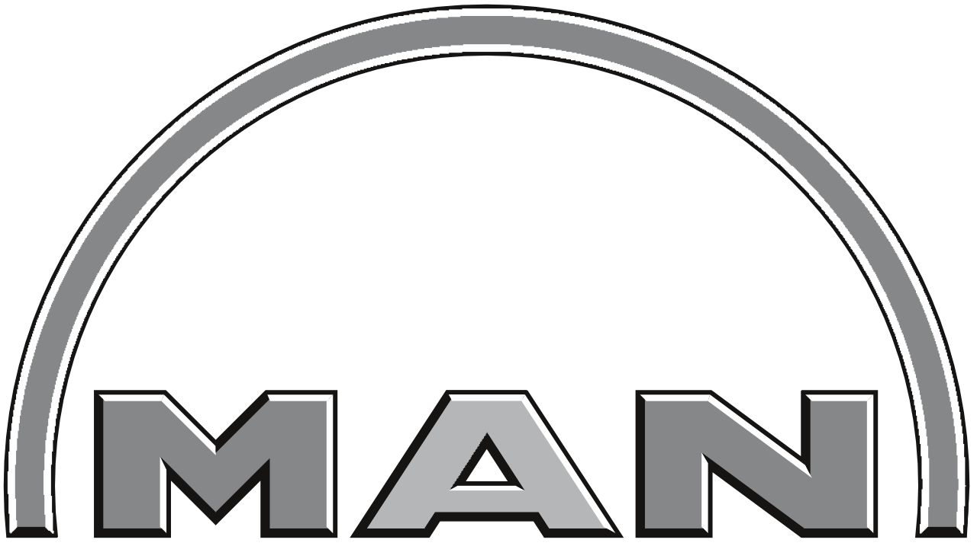

11.1 Employees
MAN is one of Europe’s leading players in the commercial vehicle and mechanical engineering sectors. To maintain this position going forward, we need a first-class team which delivers outstanding performance. 55,030 talented individuals work at MAN. Only by promoting the professional growth of all our employees — from vocational trainees to executives — can we ensure that the Company will remain successful in the long term. This is why our human resources (HR) strategy is built around outstandng performance, the resultant success, and sharing in the benefits of that success. We also live up to our responsibility to our employees by fostering health, skills, and dedication. To attract and retain committed, responsible, and competent employees, we need responsible leadership and indi- vidualized HR development and training opportunities.
MAN and its employees are active in more than 180 countries. We stand for respect and tolerance, have made a clear commitment to diversity, and do not discriminate based on age, gender, religion, ethnic origin, or sexual orientation. Wherever MAN has production sites, we support local economic development by recruiting employees from the region. The following policies provide a binding framework for our human resources work around the globe:
- UN Global Compact
- OECD Guidelines for Multinational Enterprises Code of Conduct
- Charter on Labor Relations
- Charter on Temporary Work

The MAN headcount is defined as active employees, employees in the passive phase of partial retirement, and vocational trainees. It does not include subcontracted employees.
As of December 31, 2015, the MAN Group employed 55,030 people. This represents a decrease of 873 employees compared to the end of 2014. The ratio of employees in Germany to those in other countries changed only slightly. Our non-German companies employed a total of 23,310 people. This is a year-on-year decrease of 284. Compared to the previous year, the number of employees working in Germany fell by 589 to 31,720.
The number of employees on xed-term contracts rose by 23% to 1,467 (2014: 1,193). The number of subcontracted employees decreased by 77 to 802. In 2015, 86 subcontracted employees were taken on as permanent stay. In the year under review, 927 women and 256 men held part- time contracts not related to parental leave.
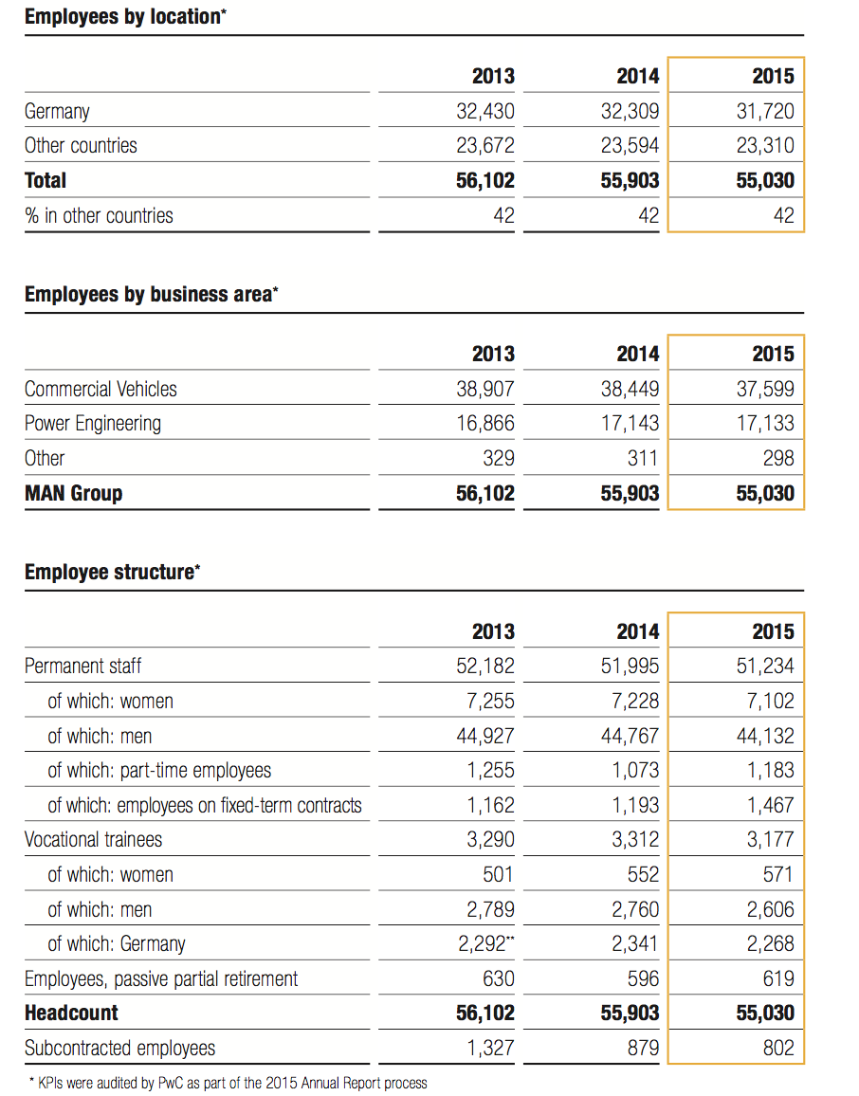
Employee turnover
The employee turnover rate indicates what percentage of employees left the company during a one-year period. Employees on xed-term con- tracts and employees starting retirement or partial retirement are not included in the calculation of this indicator. The relevant 2,070 departures in 2015 result in an employee turnover rate of 4.0%. This relatively low rate demonstrates the stability of labor relations at MAN. In the year under review, we hired a total of 4,120 people, while 4,040 le our Company.
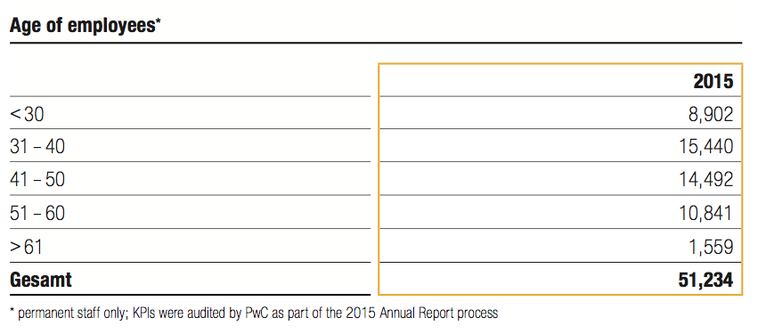

11.2 Supply/Consume
The concept, which is based on three main pillars, aims to minimize or prevent negative social, environmental, and financial impacts along our supply chain:
An early warning system identifies risks along the supply chain. Contractually mandated integration of the sustainability standards in the procurement process ensures that these are acknowledged by all suppliers before submitting a quotation on the Group Business Plat- form. Otherwise it is not possible to submit a quotation.
Supplier monitoring and development.
We regularly benchmark the effectiveness of our concept against other companies and intensively analyze the results of sustainability ratings.
Principles and guidelines
Our supplier relations are based on the “Volkswagen Group requirements regarding sustainability in its relationships with business partners (Code of Conduct for Business Partners)” which apply across the Group. They formulate our expectations for our business partners’ conduct with regard to central environmental and social standards. Among other things, they are based on the principles of the UN Global Compact, the International Chamber of Commerce’s Business Charter for Sustainable Development, and the relevant conventions of the International Labour Organization. These principles are supplemented by the Volkswagen Environmental Policy, the environmental targets and regulations derived from it, the Group’s Quality Policy, and the Volkswagen Declaration on Social Rights (see the 2015 Volkswagen Sustainability Report). Before submitting a quotation, the supplier must acknowledge the sustainability requirements; this acknowledgement must be repeated every 12 months. Since January 1, 2015, these requirements have been contractually integrated for all suppliers to General Procurement. The requirements apply to all outsourced goods and services worldwide. We also expect our tier 1 suppliers to pass these requirements on to their own suppliers.
Systems and instruments
In the interests of continuing supplier development, in the course of our business relations we make an electronic learning (e-learning) module on sustainability available to all suppliers in all of the languages of the defined risk markets. After completing this task, the supplier has to per- form a final test.
The Volkswagen Group uses an internal system for sustainable supply chain management. It provides supplier-specific sustainability information, enabling the comprehensive analysis of suppliers. If there is rea- son to suspect that tier 1 suppliers or their suppliers are failing to comply with our sustainability requirements, we ask the party concerned for a written statement using a standardized report (6D Report). Based on the six points in the report, they can describe the status quo and any remedial measures. If the answers prove unsatisfactory, we take further appropriate steps, such as the examination of documents, visits to the supplier’s premises, or other customized supplier development activities.
Through fair dialog in a spirit of partnership and through supplier development we create sustainability in supplier relations. The focus throughout all process steps and measures is on such fair dialog and on the development of the supplier in the interests of long-term collaboration.

11.3 Community
Strategic approach
At MAN we see ourselves as part of society. Our goal is to be a good corporate citizen and promote sustainable development. We can make the most valuable contributions to issues that relate to our core business areas. Our activities focus on long-term and sustainable education projects for children and young people. With our attractive initiatives, we are aiming to make a contribution to society and increase our employees’ identification with the Company.
We have enjoyed a strategic partnership with SOS Children’s Villages since 2008. In cooperation with this non-pro t organization, we implement projects around the world — often with the help of volunteer work by our employees.
Policies
All donations and sponsoring activities must comply with our mandatory, Group-wide policy. Permissible fields of activity for donations include education, academia, the arts, and community programs (social welfare organizations, charitable and humanitarian projects, and disaster relief e orts).
Instruments
Most of our sponsoring activities and donations are long standing and closely related to our core business areas. We apply the internationally recognized standard of the London Benchmark Group (LBG) to measure the success of our community projects.
Dialog with policymakers
We are actively working to develop solutions for global challenges. To this end, we also contribute our knowledge and expertise to the ongong political debate. Our focus here is on topics relevant to our core business, such as reducing worldwide CO2 emissions caused by the transportation of goods and people. We maintain an ongoing dialog with the responsible ministries at the national, EU, and international levels, as well as with elected representatives and opinion leaders from the government and the opposition.
The MAN guidelines for lobbying are defined in a Code of Conduct which applies Group-wide. This Code explicitly outlines our commitment to nonpartisanship and to making our positions transparent. In 2015, MAN spent around €80,000 on direct lobbying activities.
Dialog event
The 2014 CR Report was presented at a stakeholder dialog event held at the SOS Children’s Village in Diessen am Ammersee, Germany, as part of the celebrations to mark the 60th anniversary of SOS Children’s Villages. Some 80 stakeholders, including employees and representatives of local businesses as well as 30 children and caregivers from the SOS Children’s Village, were invited. The dialog focused on MAN’s CR activities in the context of its long-term partnership with SOS Children’s Villages.
Customer involvement and dialog
Dialog with our customers — one of the core initiatives of MAN’s Climate Strategy — represents a valuable opportunity to discuss the reduction of global CO2 emissions. After all, many of them have already rolled out their own CO2 reduction targets. It is essential for MAN to understand future customer needs; by owing customer requirements into the development of our products and services, we create more customer value.
At meetings of the customer advisory panel, first set up in 2009, MAN Truck & Bus customers exchange ideas with MAN experts and the board member responsible for sales. Selected customers participate in this discussion and feedback platform.
We also conduct targeted customer dialog at trade fairs for our sec- tor. For instance, at the Power-Gen Europe event MAN Diesel & Turbo presented its new, highly efficient line of gas-powered engines with two-stage turbocharging.
Customer satisfaction
Along with our employees, customers are our most important stakeholders because they drive our business success. In order to maintain long- term relationships with our customers and to better understand their needs, we conduct regular surveys in all our business areas to find out how satisfied customers are with our products and services. MAN Truck & Bus America has been tracking customer satisfaction each year using the Customer First Study (CFS). As part of the CFS, in 2015 we conducted telephone surveys of some 29,000 customers — 5,000 more than in the previous year. More than 90% gave MAN Truck & Bus a “good” rating or better, while almost 65% responded with “very good.” This indicates that customer satisfaction has risen above 2014 levels.
Every two years, MAN Diesel & Turbo conducts an online survey which also serves to monitor customer satisfaction. In 2015, some 4,000 customers were asked to give their feedback on the company’s products and services. Thirty-five percent of the participants rated the performance of MAN Diesel & Turbo as “good,” 42% as “very good,” and 9% as “excellent.”
We use the results of these customer surveys to check the effective- ness of our customer satisfaction improvement measures and initiate follow-up activities.

11.4 Environment
Potential for reducing the life cycle CO2 emissions of our products
To identify the potential for reducing the life cycle CO2 emissions of our products, we calculate Product Carbon Footprints (PCF) for virtually all product groups of the MAN Truck & Bus subgroup and for selected product groups of MAN Diesel & Turbo. The benchmark products for which calculations have been performed here included not only a dual-fuel engine, but also a performance-enhancing system (turbocharger) and a Selective Catalytic Reduction (SCR) system. The calculation methodology is based on the requirements of the Greenhouse Gas Protocol. The findings confirm that more than 90% of our products’ life cycle CO2 emissions are generated during the use phase.
The product life cycle stages used by MAN Truck & Bus in this calculation model are defined in accordance with standard automotive industry practice. They comprise:
1. Production
2. Use phase
3. End of life (recycling and waste processing)
Since 2014, we have also been using more specific — and therefore more realistic — calculation data for the PCF. For example we now use segment- specific lifetime mileages instead of an average for all trucks. To take a specific example, over a total lifetime mileage of 1.8 million kilometers, a TGX 18.440 4x2 BLS Euro 5 semitrailer tractor produces total greenhouse gas emissions of 1,746 tonnes of CO2 equivalent, 98% of which is generated in the use phase.
In 2013, this truck topped the production charts at MAN. The calculation was carried out in line with the requirements of the GHG Protocol Product Accounting and Reporting Standard and was verified in accordance with TÜV NORD standard TN-CC 020 and the international standard ISO 14064-3. We are currently preparing a PCF for the Euro 6 successor model. In addition, we are looking at the potential for reducing the carbon footprint of our vehicles during the use phase. The principal focus here is on fuel-efficiency measures and on calculating the greenhouse gas emissions of potential alternative fuels and drive concepts.
In future, MAN Truck & Bus also plans to perform Life Cycle Assessments (LCAs) for its products. In addition to CO2, these will also take into account additional environmental impact categories not considered in the PCF. To ensure that the LCA provides an even more accurate picture of our products, we are currently collating a database of the materials used in these products.
Commercial Vehicles Cost-efficient and clean transportation solutions from MAN Truck & Bus include the new TGX EfficientLine 2, which incorporates a whole series of new, fuel-saving technologies aimed at further reducing total cost of ownership and CO2 emissions. Standard speci cation includes the E cientCruise predictive cruise control system, the torque-enhancing TopTorque system, and the MAN TeleMatics system. The GPS-based EcientCruise cruise control anticipates upcoming uphill and downhill stretches and calculates the most fuel-efficient speed in advance. In this way the vehicle’s momentum can be used to save fuel. These measures result in fuel savings of up to 6% compared with the previous model. The TGX Efficient Line is the most successful efficiency model on the market. Since market launch in 2010, more than 50,000 customers have already opted for the extra-fuel-efficient Efficient Line models and packages. In 2015, the TGX Efficient Line 2 was named “Truck of the Year” in Spain. The products of MAN Latin America combine enhanced customer bene- ts with sustainability. The company offers a wide range of products, tailored in accordance with the motto “Less you don’t want, more you don’t need.” In addition, solutions for specific customers are custom-developed and built at a special vehicle modification center.
Power Engineering The highly effcient gas engines and emissions control systems offered by MAN Diesel & Turbo allow customers to comply with both present and future emissions requirements. The technologies used in new engines are also offered for retrofitting in engines already being operated by customers. In its Power Plants strategic business unit, MAN Diesel & Turbo offers one-stop power plant solutions that are optimized to meet the requirements of the individual customer. Following the launch of the 35/44G gas engine (electrical output 10,335 kW) on the power generation market, the latest addition to the MAN Diesel & Turbo portfolio is the 51/60G gas engine, with an electrical output of 18,465 kW. This engine too boasts very high efficiency. In 2015, MAN Diesel & Turbo show- cased versions of these highly efficient gas engines at Power-Gen Europe in Amsterdam — the world’s leading technology fair, outside the USA, for the power plant and power generation industry.
In 2016, the IMO Tier III standard came into force for ships operating in the ports and coastal waters of North America, imposing substantially more stringent limits for nitrogen oxide emissions. MAN Diesel & Turbo offers customers an IMO Tier III-compliant marine engine portfolio based on a diverse and extensive range of technologies. We are the rst company to successfully make four-stroke marine engines IMO Tier III- compliant, based on a fully modular SCR system that can be used across the entire MAN Diesel & Turbo four-stroke engine portfolio. The DNV-GL certi- cation body has awarded MAN Diesel & Turbo a Tier III-compatibility certificate for the MAN 8L21/31 four-stroke engine with retrofitted SCR system.
Alternative drive technology
In MAN’s view, alternative drive technology will take on new importance in the future. While hybrid drive, for example, has long been established in the local mass transit sector, the challenge for the future will be to establish this technology in long-distance transportation too.
The MAN Lion’s City Hybrid bus offers reductions of up to 30% in fuel consumption, which equates to a reduction in annual CO2 emissions of 26 tonnes per bus. In 2015, MAN sold 126 of these vehicles, 68% more than in the previous year.
With the TGX Hybrid, the Company also offers a hybrid-powered truck for long-distance haulage. While the diesel engine provides the main source of motive power, the electric motor operates as a generator on the overrun and during braking. Tests have showed that this solution can bring a reduction in fuel consumption and CO2 emissions of around 8%.
In 2015, MAN Latin America launched an exclusive low-cost, light- weight “Smart Ratio” automated transmission system for trucks and buses in the 13 to 30 tonne weight range. This technology maximizes the potential of a six-speed transmission by combining it with a two-speed rear axle. Performance is equivalent to that of a 12-speed automatic transmission, but at lower cost and weight. “Smart Ratio” technology has already been implemented on the Constellation truck model, developed by MAN Latin America. This vehicle is available with hydraulic hybrid drive, which can reduce fuel consumption by up to 25%, cutting CO2 emissions by up to 20 tonnes per year. For 2016, there are plans to advance the city bus technologies with prototype development and testing. For the truck model Constellation a more sustainable cab has been developed with plastic
components manufactured using nanoclay and featuring increased use of renewable materials, while offering the same standards of quality and functionality as conventional cabs.

11.5 Education
Vocational training and the dual model
Our dual model of vocational training ensures the development of the next generation of outstanding technical and commercial employees. The program, which is anchored in the MAN Academy, saw almost 800 young people starting their careers at MAN in the fall of 2015 — in locations including Germany, Austria, and Turkey. In the year under review we also rolled out a dual vocational training model at our site in Poland.
MAN offers its vocational trainees the opportunity to enter one of 28 vocational training programs, which provide training in 20 technical and eight commercial professions. The number of young women entering our programs and showing an interest in technical professions has grown. In the year under review, 17.8% of our 2,957 vocational trainees were women.
Dual education programs in cooperation with various universities are increasing in popularity among young people. At present, more than 200 students from dual education and integrated vocational training and degree programs are completing the practical part of their studies at our sites in Germany. And 20.5% of the participants in these programs are women.
The digitization of the workplace means that going forward, the restructuring of vocational training programs will present a particular challenge. With this in mind, projects have been initiated within the Volkswagen Group.
Our trainees have received several awards for excellence. The four best MAN Group vocational trainees were honored with the Volkswagen Group’s 2015 Best Apprentice Award. In addition, the Chamber of Commerce and Industry awards for the best vocational trainee in the machinist program in their respective regions went to a young talent from MAN Truck & Bus in Lower Saxony and another from MAN Diesel & Turbo in Bavaria. And an international award also honored a vocational trainee
from MAN Diesel & Turbo, who received the 2015 Apprentice of the Year Award from the Confederation of Danish Industry in Copenhagen, Denmark.
Continuing professional development and training
Approximately 145,000 participants around the globe took part in some 14,400 continuing professional development (CPD) and training initiatives in 2015. Learning and teaching take place in close cooperation with internal experts. They pass their knowledge on to their colleagues within the Berufsfamilien, which include all employees who have a common skill that they develop further. This training and knowledge transfer takes place within the Berufsfamilien Academies.
In 2015, the principle of the Berufsfamilien Academies (BFA) was further expanded and broadened by the MAN Academy to guarantee uniform standards of quality and competencies around the globe. Here the focus was on the Berufsfamilien of Sales/After Sales, Engineering, Purchasing, Finance, HR, and Quality. The Production BFA had already launched its activities in 2014. The user base of the central MAN training portal has also been expanded. Employees in our Steyr and Ankara sites are among those who will be able to take advantage of the full range of offerings starting in early 2016. This will include a broader spectrum of digital learning opportunities.
Additional training programs were successfully rolled out to improve the leadership skills of group leaders (“Meister”) and support them in their day-to-day leadership roles. In 2015, some 200 group leaders were trained from the production, logistics, service operations, and vocational training sectors.
Leadership and management training
The selection and training of high potentials for management functions and leadership roles is a key aspect of HR development. We offer these employees a comprehensive training program designed to prepare them for their future leadership roles and management functions. In 2015, we expanded our leadership and management training program. The Company’s current requirements determine the focus of these HR development measures.
Fostering young talent
It is our aim to attract and retain talent at an early stage. We offer internships, scholarships, and career development programs to young people who are attending or have recently graduated from universities and vocational-technical schools. In 2015, the MAN Group supported 23 PhD students and gave some 3,000 students from colleges and schools around the world a chance to gain first-hand practical experience working in the Company. Also in 2015 MAN Latin America granted scholarships to 44 employees. 64 employees participated in a scholarship program for language learners launched in 2014.
Our young talent programs target students at more than 100 technical colleges and universities. The MAN Group was represented at more than 20 specialist and university career fairs in 2015. In addition, our experts held numerous lectures around the world. For four years now, MAN has also supported teams from Munich Technical University, Munich University of Applied Sciences, Karlsruhe Institute of Technology, and RWTH Aachen in the Formula Student Germany race series. These activities focus on providing opportunities for face-to-face meetings and discussions with MAN employees.

11.6 Healthcare
Challenges and objectives
Shifting demographics and today’s changing working environments bring significant challenges for occupational health and safety at MAN. These factors affect our employees’ productivity and require holistic approaches to maintain their health and provide them with treatment when necessary. Only healthy and productive employees can make a meaningful contribution to the long-term success of the Company. With this in mind, MAN places high priority on ergonomics and preventive health and safety in the workplace within the framework of its comprehensive occupational safety and health management program.
Organization
The corporate health services function at MAN is responsible for guiding the employer in the formulation and implementation of its Company- wide health management strategy. The goal is to de ne a coordinated strategic approach to health services worldwide by developing principles which are applicable in every location. In addition, the health services at our plants act independently to address specific concerns with appropriate measures.
Systems and instruments
At MAN, occupational health measures aim to strengthen our employees’ and managers’ health awareness and encourage them to take the initiative in matters concerning their own health. To this end, we offer health counseling, training courses, therapeutic measures, and re-integration assistance. Occupational safety includes all measures related to preventing workplace accidents, work-related illnesses, and occupational diseases. Our occupational safety management is part of our integrated management system (, page 37).
Certifying our sites under the OHSAS 18001 management system for occupational health and safety helps to continuously improve the safety and health of our workforce.
Across the Group, we systematically evaluate workstation ergonomics and potential workplace hazards. This reflects the high priority that we assign to improving ergonomics in our production sites with the aim of keeping our employees healthy and physically fit. In addition, we conduct regular internal and external occupational health and safety audits and inspections.
Preventive occupational safety
Across the Group we have continued with a variety of initiatives to cut accident rates and prevent work-related illness. The success of these measures is demonstrated by the 4% decrease in lost-time injuries in 2015 com- pared to the previous year. As part of our “Workplace Optimization” initiative, we have systematically assessed the ergonomics of all workstations in MAN Truck & Bus production sites.
The Health and Safety Competence Forum, which was set up by MAN Truck & Bus and includes all its sites, aims to facilitate the exchange of information and the strategic development of occupational health and safety in the coming years.
In 2015, MAN Diesel & Turbo spotlighted employee health and safety on business trips. A cross-functional working group took a close look at all processes related to business travel. Initial measures for improving these processes have already been rolled out.
MAN Latin America has appointed workplace safety sponsors, who both advise their colleagues on safety questions and report risks to their supervisors. In 2015, 287 suggestions for improving workplace safety were submitted by employees in Resende, Brazil and 264 of these were implemented. And the employees’ initiative has paid o . In November 2015, the Resende plant was able to celebrate an occupational safety milestone: two million working hours without any missed workdays due to accidents.
The “Always Safe. Always Good” project at MAN Truck & Bus production sites aims to improve behavior-based safety. This initiative, which was first launched in Munich and Dachau, has now been expanded to include Nuremberg and Salzgitter. Some 30 workshops have been held for managers, employees, and trainers, focusing on safe behavior for oneself as well as staff and colleagues. In the first stage of the campaign, the target is to reach at least 30% of the employees in each plant with the aim of achieving a lasting improvement in the safety culture. Almost 100% of the employees at the Steyr site have already completed the training. Planning for the rollout to non-German-speaking sites was completed in 2015; the rollout itself will begin in 2016.
MAN Diesel & Turbo places particular emphasis on preventing occupational accidents. Thanks to the MAN Diesel & Turbo Zero Accident Initiative, 2015 marks the seventh year in a row in which there has been a decrease in the severity of workplace accidents within the subgroup. Established in 2014, behavior-based safety programs were ne-tuned in the UK, the U.S., and the Augsburg site in 2015. The programs aim to increase awareness of hazardous situations, systematically remove risks, and foster safe workplace habits. In addition, the “Safety First” campaign has made a valuable contribution to improving safety awareness and occupational health and safety. The majority of MAN Diesel & Turbo’s service engineers have also been trained and certified in line with the Safety Certificate Contractors standard, which aim to sharpen safety awareness on customer construction sites and in projects.
11.7 Specific projects
Long-term partnership with SOS Children’s Villages
As part of our long-term partnership with SOS Children’s Villages, we have pledged annual funding of €150,000 to support SOS Children’s Villages facilities in Germany and around the globe. In addition to offering financial assistance, we strongly encourage employee volunteering. In 2015, 76 MAN employees volunteered 625 hours in SOS Children’s Villages facilities.
One international program which we support is the SOS Vocational Training College in Kality, Ethiopia. Since 2008, MAN has contributed some €600,000, which has gone toward construction of a new training building, facilities maintenance, the salaries of five teachers, and MAN scholarships for the young people. Our decision to continue funding the project was based on an analysis we conducted using the London Bench- marking Group methodology. Another international project we support is the SOS Hermann Gmeiner School on the outskirts of the Haitian capital city of Port-au-Prince, where we cover the cost of five teachers.
In the year under review, the longstanding and successful relation- ship between MAN and SOS Children’s Villages was expanded to include a partnership between MAN Diesel & Turbo and the SOS Children’s Villages organization in Augsburg, Germany.
Aid for refugees
From early in 2015, we focused our charitable activities on providing aid to refugee children and their families as well as unaccompanied refugee minors. To help address this issue, here too we are collaborating with our strategic partner SOS Children’s Villages. We have donated almost €90,000 to the non-pro t organization’s refugee assistance programs, earmarked for its facilities in Munich, Augsburg, Salzgitter, and Dießen am Ammersee. It is our goal to help create a brighter future for refugee children by opening up opportunities for education and participation in our society.
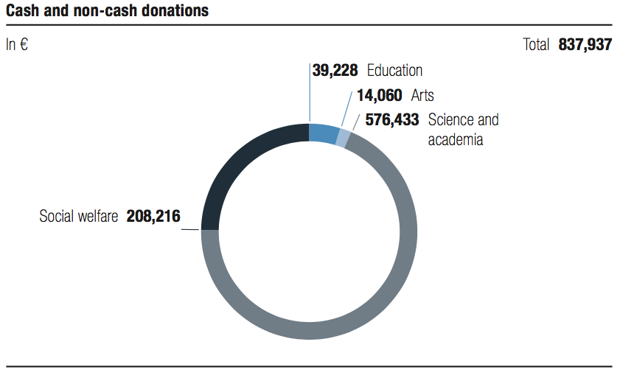
Scholarships
MAN supports 60 recipients of the Germany Scholarship at the Technical University of Munich (TUM), making us the primary sponsor. Half of the funding for the scholarships, which are awarded in recognition of out-
standing achievements, comes from the German federal government, with the other half contributed by companies, foundations, and private individuals. In addition to TUM, MAN also provides Germany Scholarship funding at RWTH Aachen University, Deggendorf Institute of Technology, and the Technical University of Berlin. Around the world we collaborate with a total of almost 100 technical universities.
Several years ago, MAN PrimeServ China launched its own scholar- ship program, which allows MAN Diesel & Turbo to support students of marine technology at Shanghai Maritime University and Dalian Maritime University in China. Each year, four students are granted scholarships based on their outstanding academic achievements.

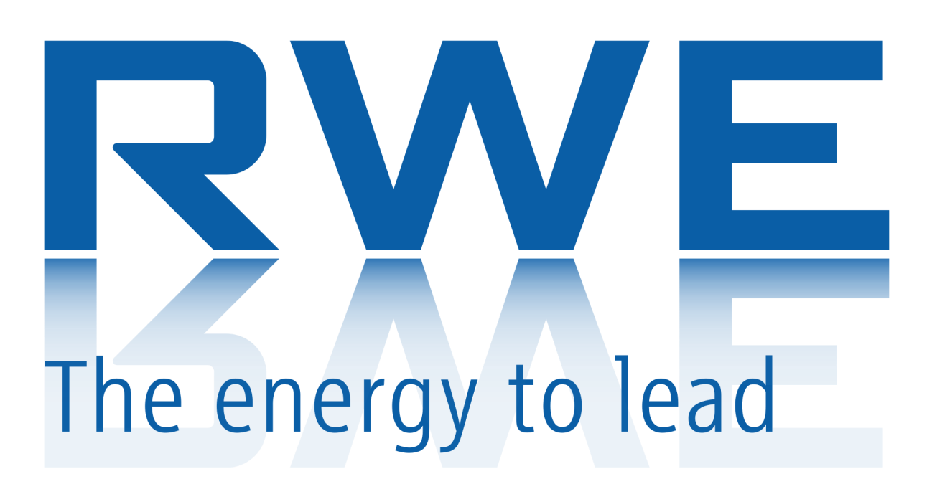
12.1 Employees
RWE needs to adapt to the new framework conditions in the energy economy. Organisational changes are inevitable in this process. We intend to structure the cultural change responsibly and in close communication with our employees. If we are to create a working environment which will enable us to remain an attractive employer, we are dependent on the key elements of flexibility.
Challenge
The RWE Group continues to be confronted by the biggest challenges in the history of the company. And our human resource policy is no exception. Restructuring operations and organisational realignments are unavoidable as far as we are concerned. New areas of business have been built up, while the number of employees is stagnating or declining with others. The number of employees in our workforce (expressed in full-time jobs or full-time equivalents, FTE) remained virtually constant with 59,784 at the end of 2014 com- pared to 59,762 at the end of 2015.
Motivation and targets
We are organising necessary restructuring measures, reallocations of human resources and a reduction in the overall number of jobs in a socially responsible and ethical approach. The process involves ongoing conversations with employee representatives throughout the Group and with union representatives. We are structuring our work culture together with our employees in order to remain competitive and attractive. In this process, we believe it is important for us to maintain the engagement and motivation of our employees at all times even though the framework conditions have become tougher.
Monitoring and performance measurement
We have defined the Motivation Index as a benchmark for measuring the engagement and motivation of our employees. This is recorded in a staff survey carried out across the entire Group. This index is integrated as a performance indicator in the calculation of the variable compensation paid to the Executive Board of RWE. During the year under review 2015, the index had a value of 72.4 points. We have therefore already reached our target value of 72.2 for 2017.
We also use the Demography Index as the second indicator in the area for action Employees. This indicator provides a method of assessing the age structure of the employees in the company. In 2015, the Demography Index was 82.5 points. As the value of the index approaches 100, the age structure within the Group becomes more balanced. By 2018, we intend to achieve a score of at least 84 points.
Group-wide job market
Change in employment driven by the energy transition entails a far- reaching restructuring of the workforce. In April 2015, our central SWITCH Job Platform was therefore launched as a dedicated business unit with group-wide focus. SWITCH offers an overview of vacant jobs within the Group, supports recruitment to posts from the vacancy notice to the appointment, helps employees to recalibrate their career, achieve further qualifications and mediates new jobs for them as necessary. SWITCH is also building up its own employee base which can be booked for projects in other areas over a limited period of time.
Cultural change in the company
The growing business pressure being exerted on the RWE Group and the changes occurring in the energy market present us with challenges which necessitate a cultural change at our company. We have therefore initiated an array of different programmes in order to make this a reality.
Our objective is to establish new mindsets and new ways of working within the Group. The programme New Way of Working (NWoW) has been designed to achieve this. We are defining new standards for our working practices, promoting the skills of our employees and developing a common working culture in the three areas of leadership and alignment, universal process management, and operational excellence. We are also analysing functions, processes and methods of working in different areas of the Group and initiating any changes required, for example we are improving internal cooperation and implementing a more robust feedback culture. Our intention is to use these and other measures to enhance customer satisfaction and improve the financial result.
At the moment, around 200 NWoW experts are currently working on a total of 20 projects for rolling out the concept more extensively in the Group. Alongside 70 employees at Group Headquarters, 130 local experts are working in the companies. Some 17,000 colleagues are now being trained in new working practices.

12.2 Supply/Consume
As globalisation of markets continues apace, national borders also lose their relevance for trade in energy sources. However, internationally binding standards for environmental protection, human rights and occupational safety have hardly been established. Companies like RWE are therefore being challenged by their stakeholders to exert influence on suppliers through their procurement policy.
Challenge
RWE purchases a large proportion of its combustion fuels in global wholesale markets. This also applies to many goods and services. Our stakeholders expect us to purchase these products from companies which observe compliance with human rights, offer workers reasonable working conditions and operate effective environmental protection.
Motivation and targets
In cooperation with our suppliers, we intend to go beyond the statutory requirements relating to compliance and promotion of international environmental and social standards for procurement. All sup- pliers of RWE should understand and take account of the relevant international environmental and social standards, and other detailed requirements as necessary. We therefore include information about how our suppliers comply with sustainability requirements in our purchasing decision. The ten principles of the UN Global Compact, our Code of Conduct and other detailed guidelines form the basis for these requirements.
Monitoring and performance measurement
We use the proportion of the purchase volume subject to the requirements of our Code of Conduct as a constituent element of the contractual relationship in the form of the key performance indicator (KPI) and indicator for target attainment in the area for action of Supply Chain. This proportion should be at least 98% of our purchasing volume. Our target here is complete coverage of our purchasing volume. During the year under review, the degree of coverage was 99.4%.
Sourcing energy commodities and trading
Key elements of our value chain are the procurement of hard coal and natural gas, as well as trading in combustion fuels. Raw materials are traded as standardised products with defined quality attributes on international virtual wholesale markets. These markets are the most important source of procurement. Trading is carried out along standardised processes with the involvement of a large number of market players. Before we take physical ownership of the raw materials, they have often changed ownership several times in the virtual market after they were first offered for sale by the producers. Generally, it is only possible for us to identify the immediate upstream owner, but the precise geographical origin of the raw material is not known. There are therefore only direct supplier relationships to a limited extent between RWE and the producers. This means we have virtually no opportunities to exert any direct pressure on production conditions.
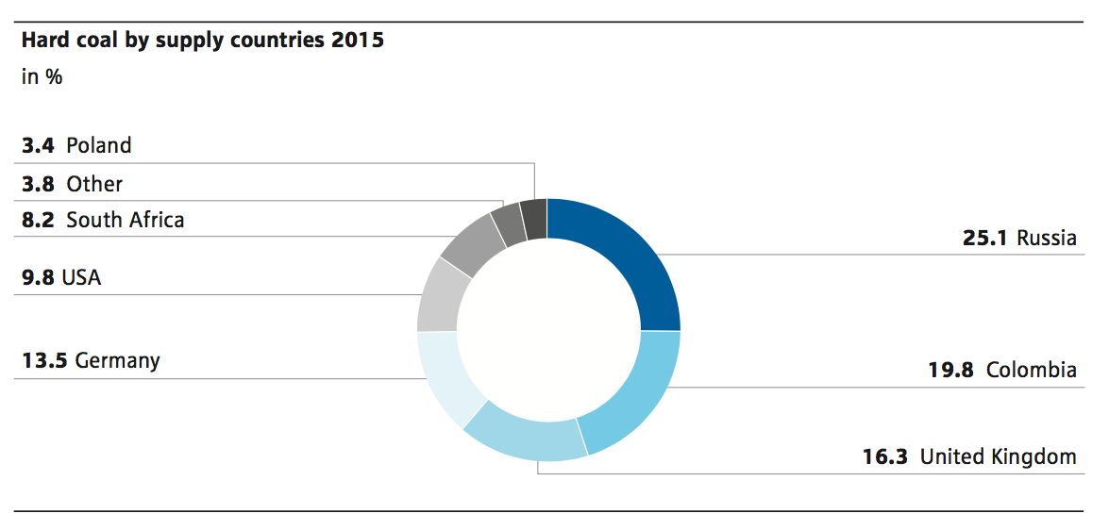
Review of trading partners
We review all potential trading partners for energy commodities before we enter into any business relationships with them. Our Counterparty Risk Assessment (CPRA) provides helpful assistance in carrying out this review. We undertake a standardised, multistage process to check international databases and information systems to see whether any misconduct is known in relation to the ten principles of the UN Global Compact or our Code of Conduct. Since 2014, we have been taking account of the information garnered in the Bettercoal Initiative. The number of our accredited trading partners fluctuates and is generally between 1,500 and 2,500. The purchasing volume procured through wholesale markets amounted to around € 8.2 bil- lion in 2015.
Requirements for procurement of hard coal
Our goal is to ensure sourcing of hard coal in the necessary amounts and to the required quality while at the same time monitoring environmental and social standards in our supply chain. In 2015, we imported around 57% of our hard coal from countries which are not members of the OECD. When Germany ceases production of hard coal after 2018, the country will be completely dependent on the import of this combustion fuel.
Bettercoal Initiative
Acting alone as an individual company, RWE can only exert a very limited impact on compliance with standards in occupational safety, employment relations and environmental protection in the supply chain for hard coal. Cooperating with other energy companies is absolutely essential in order to be in a position to exert more pressure and achieve sustainable production conditions. In 2012, we
joined forces with other large purchasers of hard coal to launch the Bettercoal initiative. By the end of 2015, twelve of the biggest European energy companies were already members of Bettercoal. The Dutch ports also joined the initiative as associate members.
The first inspection of a coal mine by independent auditors was carried out in Columbia in 2014. On the basis of the results, an improvement process was agreed with clear targets and deadlines. At the end of 2015, another inspection took place and confirmed the implementation of the agreed measures. Bettercoal uses a central data- base to provide its member companies with the results of the audits or the outcomes of self-assessments by the mines. The names of the mines which have undergone a self-assessment or an on-site audit are regularly listed on the Bettercoal website – provided that the mines agree to publication. At the end of 2015, 12 mines had been recorded in this way. They cover the key potential supplier countries for Europe. In the summer of 2015, Bettercoal published its first annual report.
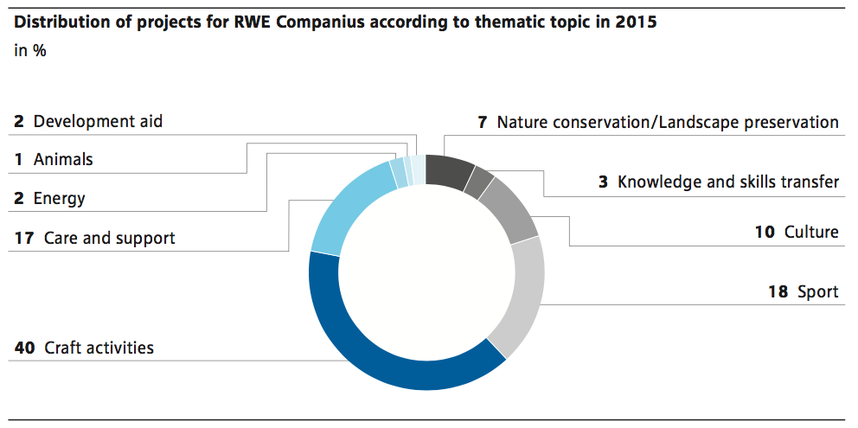
Implementation of commitment
At the end of 2014, the Dutch utility companies, including RWE subsidiary company Essent, and the Dutch government signed a declaration of commitment for improvements in the international production and procurement of hard coal. An initial progress report was published at the end of 2015. It presents the progress that energy utilities and government institutions made during the year under review. One of the core elements is the Bettercoal initiative. The report and further steps to be taken for the year 2016 were discussed in a stakeholder dialogue.
Requirements for the procurement of biomass
In order to be able to establish biomass as a sustainable alternative to fossil fuels, environmental and socially ethical conditions must be guaranteed for the methods of cultivation and production. Certificates are used for this in order to guarantee compliance with sustain- ability aspects along the entire supply chain for the wood pellets imported by us. Up until the end of 2015, we applied the Green Gold Label (GGL) for certification. In future, we will use the new industrial standard of the Sustainable Biomass Partnership (SBP) for this purpose. The reference standard was published in March 2015. Up to now, the United Kingdom and Denmark have acknowledged the SBP Standard as being compliant with the national sustainability criteria. During the first half of 2016, this should also be confirmed in the Netherlands in the course of an official proceeding by the authorities there. Over the coming months, the standard will be continuously improved and this process will have been published by the end of 2016.
Sourcing goods, services and plants
Our uniform Group reference standard is the tool we use to monitor the purchase of goods, services and plant components for the operation, maintenance and new-build of our plants. Direct business relationships we have with individual suppliers and service providers mean that we can include our Code of Conduct as an addendum and constituent element of each contract. This enables us to communicate a clearly defined specification of our expectations for our suppliers and service providers.
An initial appraisal of potential suppliers based on a self-assessment helps us to gather additional information on the issues of environ- mental protection, occupational safety and compliance. During the year under review, 285 suppliers were assessed on the issue of environmental protection and 3,362 on occupational safety. Regular reviews are carried out for all suppliers to verify conformity with potential compliance risks and we also carry out reconciliations with the Black List maintained by the World Bank and with the sanctions lists drawn up by the EU. When any problems occur in the course of a business relationship, we address the matter with our suppliers and work together with them to achieve improvements jointly.
Around 11,900 suppliers are registered in our supplier portfolio, 330 of them are of particular strategic importance. We are in regular, close contact with these specific suppliers. The purchasing volume for goods, services and for plant components was € 6.8 billion in 2015.

12.3 Community
We carry out key functions for energy supply and the employment market with our products and services, our capital expenditure, and also as an employer. Our mission is to ensure a secure supply of electricity and gas at all times. Part of that mission is also to provide jobs. The activities we pursue are dependent on trust and acceptance at international, national, regional and local level, particularly in the districts surrounding our sites. RWE seeks dialogue in order to create trust. We communicate with groups impacted by the activities of our company or groups carrying out activities influencing our business operations. We want to know about their positions and respond to their concerns in an appropriate way
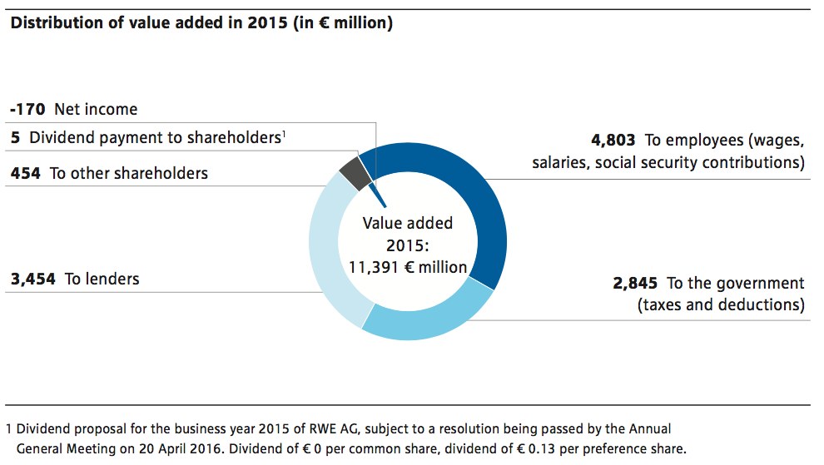
Motivation and targets
The challenges of the energy transition can only be solved at the level of society as a whole. We are the credible partner for this challenge and we want to enhance trust in our company within our regional and local environment, as well as within society overall. That is why we promote social developments through initiatives in social, environmental and cultural spheres, with volunteering engagement by RWE employees, by neighbourhood support and through financial assistance. We want to continue strengthening our acceptance in this way and create a profile that is distinct from our competitors.
Monitoring and performance measurement
We want to use the resources available effectively and in conformity with our compliance objectives. We have defined the rules for the allocation of resources in our Guideline on Donations and Sponsor- ship which applies throughout the Group. A standardised annual sur- vey is used to measure the results of our engagement in order to determine the Reputation Index. We apply the results to check the effectiveness of our measures. In 2015, we achieved a score of 58.4 but this still remains below our target score of at least 59.0 points. Our objective is to have achieved this target by 2018.
Action on fuel poverty
We help to ameliorate fuel poverty in the countries where we are operating – particularly where the government and civil society do not provide enough support. Fuel poverty is defined as households which have to spend more than 10% of their net income on energy needs. There are various differences here between the needs and offerings in the individual countries.
RWE has been cooperating with the Trussell Trust in a number of communities across the United Kingdom. This is a charity working to alleviate poverty and the two organisations have launched the Fuel Bank Initiative to help vulnerable families which are unable to afford to purchase electricity and gas. The initiative provides vouchers worth about € 68 (£ 49) each that can be used to purchase energy allocations. The vouchers are issued through the organisation Trussell Trust Food Banks, which distribute food packages to vulnerable people.
The Health Through Warmth Programme enables us to support vulnerable people with long-term illnesses who need help to install heating and carry out insulation measures, or to repair existing systems and appliances, which they cannot afford to fully fund themselves. RWE also helps people affected by cancer who cannot pay their energy bills through its partnership with the non-profit organisation Macmillan Cancer Support in the United Kingdom.
In Hungary, we work together with aid organisations and local authorities in order to help vulnerable customers by providing advisory services on energy consumption and pre-paid electricity meters so that they have the capability to control their own costs. We also offer lignite to residents living in the vicinity of the Mátra power plant for use as a heating fuel at a reduced price.
The Croatian Government has issued a Directive on Energy Poverty. On 1 October 2015, around 60,000 vulnerable households in Croatia started receiving monthly vouchers to help cover their bills for electricity consumption. As one of the major electricity suppliers in the Croatian market, RWE has given its support to this solution.
Corporate volunteering
We promote volunteering by our employees under the umbrella of the group-wide Corporate Volunteering Programme known as RWE Companius. Targeted formats help us to allocate employees to a volunteering role appropriate to their requirements. The Expertise Exchange gives the local community access to the know-how of our employees, including on topics such as public relations work and performance audits. In cooperation with the Caritas Association for the Diocese of Essen, we qualify and make arrangements for employees to act as support mentors for older people. The RWE Companius format “Kopfverleih” or “Expert Advisor Group” is our way of enabling colleagues to provide advice for non-governmental organisations. This year the Expert Advisor Group was integrated in an internal strategy meeting for the first time. Around 75 employees from 15 international RWE companies provided comprehensive advice for organisations keen to benefit from this assistance. We also integrate Companius projects into commercial training in order to expand the expertise of apprentices at RWE. In 2015, a total of more than 2,031 employees dedicated their time to providing assistance on 1,344 pro- jects. The amount contributed to these projects totalled € 2 million during the period under review.
Charitable projects in Hungary included giving Christmas presents and donating 1,000 hot meals to vulnerable people there. We also carried out several blood donation campaigns and contributed to the Smiling Hospital Project. RWE also provided support for a non- denominational aid organisation with donations and a 14 kW photo- voltaic plant so that it could generate its own electricity.
Aid for refugees
In cooperation with its long-standing community partners, RWE Companius Volunteering develops projects in the area of aid for refugees. Employees of the entire Group, from apprentices to the executive management make a commitment to team projects and individual projects for refugees. In this year alone, 239 employees provided assistance for refugees. They provided support by collecting aid sup- plies, worked as language teachers or renovated refugee homes. Refugees in Hungary were helped through the provision of blankets and opportunities to charge their mobile phones. RWE employees from different companies in Germany took part in a project where they worked together with refugees and local people to establish a Talent Workshop. RWE Companius promotes volunteering engagement.
Furthermore, RWE provided refugees with apartments located in former villages in the Rhineland lignite mining area which had been vacated when the people in the villages were resettled. Land in the surrounding areas of some power plant sites was also made available, for example in Niederaußem, Essen-Karnap, Weisweiler and Ibbenbüren. These premises and sites are made available free of charge. Only the provision and disposal of the facilities is compensated on the basis of cost.

12.4 Environment
Challenge
The operation of conventional power stations and plants for generating electricity from renewable energies, the production of lignite and the operation of our distribution grids inevitably result in our impacting on natural ecosystems. Pollutants are released during the production of electricity and heat in our power plants or the operation of our opencast mines and they can lead to negative impacts on people and the environment. We are therefore committed to ensuring air pollution control and to conserving natural resources. This applies in particular to the use of water. We compensate the use of land for our opencast mining activities by recultivating the extraction sites. This approach enables us to return usable areas of land to agriculture and for other use while also creating space for nature conservation where we can strategically foster biological diversity.
Motivation and targets
We want to avoid direct and indirect interventions in ecosystems through our activities. If this is not feasible, our aim is to keep the impact to a minimum. As far as possible, we mitigate unavoidable or irreversible negative consequences with adequate nature conservation measures. This means that we create ecosystems with at least the same functional capability as before the intervention and as a result frequently go beyond the statutory requirements. We carry out a major share of our activities in the area of environmental protection on the basis of the licensing regulations that we have to comply with when we construct and operate our plants. We are therefore continuously driving forward our group-wide coverage of RWE’s activities by our environmental management system. Furthermore, we are also committed to steadily promoting and improving the elimination or reduction of environmental impacts. At the same time, we are regularly in dialogue with our stakeholders, in order
to strengthen acceptance for our activities
Monitoring and performance measurement
We are continuously carrying out analyses and evaluations of environmental issues in order to assess their relevance for the RWE Group. The key performance indicator in the area of environmental protection is compliance with the licensing regulations for the installation and operation of our plants and facilities. Our compliance with such systems is ensured with regular on-site checks. The percentage coverage by our environmental management system provides us with a further key performance indicator.
All RWE companies have an obligation to act in compliance with our Group Directive on Environmental Management and set up a dedicated environmental management system in conformity with the requirements of the ISO 14001 international standard. Compliance with this standard is ensured by annual audits. During the course of 2015, group-wide expenditure on environmental protection amounted to € 2 billion.
During the year under review, there were no major incidents at the plants of the RWE Group that resulted in significant impacts relevant to the environment. Compliance with all licensing regulations was consistently ensured. In 2015, 20 notifiable events at notification level 0 were registered for our nuclear power stations. There were 14 notifiable events in the previous year. Our fossil-fired power stations were operated in 2015 without any major disturbances.
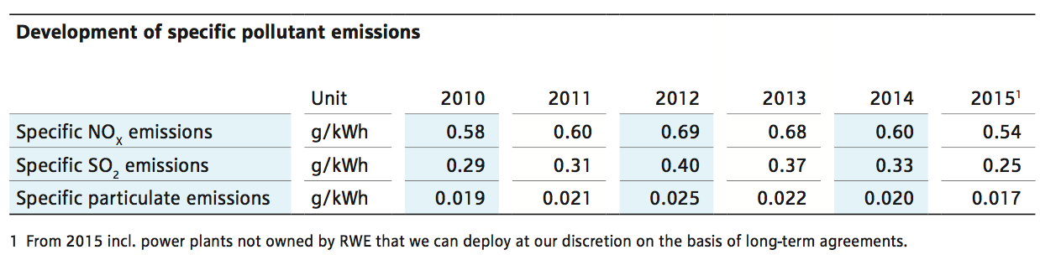
Pollutant emissions and waste
Upgrading our power plant portfolio with modern burner technologies and optimised separation processes enable us to reduce the emissions of pollutants which are released during the production of electricity and heat at our power plants. One example of this is mercury, where the advanced technologies used today for flue-gas scrubbing remove up to 90% of this pollutant with pure coal combustion. At the Coal Innovation Centre in the Rhineland lignite mining area, we are currently working on improved procedures for the removal of mercury, for example by adding activated coke to flue gas. The results of test trials to date lead to the expectation of further improved separation of mercury. However, further, tests still need
to be carried out. There is not currently a standard marketable technology that could be used directly in our plants to reduce mercury transmissions.
However, the Federal Environment Ministry has not identified any adverse readings when measurements have been taken – even in the environment of coal-fired power stations. The level of pollution measured in the ambient air outside, in other words the amount of pollutants which impact on people and nature are in the range between 1 and 2 billionths of a gram (ng) per standard cubic metre of air (ng/Nm3). In Bergheim, this figure is actually significantly less at 0.04 ng/Nm3. The critical value for outside air is 50 billionths of a gram per Nm3.
Avoid, recovery, disposal – this is the principle underlying our waste management. We are continually reducing the amount of waste which cannot be recycled for further downstream application. Accordingly, all residual waste is disposed of in compliance with statutory regulations.
This also applies to residual materials and waste from our nuclear power stations which occur while they are being operated as well as when the power plants are decommissioned. Only a small part of the entire mass of the nuclear plants ever comes into contact with radio- active materials when they are operational. The greatest proportion of this material is then cleaned with the assistance of decontamination measures so that it can be released by the government authorities and then returned to the normal cycle of materials. The remaining residue – only around 3% of the total mass of a nuclear power station – is destined for disposal in a final repository for radioactive waste. This material primarily includes components near the core of the reactor. Until the material is consigned under statutory regulations to a final repository operated by the government, these waste materials, such as spent fuel rods, are kept at an intermediate storage facility under the supervision of the nuclear regulatory authorities.

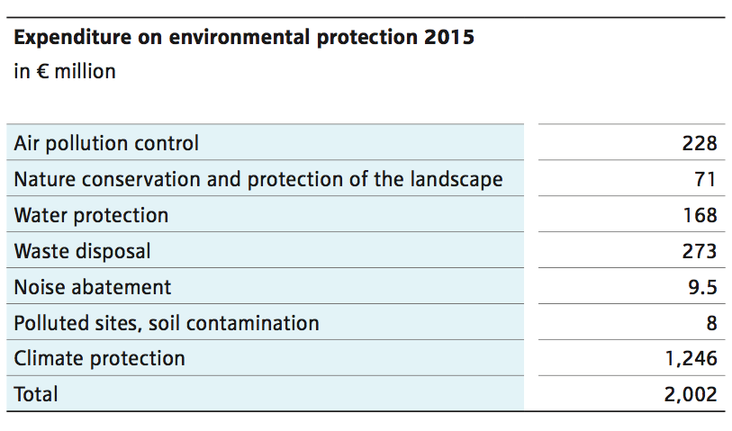
Water use
A top priority for RWE is ensuring that our use of water exerts mini- mum impact on natural resources when we supply our thermal power plants with cooling water. We also provide the best protection for aquatic habitats and other ecosystems linked with such habitats against adverse effects. Environmental impacts are prevented by methods such as recycling water, more intensive use of pumped water from opencast mines and using collected rainwater, as well as recovering and re-using process water from operations. Our internal wastewater treatment and continuous monitoring of the process ensure that potential contamination is eliminated. We provide verifiable compliance with the statutory threshold values. This enables us to avoid negative impacts on nature and human health.

12.5 Education
We will only be able to continue mastering the future challenges presented in the energy business by having professional and dedicated employees and managers. Our aim is therefore to continue recruiting
talented young people to work at RWE. We use a range of different tools to make contact with them including our Online Career Portal and our Applicant Academy where we advise graduates, school children and people with career experience. The aim is to help them make a start on the career ladder in the world of work or change jobs. We focus our on-site activities on selected universities in Germany and abroad, as well as offering personal interviews. We also provide around 2,400 young people with a high-quality apprenticeship training in 30 different training vocations encompassing industrial, technical and commercial fields. In addition, we also offer twin-track degree courses incorporating practical and in-service training modules within the course structure. We continue to carry out training that extends beyond our own specific needs and this gives a large number of young people an opportunity to enter the job market.
We have been using the initiative: “I can do this” (Ich pack’ das) for a long time to provide support for teenagers and young adults who have not yet been able to gain an apprenticeship place although they have successfully completed education at school. Since the programme was launched, more than 1,000 participants have benefited from the one-year entry-level foundation qualification. 80% of them have gone on to obtain an apprenticeship place afterwards.
Diversity and equal opportunity
Diversity represents an opportunity for cultural change in our company and it improves our routine work every day. Taking advantage of this opportunity involves us in promoting the careers of women, integrating people with disabilities, fostering intercultural exchange within the Group and getting the work-life balance right between career and family.
We established the Inclusive Culture Focus Group in our subsidiary companies with the aim of promoting diversity among our employees. The objective is also to design measures through discussions, which will be able to continue strengthening integrative corporate culture throughout the Group. Participants include men and women from different origins, religion and sexual orientation, and any individuals with and without disabilities.
Increasing the proportion of women
Our original aim was to increase the overall proportion of women in management positions to 22% by 2018. However, this has become too ambitious a goal in view of the sustained restructuring measures. We have therefore redefined the target as 17%. By the end of 2015, the proportion of women in management positions throughout the
Group was 15.2% (2014: 14.3%). In order to comply with the new statutory regulation in Germany, we have defined targets for the pro- portion of women in Supervisory Boards and management bodies for RWE AG and all our subsidiary companies affected by the legislation. As far as RWE AG is concerned, this means achieving a percentage of women on the Supervisory Board amounting to a minimum of 30% by 2017. In future, at least one position on the Executive Board of RWE AG should be occupied by a woman. Our ambition is to achieve a proportion of women amounting to 25% at the first management level below the Executive Board and a proportion of 30% at the second level below the Executive Board. Three women are currently members of the 20-strong Supervisory Board of RWE AG and two of these are elected by the employees. During the year under review, the Executive Board did not have a woman representative.
RWE Education Initiative 3malE
“Education with Energy” is the slogan we are using to generate enthusiasm among young people for energy and technological issues. We discuss the energy supply of the future with them under this focus. “3malE - Education with Energy” bundles the education packages of all RWE companies in Germany. This initiative is intended to help young people research, discover and experience energy. During the year under review, we significantly expanded these packages for children, teenagers, students and teachers. School competitions, trips, preparation of teaching materials and packages in social media are some of the activities making a contribution to communicating knowledge about topics related to energy in an informative approach. Another example is a digital game which helps young people to learn about generating and using renewable energy. In 2015, 492 experiment kits were loaned to 62 schools and 62 nurseries. 85 RWE employees were sent into schools as energy ambassadors. Around 600 school classes, with more than 1,700 school children, and a large number of students paid a visit to the company’s operational locations.
Education initiative in Poland
In 2013, the RWE Foundation in Poland and the Copernicus Science Centre (CNK) launched their own educational programme - the RWE Power Box. The initiative is based on an innovative approach in which teachers apply modern teaching methods based on experiments when they work together with school children. The focus is on important topics relating to energy generation, storage and use. The system also gives teachers in schools the opportunity to engage in discussions on natural phenomena and sustainable development. The programme is intended for teachers and children attending elementary schools and lower grades at secondary schools.
In 2015, the third edition of the workshop in the RWE Power Box Programme was held in Warsaw, Szczecin, Lublin, Elbląg, Poznań, Wrocław, Gdańsk, Kraków and Katowice.
The 1st edition of the RWE Power Box Programme was used at 60 elementary schools in Warsaw. 40 educational institutions located in Malbork and the Suwałki regions participated in the 2nd edition. A total of more than 100 RWE Power Box sets were handed over to schools. Ten thousand school children participated in the two editions of the programme. The programme is also being continued in 2016.
12.6 Healthcare
Challenge
Our employees and the employees of our partner companies often carry out their assignments at workplaces with special requirements for occupational health and safety. In particular, these include activities in the area of opencast mining, in technical areas at our power plants, and at transmission lines or wind turbines. As an employer, we take our responsibilities very seriously and minimise the risks of accidents and health hazards. Alongside retaining the physical health or our employees, we also have a duty to look after the mental health of our staff. We believe that this is a particularly important task in times of change within the company, which are also accompanied by uncertainties.
Motivation and targets
Our aim is to achieve a uniformly high level of occupational health and safety by developing standards. This ambition is fostered by carrying out needs-based prevention campaigns focusing on accident prevention. Our objective is to promote the health of our workforce, as well as preventing all accidents and work-related health hazards relating to our employees and colleagues working with partner companies.
Monitoring and performance management
The key performance indicator we use for occupational safety is the number of accidents with the loss of at least one day of work for every one million hours worked (Lost Time Incident Frequency, LTIF). In the reporting year 2015, we succeeded in maintaining the number of occupational accidents at a uniformly good level and achieved an LTIF of 2.2. We intend to reduce this level to 1.8 by 2018.
A Health and Safety Index (H&S Index) was determined in the staff survey for the first time in 2015. It reflects the cultural development in the field of safety at RWE. In the long term, the H&S Index will be used to document progress in the development of the health and safety culture over the years in relation to team orientation and coaching. In 2015, the Health and Safety Index (H & S Index) was 71.5.
We also measure the progress in healthcare management on the basis of annual indicators such as the health ratio or the Work Ability Index (WAI). In 2015, the health ratio was 95.1% (2014: 95.4%) in the RWE Group.
We very much regret to have to report that four fatal occupational accidents occurred in 2015. The causes of these accidents are being investigated by international accident analysis teams. On the basis of the results of the analyses carried out by our specialist experts, we are taking action together with our partner companies to adopt suitable measures for preventing similar accidents of this nature in the future.

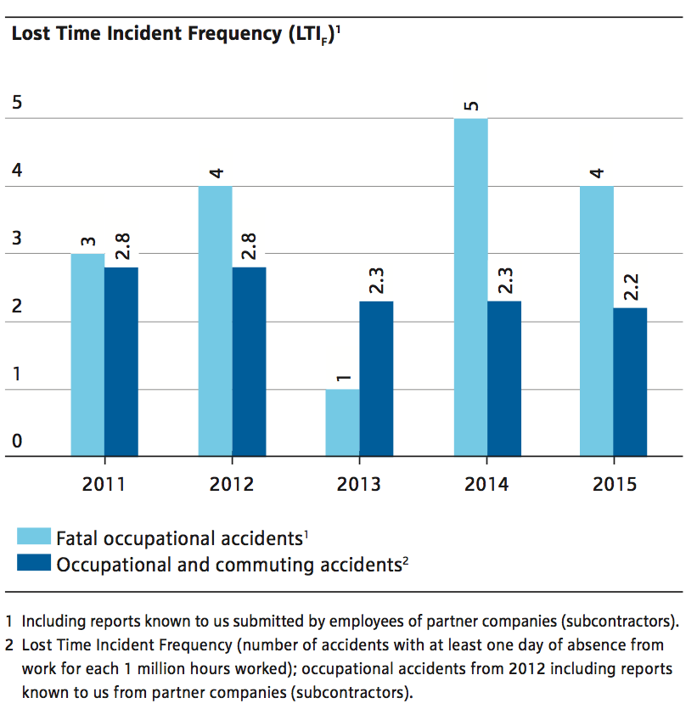
We very much regret to have to report that four fatal occupational accidents occurred in 2015. The causes of these accidents are being investigated by international accident analysis teams. On the basis of the results of the analyses carried out by our specialist experts, we are taking action together with our partner companies to adopt suitable measures for preventing similar accidents of this nature in the future.
Anchoring at management level
In 2015, Health and Safety Culture Development was launched in the RWE Group. This project analyses and develops the issues of health and occupational safety for the first time within the framework of cultural development. The aim of the project is to increase the health ratio sustainably and reduce the LTIF rate. This was implemented by starting three processes in parallel:
- Managers come together with employees in order to discuss the issues of health and occupational safety in concrete terms and in a joint forum. The prime aim is to bring down the level of absences linked to motivation, reduce mental stress and physical burdens, and prevent accidents from happening in the first place.
- Furthermore, relationships in the workplace and autonomous responsibility of employees are discussed together with line managers. Moreover, the employees are given the opportunity of integrating the issue of health into employee discussions, during inspections and at meetings.
- As a third measure, best practices from individual companies are recorded and transferred to other companies.
The project was launched in January 2015. In the meantime, more than 800 managers have been trained in 35 workshops and approximately 300 experts in ten workshops. The Group is providing the
appropriate funds for implementing the project and pursuing the goal of developing the health and safety culture in a sustainable approach.
Occupational safety with partner companies
The concept of the Safety Team is implemented within the framework of workplace safety management throughout the RWE Group. Experts from RWE and partner companies work together in teams to improve workplace safety in all areas of the companies involved. The Safety Team proved to be successful especially in the pilot sector of Süwag in 2015. The accident rate of partner companies had already been reduced by 50% during the first year of the project and it fell again by one third during the second year. Based on this success the Safety Teams is now increasingly to be installed group-wide.
Excellent occupational safety
In 2015, an RWE company was awarded the German Workplace Safety Prize for the second time in succession. RWE’s subsidiary company Süwag and its Safety Team were awarded the prize in the cate- gory of Organisational Solutions at large companies. The workplace safety prize is awarded every two years and is presented at the world’s biggest specialist forum for workplace safety and occupational safety in Dusseldorf.
In the Czech Republic, RWE received the highest award as a Health Promoting Company from the Institute for Public Health. A seven-point programme allows every employee to monitor their own health. The package includes mobile diagnostic instruments located directly at workplaces and benefits with service providers in the healthcare sector.
Expansion of Operational Healthcare Management
Since June 2015, international management and coordination in the area of health has been carried out in the Centre of Expertise Health. The centre bundles the issues of occupational medicine, healthcare management, social counselling service and emergency medicine.
An important focus is provided by raising the awareness of effective handling of stress and career workload. We have developed a modular package on the issue of resilience as part of the training package offered by Operational Healthcare Management (OHM). We use a number of measures including the Work Ability Index (WAI) to record employees’ performance and ability to carry out their work. This is based on the subjective assessments by the employees in our work- force and it records the extent to which they are in a position to carry out their work satisfactorily at the present time and in the future.
At the end of 2015, 70% of the employees in our German companies were recorded in the index (2014: 70%). By the end of 2015, a total of 22,600 questionnaires had been completed for the index.

12.7 Specific projects
Ecological projects
They are called four-spotted chaser, red-eyed damselfly, southern skimmer or white-faced darter – these and 38 other dragonflies and damselflies have been found by scientists in the recultivated sections of the opencast mines Ville, Frechen, Berrenrath, Bergheim, Fortuna, Frimmersdorf, Garzweiler, Hambach, Zukunft and Inden - a sizeable number, which the recultivation research centre documented when these insects were mapped in 2003.
Biodiversity
Seven species more than in the previous year were sighted by the scientists, including the small red damselfly, which is threatened by extinction, or damselfly species like the Mediterranean hawker, which is not even at home in Germany, since it prefers the warmer climes of the Mediterranean.
While they were at it, our scientists also shed light on the natural enemies of the dragonfly – frogs and toads. A total of 13 species, they found, were splashing about in lakes, ponds and the retention basins created on the terrain of the former opencast mines.
Help for hares
In another environmental project, RWE addressed the needs of the brown hare. Between 2001 and 2004, the recultivation research centre took part in the state-wide initiative "Hilfe für den Hasen" (Help for the hare). This help is sorely needed, because the brown hare in North Rhine-Westphalia has been on the Red List of endangered species since 1994. Natural enemies, from eagle to fox, and, above all, a lack of habitats to suit the species had been threatening the hare since the 1980s. So, in recultivating the Fortuna-Garsdorf opencast mine, RWE backed measures that offered the brown hare protection from its enemies and improved its habitat. The result: toward the end of the project, the hare population in the project territory had more than doubled.
Protection and promotion of biodiversity
In 2015, we adopted a Biodiversity Policy for the Group. This guide- line establishes how RWE intends to protect and promote biodiversity stewardship as the company carries out its business activities. We protect species diversity by strategic measures if natural habitats are destroyed by our activities. These include fish ladders at run-of- river power stations and the use of technical measures to protect marine species at offshore wind farms. The same approach continues as we reinstate substitute habitats or facilitate the repopulation of existing habitats. We also contribute to the promotion of biodiversity through the recultivation of mining areas.
A green bridge was constructed over the German A 61 highway at a cost of € 4 million. The structure is part of the species protection concept for the Hambach opencast mine and helps to provide an integrated network of habitats outside the mining excavation area. The main reason for erecting the green bridge was as a crossing aid for the bats from Hambach Forest. It provides a route for these particularly shy animals to cross the motorway in the protected landscapes and nature conservation areas of the Erftal Valley. Bats make use of ultrasound waves for purposes of orientation and they need trees and bushes growing more closely together than is the case in a motorway corridor so that they can utilise this echolocation system effectively. The bridge helps the animals to negotiate the space with- out any danger. Naturally, other wild animals also benefit from the bridge.
Our cooperation with the International Union for Conservation of Nature (IUCN) was based on the topic of biodiversity management in the context of recultivation of opencast mining extraction areas and this was successfully completed in the summer of 2015. The final report compiled by the IUCN describes exemplary approaches by our biodiversity management and also puts forward proposals for improvement.

Daimler sustainability report 2015: part „Employees “, p. 65 URL: https://www.daimler.com/documents/sustainability/other/daimler-sustainability-report-2015.pdf Date: 01.09.2016
Daimler sustainability report 2015: part „Employees “, p. 64-71 URL: https://www.daimler.com/documents/sustainability/other/daimler-sustainability-report-2015.pdf Date: 01.09.2016
Daimler sustainability report 2015: part „ Suppliers“, p. 81-84 URL: https://www.daimler.com/documents/sustainability/other/daimler-sustainability-report-2015.pdf Date: 01.09.2016
Daimler sustainability report 2015: part „ Social responsibility“, p. 90 URL: https://www.daimler.com/documents/sustainability/other/daimler-sustainability-report-2015.pdf Date: 01.09.2016
Daimler sustainability report 2015: part „Corporate environmental protection“, p. 52 URL: https://www.daimler.com/documents/sustainability/other/daimler-sustainability-report-2015.pdf Date: 01.09.2016
Daimler sustainability report 2015: part „Corporate environmental protection“, p. 52-62 URL: https://www.daimler.com/documents/sustainability/other/daimler-sustainability-report-2015.pdf Date: 01.09.2016
Daimler sustainability report 2015: part „Employees “, p. 72-75 & part “Social responsibility” p. 85 URL: https://www.daimler.com/documents/sustainability/other/daimler-sustainability-report-2015.pdf Date: 01.09.2016
Daimler sustainability report 2015: part „Employees “, p. 75-79 URL: https://www.daimler.com/documents/sustainability/other/daimler-sustainability-report-2015.pdf Date: 01.09.2016

